- What are the 2 most abundant gases in the atmosphere
a. oxygen, nitrogen b. oxygen, water vapor
c. carbon dioxide, methane d. nitrogen, carbon dioxide

- Connect the gas to the symbol These have now been aligned

(molecular) oxygen O₂
(molecular) nitrogen N₂
carbon dioxide CO₂
water H₂O
ozone O₃
- Which gas’ concentration varies the most from place to place
a. oxygen b. water vapor c. nitrogen d. argon

- Which molecule in the atmosphere protects surface creatures from UV radiation
a. oxygen b. water vapor c. nitrogen d. ozone

- Where is most of this molecule located?
a. troposphere b. stratosphere c. mesosphere d. thermosphere

- Which are the two most important greenhouse gases in the atmosphere
a. oxygen, nitrogen b. oxygen, water vapor
c. carbon dioxide, water vapor d. nitrogen, carbon dioxide

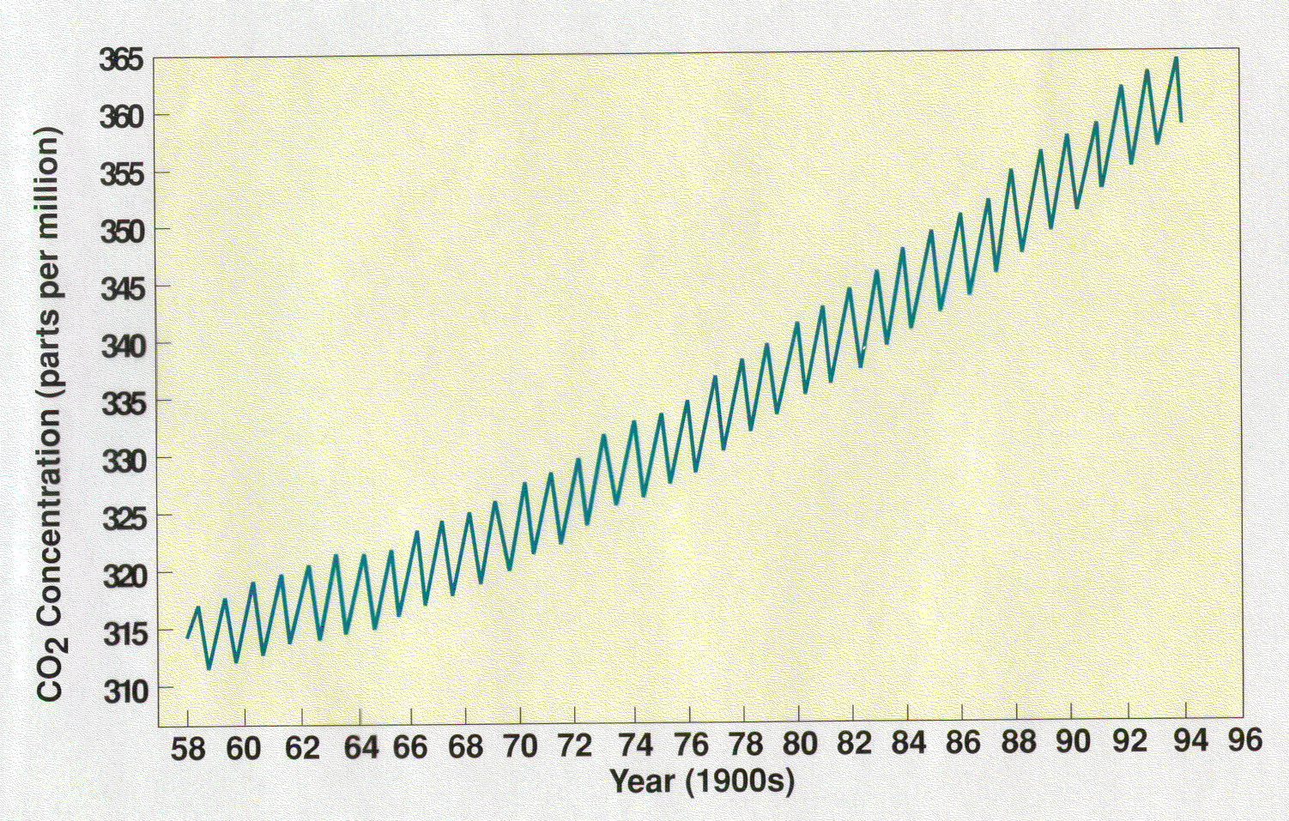
- Which greenhouse gas concentration has been increasing due to fossil fuel burning?
a. oxygen b. nitrogen c. water vapor d. carbon dioxide

- Temperature conversion: 40ºC is
a. 40 ºF b.72ºF c. 80ºF e. 90ºF f. 104ºF

- What is 40ºC in Kelvin (K)?
a. 273 b. 213 c. 313 d. 333 e. 104

- What is the approximate standard atmospheric pressure at sea level in millibars?
a. 1000 b. 14.7 c. 100 d. 29

- Approximately 25% of the atmosphere is above 11 km altitude. Therefore what is the approximate atmospheric pressure at 11 km altitude?
a. 1000 mb b. 750 mb c. 500 mb d. 250 mb

- In what layer of the atmosphere does weather occur?
a. troposphere b. stratosphere c. mesosphere d. thermosphere

Use the map figure to the right to answer questions 13-18

- What is the sea level surface pressure (in mb) 998.7
- What is the surface air temperature (in ºF) 31 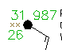

- What is the surface air dew point (in ºF) 26

- The approximate wind direction is
a. southeasterly b. northwesterly c. southerly d. westerly

- What is the wind speed (in knots)?
a. 0 b. 10 c. 15 d. 20

- Approximately what fraction of the sky is covered with clouds?
a. none b. 1/4 c. 1/2 d. 4/4

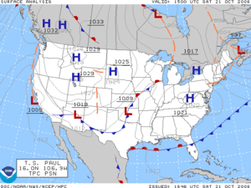

- In the figure above, the weather front across New Mexico and Texas is a
a. cold front b. warm front c. stationary front d. occluded front

- Connect the following types of Heat transfer with the descriptions (have been aligned)
Conduction | When two objects touch, heat is transferred from the hot object to the cold object.
Convection | Hot air rises, cold air sinks, transferring heat upward
Latent heat | Where water vapor condenses into a cloud, the atmosphere is warmed.
Radiation | Transfer of energy from a (red hot) campfire to people sitting around the campfire.

- Which state of water is less ordered and more energetic?
a. water ice b. liquid water c. water vapor

- If we increase the absolute temperature of an object by a factor of 10, the radiation energy emitted from the object increases by a factor of
a. 10 b. 100 c. 1,000 d. 10,000

Short Answers
- Briefly explain how weather differs from climate

Extra credit

- Explain how average daytime temperatures in Tucson are higher in June than in July, but July is the hottest month in Tucson.

- The pressure in the figure for questions 12-18 is from Flagstaff which is approximately 2 km above sea level. Is the reported pressure the actual pressure one would measure at Flagstaff or that pressure converted to sea level altitude? Why?

ANSWER SHEET

1. a b c d
2. a b c d
3. a b c d
4. a b c d
5. a b c d
6. a b c d
7. a b c d
8. a b c d
9. a b c d
10. a b c d
11. a b c d
12. a b c d
13. a b c d
14. a b c d
15. a b c d
16. a b c d
17. a b c d
18. a b c d
19. a b c d
20. a b c d
21. a b c d
22. a b c d

