- If the temperature of an object increases, the amount of radiation the object emits
  - Increases b. Decreases c. Remains the same

- The primary factor that causes the seasons is the
  - 23.5º tilt of the Earth’s spin axis b. variation of the Earth’s distance to the sun
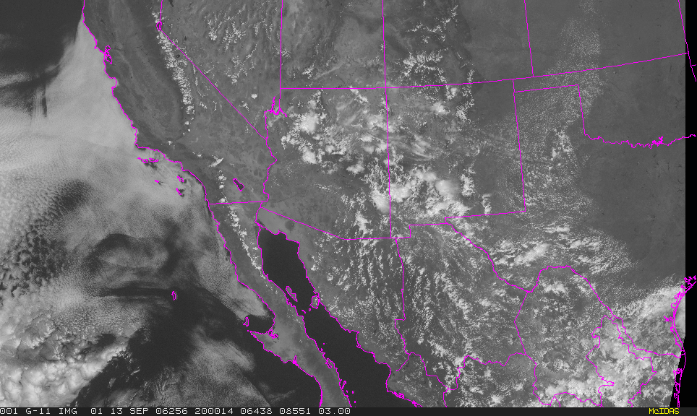
c. oceans cover 2/3 of the Earth’s surface

- The Earth reflects about 30% of the sunlight that hits it (the Earth’s “albedo” = 30%). What part of the Earth is responsible for most of this reflection (and therefore cooling the Earth)?
  - Ocean
  - Land
  - Clouds
See visible satellite image to the right Remember: things that reflect visible light are bright and white to our eyes. Dark things absorb visible light.

- Which of the following affects the seasonal temperatures
  - latitude b. length of day c. angle of sunlight striking the Earth’s surface
d. length of the path through the atmosphere e. all of the above

- As long as the surface is absorbing more energy than it is emitting, its temperature will
  - increase b. remain the same c. decrease

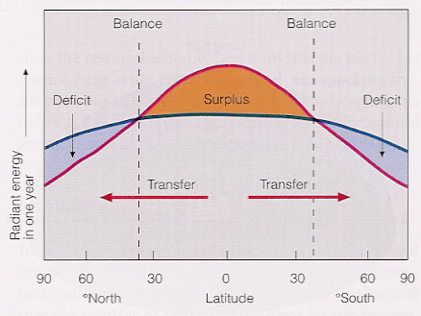
- The figure to the right shows how the Earth’s energy transfer (averaged over a year) varies with latitude. The red curve is the amount of solar radiation energy absorbed and the blue curve is the IR energy emitted from the Earth into space. At the equator there is more solar radiation being absorbed by the Earth than IR emitted by the Earth. At the high latitudes, the opposite is occurring. This means that energy must be being transferred horizontally from the equator to the poles. What is responsible for transferring heat (energy) from equatorial region toward the poles?
  - radiation
  - atmospheric circulation
c. oceanic circulation
d. b & c

- If there were no horizontal energy transport, then, relative to present temperatures, the temperatures at high latitudes would be
  - Warmer b. cooler c. the same

- In June, Tucson temperatures can increase from 70ºF in the morning to 100ºF (or more). What is the temperature range in C?
  - 70 to 100 b. 21 to 38 c. 20 to 50 d. 10 to 28

- What is the temperature range in K?
  - 294 to 310 b. 200 to 230 c. 300 to 330 d. 294 to 324

Note: As a result of this daytime temperature increase at the surface, the surface is radiating 25% more energy in the afternoon than it was during the morning.
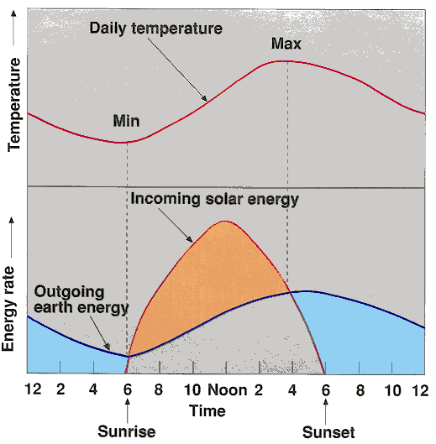

- In the figure to the left, the peak temperature occurs at about 3:30 in the afternoon. Why is the warmest time of day typically in the mid to late afternoon rather than noon?
  - The sun is directly overhead
  - Net outgoing infrared radiation emitted by the surface equals the incoming sunlight absorbed by the surface
  - At sunset the sun has been warming the surface all day

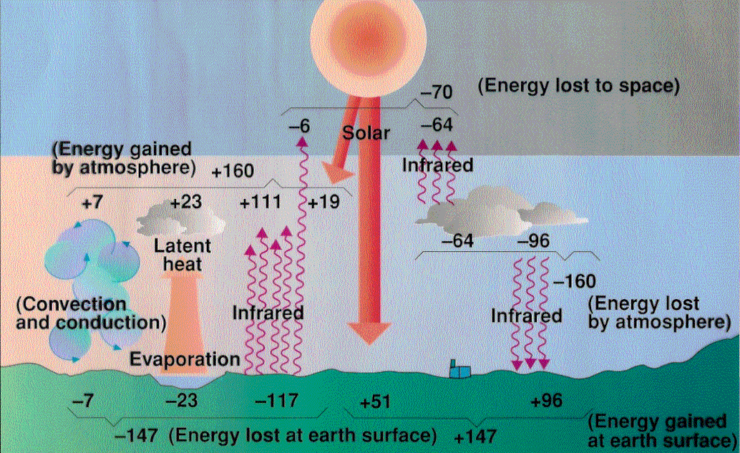
- In the figure to the left, three of the following cause the surface to cool. Which one does NOT?
  - IR radiation emitted by the surface
  - Conduction (as long as the surface is warmer than the air)
  - Evaporation of water from the surface
  - Surface absorption of IR that was emitted downward from the atmosphere

- In the figure to the left, the greenhouse effect (which keeps the surface warmer than it would be without an atmosphere) is due to
  - The solar radiation absorbed by the surface (+51 term in the figure)
  - The IR radiation emitted by the surface (-117 term in the figure)
  - The IR radiation emitted by the atmosphere and absorbed by the surface (+96 term)

- Desert conditions: the increase in temperature during the day is larger than regions with more moisture in the air. Why?
  - Sunlight reaching the surface is more intense because there are less clouds reflecting sunlight
  - There are fewer clouds radiating infrared radiation down to the surface
  - The specific heat of land is ~5 times lower than that of water so its temperature rises more for the same heat input
  - all of the above

- The drop in temperature at night in desert regions is larger than regions with more humidity. Why?
  - There is more evaporative cooling at night
  - There is less water vapor and fewer clouds radiating infrared radiation down to the surface
  - The specific heat of land is 5 times less than that of water so its temperature drops more for the same loss of heat
  - b & c

- The first and last freezes of the season usually occur in low areas. Why?
  - Low areas tend to have low specific heats
  - Low areas are hotter in summer
  - Cold air is dense and sinks

- The weather conditions that contribute to very cold surface temperatures are
  - Night time b. no wind c. clear
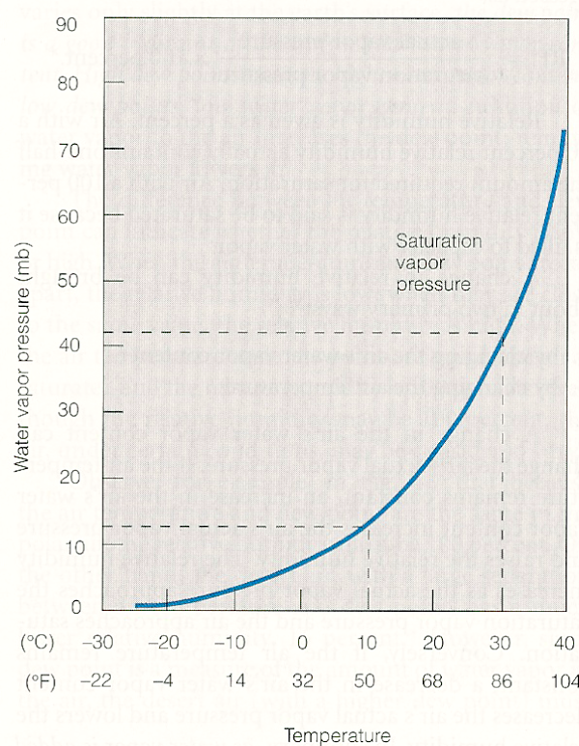
d. all of the above

- Land has 5 times lower specific heat than water. Therefore, in the winter, which gets colder?
  - the continents b. the oceans

- Dew point is 25ºC. What is the dew point in Fahrenheit?
  - 25 b. 50 c. 68 d. 77 e. 86

- Dew point is 25ºC. What is the water vapor pressure in mb?
  - 10 b. 20 c. 30 d. 40 e. 50

- The air temperature is 35ºC, what is the saturation vapor pressure in mb?
  - 10 b. 25 c. 40 d. 55

- Dew point is 25ºC and the air temperature is 35ºC. What is the relative humidity?
  - 10% b. 25% c. 55% d. 80%

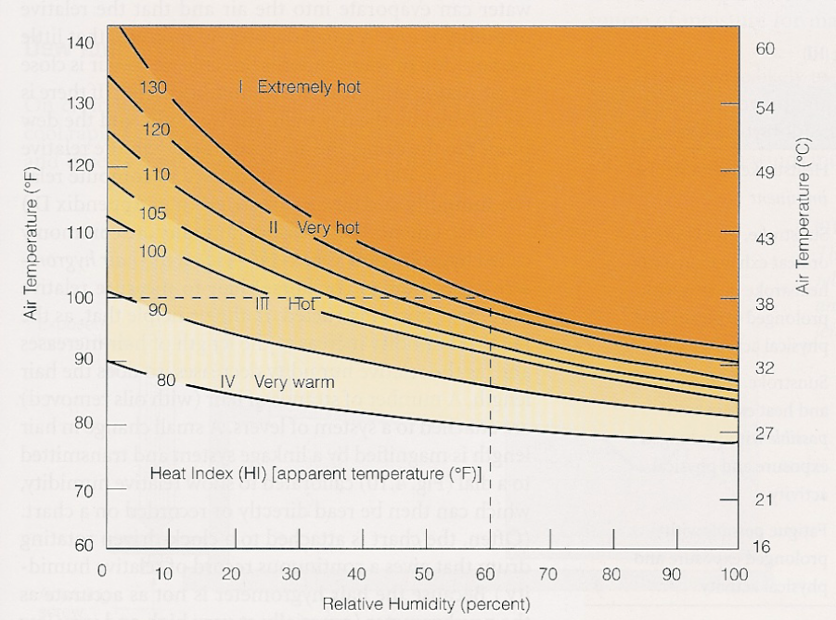

- What does a Sling Psychrometer do?
  - Measure the intensity of sunlight
  - Measure evaporative cooling to determine relative humidity
  - Measure cloud amount

- Heat index: Tucson has a temperature of 100ºF and a relative humidity of 10%. Rocky Point at the north end of the Gulf of California has a temperature of 90ºF and a relative humidity of 70%. According to the figure to the right, which feels warmer:
  - Tucson b. Rocky Point

- Evaporative or swamp coolers work better in Tucson in June before the monsoonal moisture arrives here from Mexico than after the monsoon moisture gets here in July. Why?
  - Daytime temperatures are higher in June
  - Nighttime temperatures are warmer in July
  - Relative humidity is lower in June

- How does one decrease relative humidity?
  - Add more water molecules to the air
  - Increase the air temperature and the saturation vapor pressure
  - Decrease the air temperature and the saturation vapor pressure

- Connect the following water-related variables to their definitions

Relative humidity | Fraction of the air mass that is water
Specific humidity | Amount of water vapor actually in the air divided by how much water vapor the air can hold
Dew point temperature | Lowest Temperature your evaporative cooler can cool to
Saturation vapor pressure | Temperature at which water will begin to condense out
Wet bulb temperature | Amount of water vapor the air can hold

Extra credit:

- When air temperature rises above body temperature, conduction will cause the air to transfer heat into the body causing the body to overheat. How does the body avoid this from happening? (How does the body cool itself when the air temperature is warmer than the body temperature?) Identify which of the 4 heat transfer processes is involved in this cooling process (conduction, convection, radiation and latent heat transfer)

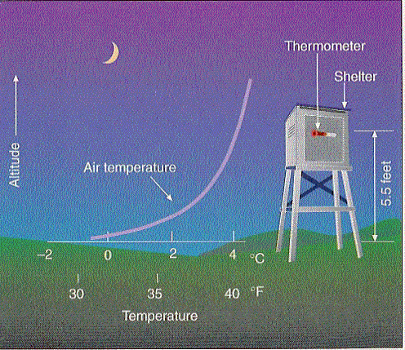
- Using the temperature profile in the figure to the right, explain how winds at night can keep crops from freezing

- Explain why the warmest day in the year is not June 21 but typically late July or early August. (Think in terms of the Figure to Question 10 except the horizontal axis is now months instead of time of day. The reason is basically the same reason the daytime maximum temperature is afternoon rather than noon)

