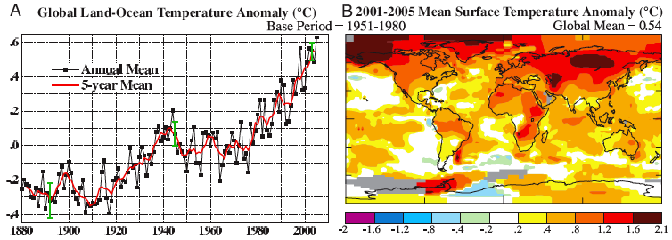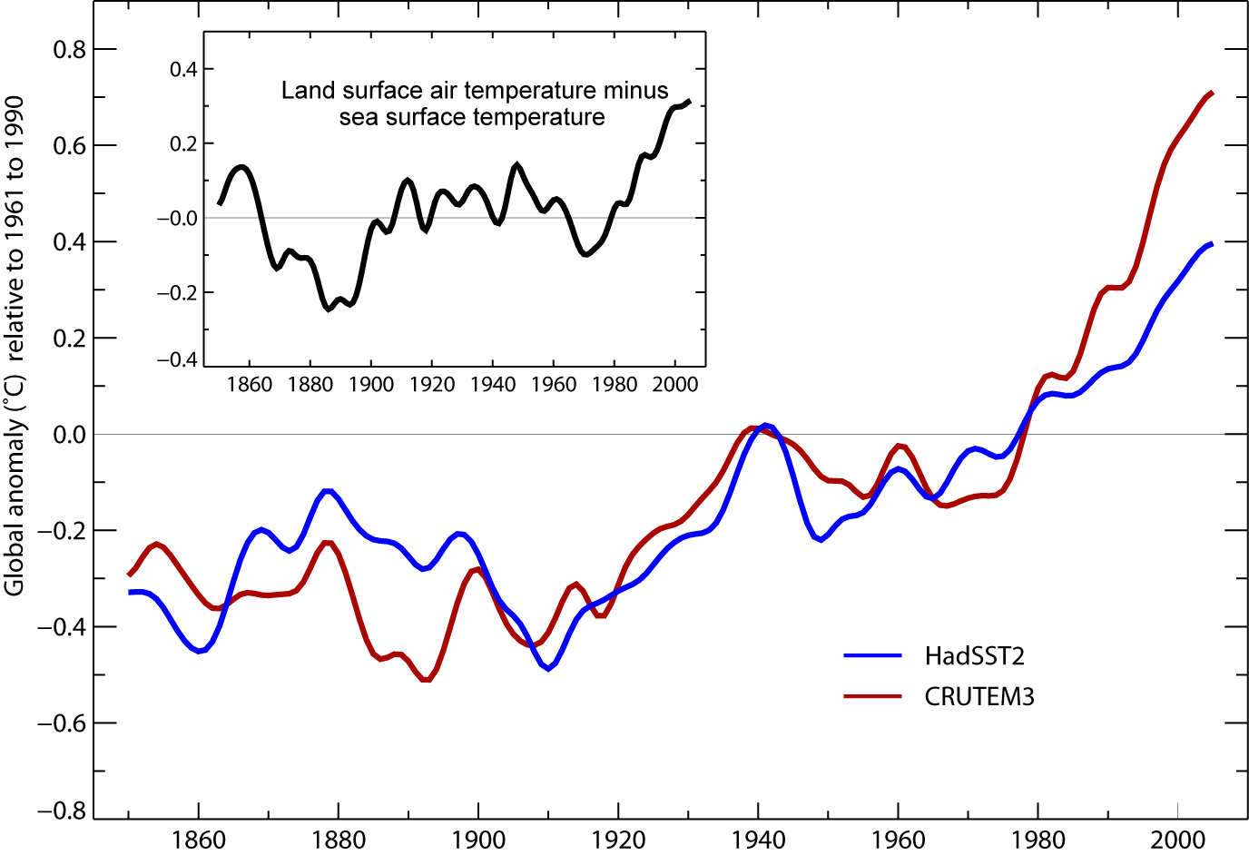
SST
Land

- How can predictions of future climate predict more flooding and increased drought at the same time?
a. Air temperatures will be warmer so the air can hold more moisture
b. Rainfall will be more intense
c. Rainfall will be less frequent
d. Warmer air means evaporation rates will be higher
e. All of the above

