Monday Aug. 25, 2008
Today's musical selection was Diablo Rojo by Rodrigo y Gabriela (sorry about the audiovisual equipment, you should have seen as well as heard Rodrigo y Gabriela). The plan this semester is to fill the 5 minutes before class with some kind of music or song (music won't take up any actual class time). Hopefully you'll enjoy at least some of the selections; comments and ideas from students are welcome.
Today was the first day of class. We first briefly discussed the Course Information handout. Read through this carefully on your own. You should try to purchase a copy of the photocopied Classnotes (in the bookstore) right away as we will probably be using some of them in class on Wednesday.
Next we looked at the Writing Requirements handout. You should be thinking about which of the 4 experiments (or book or scientific paper reports) you would like to do so that you can sign up in class on Wednesday. Distribution of the materials for the first experiment will probably begin in class on Friday.

Your grade in this class will depend on your quiz scores, how much extra credit you earn, your writing grade, and (perhaps) your score on the final exam. A sample grade report from the Spring 2008 MWF Nats 101 class was shown.
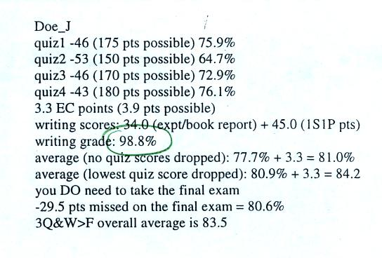
Don't worry about all the details at this point. Note that this student earned a D on one quiz and Cs on the three other quizzes. The student ended up with a B in the class largely because of the high (98.8%) writing grade and because of the extra credit (EC) points.

We'll begin this new semester in Chapter 1 of the text. Before opening the book and beginning the first reading assignment, try to imagine what you would put in the first chapter of a meteorology and climatology textbook.

Student answers to the question above included: gravity (would you be able to walk on the planet's surface) and whether there was enough oxygen in the outside air to breathe. These and other basic characteristics of the atmosphere such as air pressure and air density are covered in Chapter 1.
Today we were mostly just concerned with the composition of the earth's atmosphere, in particular the 5 most abundant gases in the earth's atmosphere.
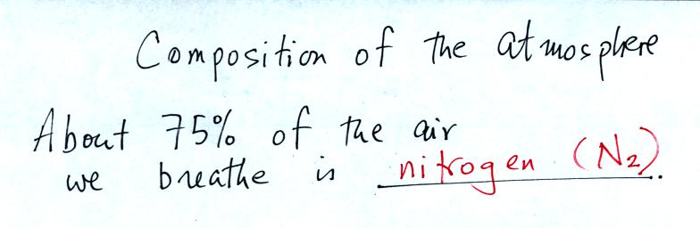
This is the first of several questions asked during class. The answer was filled in after pouring some liquid nitrogen into a cup.
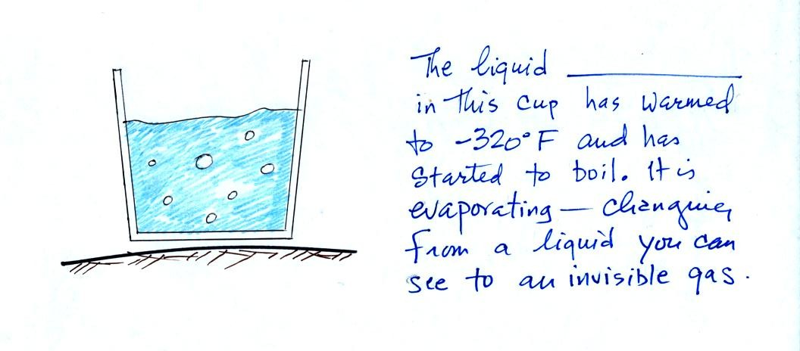
You can see liquid nitrogen, it is clear (not blue as shown above) and looks like water. Once it has evaporated and turned into a gas it is invisible. Nitrogen was discovered in 1772 by Daniel Rutherford (a Scottish botanist). Atmospheric nitrogen is relatively unreactive and is sometimes used to replace air in packaged foods to preserve freshness. We'll use liquid nitrogen in several class demonstration this semester.
Nitrogen is the most abundant gas in air, what other gases are there?

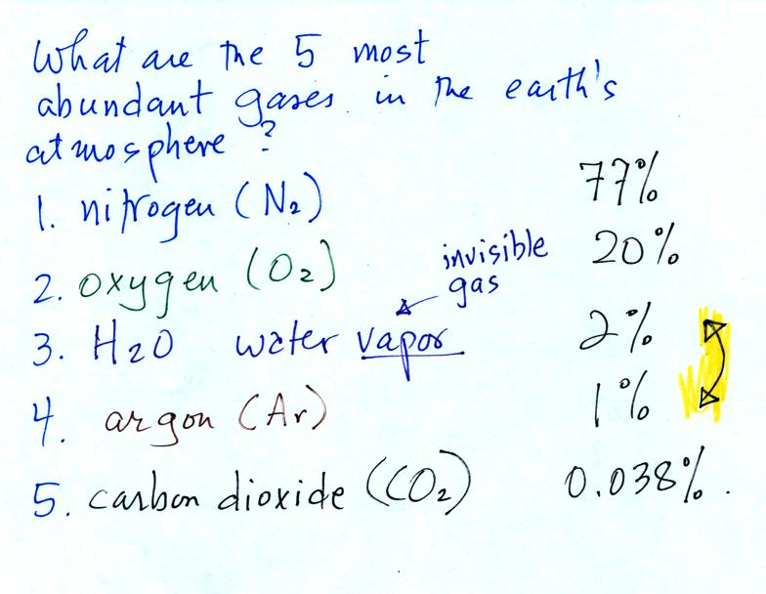
Oxygen is the second most abundant gas in the atmosphere. Oxygen is the most abundant element (by mass) in the earth's crust, in ocean water, and in the human body. Here's a photograph of liquid oxygen. It has a (very faint) blue color.
When heated (such as in an automobile engine) the oxygen and nitrogen in air react to form compounds such as nitric oxide (NO), nitrogen dioxide (NO₂), and nitrous oxide (N₂O). Together as a group these are called oxides of nitrogen; the first two are air pollutants, the last is a greenhouse gas. More about those in class on Wednesday.
Water vapor and argon are the 3rd and 4th most abundant gases in the atmosphere. The concentration of water vapor can vary from near 0% to as high as 3% or 4%. Water vapor is, in many locations, the 3rd most abundant gas in air. In Tucson, the air is often dry enough that argon is in 3rd position and water vapor is 4th.
Water vapor, a gas, is invisible. Clouds are visible because they are made up of small drops of liquid water or ice crystals. Water is the only compound that exists naturally in solid, liquid, and gaseous phases in the atmosphere.
Argon is an unreactive noble gas (helium, neon, krypton, xenon, and radon are also inert gases). Noble bases are often used in "neon signs."
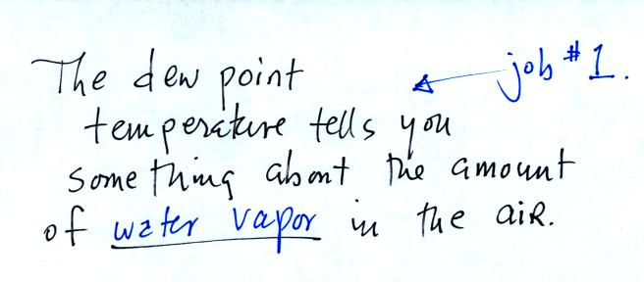
Water plays an important role in the formation of clouds, storms, and weather. Meteorologists are very interested in knowing and keeping track of how much water vapor is in the air at a particular place and time. One of the variables they use is the dew point temperature. The higher the dew point value, the more water vapor there is in the air.
The chart below gives a rough equivalence between dew point temperature and percentage concentration of water vapor in the air.
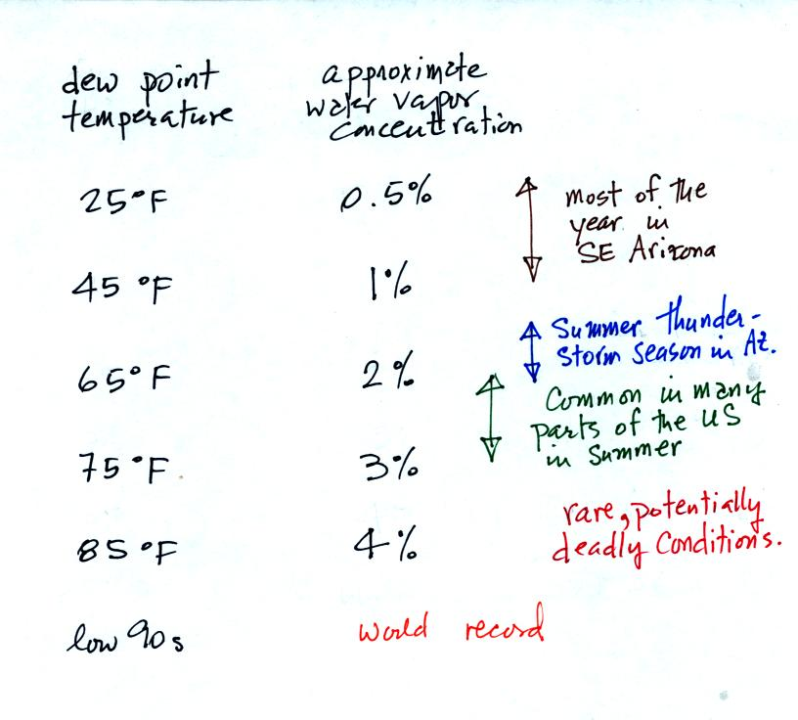
Click here to see current dew point temperatures across the U.S.
The second job of the dew point temperature is
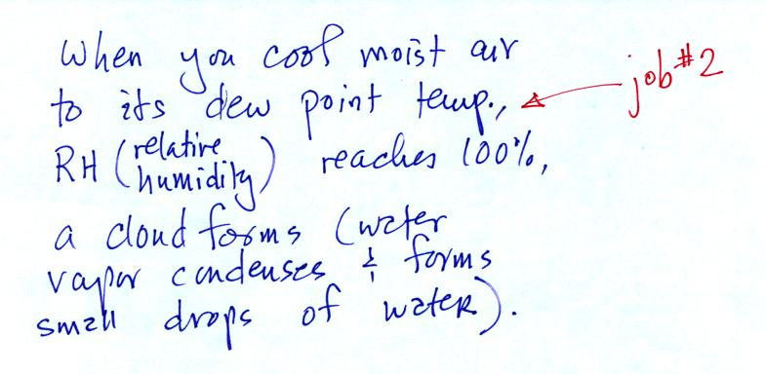
We could use the cup of liquid nitrogen to show this.
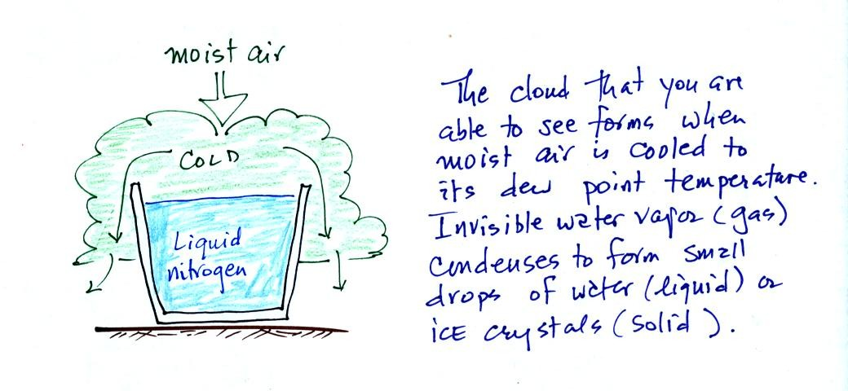

The earth's original atmosphere, which was composed mostly of hydrogen (H) and helium (He), was very different from today's atmosphere. This atmosphere escaped (the earth was hot and the gases were moving around with enough speed that they could overcome the pull of the earth's gravity) or was swept (by the solar wind) into space.
Our present atmosphere is though to have come from volcanic eruptions.
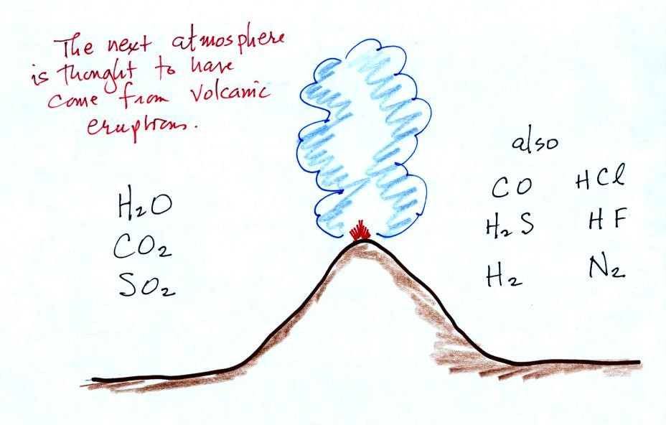
Volcanoes emit a lot of water vapor and carbon dioxide. As the earth began to cool the water vapor condensed and began to create oceans. Carbon dioxide dissolved in the oceans and was slowly turned into rock. Smaller amounts of nitrogen (N2) are emitted by volcanoes. Nitrogen is relatively inert and remained in the air. Nitrogen concentration built up over time.
Volcanoes didn't add any of the oxygen that is the atmosphere. Where did that come from? The following figure was not shown in class.
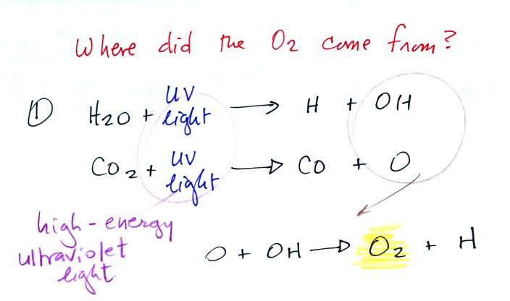
The oxygen is thought to have first come from photodissociation of water vapor and carbon dioxide by ultraviolet light (the high energy radiation splits the H₂0 and CO₂ molecules into pieces). The O and OH react to form O₂ and H.
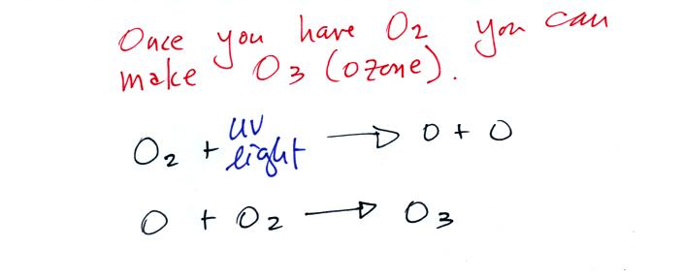
Once O₂ begins to accumulate in the air it can react with O to form ozone, O₃. The ozone then begins to absorb ultraviolet light and life forms can safely move from the oceans (which would absorb UV light in the absence of ozone) onto land. Eventually plants and photosynthesis would become the main source of atmospheric oxygen.
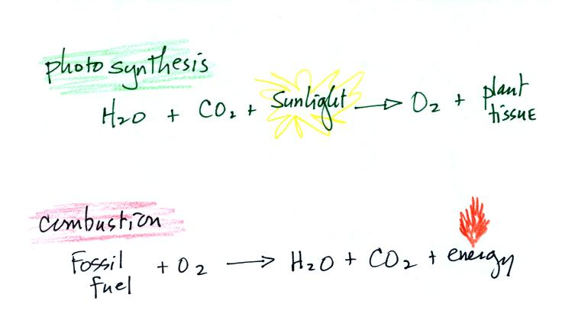
Note that combustion (and respiration) is really just the opposite of photosynthesis. We burn fossil fuels to generate energy. Water vapor and carbon dioxide are by products.
In class on Wednesday we will see that blue-green algae (cyanobacteria) in the ocean began to produce oxygen by photosynthesis before plants moved from the oceans onto land.

