Friday Nov. 21, 2008
No music before class today. Instead a few minutes from the 1999 Le Tour de France. You saw the finish of the first really tough mountain stage in the race that year (they finished in the town or resort of Sestrieres). Lance Armstrong started the day leading the race and wearing the Yellow Jersey, but many people thought he would crack in the mountains. Well that didn't turn out to be the case. He won the stage and would go on to win the race that year for the first time. A bicycling video seemed appropriate because the El Tour de Tucson is tomorrow.

We will spend the next two classes on Hurricanes.
A good place to begin is to compare hurricanes (tropical cyclones) with middle latitude storms (extratropical cyclones). The following figure was on a handout distributed in class.
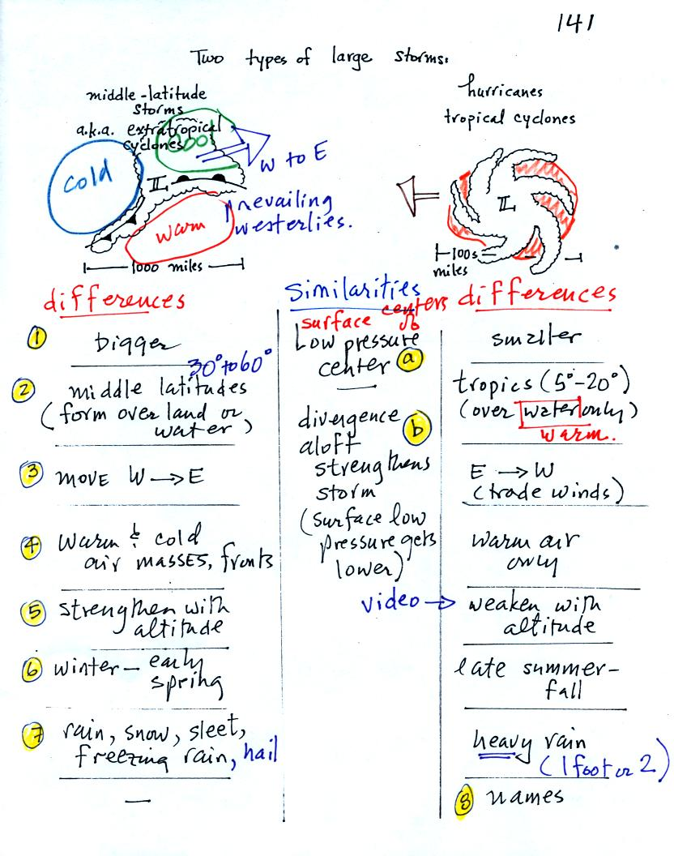
1. Middle latitude storms (MLS) are generally bigger than hurricanes. A large middle latitude storm might cover half of the United States. A big hurricane might fill the Gulf of Mexico.
2,3. MLS can form over land or water. At middle latitudes they are in the prevailing westerly wind belt and move from West toward East. Hurricanes can only form over warm ocean water (80 F or above). The trades winds cause hurricanes to move from east to west.
a. Both MLS and hurricanes from around surface centers of low pressure (that is why the term cyclone appears in the names of both types of storms).
b. Upper level divergence can lower the surface pressure which then can cause both types of storms to intensify.
4. Warm and cold air masses collide along fronts in MLS. You only find warm moist air in a hurricane.
5. MLS intensify with altitude. Hurricanes weaken with altitude - the low pressure at the bottom center of the storm actually becomes high pressure at the top center of the storm. The fact that hurricanes weaken with altitude came up in the video tape shown at the end of class. In the video a NOAA reconnaisance plane was flying into the center of a very strong hurricane. Normally the plane would fly in at an altitude of 5,000 feet. This particular hurricane was so strong however that they decided to play it safe and to fly in at 10,000 feet altitude.
6. The strongest MLS form in the winter and early spring. The peak of hurricane season is already behind us.
7. MLS can produce a variety of types of precipitation. Hurricanes mostly just produce very large amounts of rain.
8. Hurricanes receive names (when they reach tropical storm strength). The names now alternate male and female. The names of particularly strong or deadly hurricanes (such as Katrina) are retired, otherwise the names repeat every 6 years.

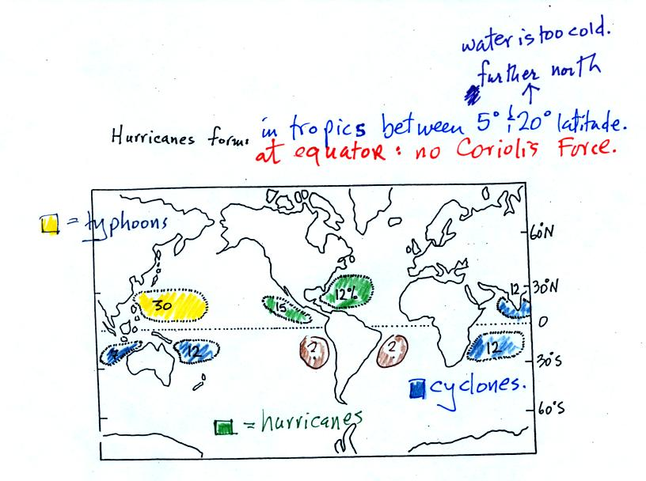
The figure above shows the relative frequency of tropical cyclone development in different parts of the world. The name hurricane, cyclone, and typhoon all refer to the same type of storm (tropical cyclone is a general name that can be used anywhere). In most years the ocean off the coast of SE Asia is the world's most active hurricane zone. Hurricanes are very rare off the east and west coasts of South America.
Hurricanes form between 5 and 20 degrees latitude, over warm ocean water, north and south of the equator. The warm layer of water must be fairly deep to contain enough energy to fuel a hurricane and in order that mixing doesn't bring cold water up to the ocean surface. The atmosphere must be unstable so that thunderstorms can develop. Hurricanes will only form when there is very little or no vertical wind shear (changing wind direction or speed with altitude). Hurricanes don't form at the equator because there is no Coriolis force there (the Coriolis force is what gives hurricanes their spin and it causes hurricanes to spin in opposite directions in the northern and southern hemispheres.
Note that more tropical cyclones form off the west coast of the US than off the east coast. The west coast hurricanes don't generally get much attention, because they move away from the coast and usually don't present a threat to the US (except occasionally to the state of Hawaii). The moisture from these storms will sometimes be pulled up into the southwestern US where it can lead to heavy rain and flooding.
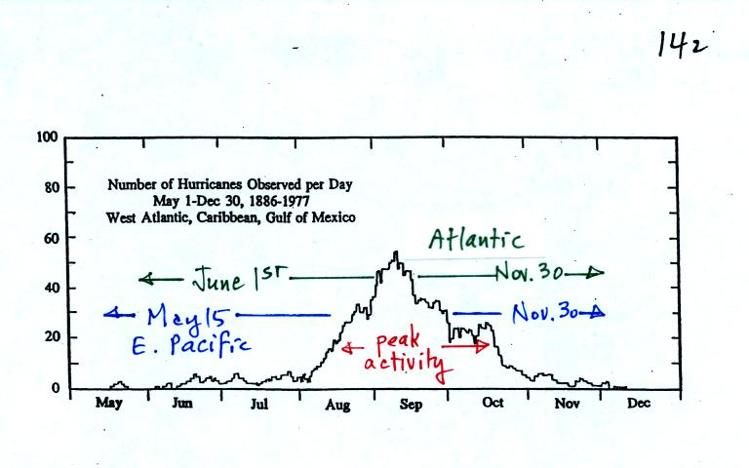
Hurricane season in the Atlantic officially runs from June 1 through to November 30. The peak of hurricane season is in September. In 2005, an unusually active hurricane season in the Atlantic, hurricanes continued through December and even into January 2006. Hurricane season in the Pacific begins two weeks earlier on May 15 and runs through Nov. 30.

Some kind of meteorological process that produces low level convergence is needed to initiate a hurricane. One possibility, and the one that fuels most of the strong N. Atlantic hurricanes, is an "easterly wave." This is just a "wiggle" in the wind flow pattern. Easterly waves often form over Africa or just off the African coast and then travel toward the west across the N. Atlantic. Winds converge as they approach the wave and then diverge once they are past it . The convergence will cause air to rise and thunderstorms to begin to develop.
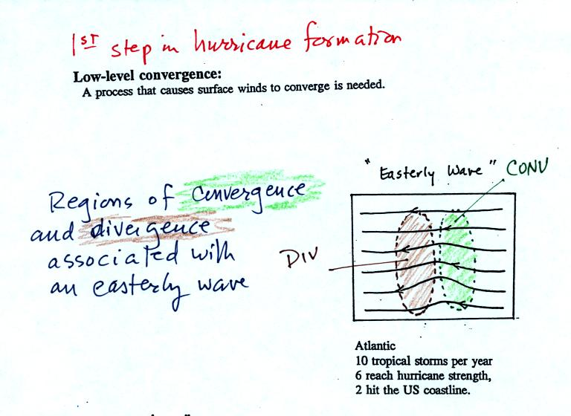

In an average year, in the N. Atlantic, there will be 10 named storms (tropical storms or hurricanes) that develop during hurricane season. 2005 was, if you remember, a very unusual year. There were 28 named storms in the N. Atlantic in 2005. That beat the previous record of 21 names storms that had been set in 1933. Of the 28 named storms, 15 developed into hurricanes.
In some ways winds blowing through an easterly wave resembles traffic on a multi-lane highway. Traffic will back up as it approaches a section of the highway with a closed lane. Once through the "bottleneck" traffic will begin to flow more freely.
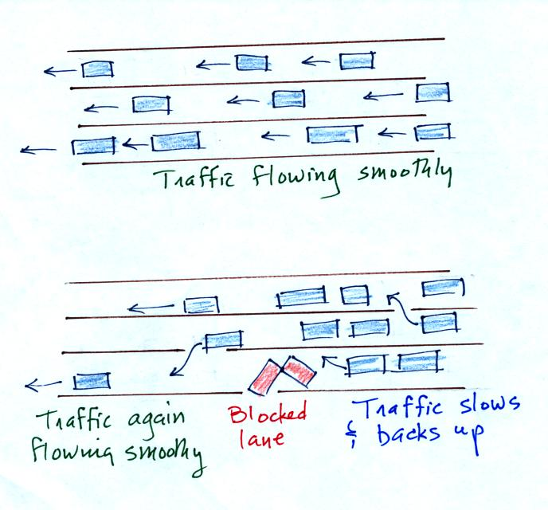
Another process that causes surface winds to converge is a "lee side low."
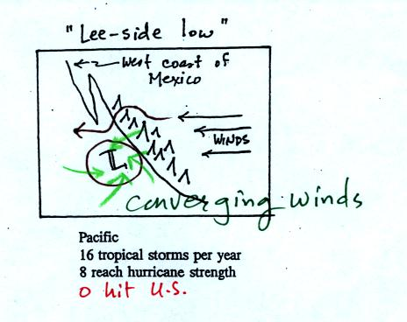

Winds blowing over mountains on the west coast of Mexico will sometimes form a surface low on the downwind side of the mountains. Surface winds will spiral inward toward the center of the low. Note there are generally a few more tropical storms and hurricanes in the E. Pacific than in the N. Atlantic. They generally move away from the US coast, though the Hawaiian Islands are sometimes affected.

That was about all the new material we had time to cover in class because a 20 minute segment from a NOVA program (PBS network) on hurricanes was shown. A film crew was on board a NOAA reconnaissance plane as it flew into the narrow eye of hurricane GILBERT. Gilbert set the record low sea level pressure reading for the Atlantic ocean (888 mb). That record stood until the 2005 hurricane season when WILMA set a new record of 882 mb. The world record low sea level pressure, 870 mb, was set in a SE Asian typhoon in 1979.
Here are some of the comments written down during the video (these were on the back of the handout distributed in class. We will review the Saffir Simpson scale in class on Wednesday and look at the 3-dimensional structure of hurricanes in more detail.
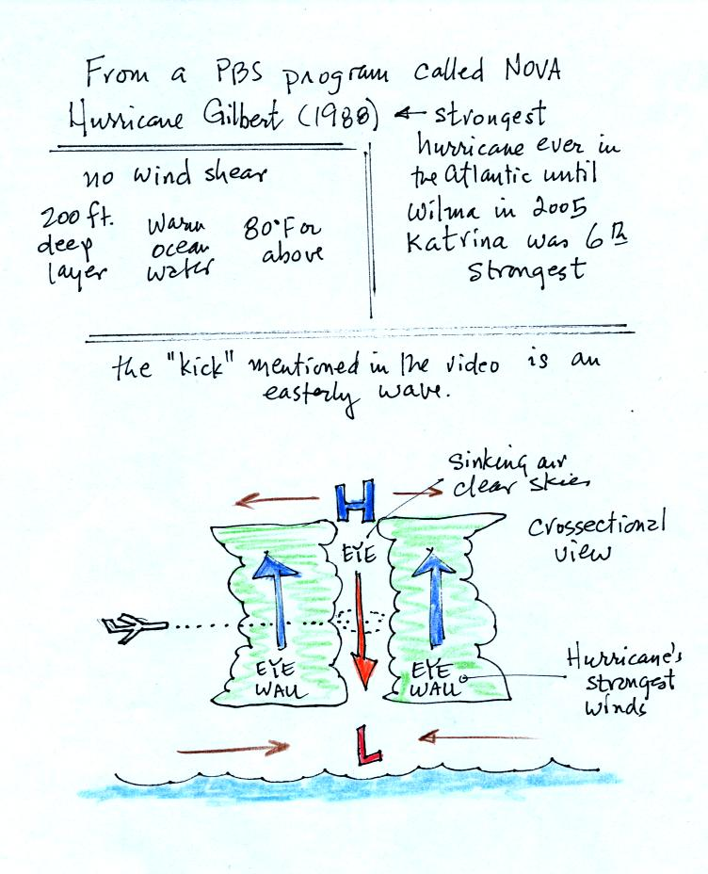

One of the most distinctive features of a hurricane is the clear eye in the center. The eye is produced by sinking air. Once in the eye, the people in the NOAA plane where able to see blue sky when they looked and and saw the ocean surface when they looked down. The eye of a hurricane is something that very few people will ever see. The eye is surrounded by the eye wall, a ring of strong thunderstorms.
