Friday Oct. 3, 2008
YouTube is amazing; I was able to find a good recording of today's song Vivere with Andrea Bocelli and Laura Pausini on YouTube.
Here's the latest Optional Assignment. Click on the link at left and follow the instructions. The assignment is due next Wednesday.
A change in the weather is expected over the weekend. Breezes, gusty winds (not good bicycling news), a slight chance of rain and a forecast high temperature of 79 F for Sunday. You can find the current weather forecast at the Tucson National Weather Service webpage (click on Tucson on the map).

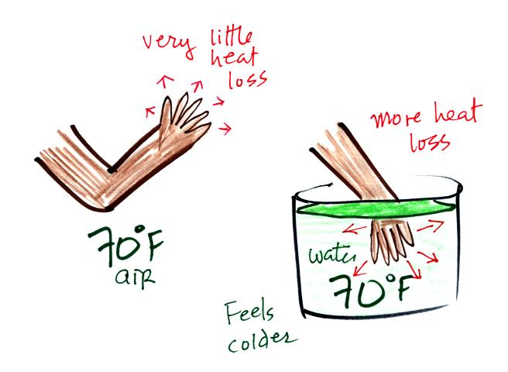  70 F water feels colder than 70 F  because water is a better conductor | 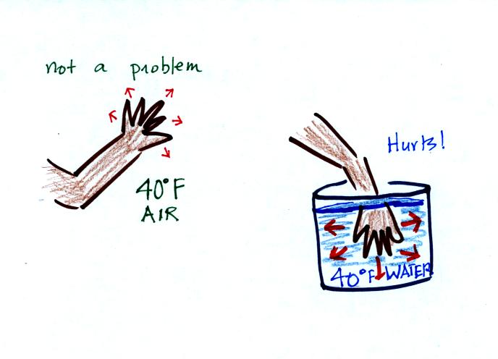  40 F air will feel cool because there is a bigger temperature difference between your hand and the air.  Leave your hand in 40 F water and it will start to hurt.
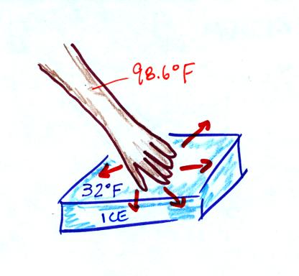  Ice feels cold even though it is not  a particularly good conduction. This is because of the large temperature difference between your hand and the water. | 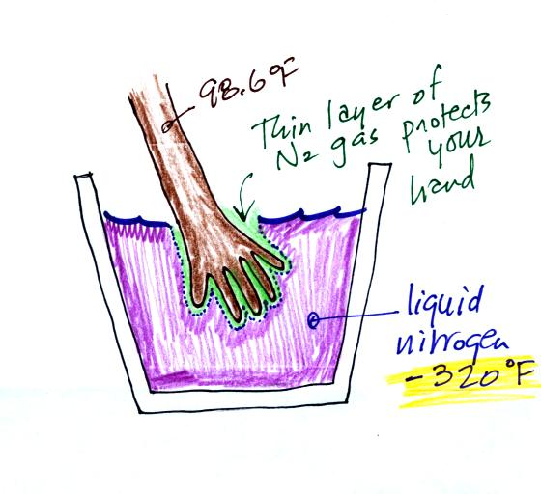  What about liquid nitrogen.  You can safely stick your hand in  liquid nitrogen for a fraction of a second. It doesn't feel particularly cold and doesn't feel wet. Some of the liquid nitrogen evaporates and surrounds your hand with a layer of nitrogen gas. This insulates your hand momentarily from the cold.

A quick review of energy loss under various situations and our perception of cold. This was done mostly to set the scence for a picture from the March 2005 issue of National Geographic showing a Buddhist monk standing in a frigid waterfall. The caption for the photograph read "To focus the mind and increase awareness of self, Shingon Buddhists like Souei Sakamoto practice takigyo,chanting for hours while standing in frigid waterfalls at the Oiwasan Nissekiji Temple in Toyama, Japan." (I can't really scan the photograph and include it in the classnotes because of copyright laws)
A second photograph from the December 2005 issue showed a monk hanging from a tree by his feet. The caption there read "To see life as it truly is - that's the goal of a student in China who strengthens mind and body under the rigorous tutelage of a Shaolin kung fu master."
Perhaps the most amazing example of a physical and mental task is the 1000-day challenge undertaken by the "marathon monks" of Mount Hiei, Japan.
I hope you don't mind an occasional digression like this (do feel free to send me emails with comments about the class, good or band, without any fear of repercussions). I spend a lot of time riding my bicycle uphills. It's not really painful but uncomfortable. I've noticed that you can sometimes be distracted by a thought and ride a mile or so and completely blank out the discomfort. With some "Buddhist monk like" training I wonder if maybe I couldn't ride uphill more or less indefinitely and not feel any pain. That's something I'll continue to work on.

We moved from Japan and China to ancient Greece and Archimedes Law of Bouyancy. You'll find this discussed on pps 53a and 53b in the photocopied Classnotes.
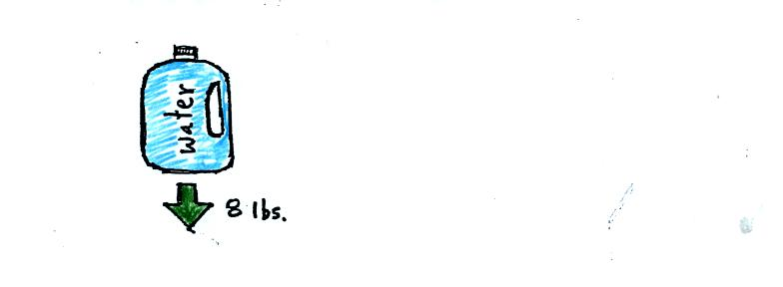
A gallon of water weighs about 8 pounds (lbs).
If you submerge a 1 gallon jug of water in a swimming pool, the jug becomes, for all intents and purposes, weightless. Archimedes' Law (see figure below) explains why this is true.
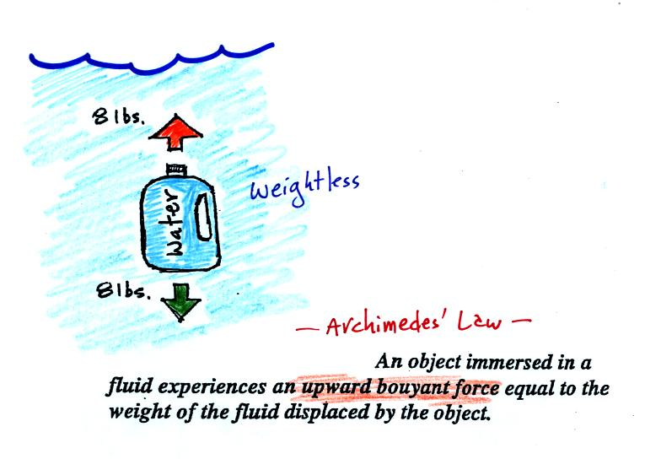
The upward bouyant force is really just another name for the pressure difference force covered on Wednesday (higher pressure pushing up on the bottle and low pressure at the top pushing down, resulting in a net upward force). A 1 gallon bottle will displace 1 gallon of pool water. One gallon of pool water weighs 8 pounds. The upward bouyant force will be 8 pounds, the same as the downward force on the jug due to gravity. The two forces are equal and opposite.
Now we imagine pouring out all the water and filling the 1 gallon jug with air. Air is about 1000 times less dense than water; the jug will weigh practically nothing.
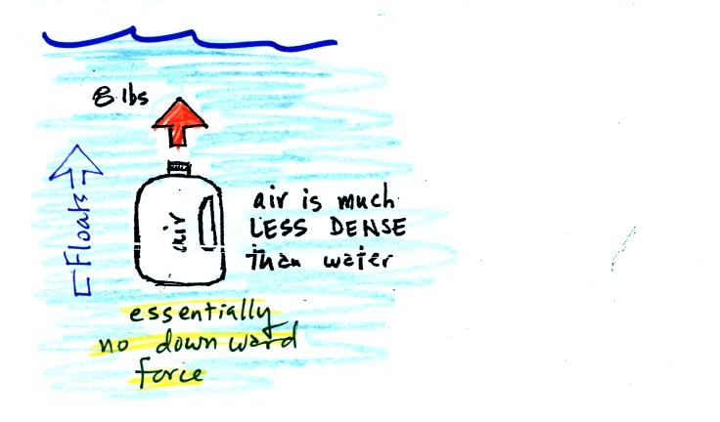
If you submerge the jug in a pool it will displace 1 gallon of water and experience an 8 pound upward bouyant force again. Since there is no downward force the jug will float.
One gallon of sand (which is about 1.5 times denser than water) jug will weigh 12 pounds.
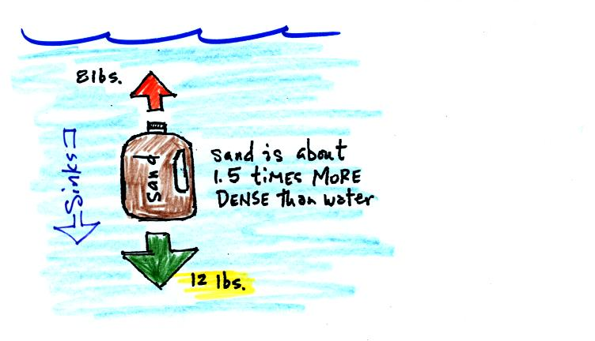
The jug of sand will sink because the downward force is greater than the upward force.
You can sum all of this up by saying anything that is less dense than water will float in water, anything that is more dense than water will float in water.
The same reasoning applies to air in the atmosphere.
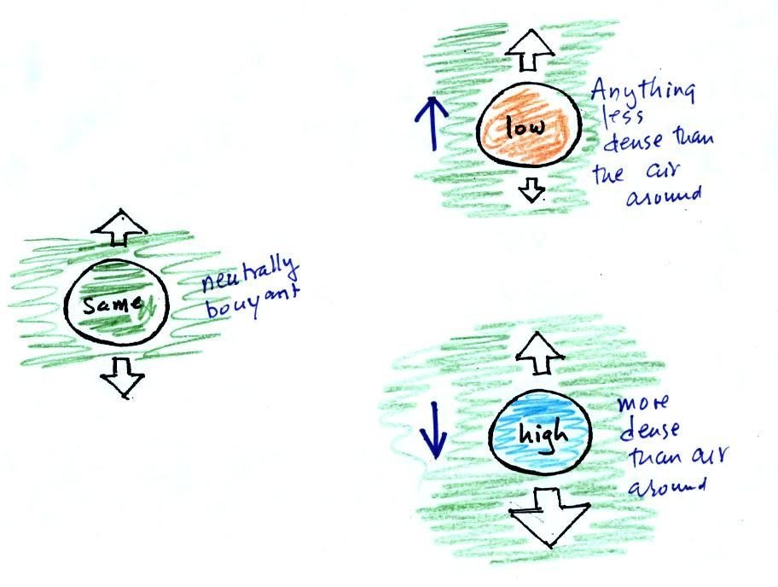
Air that is less dense (warmer) than the air around it will rise. Air that is more dense (colder) than the air around it will sink.
Here's a little more information about Archimedes which wasn't covered in class.

It was time for a colorful demonstration involving water and objects that either float or sink in water.
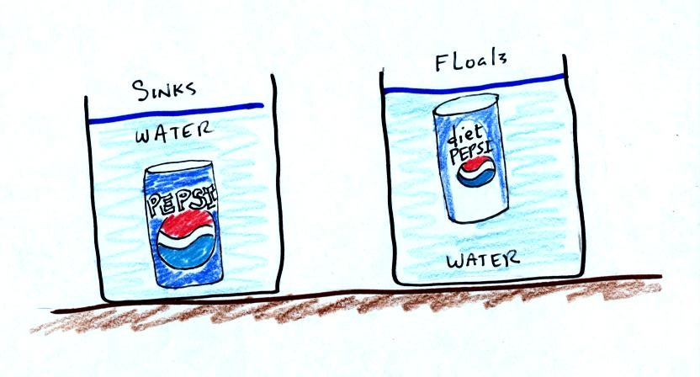
A can of regular Pepsi was placed in a beaker of water. The can sank. We repeated the demonstration with Coke and Diet Coke (Coke now has the exclusive franchise at The University).
Both cans are made of aluminum which has a density almost three times higher than water. The drink itself is largely water. The regular Pepsi also has a lot of high-fructose corn syrup, the diet Pepsi doesn't. The mixture has a density greater than plain water. Both cans contain a little air (or perhaps carbon dioxide gas) or neither one would float. This is much less dense than water.
The average density of the can of regular Pepsi (water&sugar + aluminum + air) ends up being slightly greater than the density of water. The average density of the can of diet Pepsi (water + aluminum + air) is slightly less than the density of water.
In some respects people in swimming pools are like cans of regular and diet Pepsi. Some people float (they're a little less dense than water), other people sink (slightly more dense than water). The next figure wasn't shown in class.
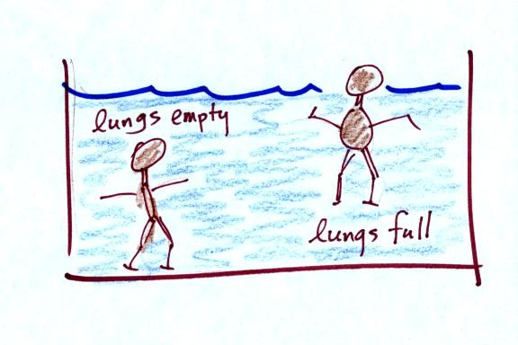
Many people can fill their lungs with air and make themselves float, or they can empty their lungs and make themselves sink.
People must have a density that is about the same as water.

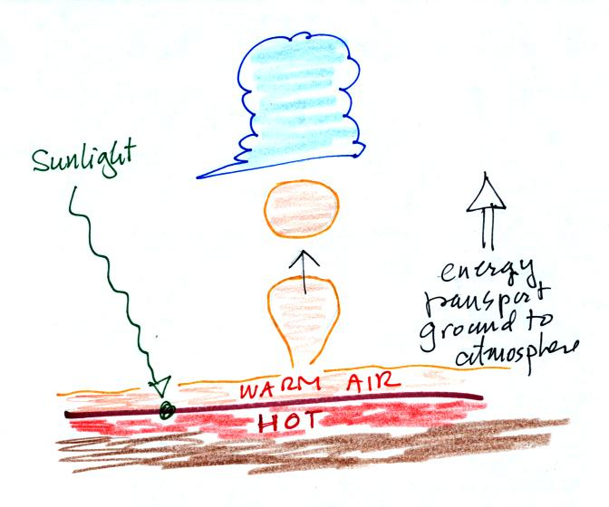
Convection is one of 4 ways causing air to rise. Rising air expands, cools, and can form clouds; most of the summer thunderstorms in Tucson are convective storms. Convection is also an energy transport process. The figure above shows sunlight arriving at the ground, being absorbed, and heating the ground. The ground in turns warms air in contact with the ground. Little "parcels" of warm low density rise and carry heat vertically from the ground to higher in the atmosphere.

Latent heat energy transport was the final topic of the day.
Energy transport in the form of latent heat is the second most important energy transport process (second only to electromagnetic radiation). A copper bar was heated with a propane torch. How could you cool the bar? You could just hold onto it and let conduction and free convection carry away heat. It might take several minutes for the bar to cool. You cold blow on the bar, forced convection would cool it a little more quickly. The fastest way to cool the bar is to plunge it into a glass of water. The "pssst" that that you heard in class was boiling (evaporating) water. This was an illustration of latent heat energy transport and cooled the bar in a few seconds.
Latent heat energy transport is sometimes a little hard to visualize or understand because the energy is "hidden" in water vapor or water.
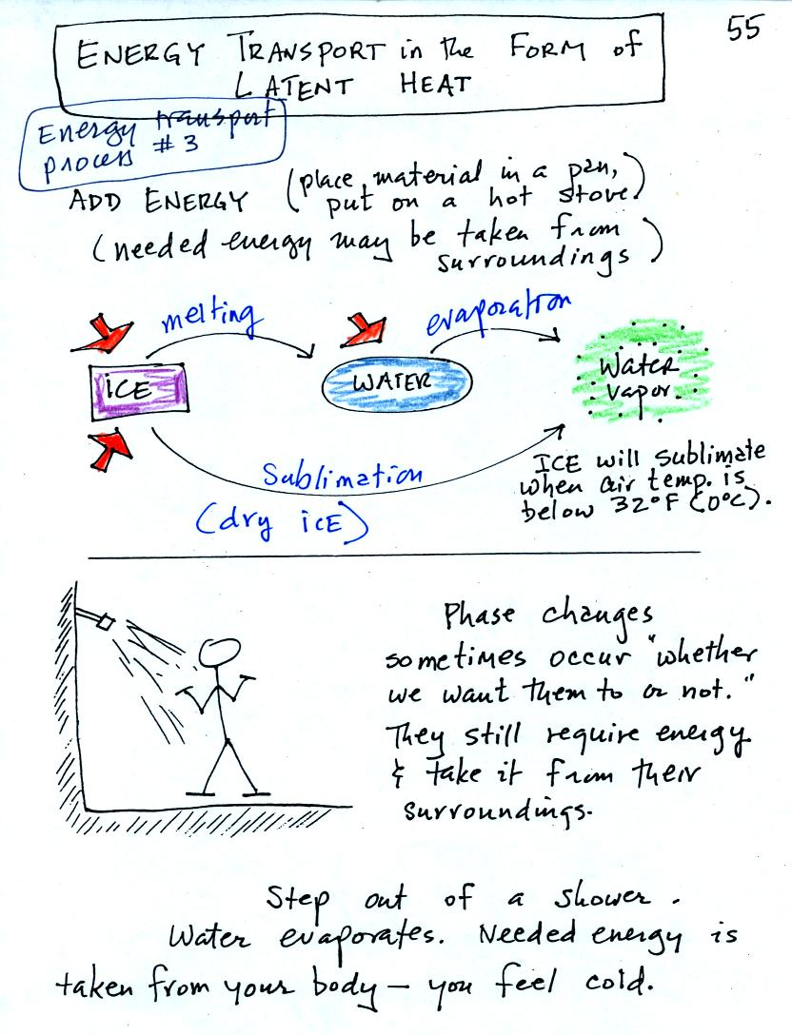
Latent heat energy transport is associated with changes of phase (solid to liquid, water to water vapor, that sort of thing) A solid to liquid phase change is melting, liquid to gas is evaporation, and sublimation is a solid to gas phase change (dry ice sublimates when placed in a warm room, it turns directly from solid carbon dioxide to gaseous carbon dioxide).
In each case energy must be added to the material changing phase. You can consciously add or supply the energy (such as when you put water in a pan and put the pan on a hot stove) or the needed energy will be taken from the surroundings (from your body when you step out of a shower in the morning).
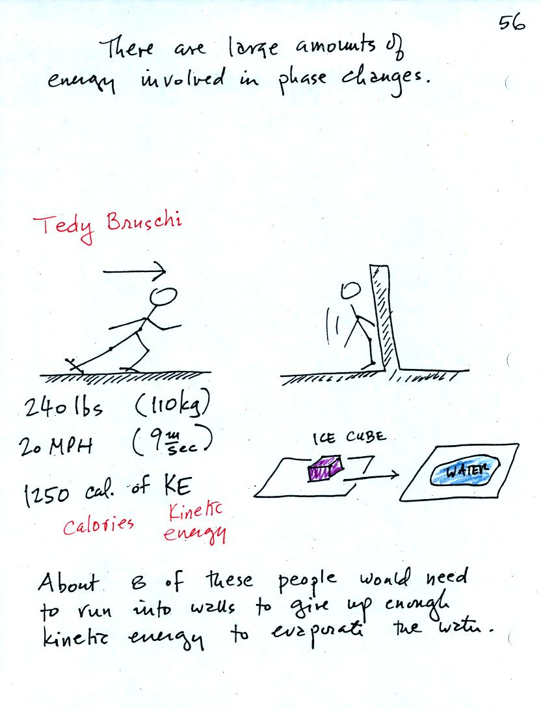
A 240 pound man (or woman) running at 20 MPH has just enough kinetic energy (if you could somehow capture it) to be able to melt an ordinary ice cube. It would take 8 people to evaporate the resulting water.
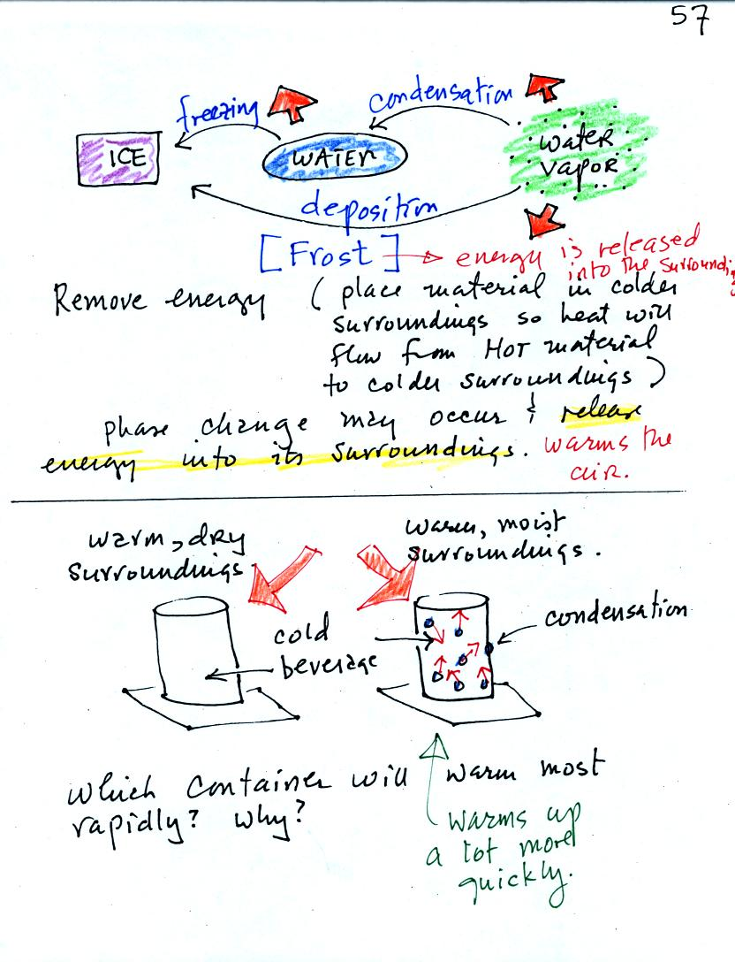
You can consciously remove energy from water vapor to make it condense or from water to cause it to free (you could put water in a freezer; energy would flow from the relatively warm water to the colder surroundings). Or if one of these phase changes occurs energy will be released into the surroundings (causing the surroundings to warm). Note the orange energy arrows have turned around and are pointing from the material toward the surroundings.
A can of cold drink will warm more quickly in warm moist surroundings than in warm dry surroundings. Heat will flow from the warm air into the cold cans in both cases. Condensation of water vapor is an additional source of energy and will warm that can more rapidly. The condensation may actually be the dominant process.
You feel cold when you step out of a shower and water on your body evaporates. The opposite situation, stepping outdoors on a humid day and actually having water vapor condense onto your body (it can happen to your sunglasses but not to you, your body is too warm). If it did happen it would warm you up.
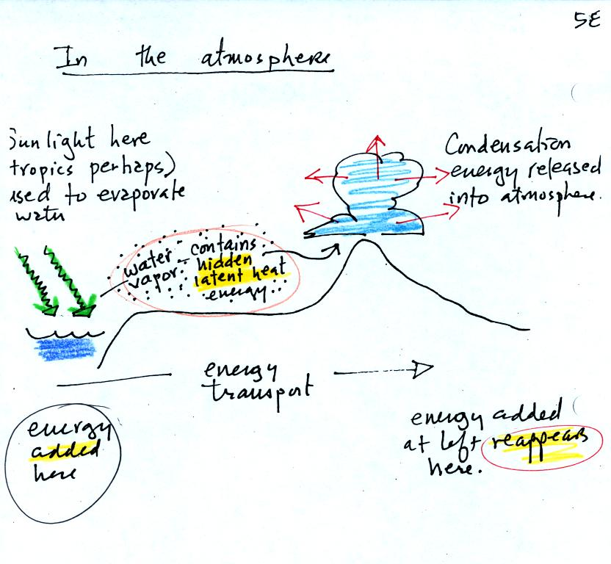
The story starts at left in the tropics where there is often an abundance or surplus of sunlight energy. Some of the incoming sunlight evaporates ocean water. The resulting water vapor moves somewhere else and carries hidden latent heat energy with it. This hidden energy reappears when something (air running into a mountain and rising, expanding, and cooling) causes the water vapor to condense. The condensation releases energy into the surrounding atmosphere.
Energy arriving in sunlight in the tropics has effectively been transported to the atmosphere in Tucson.

We'll add an additional detail to an earlier picture.
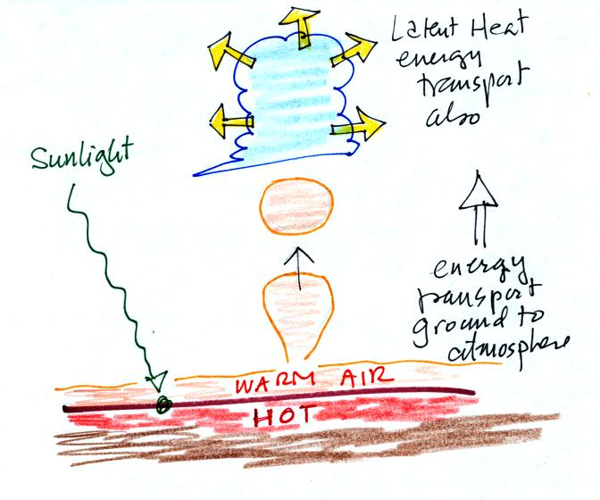
The formation of a cloud means that latent heat is being released into the air. Two energy transport processes are at work in this picture: convection and latent heat (conduction is also present, that is how is energy is transported from the hot ground into the thin layer of air in contact with the ground.

