Monday Oct. 6, 2008
The new MySpace music player was being difficult, the result was no music in class today.
It's looking like it might be a busy week in NATS 101.
The Controls of Temperature Optional Assignment is due at the start of class on Wednesday.
A new Optional Assignment is due next Monday.
The Quiz #2 Study Guide is now available online in preliminary form (there may be some significant changes to the second half of the study guide)
If you're a member of a UA athletic team, a "weekend warrior," or just interested in some of the things Buddhist monks can accomplish when they set their mind to it, you really should read about the "Marathon Monks" of Mt. Hiei, Japan.
With your permission, rather than talking about my 2 cats this week, I'd prefer to talk about my 4 pigs.
We didn't have time for a short story (actually a warning) that I found in the Spring 2008 online notes. It's not a very interesting story, but you can read it if you want to.
Please bring back the Expt. #2 materials this week. Reports are due next Monday.

We'll spend the next three or four class periods on electromagnetic radiation. It is the most important energy transport process because it can travel through empty space.
To really understand EM radiation you need to understand electric fields. To understand electric fields we need to quickly review a basic rule concerning static electricity.
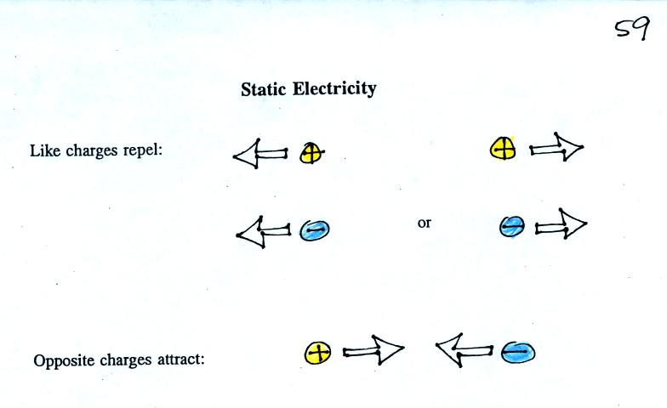
I had hoped to avoid the following demonstration of these rules, but bowed to class pressure.
A sweater (a gift from my Aunt Ethel and Uncle Nelson made of acrylic fiber and wool) and two balloons were used.
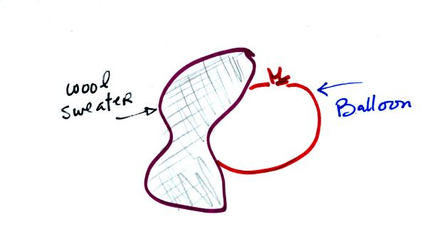
Each balloon was rubbed with the sweater. The balloons (and the sweater) became electrically charged (the balloons had one polarity of charge, the sweater had the other). We didn't know what charge the balloons carried just that they both had the same charge.
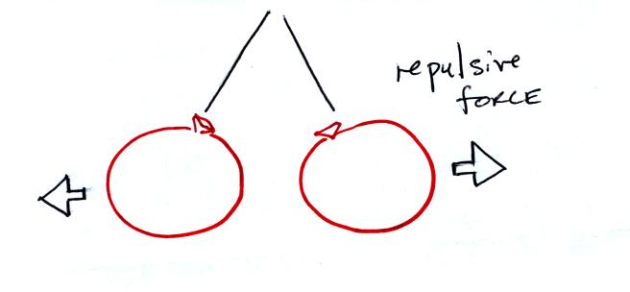
If you bring the balloons close to each other they are pushed apart by a repulsive electrical force.
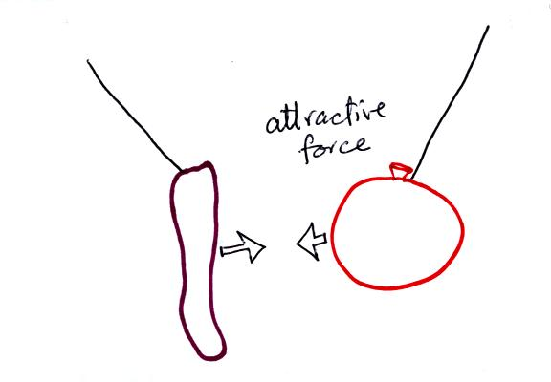
The sweater and the balloon carry opposite charges. IF they are brought together they experience an attractive electrical force.

Next imagine placing a + charge at the three positions shown in the figure below.
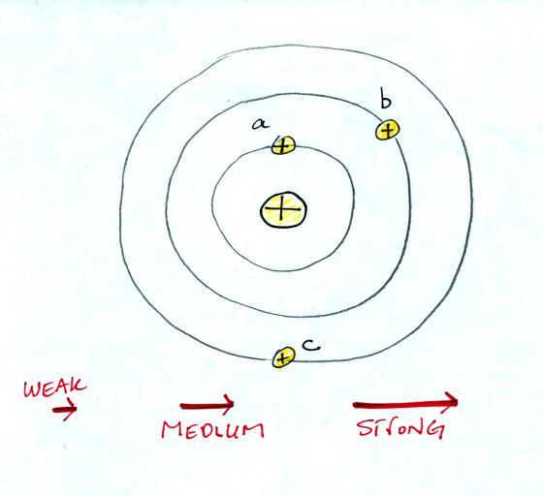
Then choose one of the three arrows at the bottom of the picture to show both the direction and the force that would be exerted on each charge.
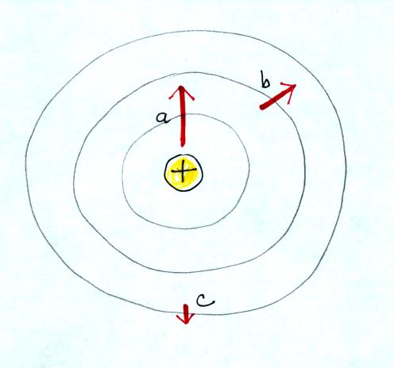

Here's the answer. The closer the charge is to the center, the greater the strength of the outward force. With just a little thought you can see that if you were to place + charges at other positions you would quickly end up with a figure that looks like the pattern at the bottom of p. 59 in the photocopied ClassNotes.
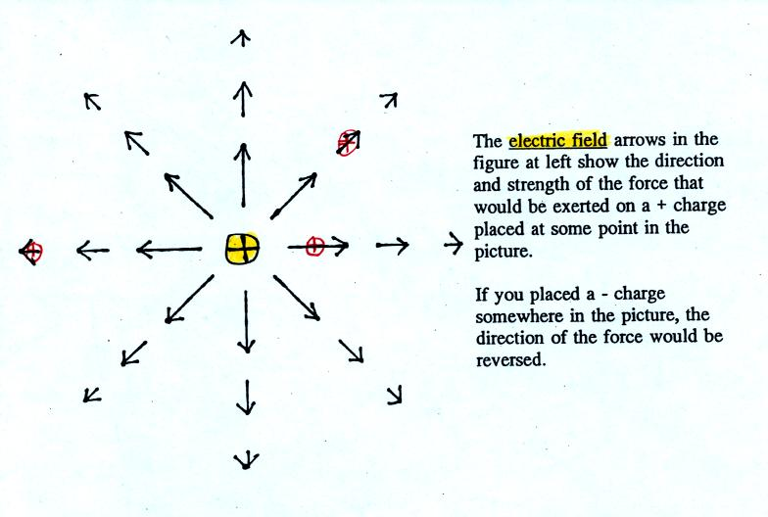
The electric field arrows in this picture show the direction and give an idea of the strength that would be exerted on a positive placed at any position in the figure.

The figures on p. 60 in the photocopied class notes have been redrawn below for clarity.
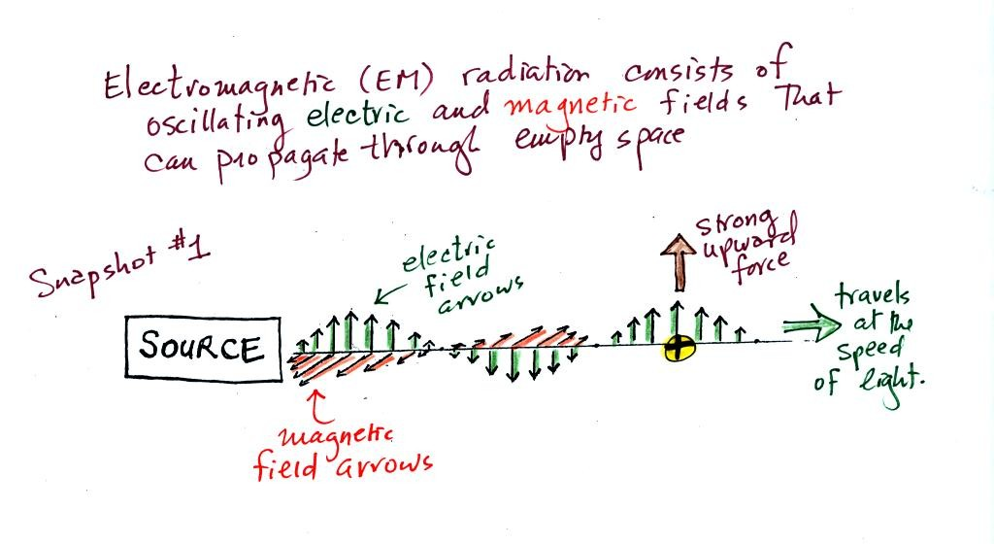
We imagine turning on a source of EM radiation and then a short time later we take a snapshot. The EM radiation is a wavy pattern of electric and magnetic field arrows. We'll ignore the magnetic field lines. The E field lines sometimes point up, sometimes down. The pattern of electric field arrows repeats itself.
Note the + charge near the right side of the picture. At the time this picture was taken the EM radiation exerts a fairly strong upward force on the + charge.
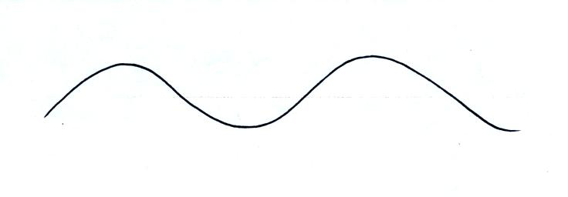
Textbooks often represent EM radiation with a wavy line like shown above. But what does that represent?
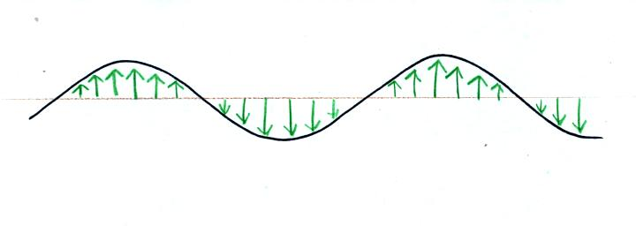
The wavy line just connects the tips of a bunch of electric field arrows.
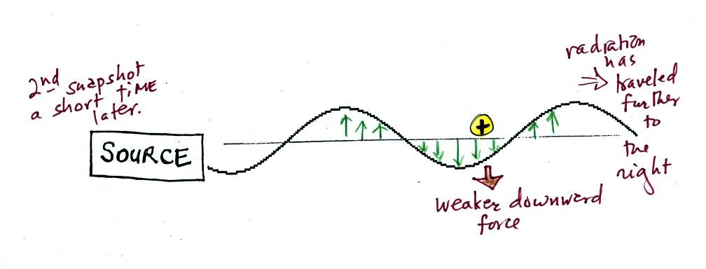
This picture was taken a short time after the first snapshot when the radiation had traveled a little further to the right. The EM radiation now exerts a somewhat weaker downward force on the + charge.
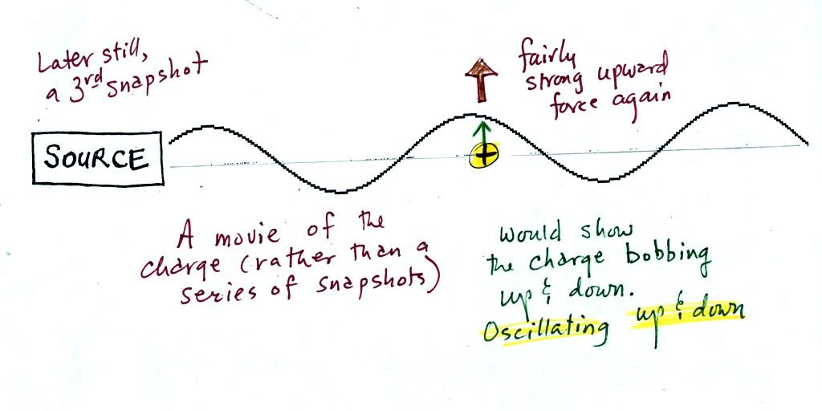
The + charge is now being pushed upward again. A movie of the + charge, rather than just a series of snapshots, would show the charge bobbing up and down much like a swimmer in the ocean would do as waves passed by.
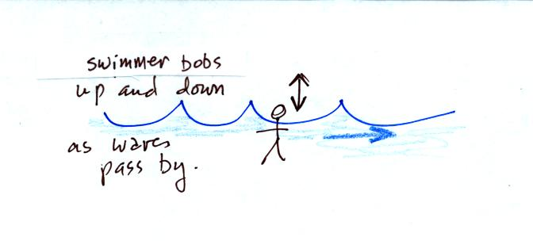
The wavy pattern used to depict EM radiation can be described spatially in terms of its wavelength, the distance between identical points on the pattern. By spatially we mean you look at different parts of the radiation at one particular instant frozen in time.
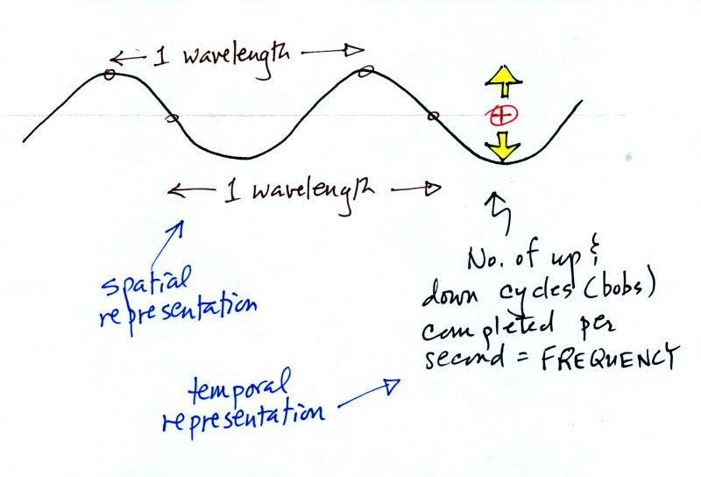
Or you can describe the radiation temporally using the frequency of oscillation (number of up and down cycles completed by an oscillating charge per second). By temporally we mean you at one particular point for a certain period of time.

The following figure (not shown in class) attempts to show how energy can be transported from location to another in the form of electromagnetic radiation.
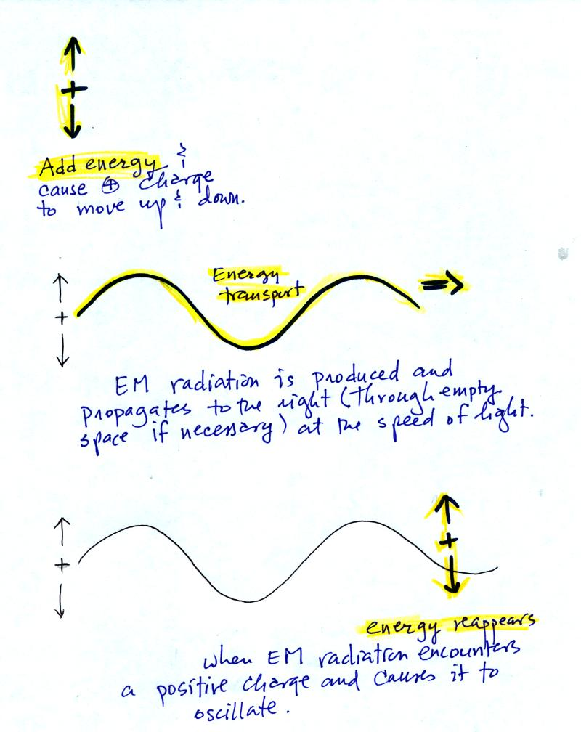
You add energy when you cause an electrical charge to move up and down and create the EM radiation (top left).
In the middle figure, the EM radiation then travels out to the right (it could be through empty space or through something like the atmosphere).

Once the EM radiation encounters an electrical charge at another location (bottom right), the energy reappears as the radiation causes the charge to move. Energy has been transported from left to right.

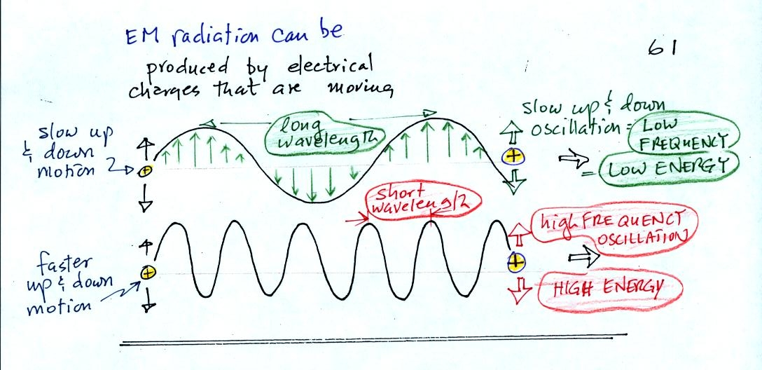
EM radiation can be created when you cause a charge to move up and down. If you move a charge up and down slowly (upper left in the figure above) you would produce long wavelength radiation that would propagate out to the right at the speed of light. If you move the charge up and down more rapidly you produce short wavelength radiation that propagates at the same speed.
Once the EM radiation encounters the charges at the right side of the figure above the EM radiation causes those charges to oscillate up and down. In the case of the long wavelength radiation the charge at right oscillates slowly. This is low frequency and low energy motion. The short wavelength causes the charge at right to oscillate more rapidly - high frequency and high energy.
The characteristics long wavelength - low frequency - low energy go together. So do short wavelength - high frequency - high energy. Note that the two different types of radiation both propagate at the same speed.
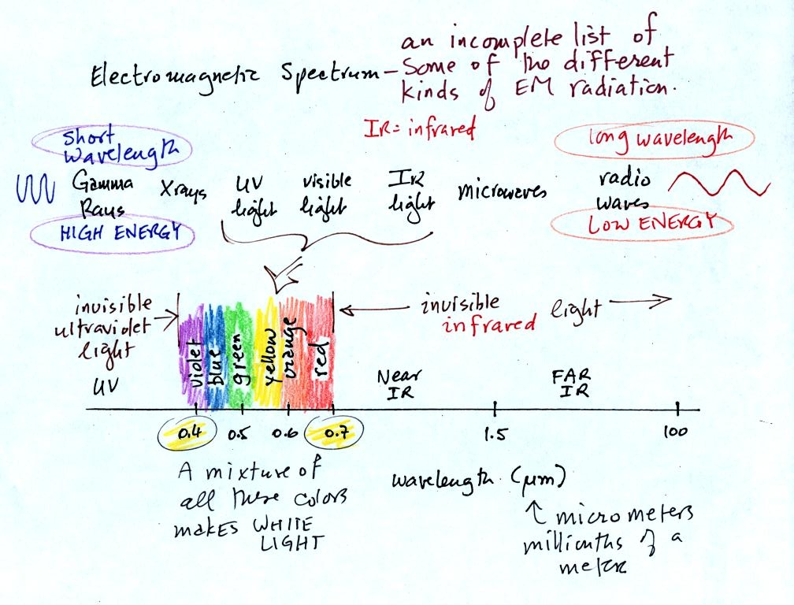
This is really just a partial list of some of the different types of EM radiation. In the top list, shortwave length and high energy forms of EM radiation are on the left (gamma rays and X-rays for example). Microwaves and radiowaves are longer wavelength, lower energy forms of EM radiation.
We will mostly be concerned with just ultraviolet light (UV), visible light (VIS), and infrared light (IR). Note the micrometer (millionths of a meter) units used for wavelength. The visible portion of the spectrum falls between 0.4 and 0.7 micrometers (UV and IR light are both invisible). All of the vivid colors shown above are just EM radiation with slightly different wavelengths. WHen you see all of these colors mixed together, you see white light.

Here are some rules governing the emission of electromagnetic radiation:
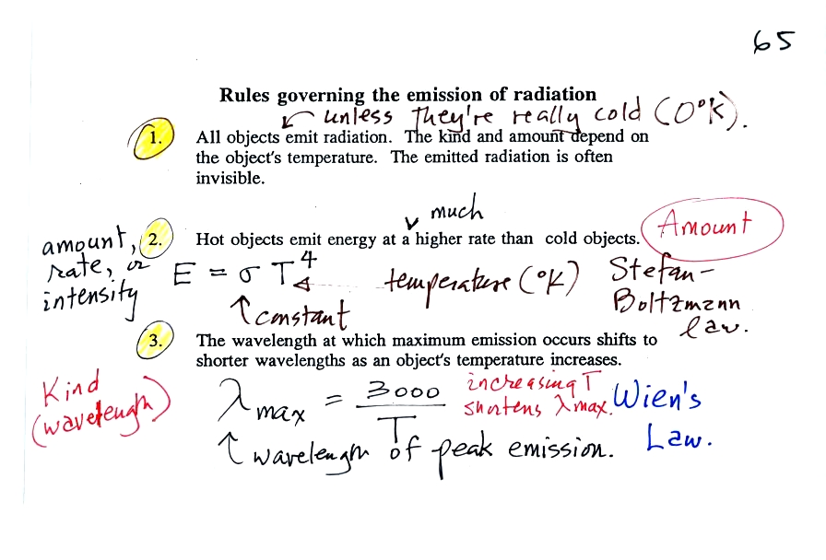
1.
Unless an object is very cold (0 K) it will emit EM radiation. All the people, the furniture, the walls and the floor in the classroom even the air are emitting EM radiation. Often this radiation will be invisible so that we can't see it and weak enough that we can't feel it. Both the amount and kind (wavelength) of the emitted radiation depend on the object's temperature.
2.
The second rule allows you to determine the amount of EM radiation (radiant energy) an object will emit. Don't worry about the units, you can think of this as amount, or rate, or intensity. Don't worry about σ either, it is just a constant. The amount depends on temperature to the fourth power. If the temperature of an object doubles the amount of energy emitted will increase by a factor of 2 to the 4th power (that's 2 x 2 x 2 x 2 = 16). A hot object just doesn't emit a little more energy than a cold object it emits a lot more energy than a cold object. This is illustrated in the following figure:
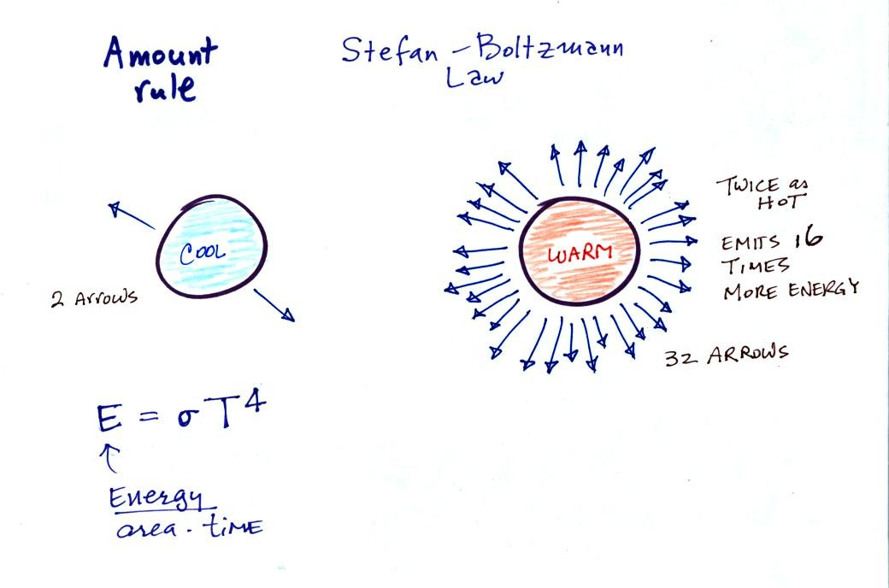
3.
The third rule tells you something about the kind of radiation emitted by an object. We will see that objects usually emit radiation at many different wavelengths. There is one wavelength however at which the object emits more energy than at any other wavelength. This is called lambda max (lambda is the greek character used to represent wavelength) and is called the wavelength of maximum emission. The third rule allows you to calculate "lambda max." This is illustrated below:
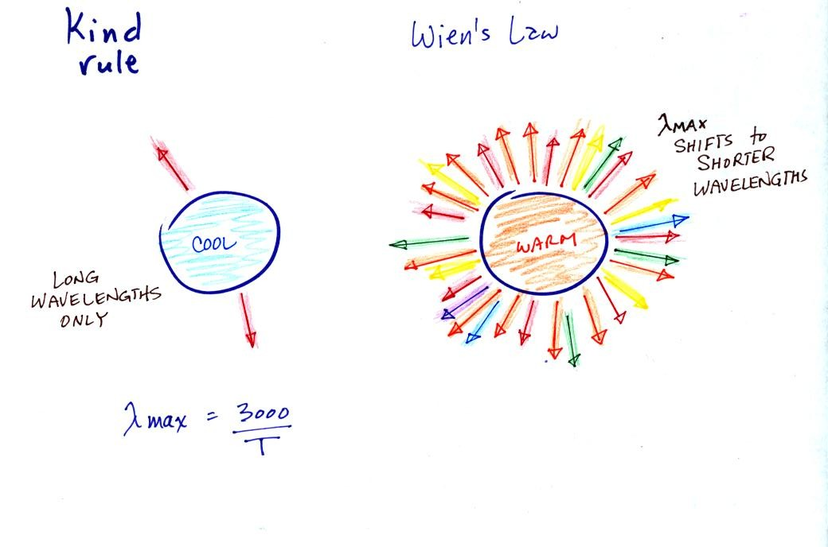
The following graphs (at the bottom of p. 65 in the photocopied Class Notes) also help to illustrate the Stefan-Boltzmann law and Wien's law.
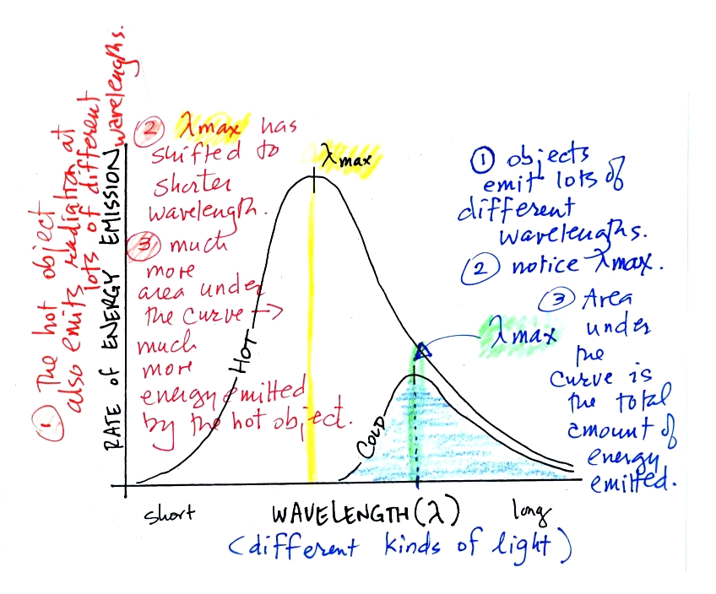
Notice first that both and warm and the cold objects emit radiation over a range of wavelengths.
The area under the warm object curve is much bigger than the area under the cold object curve. The area under the curve is a measure of the total radiant energy emitted by the object. This illustrates the fact that the warmer object emits a lot more radiant energy than the colder object.
Lambda max has shifted toward shorter wavelengths for the warmer object. This is Wien's law in action. The warmer object is emitting a lot of short wavelength radiation that the colder object doesn't emit.

