Wednesday Oct. 8, 2008
Music today was "A Whiter Shade of Pale" sung by Annie Lennox. Here also is the original version by Procol Harum.
The Controls of Temperature Optional Assignment is due today. If you haven't done it by now it is too late.
There's another Optional Assignment due next Monday
The Quiz #2 Study Guide is done and available online.

Class began with a quick review of the two rules governing the emission of EM radiation by objects.
An ordinary 200 W tungsten bulb connected to a dimmer switch can be used to demonstrate these rules (see p. 66 in the photocopied ClassNotes). We'll be seeing the EM radiation emitted by the bulb filament.
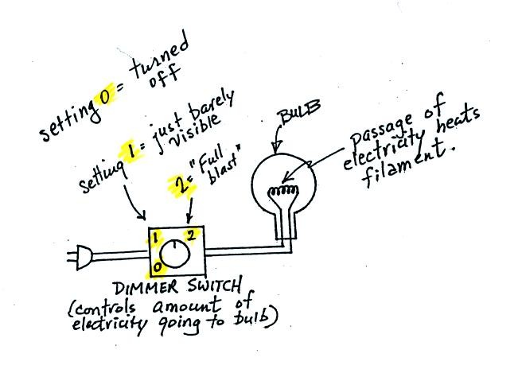
The graph at the bottom of p. 66 has been split up into 3 parts and redrawn for improved clarity.
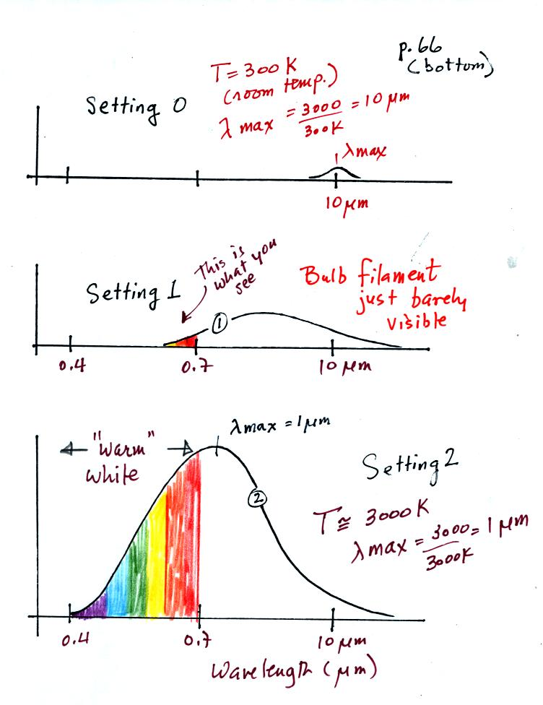
We start with the bulb turned off (Setting 0). The filament will be at room temperature which we will assume is around 300 K (remember that is a reasonable and easy to remember value for the average temperature of the earth's surface). The bulb will be emitting radiation, it's shown on the top graph above. The radiation is very weak so we can't feel it. It is also long wavelength, far IR, radiation so we can't see it. The wavelength of peak emission is 10 micrometers.
Next we use the dimmer switch to just barely turn the bulb on (the temperature of the filament is now about 900 K). The bulb wasn't very bright at all and had an orange color. This is curve 1, the middle figure. Note the far left end of the emission curve has moved left of the 0.7 micrometer mark - into the visible portion of the spectrum. That is what you are able to see, the small fraction of the radiation emitted by the bulb that is visible light (but just long wavelength red and orange light). Most of the radiation emitted by the bulb is to the right of the 0.7 micrometer mark and is invisible IR radiation (it is strong enough now that you could feel it if you put your hand next to the bulb).
Finally we turn on the bulb completely (it was a 200 Watt bulb so it got pretty bright). The filament temperature is now about 3000K. The bulb is emitting a lot more visible light, all the colors, though not all in equal amounts. The mixture of the colors produces a warm white light. It is warm because it is a mixture that contains a lot more red, orange, and yellow than blue, green, and violet light. It is interesting that most of the radiation emitted by the bulb is still in the IR portion of the spectrum (lambda max is 1 micrometer). This is invisible light. A tungsten bulb like this is not especially efficient, at least not as a source of visible light.
You were able to use one of the diffraction gratings to separate the white light produced by the bulb into its separate colors.
When you looked at the bright white bulb filament through one of the diffraction gratings the colors were smeared out to the right and left as shown below:
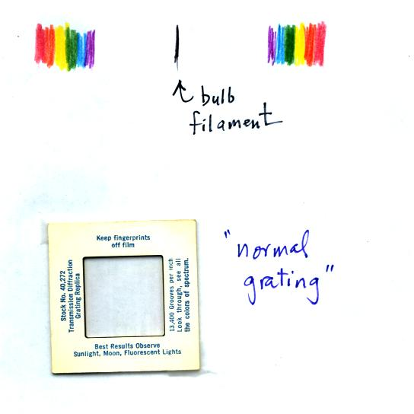
Some of the grating handed out in class behaved a little differently and spread out the colors horizontally, vertically, and diagonally.


The sun emits electromagnetic radiation. That shouldn't come as a surprise since you can see it and feel it. The earth also emits electromagnetic radiation. It is much weaker and invisible. The kind and amount of EM radiation emitted by the earth and sun depend on their respective temperatures.
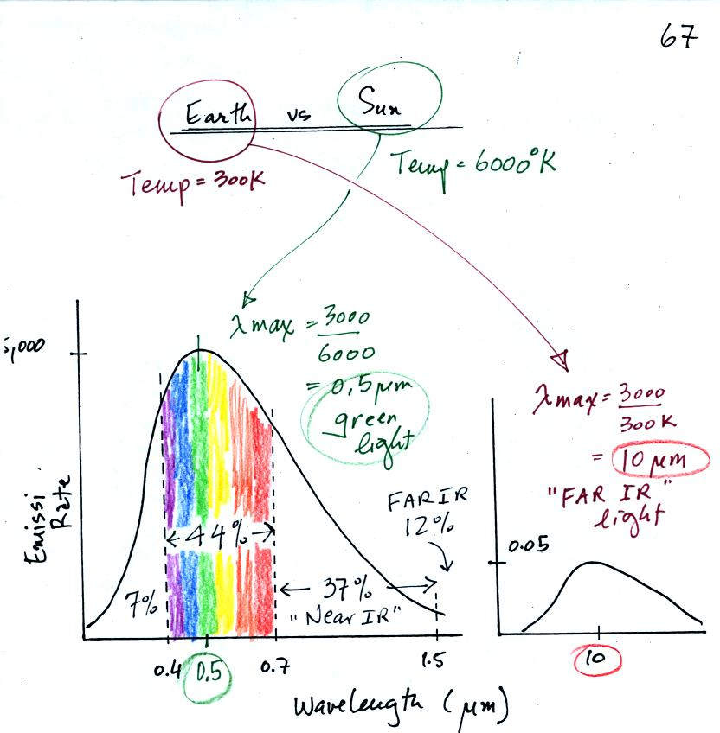
The curve on the left is for the sun. We first used Wien's law and a temperature of 6000 K to calculate lambda max and got 0.5 micrometers. This is green light; the sun emits more green light than any other kind of light. The sun doesn't appear green because it is also emitting lesser amounts of violet, blue, yellow, orange, and red - together this mix of colors appears white. 44% of the radiation emitted by the sun is visible light, 49% is IR light (37% near IR + 12% far IR), and 7% is ultraviolet light. More than half of the light emitted by the sun is invisible.
100% of the light emitted by the earth (temperature = 300 K) is invisible IR light. The wavelength of peak emission for the earth is 10 micrometers.
Because the sun (surface of the sun) is 20 times hotter than the earth a square foot of the sun's surface emits energy at a rate that is 160,000 times higher than a square foot on the earth. Note the vertical scale on the earth curve is different than on the sun graph. If both the earth and sun were plotted with the same vertical scale, the earth curve would be too small to be seen.

Now before moving on to the main event of the day (climate at a point near the Equator in the middle of the Pacific Ocean) we quickly reviewed some of the factors that cause seasonal changes in climate. The two main factors are the angle of the sun in the sky (how high is the sun above the horizon at noon), and the length of the day. In the summer, the sun is high in the sky, the sunlight reaching the ground is intense, and the incoming sunlight warms a relatively small area on the ground. In the summer, there are also more hours of daylight than in the winter. This is the main reason why it gets so much hotter during the summer than in winter. You should read through the section Causes of the Seasons on your own.
At the equator, the sun is always high in the sky (not always overhead at noon, but always high in the sky). At the equator the days are always 12 hours long. So the amount of incoming sunlight energy stays relatively constant throughout the year at the equator. You may remember that water moderates climate (it doesn't get as hot in the summer and doesn't get as cold in the winter). This is largely because of the high specific heat of water.
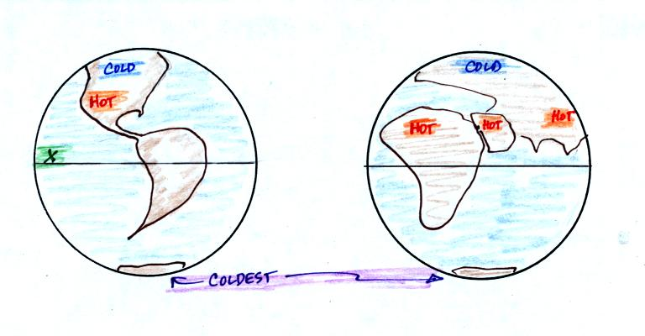
So the answer to the question "What is the climate like at Point X in the figure above at left" is that the climate is warm and moist. The most dramatic thing, however, is that there is essentially zero seasonal change in climate. It is pretty much summer all year.

Asking about the climate at Point X was really just an excuse for me to tell you about an amazing field experiment I took part in several years ago.
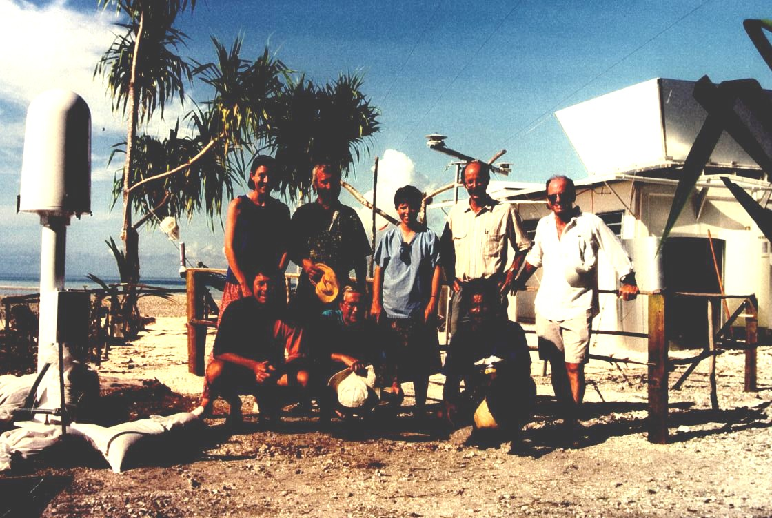
The photograph above appeared on the cover of the April 1994 issue of the Bulletin of the American Meteorological Society. If you look closely you'll notice your NATS 101 instructor (he had been given the nickname "Wilbur" by one of the members of the group, the other bald man's name was Orville). This photo was taken on Kapingamarangi Atoll (shown on the map below), shortly before all the men were about to board ship and leave Kapingamarangi. The two women (Erica at left, Maureen in the middle) were going to remain behind and operate all of the research equipment. The scene looks happy enough, but "Wilbur" revealed that he had fallen in love with one of the two women and was anything but happy.
What we were doing on Kapingamarangi? We were a small part of a much larger field experiment. Wilbur and Orville's job was to install the tall white lightning detector at the left edge of the photograph. They would later travel to Rabaul (on New Britain island) and Kavieng (New Ireland island) in Papua New Guinea and install two more detectors. Papua New Guinea would turn out to be a very different place. Until recently some of the highland tribes there practiced cannibalism. Malaria is also endemic in Papua New Guinea.
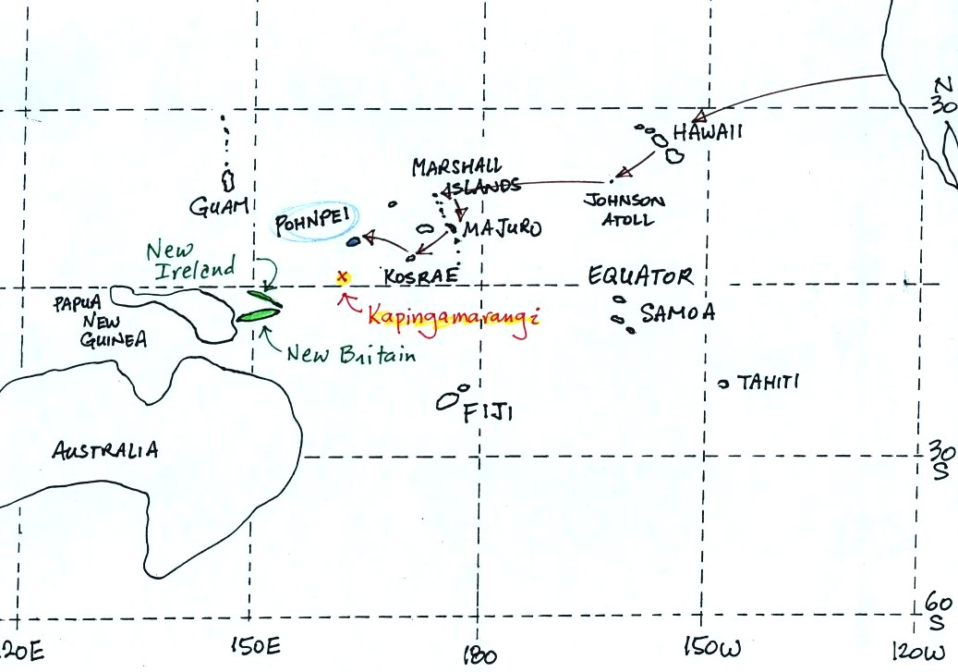
To get to Kapingamarangi you first need to fly to Pohnpei (an island in the Federated States of Micronesia). The route is shown above. Then you take a cargo ship for the 4 day sail to Kapingamarangi. We had intended to fly to Pohnpei, set sail for Kapinga the next day, and then spend about a month on Kapingamarangi. The ship however was delayed 3 weeks. That gave us plenty of time to visit the island of Pohnpei but ultimately meant we could only spend a few days on Kapingamarangi..
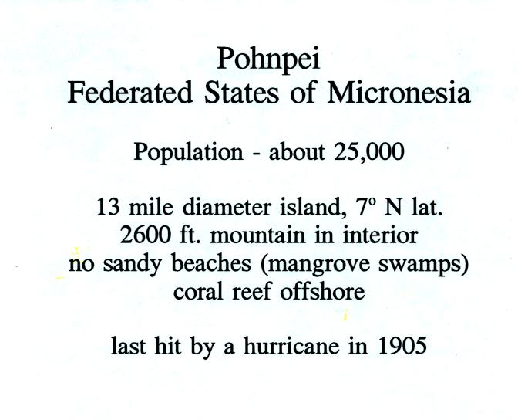
Pohnpei is a fairly large island and, together with some of the other Micronesian islands, is a popular, world-class, snorkeling and scuba diving destination. Pohnpei also has a weather station that is operated by the US National Atmospheric and Oceanic Administration (NOAA).
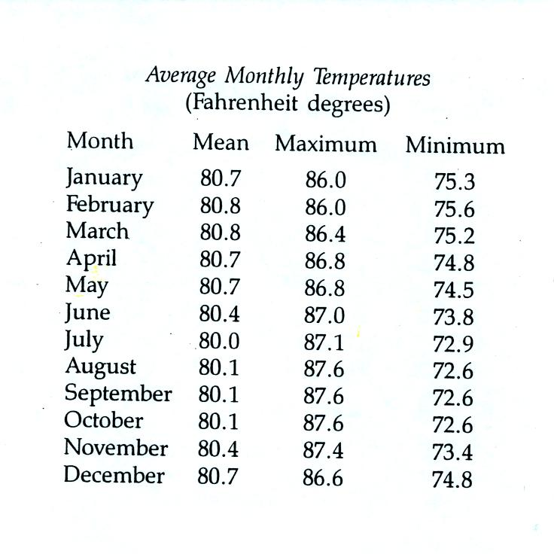
Because of its low latitude and the fact that it is surrounded by water you would expect a small annual range of temperature at Pohnpei. You can see in the table above just how small the annual range is: the average monthly temperatures in Pohnpei range from 80.8 F in February and March to 80.0 F in July. The annual range is less than 1 F. By comparison, the annual range in Tucson is about 34 F (52 F in December and January to 86 F in July).
The following precipitation data show that Pohnpei is one of the rainiest locations on earth
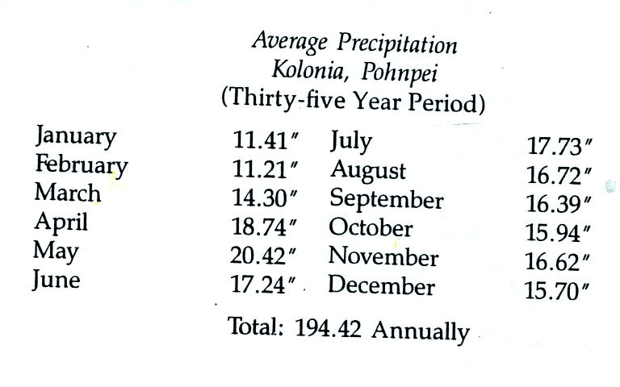
Close to 400 inches of rain may fall in the interior of Pohnpei. The rainiest location on earth is in Hawaii with about 460 inches of rain per year.
Pigs played an important part in the story told in class. Pigs are also an important part of daily life on Kapingamarangi and Pohnpei (as well as the other islands in Micronesia)
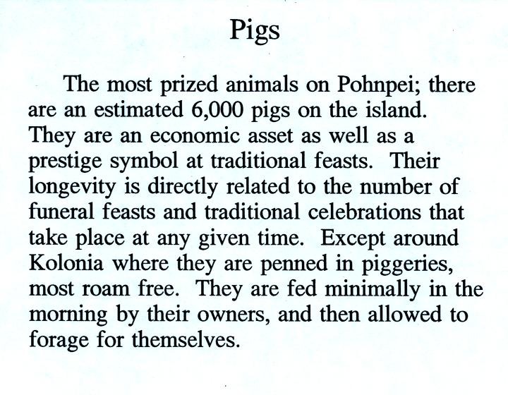
The Micro Glory (shown below) sails back and forth between Pohnpei and Kapingamarangi about once a month. The ship carries supplies to the people on Kapingamarangi. They pay for the supplies with pigs (the pigs are sold on Pohnpei). We shared deck space on the Micro Glory on the trip back to Pohnpei with 20 to 30 pigs (they were hoisted aboard in nets)

Most of the low deck in the photo above (under the hoists) was occupied by pigs on the return trip.
We also had a chance to sample some of the local beverages.


Drinking sakau (as it is called on Pohnpei) turns your mouth and throat numb. It is supposed to relax you, make you sleep more fully, and doesn't leave any after effects. Until fairly recently you could buy kava in pill form at local supermarkets. However, because of reports that it can cause serious liver problems, that is no longer the case. There are no reports of liver problems when drinking kava that has been prepared in the traditional way. Here is a link to a Wikipedia article on kava.
We never tried betelnut. Areca nuts are wrapped in betel leaves and chewed together with lime (lime is pretty caustic, that is the reason I didn't try betelnut). The resulting mixture is a mild stimulant (some people add tobacco to the mix). The most interesting aspect, however, is that chewing betelnut colors your mouth bright red. You don't swallow betelnut, you spit it out. You see the bright red stains on sidewalks and the ground wherever you go. Most hotels will also have a large sign near the entrance reminding guests not to chew betelnut inside the hotel. You can read more about betelnut here.

Class ended with a proud display of my collection of carved wooden pigs (remember they are a symbol of wealth). The pigs were purchased in Rabaul, on New Britain island, in Papua New Guinea.

