Wednesday Sept. 10, 2008
We had time for a couple of songs from the Fleet Foxes before class today.
Here's a new Reading Assignment. Basically you should finish reading Chapter 1 (you don't need to do it all at once, we will be covering this material this week and much of next week). You might also have a look at Appendix C (pps 525-529).

You would have the whole period if there were a real quiz today. However, since there is just a practice quiz we spent the first 20 minutes of class on some new material.
We are going to move into the middle part of Chapter 1 and start some new, completely different, material. We will be looking at how atmospheric characteristics such as air temperature, air pressure, and air density change with altitude. In the case of air pressure we first need to understand what pressure is and what can cause it to change.
An iron bar was passed around at the beginning of class. You were supposed to guess how much it weighed.
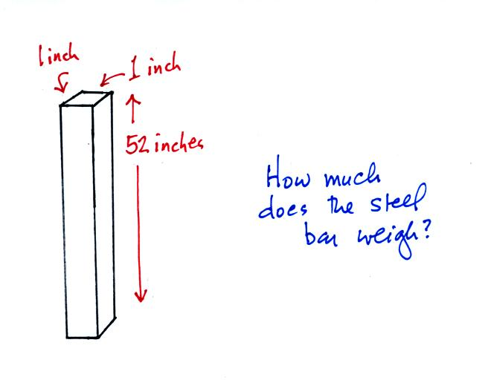
We will come back to the iron bar in class on Friday.
What follows is a little more detailed discussion of the basic concepts of mass, weight, and density than was covered in class.
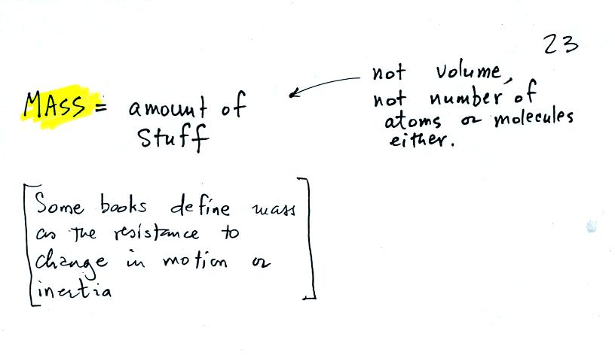
Before we can learn about atmospheric pressure, we need to review the terms mass and weight. In some textbooks you'll find mass defined at the "amount of stuff." Other books will define mass as inertia or as resistance to change in motion. The next picture illustrates both these definitions. A Cadillac and a volkswagen have both stalled in an intersection. Both cars are made of steel. The Cadillac is larger and has more steel, more stuff, more mass. The Cadillac is also much harder to get moving than the VW, it has a larger inertia (it would also be harder to slow down if it were already moving).
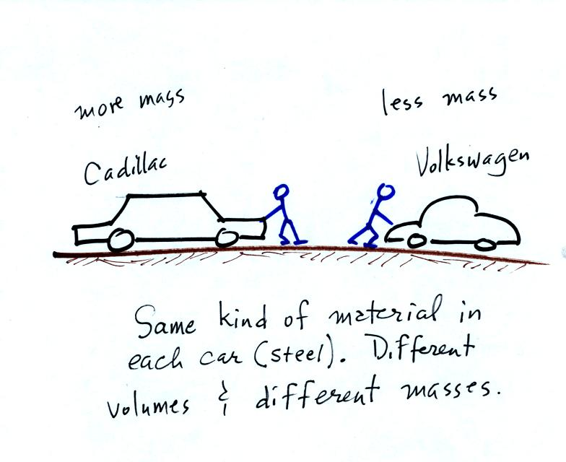
It is possible to have two objects with the same volume but very different masses. The bottles of water and mercury that were passed around class were an example (thanks for being so careful with the mercury).
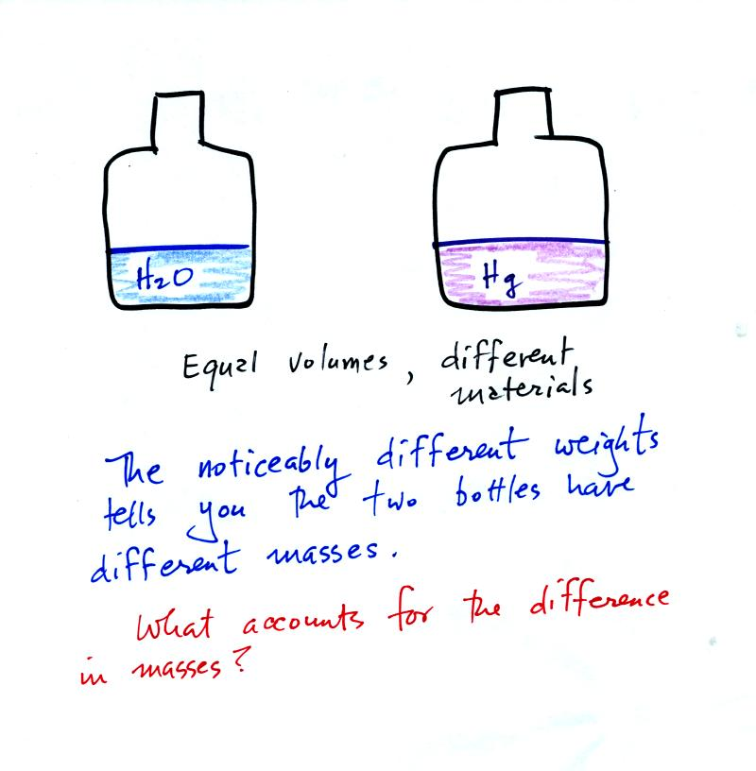
To understand why there is such a difference in mass and weight you need to look at the water molecules and mercury atoms on an atomic scale.
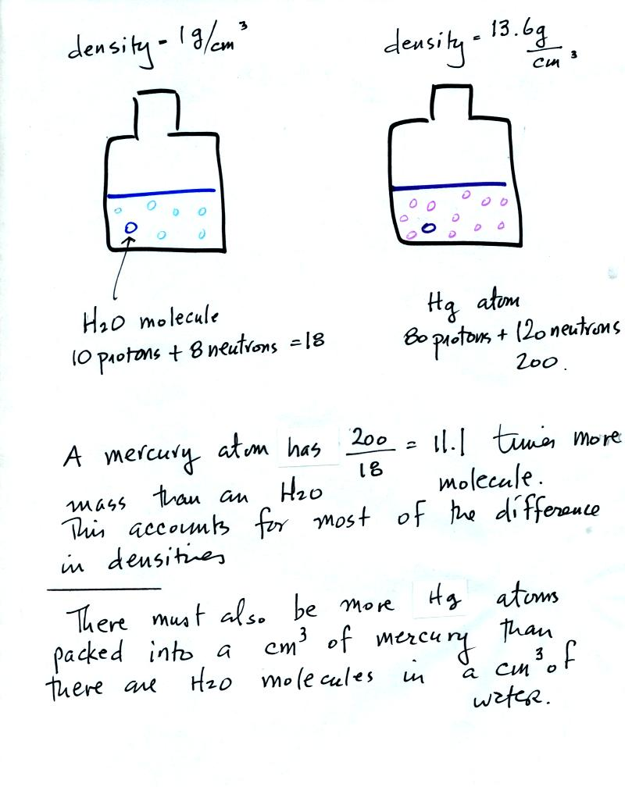
Mercury atoms are built up of many more protons and neutrons than a water molecule (also more electrons but they don't have nearly as much mass as protons and neutrons). The mercury atoms have 11.1 times as much mass as the water molecule. This doesn't quite account for the 13.6 difference in density. Despite the fact that they contain more protons and neutrons, the mercury atoms must also be packed closer together than the molecules in water.
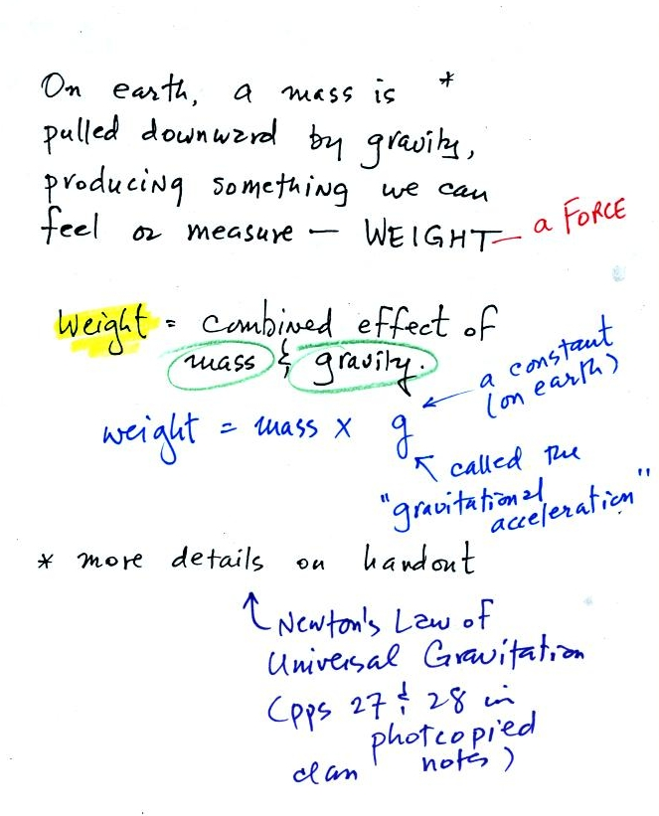
Weight is a force and depends on both the mass of an object and the strength of gravity. We tend to use weight and mass interchangeably because we spend all our lives on earth where gravity never changes.
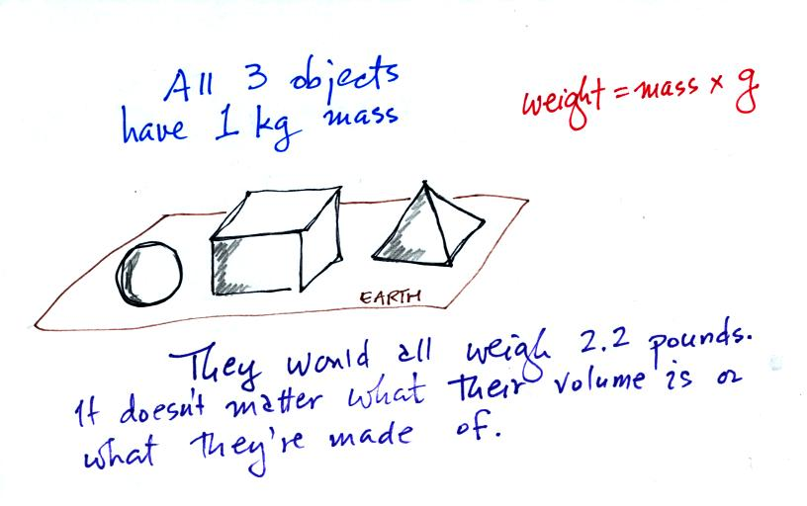
Any three objects that all have the same mass (even if they had different volumes and were made of different materials) would necessarily have the same weight. Conversely
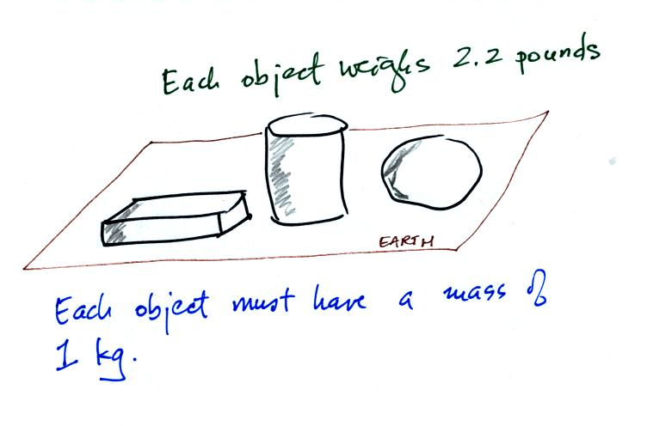
Three objects with the same weight would also have the same mass.
The difference between mass and weight is clearer (perhaps) if you compare the situation on the earth and on the moon.
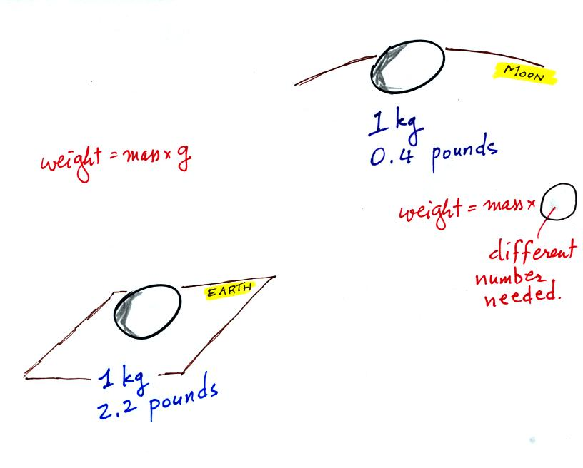
If you carry an object from the earth to the moon, the mass remains the same (its the same object, the same amount of stuff) but the weight changes because gravity on the moon is weaker than on the earth.

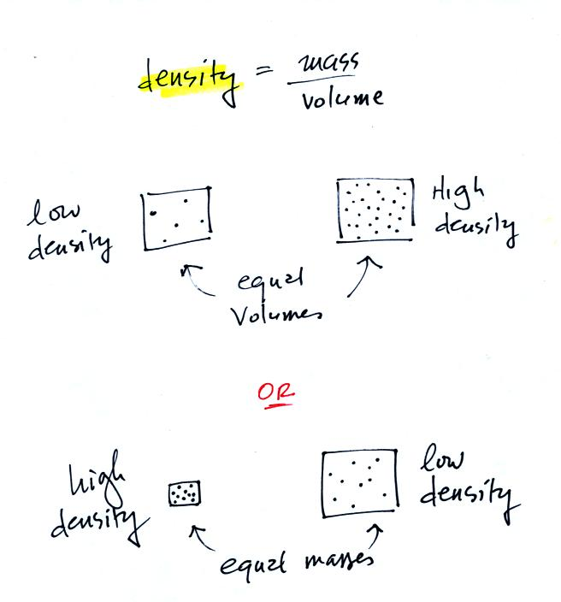
In the first example there is more mass (more dots) in the right box than in the left box. Since the two volumes are equal the box at right has higher density. Equal masses are squeezed into different volumes in the bottom example. The box with smaller volume has higher density.

