Monday Sept. 15, 2008
All this week in NATS 101 we'll be featuring a local band, Calexico, and Luz de Luna, a Tucson Mariachi band. Today you heard "The Ballad of Cable Hogue" and "Si Tu Disais." Calexico and Luz de Luna were appearing at the Barbican Theater in London and were joined by a French singer named François Breut. Incidentally Calexico (and Luz de Luna, perhaps) will be appearing at the Rialto Theater in Tucson this coming Saturday night.
The Practice Quiz and an In-class Optional Assignment from last Friday were returned in class today.
The 1S1P Bonus Assignment is due on Wednesday (Sep. 17).
An Optional homework Assignment was distributed in class and will be due next Monday. You should complete this assignment before coming to class and have it ready to turn in at the beginning of class. You can earn extra credit by completing and turning in optional assignments like this.
Finally, 1S1P Assignment #1 has been posted on the class webpage. Reports are due on or before Wed. Oct. 1.

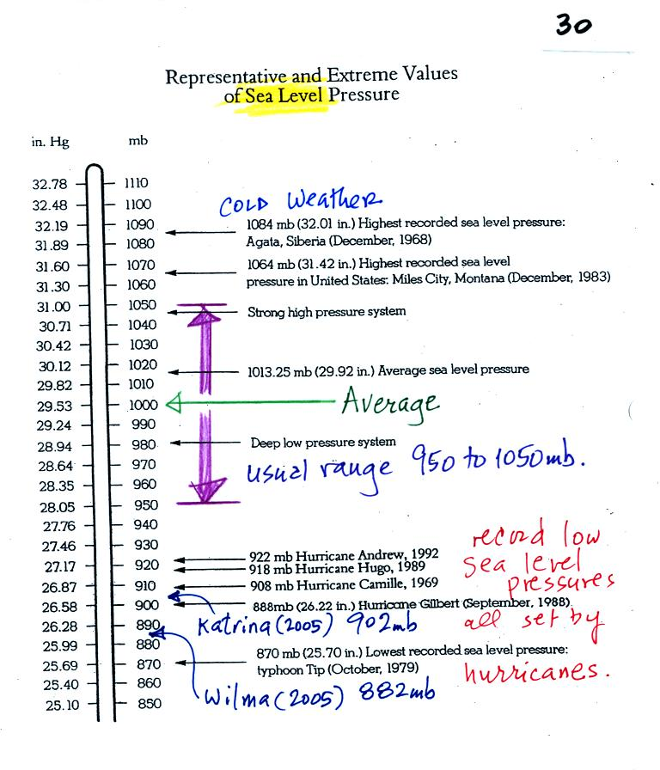
The figure above (p. 30 in the photocopied Class Notes) first shows average sea level pressure values. 1000 mb or 30 inches of mercury are close enough in this class.
Sea level pressures usually fall between 950 mb and 1050 mb.
Record high sea level pressure values occur during cold weather.
Record low pressure values have all been set by intense hurricanes (the record setting low pressure is the reason these storms were so intense). Hurricane Wilma in 2005 set a new record low sea level pressure reading for the Atlantic. Hurricane Katrina had a pressure of 902 mb. You'll find a list of the most intense, destructive, and deadly hurricanes on p. 146a in the photocopied ClassNotes.

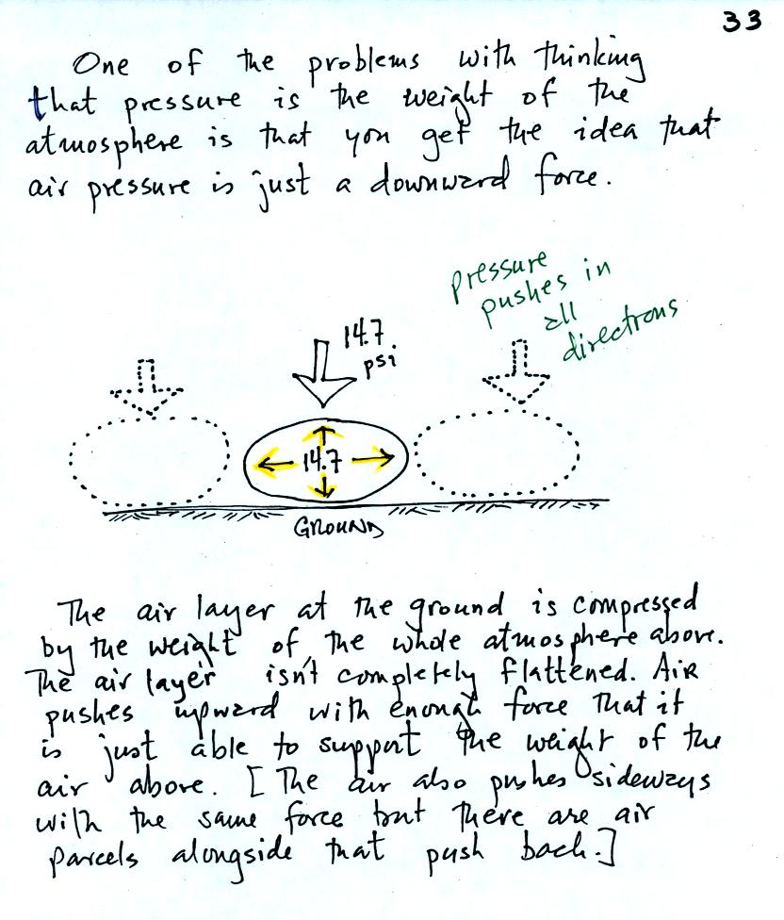
Air pressure is a force that pushes downward, upward, and sideways. If you fill a balloon with air and then push downward on it, you can feel the air in the balloon pushing back (pushing upward). You'd see the air in the balloon pushing sideways as well.
The air pressure in the four tires on your automobile pushes down on the road (that's something you would feel if the car ran over your foot) and pushes upward with enough force to keep the 1000 or 2000 pound vehicle off the road.
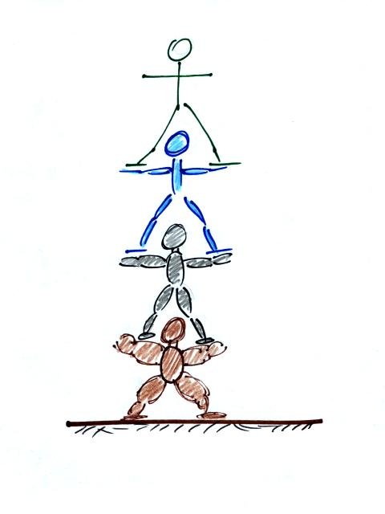
A "people pyramid" might help you to understand what is going on in the atmosphere (the picture above wasn't shown in class). If the bottom person in the stack above were standing on a scale, the scale would measure the total weight of all the people in the pile. That's analogous to sea level pressure being determined by the weight of the atmosphere above. The bottom person in the picture above must be strong enough to support the weight of all the people above. That equivalent to the bottom layer of the atmosphere having enough pressure, pressure that points up down and sideways, to support the weight of the air above.
In class on Friday we used a stack of bricks to try to understand that pressure at any level in the atmosphere is determined by the weight of the air overhead. Now we will imagine a stack of matresses to understand why air density decreases with increasing altitude.
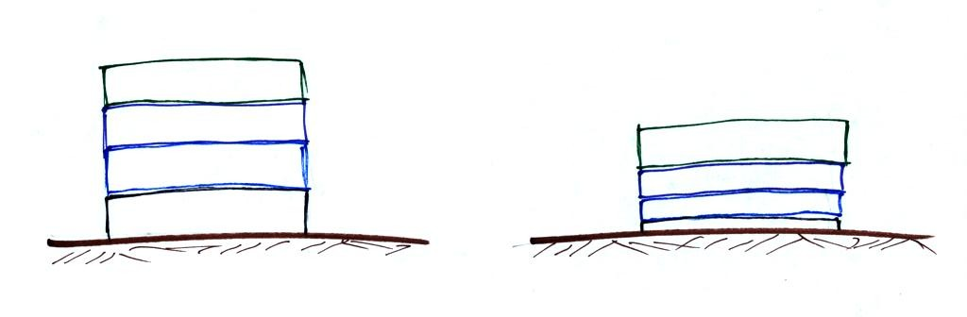
This is a more carefully drawn version of what was shown in class. Mattresses are compressible. The mattress at the bottom of the pile is compressed the most by the weight of all the mattresses above. The mattresses higher up aren't squished as much because their is less weight remaining above.
In the case of the atmosphere layers of air behave in just the same way as matresses.
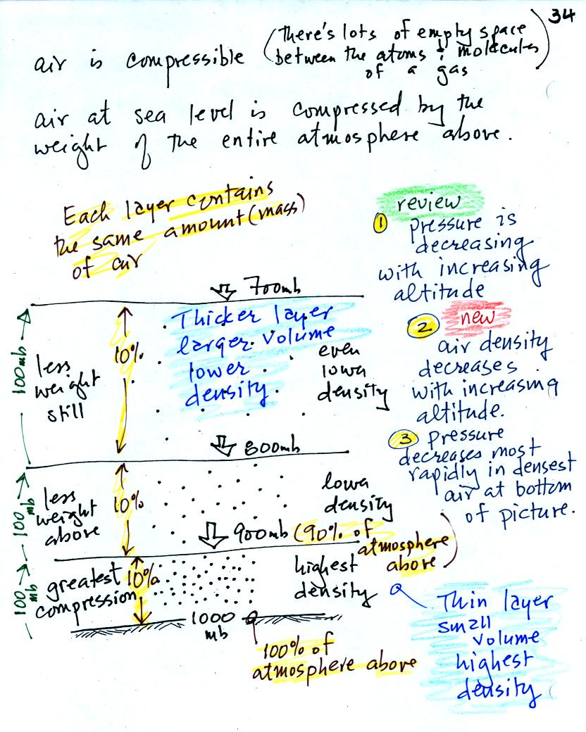
There's a lot of information in this figure. It is worth spending a minute or two looking at it and thinking about it.
1. You can first notice and remember that pressure decreases with increasing altitude.
Each layer of air contain the same amount (mass) of air. You can tell because the pressure decrease as you move upward through each layer is the same (100 mb).
2. The densest air is found in the bottom layer because the air is squeezed into a smaller volume than the other layers. Air density decreases with increasing altitude.
3. You again notice something that we covered earlier: the most rapid rate of pressure decrease with increasing altitude is in the densest air in the bottom air layer.

We took a little detour at this point.
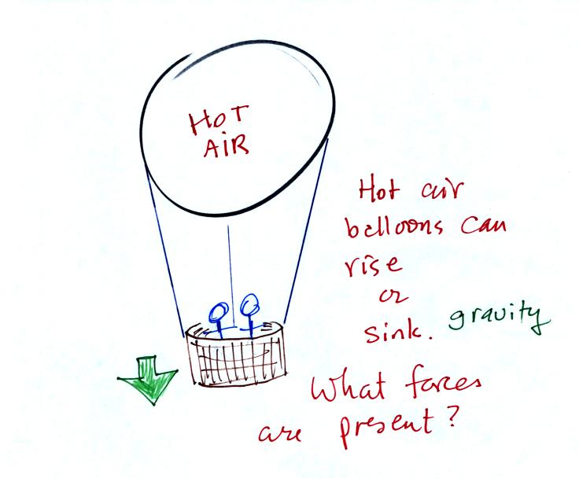
Hot air balloons can go up or down. Most everyone in the classroom knows that gravity is the force that would cause a hot air balloon to sink. Nobody was willing to suggest a force that might cause a hot air balloon to rise. We'll come back to this picture later.

Class continued with a demonstration of the upward force caused by air pressure.
The demonstration is summarized on p. 35a in the photocopied Classnotes.
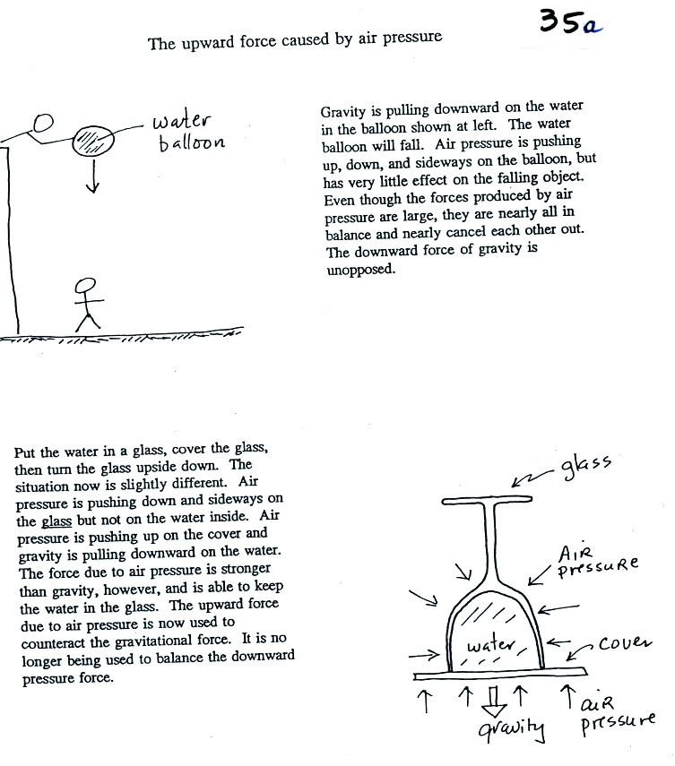
Here's a little bit more detailed and more complete explanation of what is going on. First the case of a water balloon.
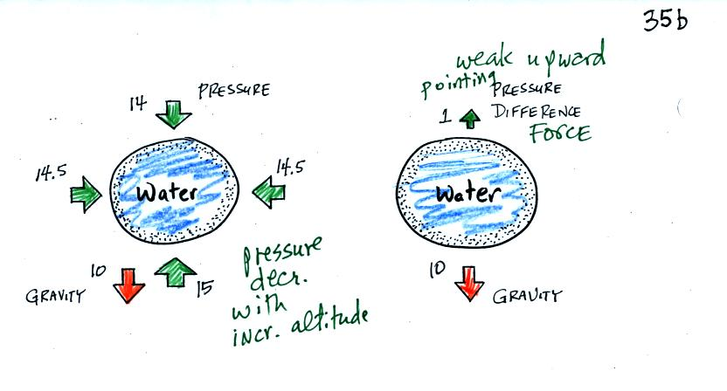
The figure at left shows air pressure (red arrows) pushing on all the sides of the balloon. Because pressure decreases with increasing altitude, the pressure pushing downward on the top of the balloon is a little weaker (strength=14) than the pressure pushing upward at the bottom of the balloon (strength=15). The two sideways forces cancel each other out. The total effect of the pressure is a weak upward force (1 unit of upward force shown at the top of the right figure, you might have heard this called a bouyant force). Gravity exerts a downward force on the water balloon. In the figure at right you can see that the gravity force (strength=10) is stronger than the upward pressure difference force (strength=1). The balloon falls as a result.
In the demonstration a wine glass is filled with water. A small plastic lid is used to cover the wine glass. You can then turn the glass upside down without the water falling out.
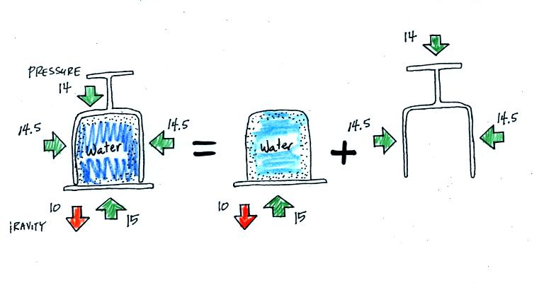
All the same forces are shown again in the left most figure. In the right two figures we separate this into two parts. First the water inside the glass isn't feeling the downward and sideways pressure forces (because they're pushing on the glass). Gravity still pulls downward on the water but the upward pressure force is able to overcome the downward pull of gravity. The upward pointing pressure force is used to overcome gravity not to cancel out the downward pointing pressure force.
The demonstration was repeated using a 4 Liter flash (more than a gallon of water, more than 8 pounds of water). The upward pressure force was still able to keep the water in the flask (much of the weight of the water is pushing against the sides of the flask which the instructor was supporting with his arms).

Look back at the hot air balloon. Can you now think of an upward force that might cause the balloon to rise?

So far we have looked at how pressure and air density change with increasing altitude. Now we will look how air temperature changes with altitude.
Here's the figure we drew in class.
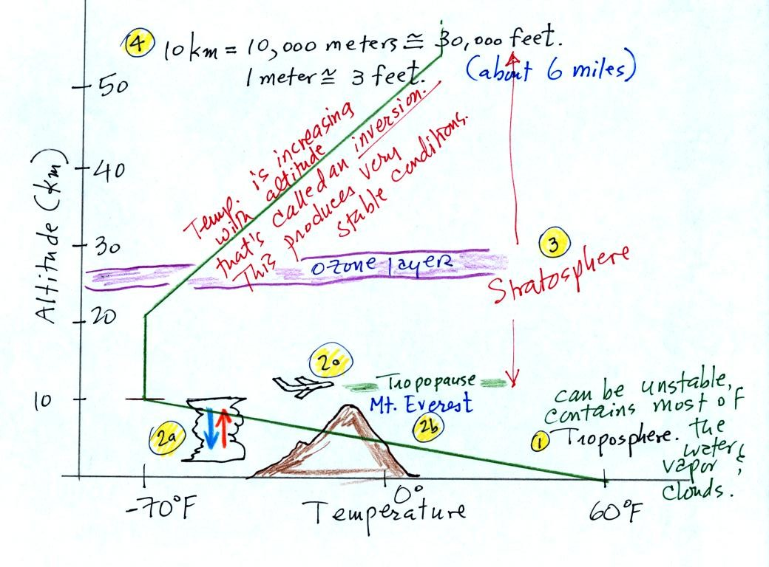
The atmosphere can be split into layers depending on whether temperature is increasing or decreasing with increasing altitude. The two lowest layers are shown in the figure above. There are additional layers (the mesosphere and the thermosphere) above 50 km but we won't worry about them. The numbered points were added after class.
1. We live in the troposphere. The troposphere is found, on average, between 0 and about 10 km altitude, and is where temperature usually decreases with increasing altitude. [the troposphere is usually a little higher in the tropics and lower at polar latitudes]
The troposphere contains most of the water vapor in the atmosphere (the water vapor comes from evaporation of ocean water) and is where most of the clouds and weather occurs. The troposphere can be stable or unstable (tropo means to turn over and refers to the fact that air can move up and down in the troposphere).
2a. The thunderstorm shown in the figure indicates unstable conditions, meaning that strong up and down air motions are occurring. When the thunderstorm reaches the top of the troposphere, it runs into the stable stratosphere. The air can't continue to rise into the stable stratosphere so the cloud flattens out and forms an anvil (anvil is the name given to the flat top of the thunderstorm, I might have forgotten to mention that term in class). The flat anvil top is something that you can go outside and see and often marks the top of the troposphere.
2b. The summit of Mt. Everest is a little over 29,000 ft. tall and is close to the top of the troposphere.
2c. Cruising altitude in a passenger jet is usually between 30,000 and 40,000, near or just above the top of the troposphere.
3. Temperature remains constant between 10 and 20 km and then increases with increasing altitude between 20 and 50 km. These two sections form the stratosphere. The stratosphere is a very stable air layer. Increasing temperature with increasing altitude is called an inversion. This is what makes the stratosphere so stable.
4. A kilometer is one thousand meters. Since 1 meter is about 3 feet, 10 km is about 30,000 feet. There are 5280 feet in a mile so this is about 6 miles.
There were a few more points to make, but we ran out of time. The following figure wasn't shown in class.
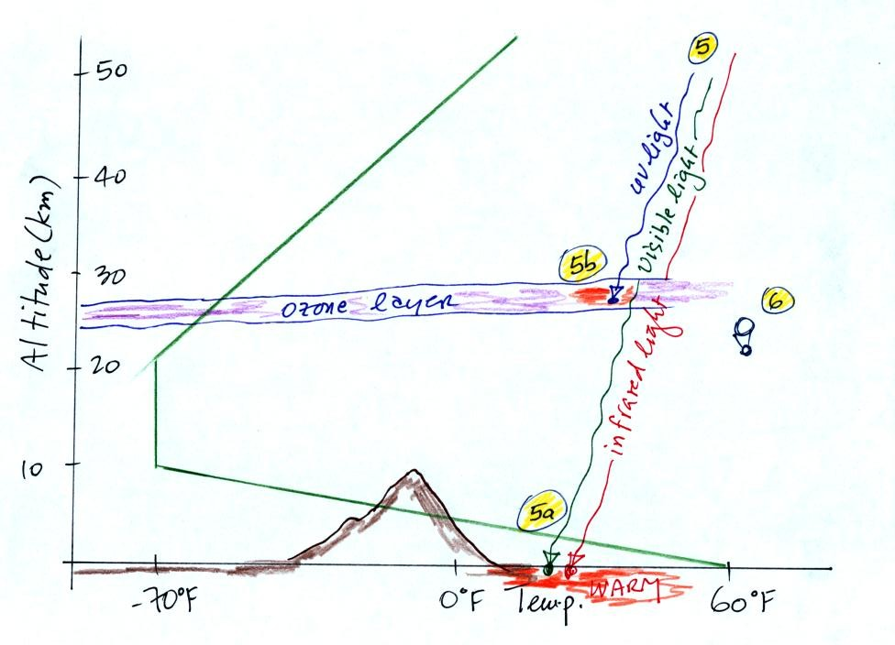
5. Sunlight is a mixture of ultraviolet, visible, and infrared light. We can see the visible light.
5a. Much of the sunlight arriving at the top of the atmosphere passes through the atmosphere and is absorbed at the ground. This warms the ground. The air in contact with the ground is warmer than air just above. As you get further and further from the warm ground, the air is colder and colder. This explains why air temperature decreases with increasing altitude.
5b. How do you explain increasing temperature with increasing altitude in the stratosphere.
The ozone layer is found in the stratosphere (peak concentrations are found near 25 km altitude). Absorption of ultraviolet light by ozone warms the air in the stratosphere and explains why the air can warm. The air in the stratosphere is much less dense (thinner) than in the troposphere. It doesn't take as much energy to warm this thin air as it would to warm denser air closer to the ground.
6. That's a manned balloon; Auguste Piccard and Paul Kipfer are inside. They were to first men to travel into the stratosphere (see pps 31 & 32 in the photocopied Class Notes). We'll see a short video showing part of their adventure at some point in the next week or so.

