Friday Sept. 19, 2008
Caution the notes were put together in a little bit of a hurry Friday afternoon, watch for typos.
The 1-2 pm class before us was finishing up an exam so we only had time for one song "Two Silver Trees" from Calexico. It is a little quieter than some of the other songs we heard this week and is from their 2008 CD Carried to Dust.
The Expt. #1 reports are due next Monday. If you haven't brought in your materials, please do so on Monday with your report. The graduated cylinders are needed for Expt. #2. Expt. #2 materials will hopefully be available in class on Wednesday next week before the quiz.
The newly added Tuesday afternoon 2-3 pm review will be held in Modern Languages 310 next week. The usual 4-5 pm reviews will still be held Monday and Tuesday afternoons in FCS 225.
Optional Assignment #1 is due at the beginning of class on Monday. Answers will be posted online since you won't get your papers back before the quiz.
Hey! Look carefully through today's online notes - there's a hidden optional assignment. If you decide to do the assignment it's due at the beginning of class on Monday.

Class started with a quick review of the station model notation used to plot weather data on a surface weather map.
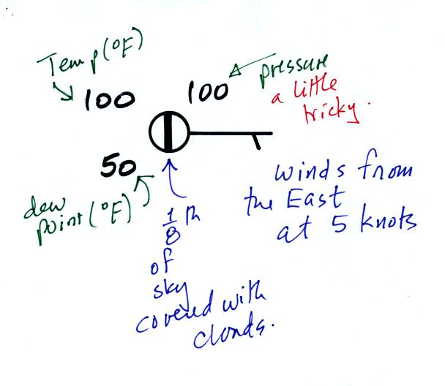
We haven't learned how to decode the pressure data yet.
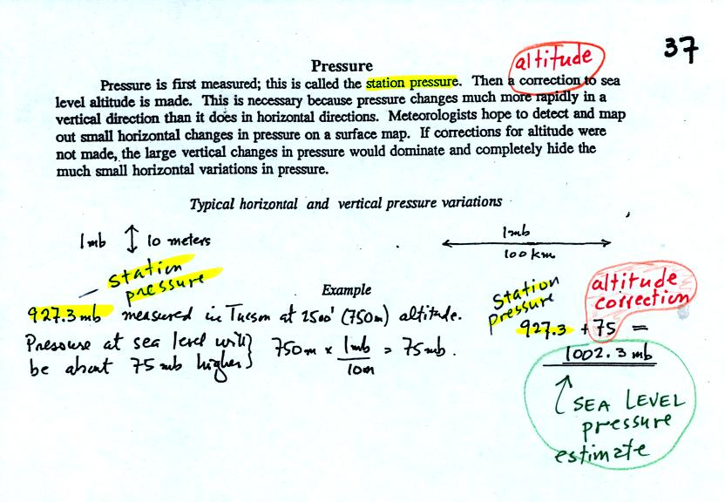
Meteorologists hope to map out small horizontal pressure changes on surface weather maps (that produce wind and storms). Pressure changes much more quickly when moving in a vertical direction. The pressure measurements are all corrected to sea level altitude to remove the effects of altitude. If this were not done large differences in pressure at different cities at different altitudes would completely hide the smaller horizontal changes.
In the example above, a station pressure value of 927.3 mb was measured in Tucson. Since Tucson is about 750 meters above sea level, a 75 mb correction is added to the station pressure (1 mb for every 10 meters of altitude). The sea level pressure estimate for Tucson is 927.3 + 75 = 1002.3 mb. This is also shown on the figure below
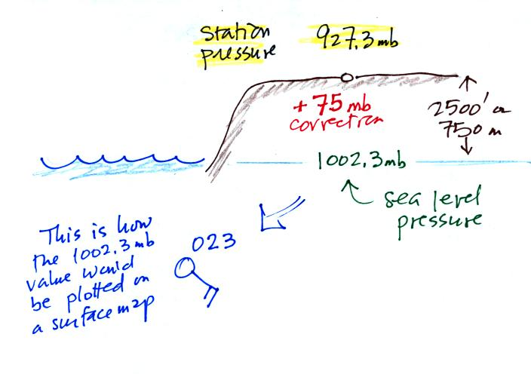

Here's the remainder of p. 37 in the photocopied ClassNotes.
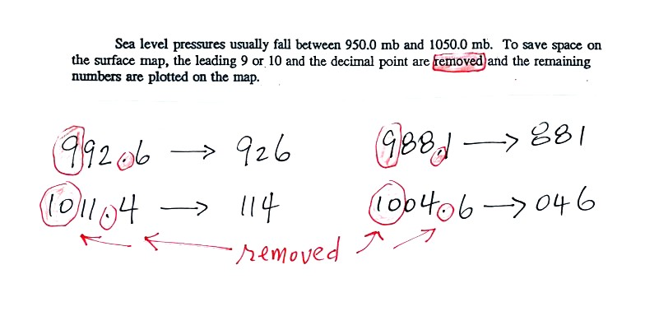
To save room, the leading 9 or 10 on the sea level pressure value and the decimal point are removed before plotting the data on the map. For example the 9 and the . in 992.6 mb would be removed; 926 would be plotted on the weather map (to the upper right of the center circle). Some additional examples are shown above.
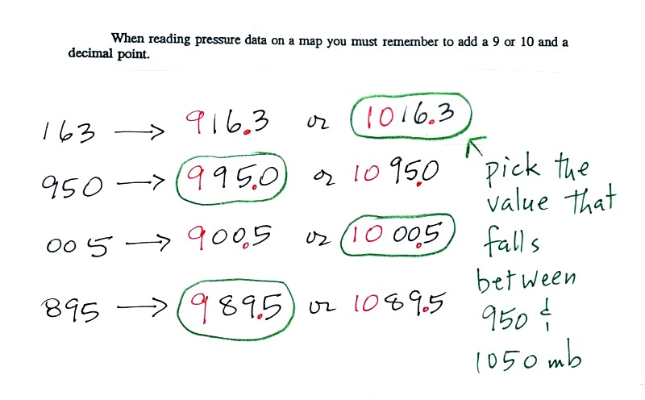
When reading pressure values off a map you must remember to add a 9 or 10 and a decimal point. For example
163 could be either 916.3 or 1016.3 mb. You pick the value that falls between 950.0 mb and 1050.0 mb (so 1016.3 mb would be the correct value, 916.3 mb would be too low).
Another important piece of information that is included on a surface weather map is the time the observations were collected. Time on a surface map is converted to a universally agreed upon time zone called Universal Time (or Greenwich Mean Time, or Zulu time). That is the time at 0 degrees longitude. There is a 7 hour time zone difference between Tucson (Tucson stays on Mountain Standard Time year round) and Universal Time. You must add 7 hours to the time in Tucson to obtain Universal Time.
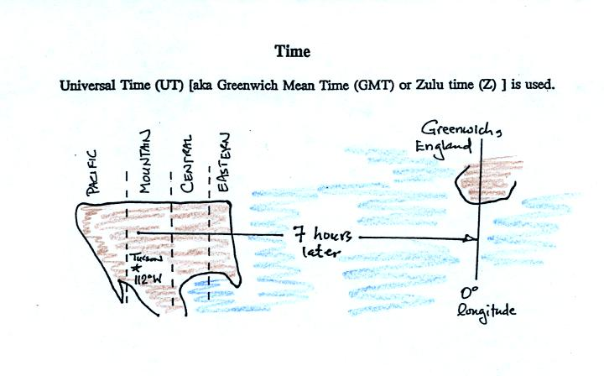
Here are some examples (only the first example was worked in class):
2:15 pm MST:
first convert 2:15 pm to the 24 hour clock format 2:15 + 12:00 = 14:15 MST
then add the 7 hour time zone correction ---> 14:15 + 7:00 = 21:15 UT (9:15 pm in Greenwich)
9:05 am MST:
add the 7 hour time zone correction ---> 9:05 + 7:00 = 16:05 UT (4:05 pm in England)
18Z:
subtract the 7 hour time zone correction ---> 18:00 - 7:00 = 11:00 am MST
02Z
if we subtract the 7 hour time zone correction we will get a negative number. We will add 24:00 to 02:00 UT then subtract 7 hours
02:00 + 24:00 = 26:00
26:00 - 7:00 = 19:00 MST on the previous day
2 hours past midnight in Greenwich is 7 pm the previous day in Tucson

A bunch of weather data has been plotted on a map in the figure below.
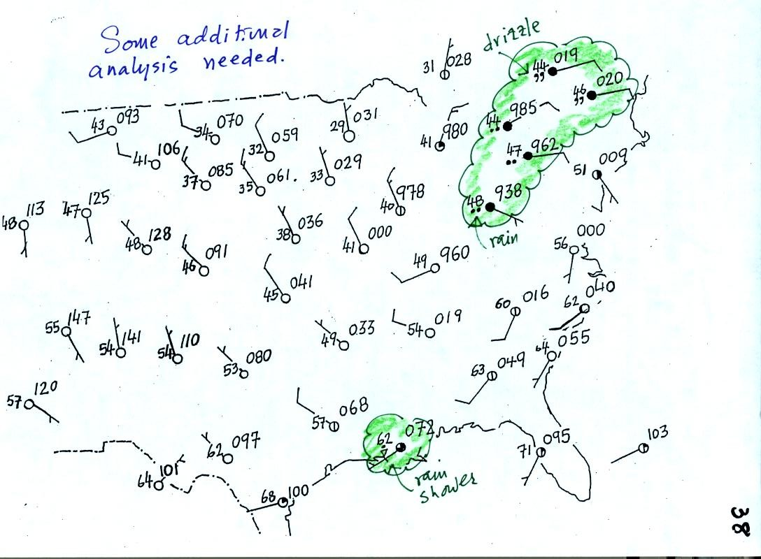
Plotting the surface weather data on a map is just the beginning. For example you really can't tell what is causing the cloudy weather with rain (the dot symbols are rain) and drizzle (the comma symbols) in the NE portion of the map above or the rain shower along the Gulf Coast. Some additional analysis is needed. A meteorologist would usually begin by drawing some contour lines of pressure to map out the large scale pressure pattern. We will look first at contour lines of temperature, they are a little easier to understand.
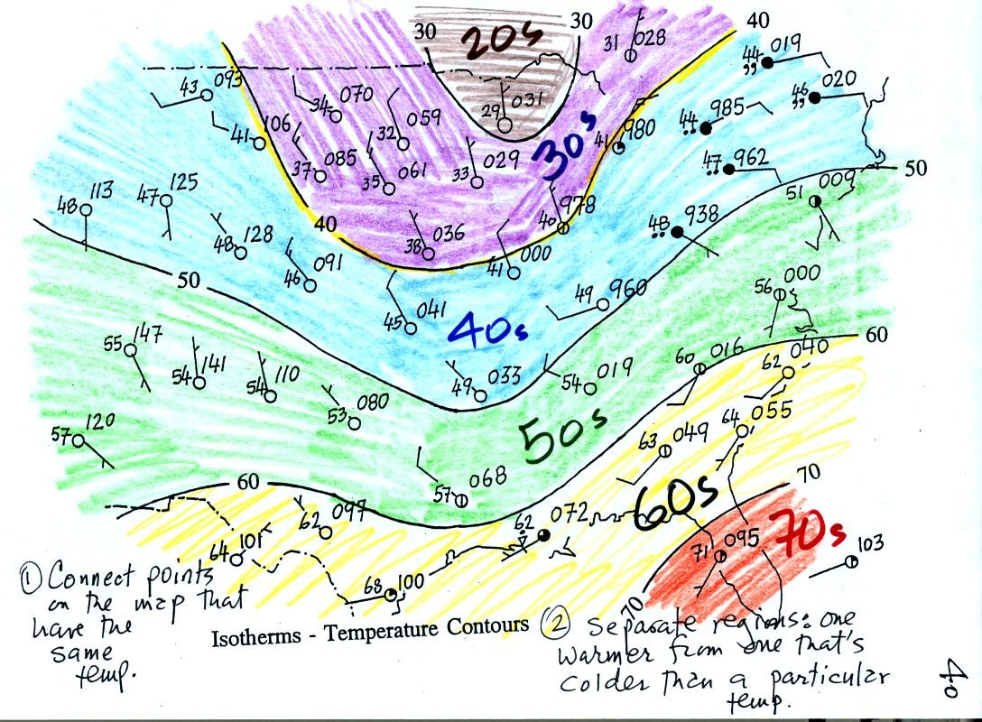
I told you I would finish coloring the map when I got back to my office. Isotherms, temperature contour lines, are usually drawn at 10 F intervals. They do two things: (1) connect points on the map that all have the same temperature, and (2) separate regions that are warmer than a particular temperature from regions that are colder. The 40º F isotherm highlighted in yellow above passes through a city which is reporting a temperature of exactly 40º. Mostly it goes between pairs of cities: one with a temperature warmer than 40º and the other colder than 40º. Temperatures generally decrease with increasing latitude.
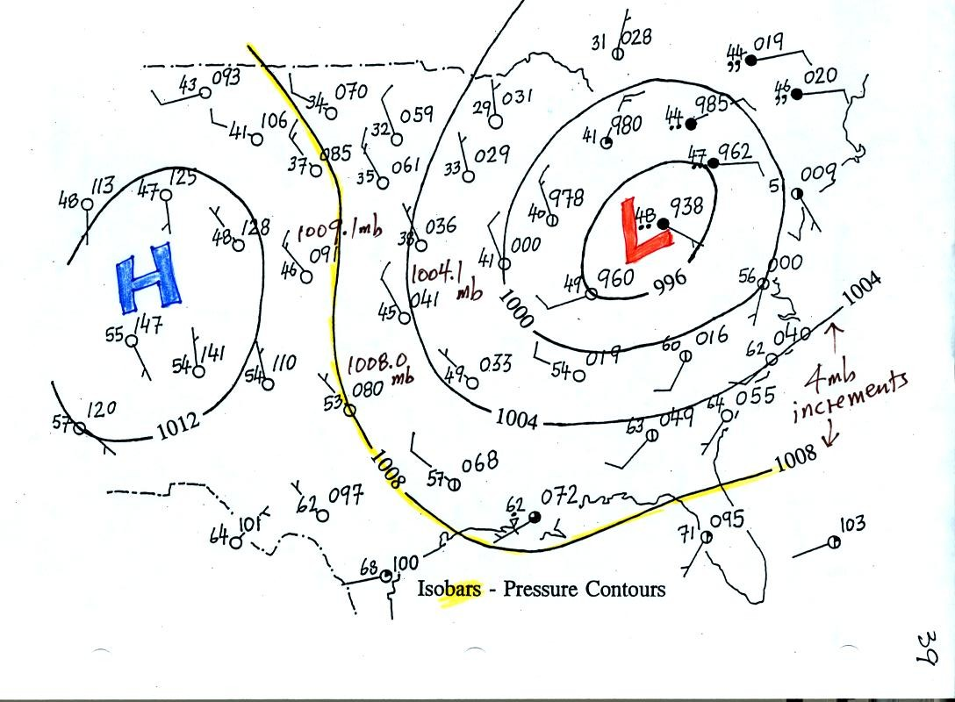
Now the same data with isobars drawn in. Again they separate regions with pressure higher than a particular value from regions with pressures lower than that value. Isobars are generally drawn at 4 mb intervals. Isobars also connect points on the map with the same pressure. The 1008 mb isobar (highlighted in yellow) passes through a city where the pressure is exactly 1008.0 mb. Most of the time the isobar will pass between two cities. The 1008 mb isobar passes between cities with pressures of 1009.1 mb and 1004.7 mb (if you look hard you'll find them). You would expect to find 1008 mb somewhere in between those two cites, that is where the 1008 mb isobar goes.
The pattern on this map is very different from the pattern of isotherms. On this map the main features are the circular low and high pressure centers.

I promised you some kind of a demonstration showing how air temperature affects pressure. Here are the two ideal gas law
equations again (without the constants k and R). Here also is the hidden optional assignment.
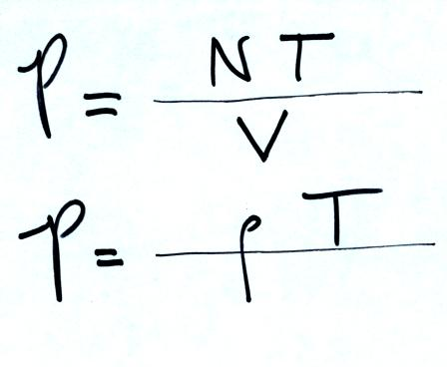
We used a flask connected to a manometer. A manometer is able to detect differences in pressure (differences between the pressure of the air inside the flask compared to the air outside the flask)

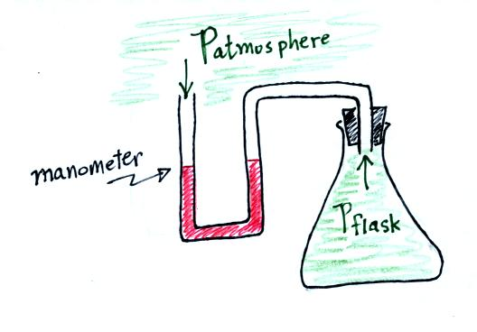
Initially the air in the flask was exactly the same as the air outside. The levels of the red liquid in the manometer were the same indicating the P_{atmosphere} and P_{flask} were the same. Next we both warmed (warm hands) and cooled (liquid nitrogen) the air in the flask.
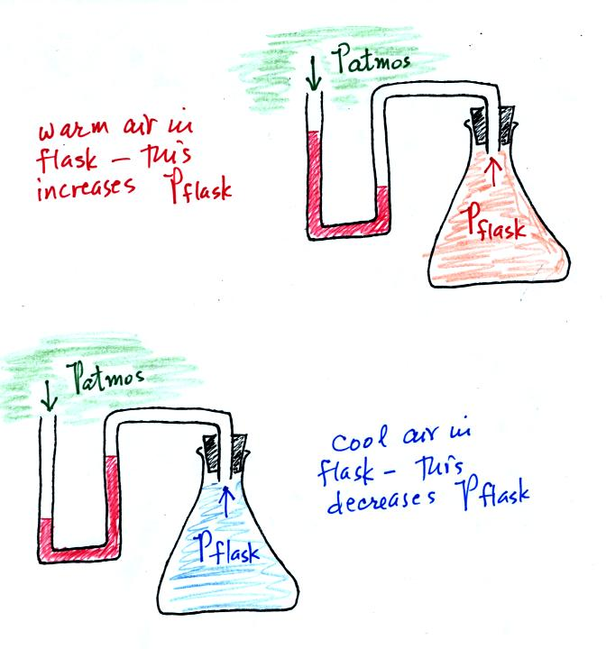
Warming the air in the flask increased the pressure inside the flask. Cooling the flask reduced the pressure of the air in the flask. The changing liquid levels revealed these changes in pressure.

You can really start to say alot about the weather once you have mapped out the pressure pattern. Differences in pressure create a force that causes the wind to blow. Wind motions then can lead to stormy or fair weather.
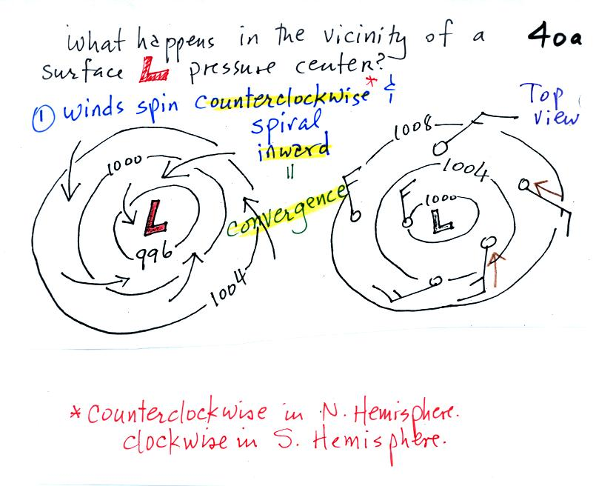

Air will start moving toward low pressure (like a rock sitting on a hillside that starts to roll downhill), then something called the Coriolis force will cause the wind to start to spin (we'll learn more about the Coriolis force later in the semester). Winds spin in a counterclockwise (CCW) direction around surface low pressure centers. The winds also spiral inward toward the center of the low, this is called convergence. [winds spin clockwise around low pressure centers in the southern hemisphere but still spiral inward]
hen the converging air reaches the center of the low, the starts to rise. Rising air expands and cools. If the air is sufficiently moist clouds can form and then begin to rain or snow. Thus you often see cloudy skies and stormy weather associated with surface low pressure.
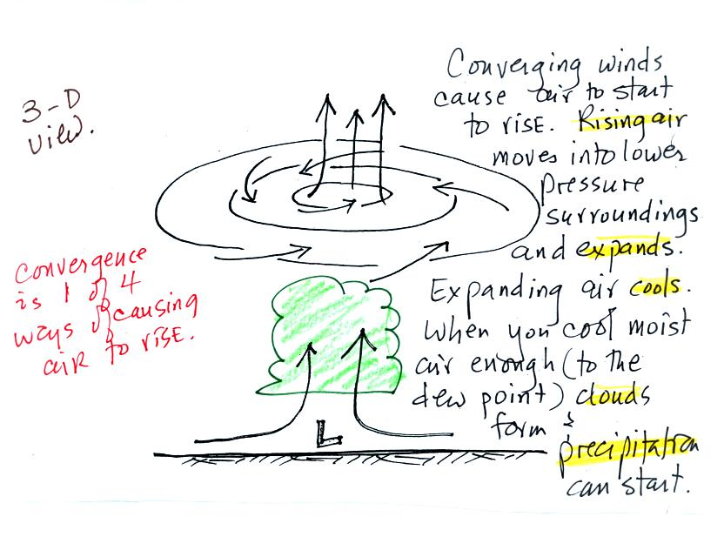
Surface high pressure centers are pretty much just the opposite situation.
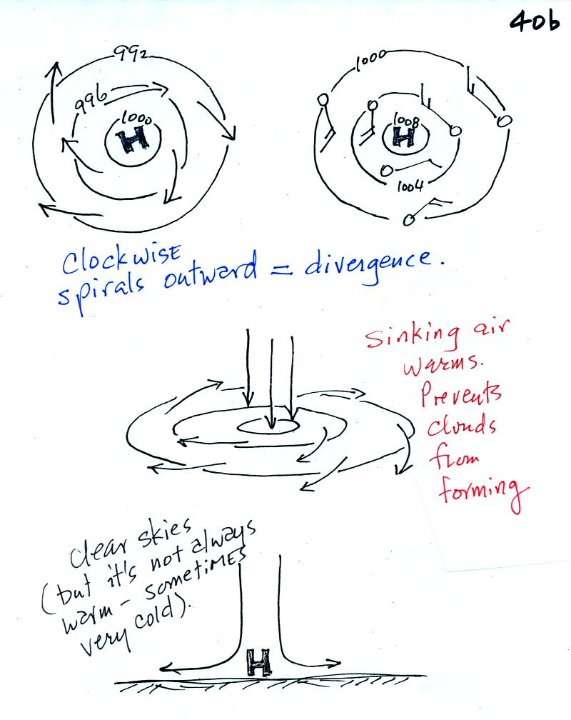
Winds spin clockwise (counterclockwise in the southern hemisphere) and spiral outward. The outward motion is called divergence.
Air sinks in the center of surface high pressure to replace the diverging air. The sinking air is compressed and warms. This keeps clouds from forming so clear skies are normally found with high pressure (clear skies but not necessarily warm weather, strong surface high pressure often forms when the air is very cold).
A good productive class today in NATS 101 - have a nice weekend.

