Friday Sep. 26, 2008
An unusually chaotic beginning to Friday's class. First, most of the Experiment #2 materials were handed out. 2 or 3 more sets of materials will be available for checkout on Monday. Data collection only takes half an hour or so. So if students with materials get started right away, materials should quickly become available for students without materials. Perhaps an appeal from a student waiting for materials would help.
The Experiment #1 reports should be graded by Wednesday.
A few minutes from the first episode of the first season of The Amazing Race was shown in class today. The new season of The Amazing Race premieres Sunday night at 7 pm on CBS. We'll return to music next week.
Quiz #1 was returned in class today. Please carefully check to see that your work was graded correctly and that the points missed were added up correctly.
The 1S1P Bonus Assignment was also returned today. You could earn up to 10 pts on this report: up to 6 pts on content and 4 pts on writing quality. Both numbers should be written on your paper. Don't think of your score as being a percentage grade. Don't think of 6 out of 10 as 60% or a D. You can earn a maximum of 45 1S1P pts, so if you earned 6 pts on this assignment, you 39 pts left to go.
Be sure not to throw away any graded work that is returned to you during the semester. This is just in case there is an error computing your semester grade or some question later about your grade.

We covered some of the following material in class on Friday. Some of it becomes a little confusing and you will probably understand it better if you work through it on your own.
Upper level maps show conditions at various altitudes above the ground. Conditions up there are important because they can strongly influence conditions at the ground.
We started with three basic things to know about upper level charts. First the overall appearance is somewhat different from a surface weather map. On a surface map you generally find circular (more or less) centers of high and low pressure. You can also find closed high and low pressure centers at upper levels, but more generally you find a wavy pattern like sketched below (the figures below are from a previous class and were used because they are a little clearer than the figures shown in class).
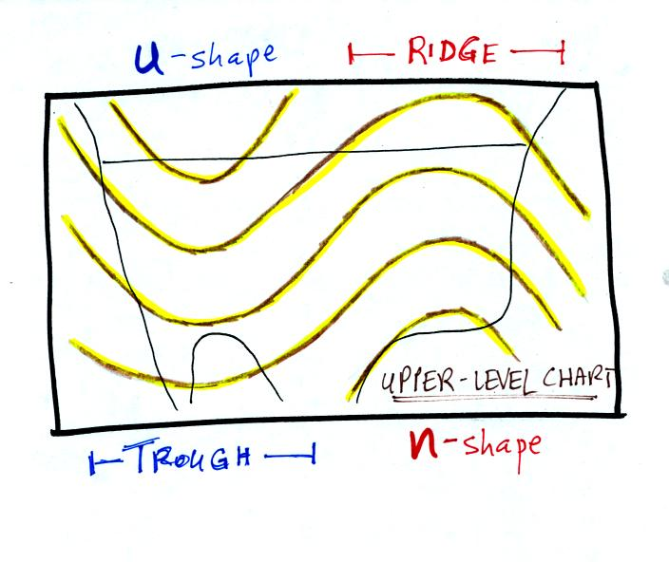
The u-shaped portion of the pattern is called a trough. The n-shaped portion is called a ridge.
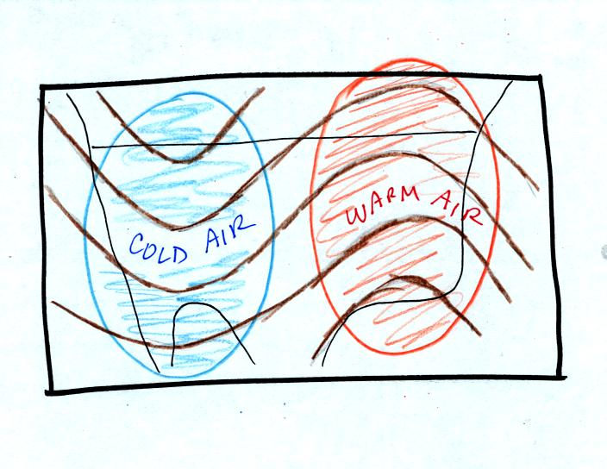
Troughs are produced by large volumes of cool or cold air (the cold air is found between the ground and the upper level that the map depicts). The western half of the country in the map above would probably be experiencing colder than average temperatures. Large volumes of warm or hot air produce ridges.
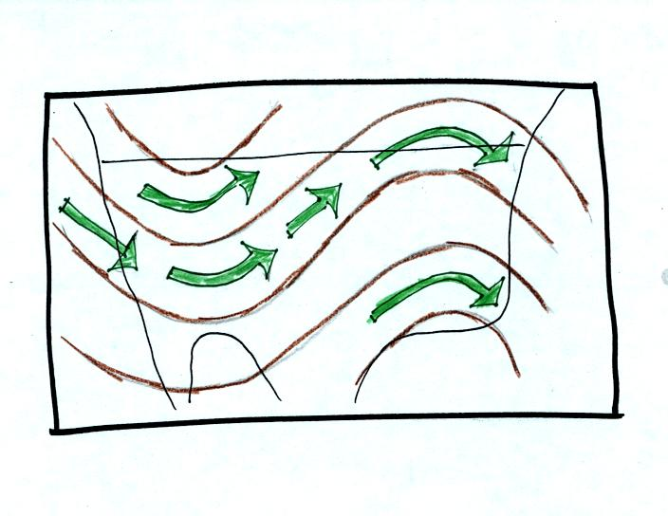
The winds on upper level charts blow parallel to the contour lines. On a surface map the winds cross the isobars slightly, spiralling into centers of low pressure and outward away from centers of high pressure. The winds generally blow from west to east.
Next we will look at some of the interactions between features on surface and upper level charts
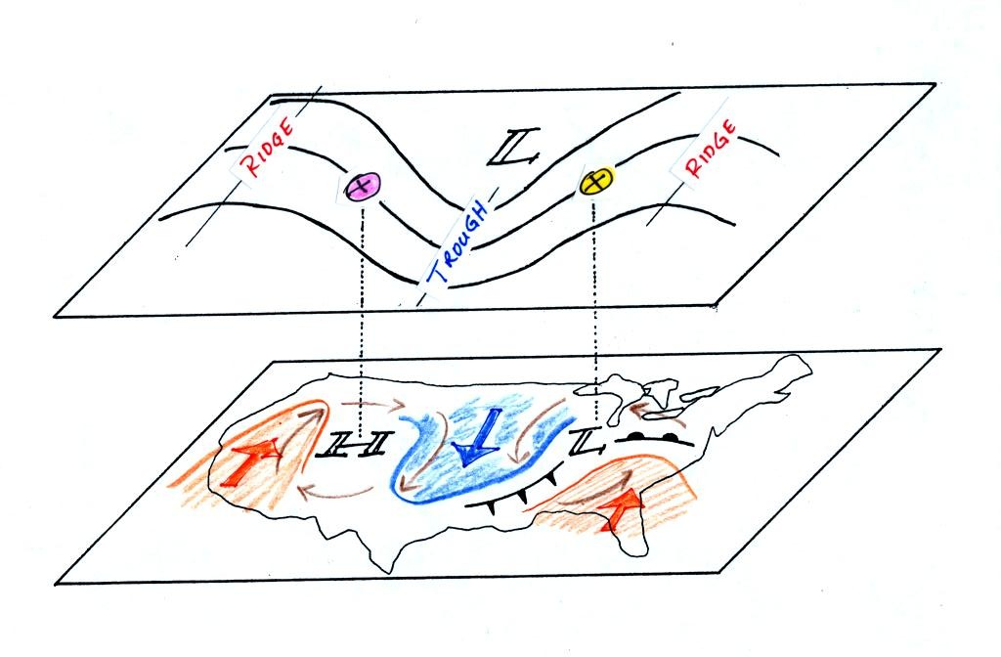
On the surface map you see centers of HIGH and LOW pressure. The low pressure center, together with the cold and warm fronts, is a middle latitude storm.
Note how the counterclockwise winds spinning around the LOW move warm air northward (behind the warm front on the eastern side of the LOW) and cold air southward (behind the cold front on the western side of the LOW). Clockwise winds spinning around the HIGH also move warm and cold air. The winds are shown with thin brown arrows on the surface map.
Note the ridge and trough features on the upper level chart. We learned that warm air is found below an upper level ridge. Now you can begin to see where this warm air comes from. Warm air is found west of the HIGH and to the east of the LOW. This is where the two ridges on the upper level chart are also found. You expect to find cold air below an upper level trough. This cold air is being moved into the middle of the US by the northerly winds that are found between the HIGH and the LOW.
Note the yellow X marked on the upper level chart directly above the surface LOW. This is a good location for a surface LOW to form or develop and strengthen (in a strengthening storm the surface low pressure in the center of the storm will get even lower than it is now) We will find that this is frequently a location where there is upper level divergence. Similary the pink X is where you often find upper level convergence. This could cause surface high pressure to get even higher.

Now we need to look in a little more detail at how upper level winds can affect the development or intensification of a surface storm. This is the confusing part.
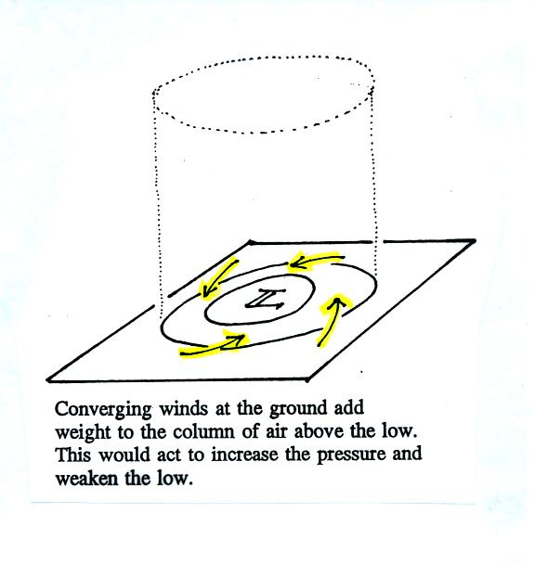
The figure shows a cylinder of air (see p. 42 in the photocopied Classnotes). The pressure at the center at the bottom of the cylinder is determined by the weight of the air overhead. The surface winds are spinning counterclockwise and spiraling in toward the center of the surface low. This adds air to the cylinder of air. Adding air to the cylinder means the cylinder will weigh more and you would expect the surface pressure at the bottom of the cylinder to increase.
We'll just make up some numbers, this might make this clearer.
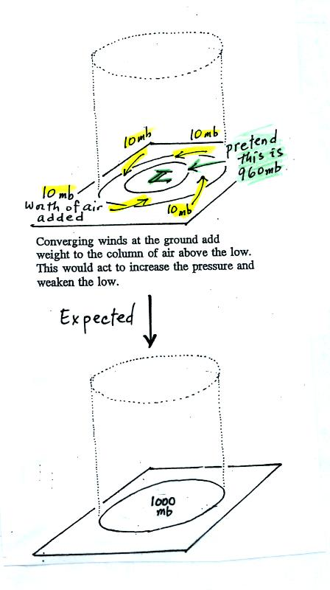
You'll find this figure on p. 42a in the Class Notes. At the top we will assume the surface low has 960 mb pressure. Imagine that each of the surface wind arrows winds brings in enough air to increase the pressure at the center of the LOW by 10 mb. You would expect the pressure at the center of the LOW to increase from 960 mb to 1000 mb.
This is just like a bank account. You have $960 in the bank and you make four $10 dollar deposits. You would expect your bank account balance to increase from $960 to $1000.
But what if the surface pressure decreased from 960 mb to 950 mb as shown in the following figure? Or in terms of the bank account, wouldn't you be surprised if, after making 4 $10 dollar deposits, the balance dropped from $960 to $950.
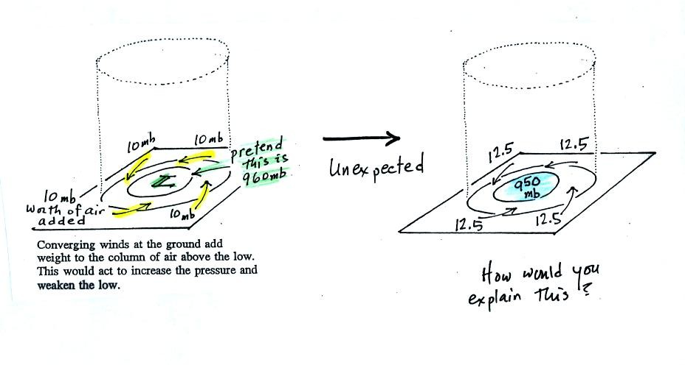
The next figure shows us what could be happening (back to p. 42 in the Class Notes).
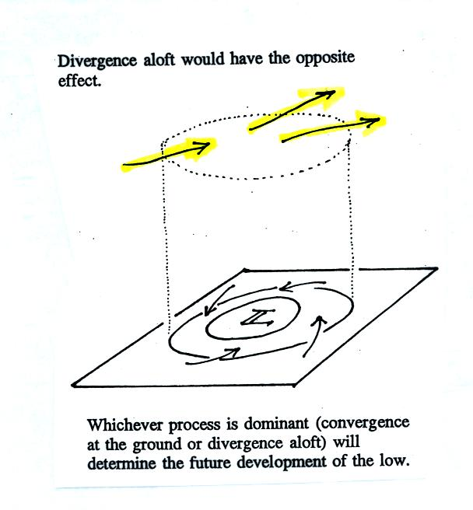
There may be some upper level divergence (more arrows leaving the cylinder than going in ). Upper level divergence removes air from the cylinder and would decrease the weight of the cylinder (and that would lower the surface pressure)
We need to determine which of the two (converging winds at the surface or divergence at upper levels) is dominant. That will determine what happens to the surface pressure.
Again some actual numbers might help (see p. 42b in the Class Notes)
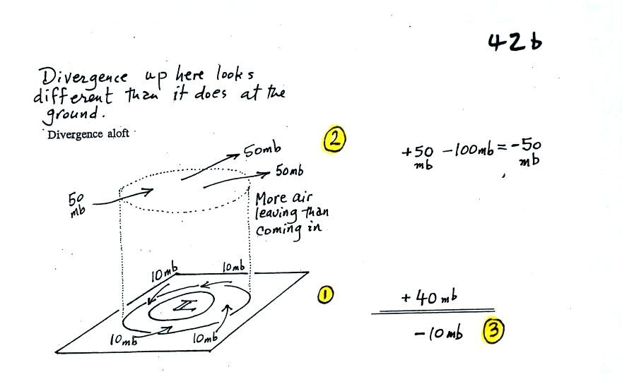
The 40 millibars worth of surface convergence is shown at Point 1. Up at Point 2 there are 50 mb of air entering the cylinder but 100 mb leaving. That is a net loss of 50 mb. At Point 3 we see the overall result, a net loss of 10 mb. The surface pressure should decrease from 960 mb to 950 mb. That change is reflected in the next picture (found at the bottom of p. 42b in the Class Notes).
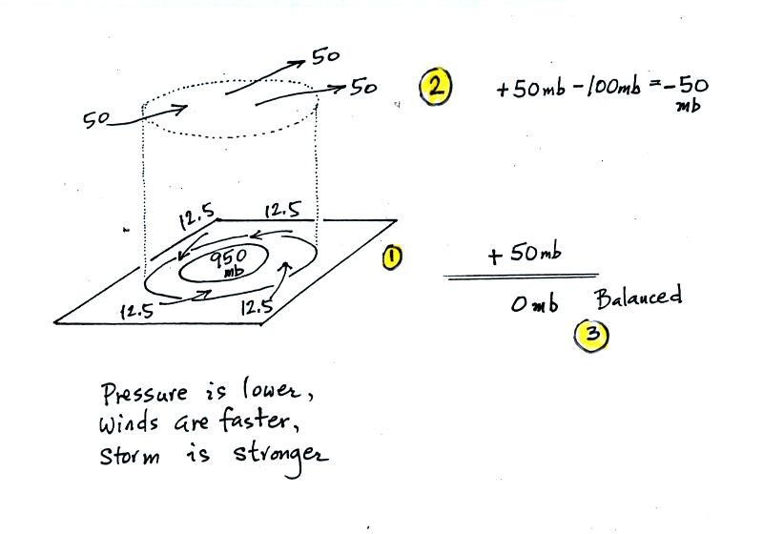
The surface pressure is 950 mb. This means there is more of a pressure difference between the low pressure in the center of the storm and the pressure surrounding the storm. The surface storm has intensified and the surface winds will blow faster and carry more air into the cylinder (the surface wind arrows each now carry 12.5 mb of air instead of 10 mb). The converging surface winds add 50 mb of air to the cylinder (Point 1), the upper level divergence removes 50 mb of air from the cylinder (Point 2). Convergence and divergence are in balance (Point 3). The storm won't intensify any further.

We're almost done, one last figure (it's the figure on p. 41 in the photocopied Class Notes again with some new information added (redrawn here for improved clarity).
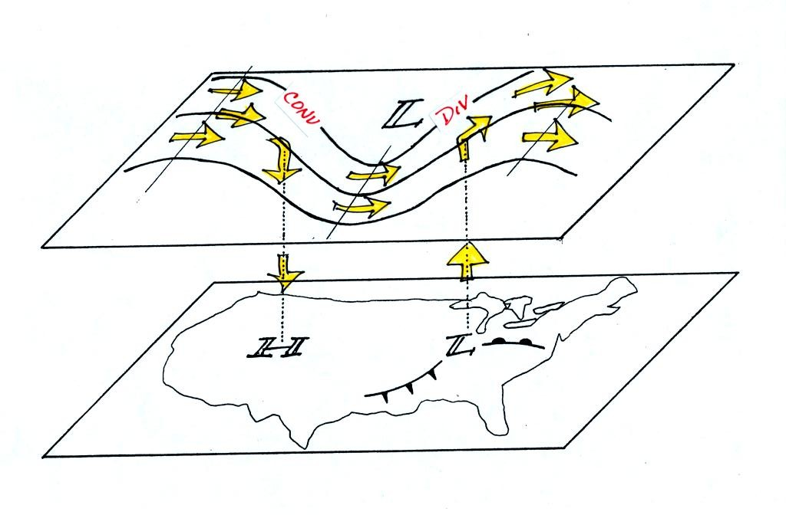
Now that you have some idea of what upper level divergence looks like (more air leaving than is going in) you are in a position to understand another one of the relationships between the surface and upper level winds.
One of the things we have learned about surface LOW pressure is that the converging surface winds create rising air motions. The figure above gives you an idea of what can happen to this rising air (it has to go somewhere). Note the upper level divergence in the figure: two arrows of air coming into the point "DIV" and three arrows of air leaving (more air going out than coming in is what makes this divergence). The rising air can, in effect, supply the extra arrow's worth of air.
Three arrows of air come into the point marked "CONV" on the upper level chart and two leave (more air coming in than going out). What happens to the extra arrow? It sinks, it is the source of the sinking air found above surface high pressure.

Next we learned a little bit about the Piccard family.
Auguste Piccard (together with Paul Kipfer, see p. 32 in the photocopied ClassNotes) was the lead member of a two-man team that made the first trip into the stratosphere in a balloon. They did that on May 27, 1931. I had hoped to show you a short video tape describing his trip (it very nearly ended in disaster), but the VCR wasn't working properly. Auguste was also somewhat of a character (he would have made a good NATS 101 teacher). I'll try to show the video at a later date.
Jacques Piccard (Auguste's son) was part of a two-man team that traveled to the deepest point in the ocean (35,800 feet) in a bathyscaph. I will show you a short segment from an earlier test of the bathyscaph where Auguste and Jacques descend to 10,000 feet.
Finally Bertrand Piccard (Jacques' son, Auguste's grandson) was part of the two man team that first circled the globe nonstop in a balloon. That occurred fairly recently, March 20, 1999, I believe. I also plan to show you some of that trip.

We'll be working in Chapters 2 and 3 between now and the next quiz. Here's some new reading if you want to get a little bit of a head start.
Chapters 2&3 is concerned with energy, temperature, heat, energy transport, and energy balance between the earth, atmosphere, and space.
It is easy to lose sight of the main concepts because there are so many details. The following (found on pps 43&44 in the photocopied Class Notes) is meant to introduce some of what we will be covering in class from Chapter 2. I stole these pictures from a previous semester because they're drawn more clearly and so that I can get these notes done before 5 pm. I'll then be able to spend more time in my vegetable garden this weekend and won't have to come into my office.
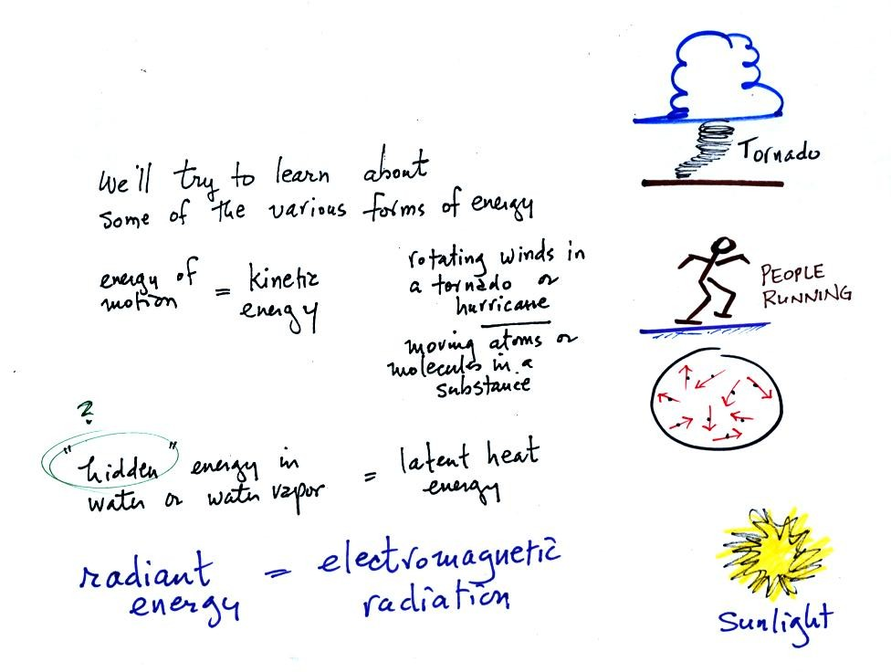
We will learn the names of several different types or forms of energy. Kinetic energy is energy of motion. Some examples are mentioned and sketched above. It is a relatively easy to visualize and understand form of energy.
Latent heat energy is perhaps the most underappreciated and most confusing type of energy. The word latent refers to energy that is hidden in water and water vapor. The hidden energy emerges when water vapor condenses or water freezes.
Radiant energy is a very important form of energy that was for some reason left off the original list. Sunlight is an example of radiant energy that we can see and feel (you feel warm when you stand in sunlight). There are many types of radiant energy that are invisible.
Four energy transport processes are listed below.

By far the most important process is electromagnetic radiation (light is a common form of electromagnetic radiation). This is the only process that can transport energy through empty space. Electromagnetic radiation travels both to the earth (from the sun) and away from the earth into space. Electromagnetic radiation is also responsible for about 80% of the energy transported between the ground and atmosphere.
You might be surprised to learn that latent heat is the second most important transport process.
Rising parcels of warm air and sinking parcels of cold air are examples of free convection. Because of convection you feel colder or a cold windy day than on a cold calm day. Ocean currents are also an example of convection. Ocean currents transport energy from the warm tropics to colder polar regions.
Note that convection is a 3rd way of causing rising air motions in the atmosphere (convergence into centers of low pressure, and fronts were the other two ways). This is a topic we are really going to beat to death. Archimedes law will also make an appearance when we cover convection.
Conduction is the least important energy transport at least in the atmosphere. Air is such a poor conductor of energy that it is generally considered to be an insulator.

Water vapor is a particularly important form of invisible energy. When water vapor condenses to produce the water droplets (or ice crystals) in a cloud, an enormous amount of latent heat energy is released into the atmosphere.
It is hard to visualize or appreciate the amount of energy released into the atmosphere during condensation. You can imagine the work that you would do carrying a gallon of water (8 pounds) from Tucson to the top of Mt. Lemmon. To accomplish the same thing Mother Nature must first evaporate the water and (if my calculations are correct) that requires about 100 times the energy that you would use to carry the 8 pounds of water to the summit of Mt. Lemmon. And Mother Nature transports a lot more than just a single gallon.
The next picture shows energy being transported from the sun to the earth in the form of electromagnetic radiation.

We are aware of this energy because we can see it (sunlight also contains invisible forms of light) and feel it. With all of this energy arriving at and being absorbed by the earth, what keeps the earth from getting hotter and hotter? The answer is that the earth also sends energy back into space (the orange and pink arrows in the figure below)

This infrared light is an invisible form of energy (it is weak enough that we don't usually feel it either). A balance between incoming and outgoing energy is achieved and the earth's annual average temperature remains constant.
We will also look closely at energy transport between the earth's surface and the atmosphere. This is where latent heat energy transport and convection and conduction operate (they can't outside the atmosphere into outer space).

That is also where the atmospheric greenhouse operates. That will be a important goal - to better understand how the atmospheric greenhouse effect works.

Remember that without the greenhouse effect, the global annual average surface temperature on the earth would be about 0º F rather than 60º F.
The topic of Buddhist monks should come up next week. I don't really know anything about Buddhist monks but am fascinated by some of the things they are able to do. Also you may hear a storm or two (perhaps see a picture or two) of may cats. They have taught me a lot of what I know about static electricity, which is something we will use to understand electromagnetic radiation.

Finally I had planned to put in a plug for the book "Into Thin Air." It is about a 1996 expedition to the summit of Mt. Everest (that ended tragically). I'll probably do that on Monday.

