Monday Sept. 29, 2008
Students were given a choice between musical selections this afternoon: Sweet Autobahn by Haugaard & Hoirup, Lost Coastlines by Okkervil River, and To Sir With Love with Natalie Merchant and Michael Stipe.
The sound system in BioWest 310 wasn't loud enough to be able to hear the 3rd choice, you'll have to listen to it on our own. The second selection wasn't much better.
The Hidden Optional Assignment and Optional Assignment #1 were returned in class today. So far this semester there have been a total of 3 optional assignments (an inclass assignment in addition to the two returned today). If you have done all three assignments and received full credit you have earned 1 extra credit point.
All of the Experiment #2 materials have been checked out. Please collect your data as soon as you can and return your materials so that they can be checked out to people on the waiting list. The Experiment #1 reports should be graded by Wednesday.

Now we're ready to start covering material on p. 45 in the photocopied Classnotes.
When you add energy to an object, the object will usually warm up (conversely when you take energy from an object the object will cool). It is relatively easy to come up with an equation that allows you to figure out what the temperature change will be.

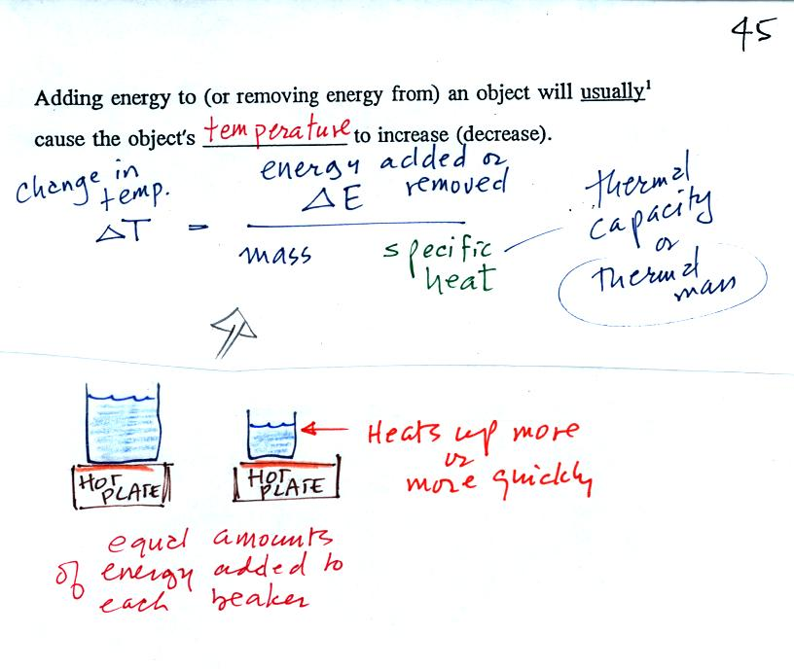
The temperature change will first depend on how much energy was added. This is a direct proportionality, so delta E is in the numerator of the equation.
When you add equal amounts of energy to large and small pans of water, the small pan will heat up more quickly. The temperature change, delta T, will depend on the mass. A small mass will mean a large delta T, so mass should go in the denominator of the equation.
Different materials react differently when energy is added to them. A material with a large specific heat will warm more slowly than a material with a small specific heat. Specific heat behaves in the same kind of way as mass. Specific heat is sometimes called "thermal mass" or "thermal capacity."
Here's an important example that will show the effect of specific heat (middle of p. 45)
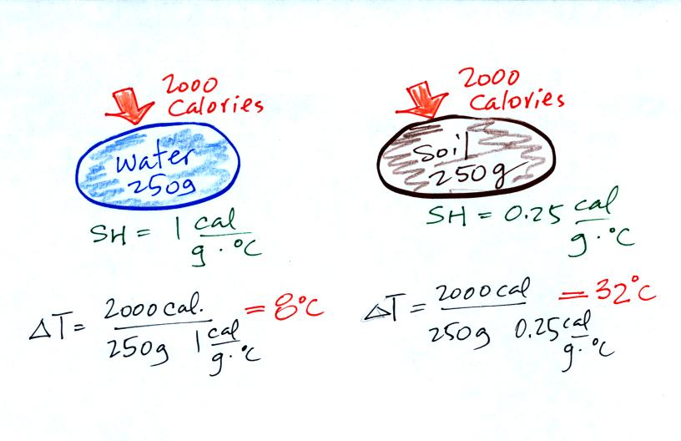
Equal amounts of energy (note that calories are units of energy) are added to equal masses of water and soil. We use water and soil in the example because most of the earth's surface is either ocean or land. Water has a higher specific heat than soil, it only warms up 8º C. The soil has a lower specific heat and warms up 32º C, 4 times more than the water.
These different rates of warming of water and soil have important effects on regional climate.
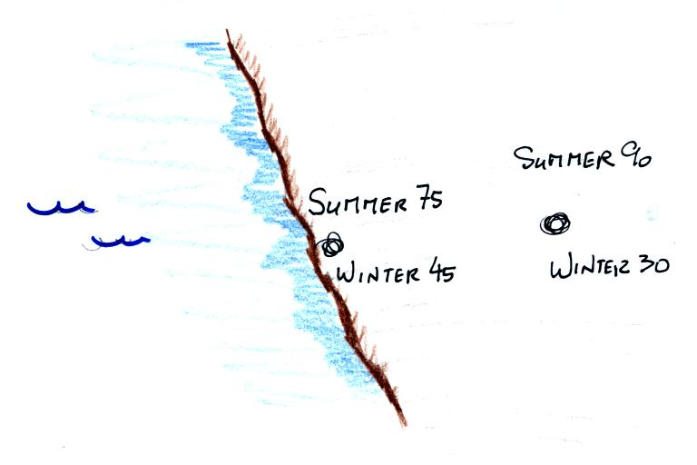
Oceans moderate the climate. Cities near a large body of water won't warm as much in the summer and won't cool as much during the winter compared to a city that is surrounded by land.
The city above on the coast has a 30º F annual range of temperature (the winter time temperature was changed from the 40F value used in class to 45F). The city further inland (assumed to be at the same latitude and altitude) has an annual range of 60º F. Note that both cities have the same 60º F annual mean temperature.

Adding energy to an object will usually cause it to warm. But there is another possibility (bottom p. 45), the object could change phase (change from solid to liquid or gas). Adding energy to ice might cause the ice to melt. Adding energy to water could cause it to evaporate.
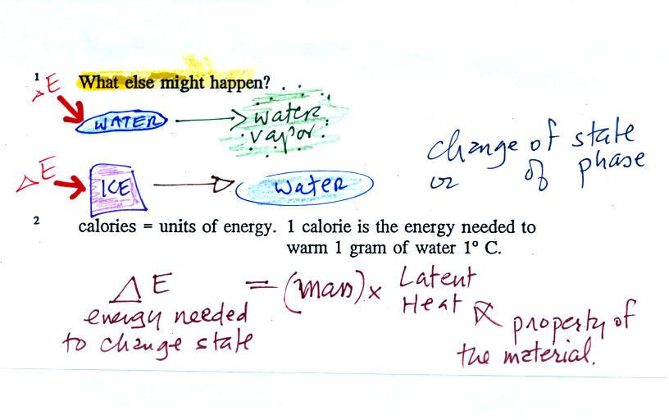
The equation at the bottom of the figure above allows you to calculate how much energy is required to melt ice or evaporate water or sublimate dry ice. You multiply the mass by the latent heat, a variable that depends on the particular material that is changing phase. We used this equation in an experiment conducted at the end of class. We'll also use the equation relating delta T and delta E that we discussed earlier. The figure below wasn't shown in class.
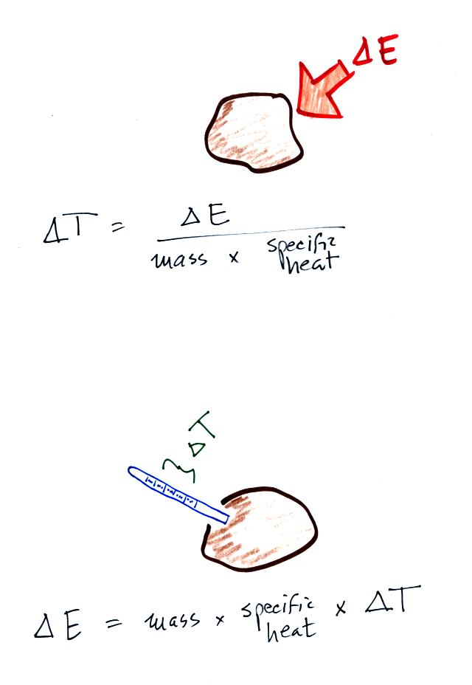
Rather than trying to calculate delta T (top figure) we are going to measure temperature change, delta T, and use the second equation (bottom figure) to measure energy flow.
The object of the experiment was to measure the latent heat of vaporization of liquid nitrogen. That just means measuring the amount of energy needed to evaporate a gram of liquid nitrogen. The students that are doing Experiment #2 are measuring the latent heat of fusion of ice, the energy needed to melt one gram of ice. A student in the 2:00 class also performed this liquid nitrogen experiment. You'll find the following figure on p. 45a in the photocopied Classnotes.
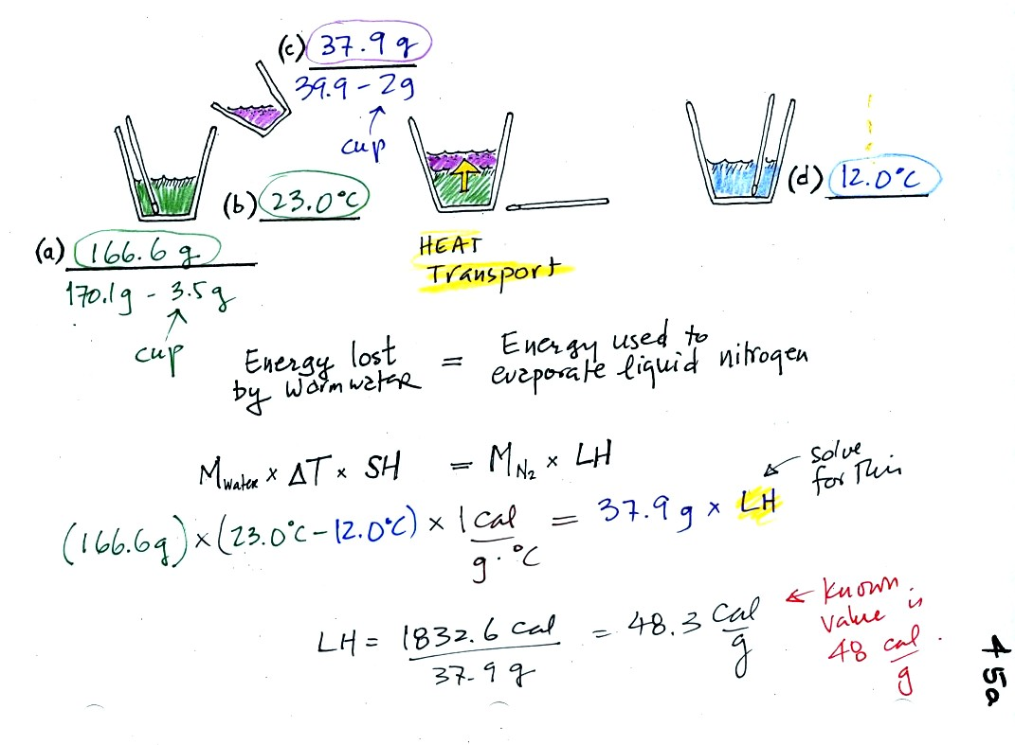
(a)
Some room temperature water poured into a styrofoam cup weighed 170.1 g. The cup itself weighed 3.5 g, so we have 166.6 g of water.
(b)
The water's temperature was 23.0 C..
(c)
37.9 g of liquid nitrogen was poured into the cup of water.
It takes energy to turn liquid nitrogen into nitrogen gas. The needed energy came from the water. This flow of energy is shown in the middle figure above. We assumed that because the experiment is performed in a styrofoam cup that there is no energy flowing between the water in the cup and the surounding air.
(d)
After the liquid nitrogen had evaporated we remeasured the water's temperature. It had dropped to 12.0 C. That is a temperature drop of 11 C.
Because we knew how much water we started with, its temperature drop, and water's specific heat we can calculate how much energy was taken from the water. That is the 1832.6 calorie figure above. This was used to evaporate 37.9 grams of liquid nitrogen. So we divided 1832.6 calories by 37.9 grams to get 48.3 calories needed per gram. That is our measured value of the latent heat of vaporization of nitrogen. A trustworthy gentleman informed us that the known value is 48 cal/g, so our measurement was dead on.

When you add energy to an object and the object warms, what exactly is happening inside the object?
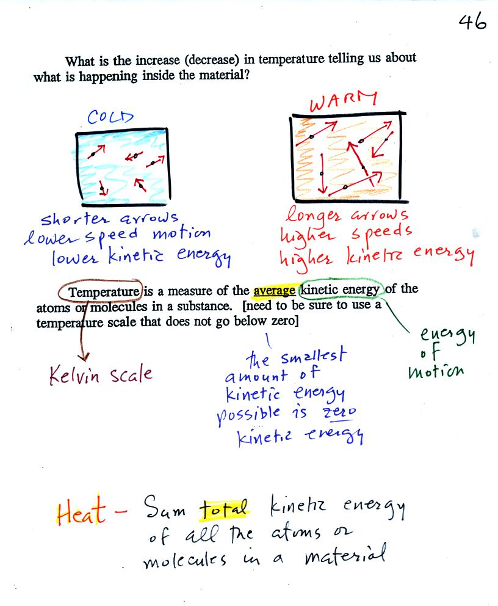
The figure above is on p. 46 in the photocopied Class Notes. Temperature provides a measure of the average kinetic of the atoms or molecules in a material. The atoms or molecules in a cold material will be moving more slowly than the atoms or molecules in a warmer object.
You can think of heat as being the total kinetic energy of all the molecules or atoms in a material. The next figure might make the distinction between temperature (average kinetic energy) and heat (total kinetic energy) clearer.
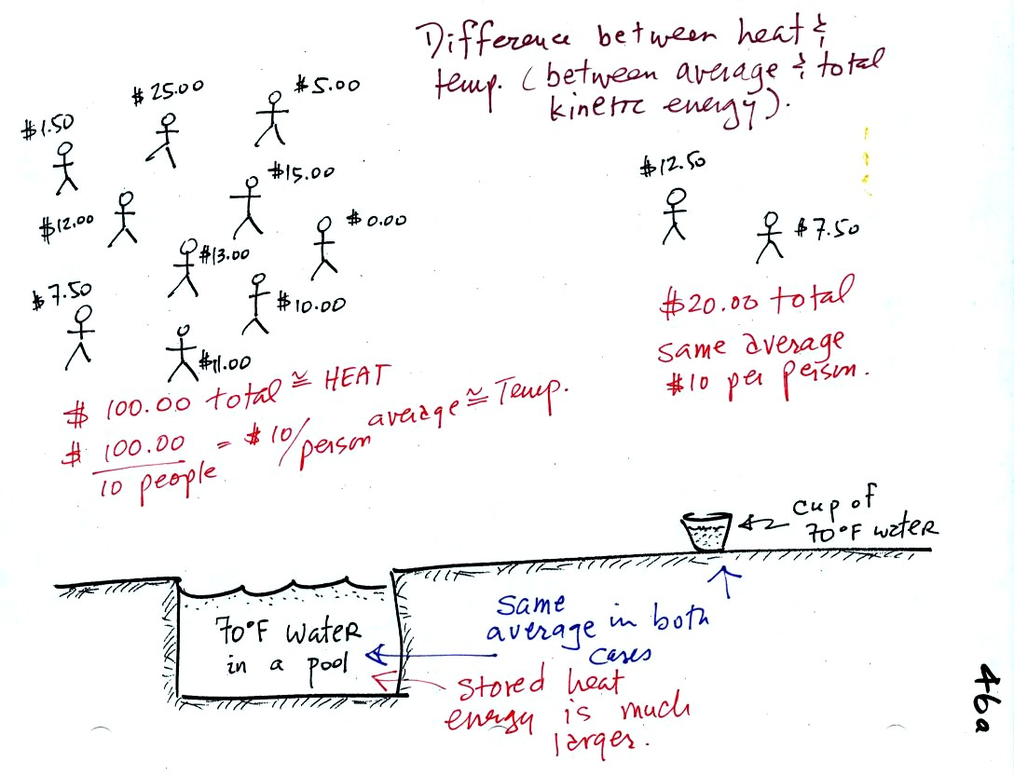
A cup of water and a pool of water both have the same temperature. The average kinetic energy of the water molecules in the pool and in the cup are the same. There are a lot more molecules in the pool than in the cup. So if you add together all the kinetic energies of all the molecules in the pool you are going to get a much bigger number than if you sum the kinetic energies of the molecules in the cup. There is a lot more stored energy in the pool than in the cup. It would be a lot harder to cool (or warm) all the water in the pool than it would be the cup.
In the same way the two groups of people shown have the same average amount of money per person. The $100 held by the larger group at the left is greater than the $20 total possessed by the smaller group of people on the right.
You need to be careful what temperature scale you use when using temperature as a measure of average kinetic energy. You must use the Kelvin temperature scale because it does not go below zero (0 K is known as absolute zero). The smallest kinetic energy you can have is zero kinetic energy. There is no such thing as negative kinetic energy.

Speaking of temperature scales.
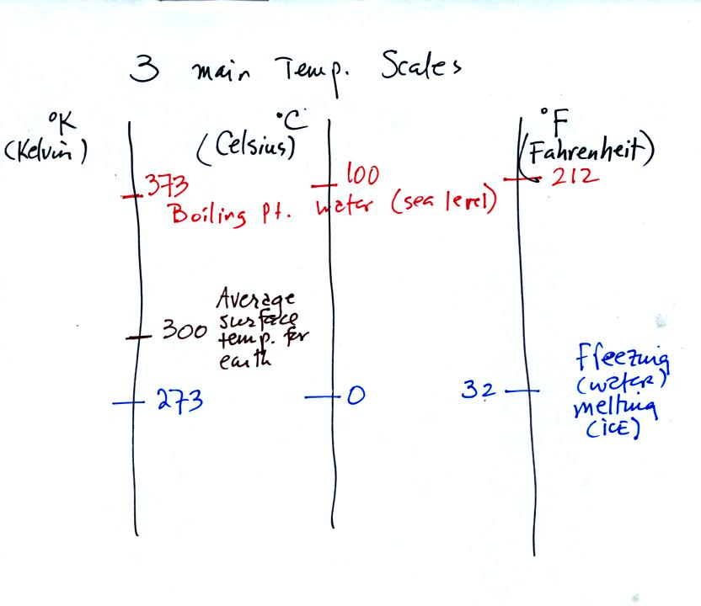
You should remember the temperatures of the boiling point and freezing point of water on the Fahrenheit, Celsius, and Kelvin scales. 300 K is a good easy-to-remember value for the global annual average surface temperature of the earth.
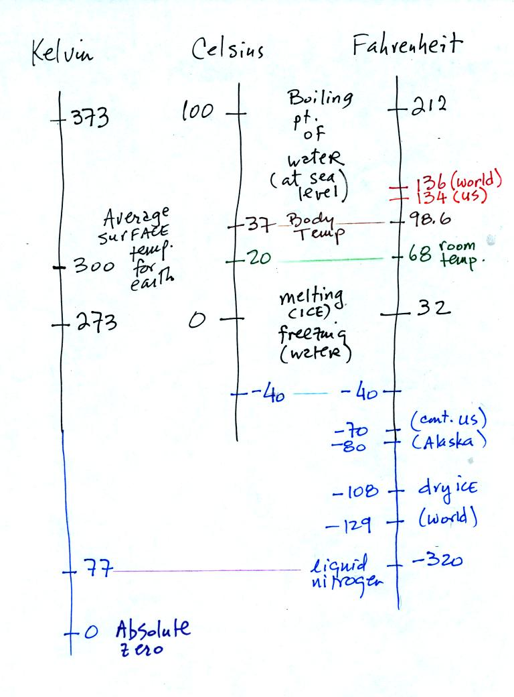
You certainly don't need to try to remember all these numbers. The world high temperature record was set in Libya, the US record in Death Valley. The continental US cold temperature record of -70 F was set in Montana and the -80 F value in Alaska. The world record -129 F was measured at Vostok station in Antarctica. This unusually cold reading was the result of three factors: high latitude, high altitude, and location in the middle of land rather than being near or surrounded by ocean. You'll find more record high and low temperature data Liquid nitrogen is cold but it is still quite a bit warmer than absolute zero.

