NATS 101 Name_________________________
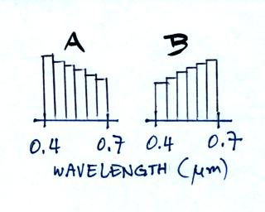
1. Which of the mixtures of different colors
of visible light at right would produce the
“cooler” shade of white?

2. Sunlight is a mixture of UV, VIS, and IR light. About half (49%) of sunlight is _______ light. Most of the _______ and some of the _______ in sunlight is absorbed by gases in the atmosphere. The atmosphere is able to emit _______light. (fill in each blank with UV, VIS, or IR; answers can be used once, more than once or not at all)
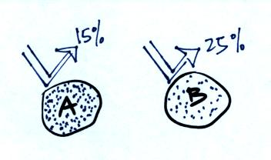

3. The two planets at right are the same size and are made
of the same material. Neither planet has an atmosphere.
Planet A reflects 15% of the sunlight that hits it, Planet B
reflects 25%. Would Planet A have a HIGHER a LOWER
or the SAME radiative equilibrium temperature than(as)
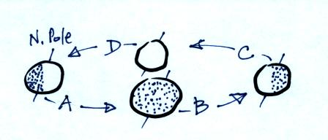
Planet B?

4. We are currently at Point _______
in the figure at right.

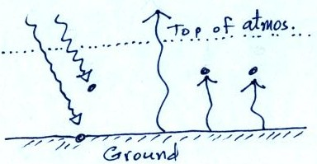
5. In order to bring the picture into radiative equilibrium,
the atmosphere needs to emit _______ arrow(s) of energy
upward and _______ arrow(s) downward toward the
ground. (hints: How many arrows of energy is the atmos-
phere absorbing, how many arrows must it be emitting to
be in energy balance. How many arrows of energy is the
ground emitting? How many arrows of energy does it
need from the atmosphere to be in balance? )

6. Based on the information shown below do you think the temperature of the ground in Figure A would be WARMER COLDER or the SAME than(as)
in Figure B?
