Tuesday Oct. 7, 2008
The Controls of Temperature Optional Assignment was collected today. Thanks for the emails (I received about 25 of them) asking about the climate at Point X.
A new Optional Assignment was handed out today. It will be due next Tuesday Oct. 14, at the beginning of class.
The Quiz #2 Study Guide is now available online in its final form.
We didn't have time for a short story (actually a warning) that I found in the Spring 2008 online notes. It's not a very interesting story, but you can read it if you want to.

Last week we talked about energy transport and our perception of cold (an indication of how quickly our body is losing energy rather than an accurate measure of temperature). I forgot to bring a couple of photographs from the National Geographic Magazine. I showed them at the beginning of class today.
The first, from the March 2005 issue, showed a Buddhist monk standing in a frigid waterfall. The caption for the photograph read:
"To focus the mind and increase awareness of self, Shingon Buddhists like Souei Sakamoto practice takigyo,chanting for hours while standing in frigid waterfalls at the Oiwasan Nissekiji Temple in Toyama, Japan." (I can't really scan the photograph and include it in the classnotes because of copyright laws)
A second photograph from the December 2005 issue showed a monk hanging from a tree by his feet. The caption there read:
"To see life as it truly is - that's the goal of a student in China who strengthens mind and body under the rigorous tutelage of a Shaolin kung fu master."
I hope you don't mind an occasional digression like this (do feel free to send me emails with comments about the class, good or band, without any fear of repercussions). I spend a lot of time riding my bicycle up hills. It's not really painful but uncomfortable. I've noticed that you can sometimes be distracted by a thought and ride a mile or so and completely blank out the discomfort. With some "Buddhist monk like" training I wonder if maybe I couldn't ride uphill more or less indefinitely and not feel any pain. That's something I'll continue to work on.
I don't remember if I mentioned what is perhaps the most amazing example of a physical and mental task: the 1000-day challenge undertaken by the "Marathon Monks" of Mount Hiei, Japan.

We'll spend the next two or three class periods on electromagnetic radiation. It is the most important energy transport process because it can travel through empty space.
To really understand EM radiation you need to understand electric fields. To understand electric fields we need to quickly review a basic rule concerning static electricity.
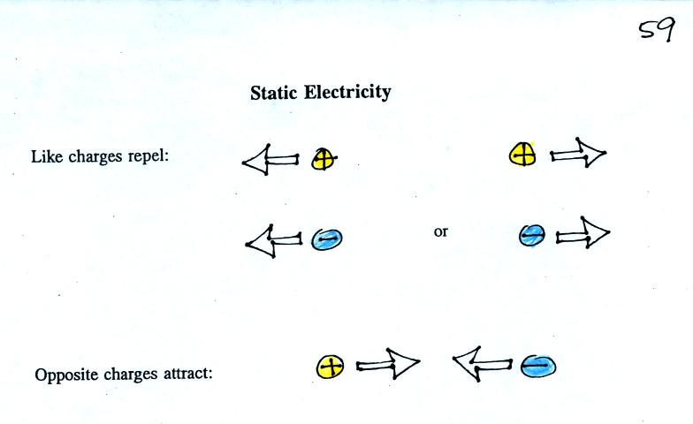
These rules can be demonstrated fairly easily using a sweater (a gift from my Aunt Ethel and Uncle Nelson made of acrylic fiber and wool) and two balloons.
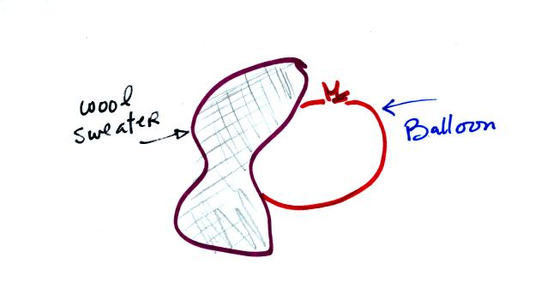
Each balloon was rubbed with the sweater. The balloons (and the sweater) became electrically charged (the balloons had one polarity of charge, the sweater had the other). We didn't know what charge the balloons carried just that they both had the same charge.
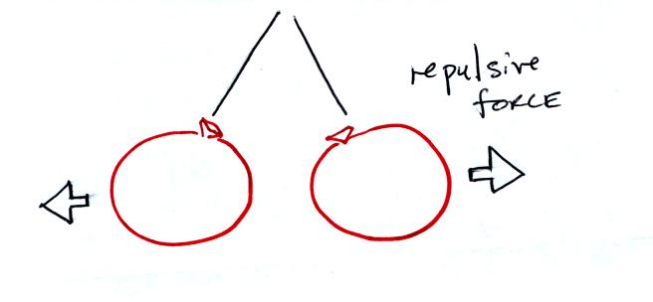
If you bring the balloons close to each other they are pushed apart by a repulsive electrical force.
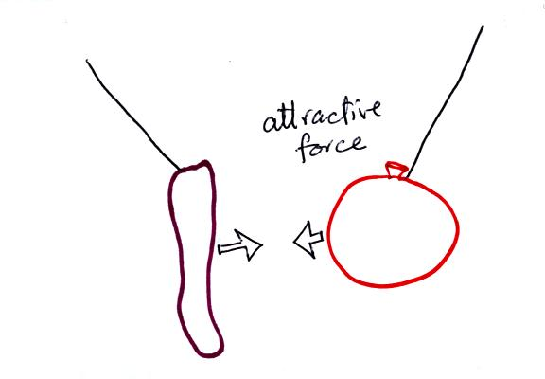
The sweater and the balloon carry opposite charges. IF they are brought together they experience an attractive electrical force.

Next imagine placing a + charge at the three positions shown in the figure below.
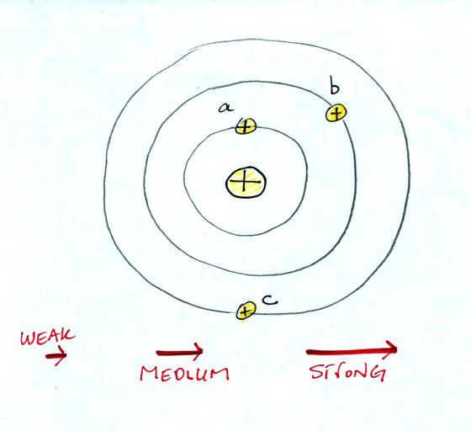
Then choose one of the three arrows at the bottom of the picture to show both the direction and the force that would be exerted on each charge.
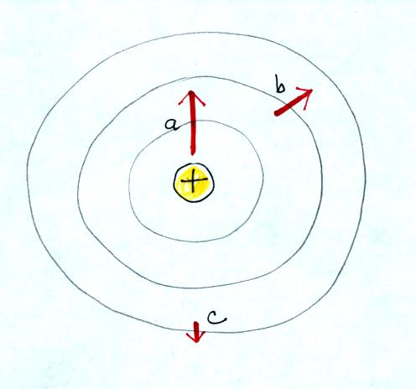

The picture above shows the answer. The closer the charge is to the center, the greater the strength of the outward force. With just a little thought you can see that if you were to place + charges at other positions you would quickly end up with a figure that looks like the pattern at the bottom of p. 59 in the photocopied ClassNotes.
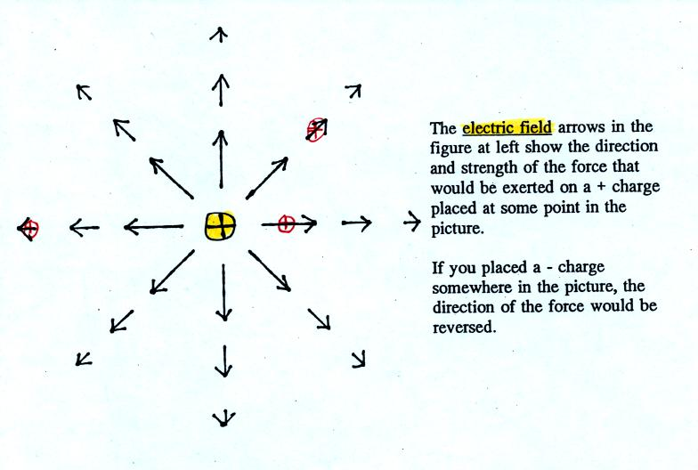
The electric field arrows in this picture show the direction and give an idea of the strength that would be exerted on a positive placed at any position in the figure.

The figures on p. 60 in the photocopied class notes have been redrawn below for clarity.
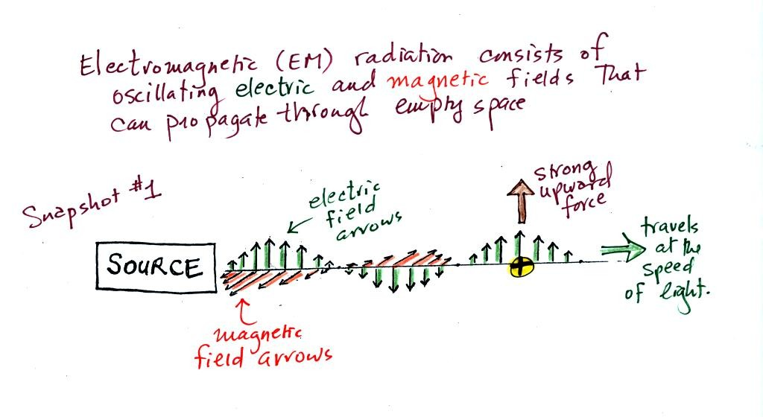
We imagine turning on a source of EM radiation and then a short time later we take a snapshot. The EM radiation is a wavy pattern of electric and magnetic field arrows. We'll ignore the magnetic field lines. The E field lines sometimes point up, sometimes down. The pattern of electric field arrows repeats itself.
Note the + charge near the right side of the picture. At the time this picture was taken the EM radiation exerts a fairly strong upward force on the + charge.
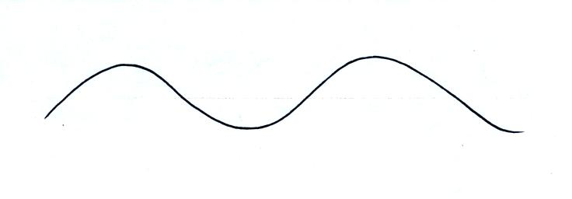
Textbooks often represent EM radiation with a wavy line like shown above. But what does that represent?
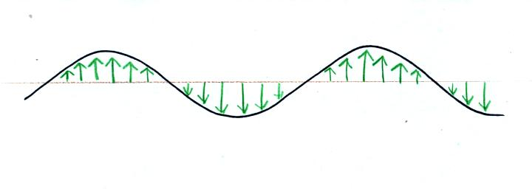
The wavy line just connects the tips of a bunch of electric field arrows.
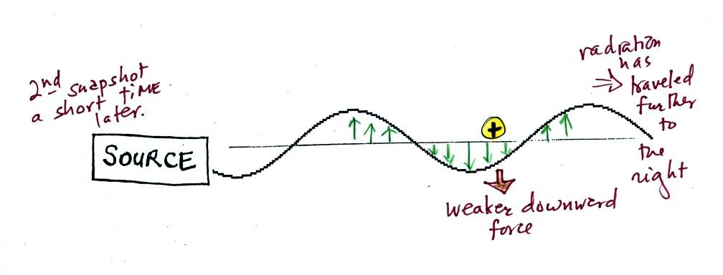
This picture was taken a short time after the first snapshot when the radiation had traveled a little further to the right. The EM radiation now exerts a somewhat weaker downward force on the + charge.
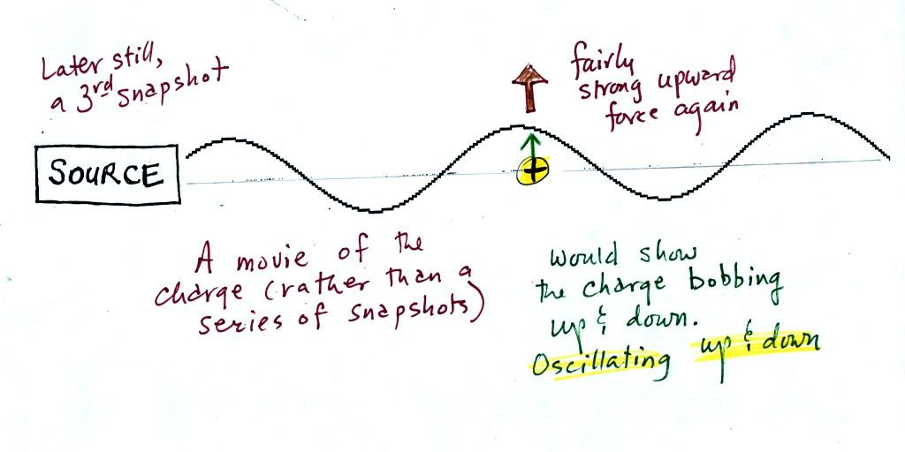
The + charge is now being pushed upward again. A movie of the + charge, rather than just a series of snapshots, would show the charge bobbing up and down much like a swimmer in the ocean would do as waves passed by.
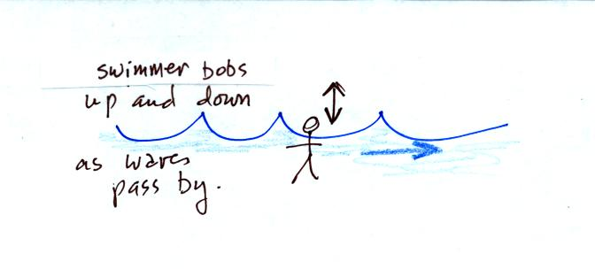
The wavy pattern used to depict EM radiation can be described spatially in terms of its wavelength, the distance between identical points on the pattern. By spatially we mean you look at different parts of the radiation at one particular instant frozen in time.
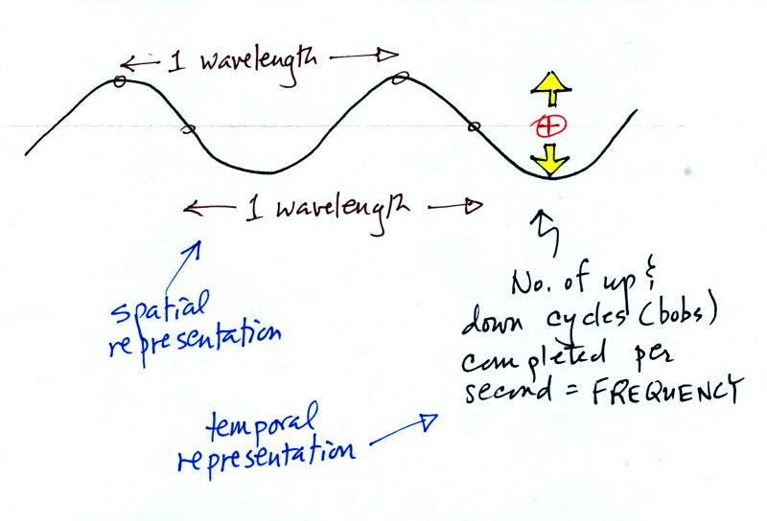
Or you can describe the radiation temporally using the frequency of oscillation (number of up and down cycles completed by an oscillating charge per second). By temporally we mean you at one particular point for a certain period of time.

The following figure (not shown in class) attempts to show how energy can be transported from location to another in the form of electromagnetic radiation.
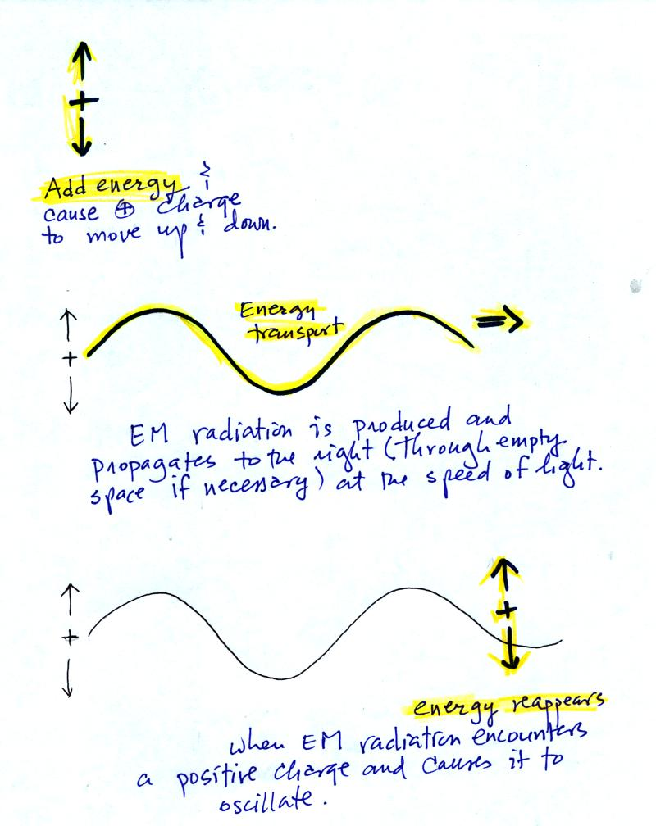
You add energy when you cause an electrical charge to move up and down and create the EM radiation (top left).
In the middle figure, the EM radiation then travels out to the right (it could be through empty space or through something like the atmosphere).

Once the EM radiation encounters an electrical charge at another location (bottom right), the energy reappears as the radiation causes the charge to move. Energy has been transported from left to right.

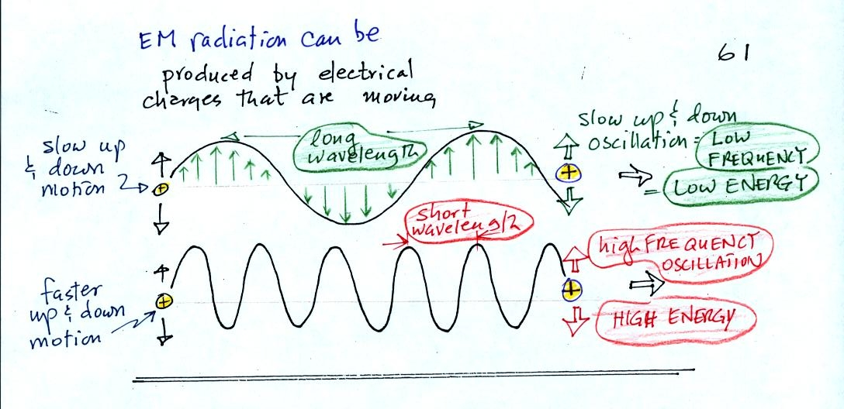
EM radiation can be created when you cause a charge to move up and down. If you move a charge up and down slowly (upper left in the figure above) you would produce long wavelength radiation that would propagate out to the right at the speed of light. If you move the charge up and down more rapidly you produce short wavelength radiation that propagates at the same speed.
Once the EM radiation encounters the charges at the right side of the figure above the EM radiation causes those charges to oscillate up and down. In the case of the long wavelength radiation the charge at right oscillates slowly. This is low frequency and low energy motion. The short wavelength causes the charge at right to oscillate more rapidly - high frequency and high energy.
The characteristics long wavelength - low frequency - low energy go together. So do short wavelength - high frequency - high energy. Note that the two different types of radiation both propagate at the same speed.

This is really just a partial list of some of the different types of EM radiation. In the top list, shortwave length and high energy forms of EM ra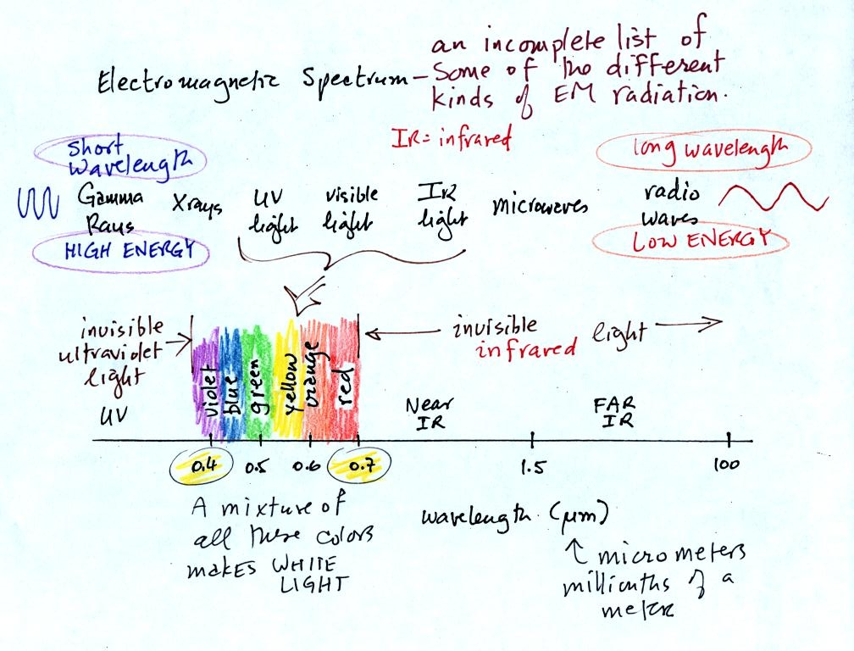diation are on the left (gamma rays and X-rays for example). Microwaves and radiowaves are longer wavelength, lower energy forms of EM radiation.
We will mostly be concerned with just ultraviolet light (UV), visible light (VIS), and infrared light (IR). Note the micrometer (millionths of a meter) units used for wavelength. The visible portion of the spectrum falls between 0.4 and 0.7 micrometers (UV and IR light are both invisible). All of the vivid colors shown above are just EM radiation with slightly different wavelengths. WHen you see all of these colors mixed together, you see white light.

Here are some rules governing the emission of electromagnetic radiation:
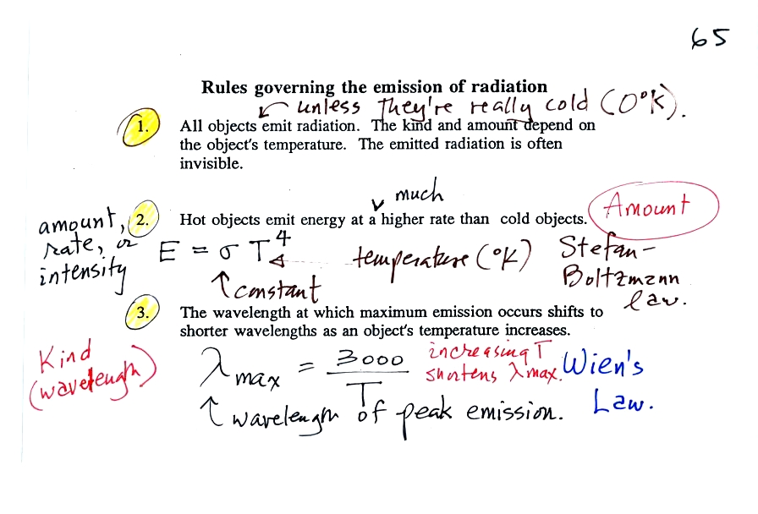
1.
Unless an object is very cold (0 K) it will emit EM radiation. All the people, the furniture, the walls and the floor in the classroom even the air are emitting EM radiation. Often this radiation will be invisible so that we can't see it and weak enough that we can't feel it. Both the amount and kind (wavelength) of the emitted radiation depend on the object's temperature.
2.
The second rule allows you to determine the amount of EM radiation (radiant energy) an object will emit. Don't worry about the units, you can think of this as amount, or rate, or intensity. Don't worry about σ either, it is just a constant. The amount depends on temperature to the fourth power. If the temperature of an object doubles the amount of energy emitted will increase by a factor of 2 to the 4th power (that's 2 x 2 x 2 x 2 = 16). A hot object just doesn't emit a little more energy than a cold object it emits a lot more energy than a cold object. This is illustrated in the following figure (not shown in class):
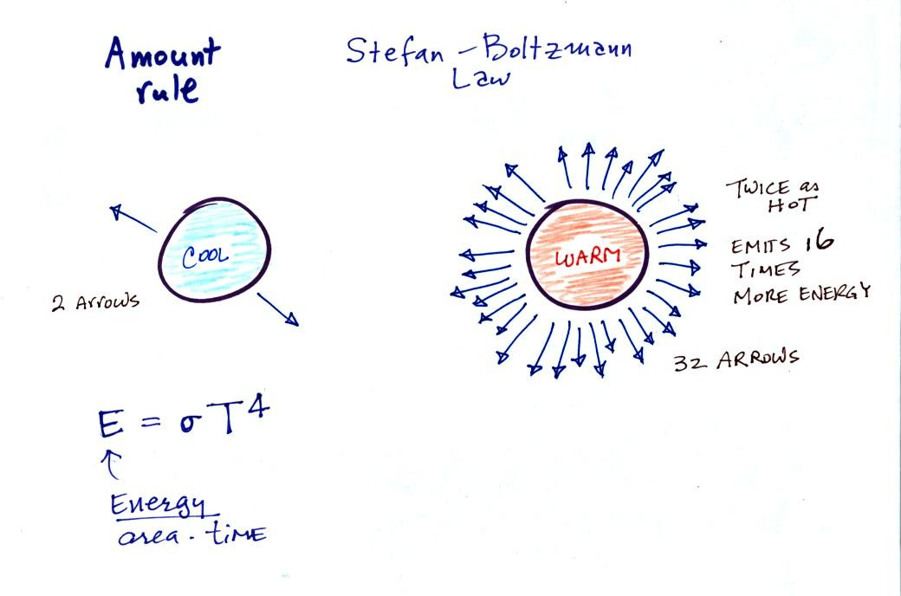
3.
The third rule tells you something about the kind of radiation emitted by an object. We will see that objects usually emit radiation at many different wavelengths. There is one wavelength however at which the object emits more energy than at any other wavelength. This is called lambda max (lambda is the greek character used to represent wavelength) and is called the wavelength of maximum emission. The third rule allows you to calculate "lambda max." This is illustrated below (this figure wasn't shown in class):
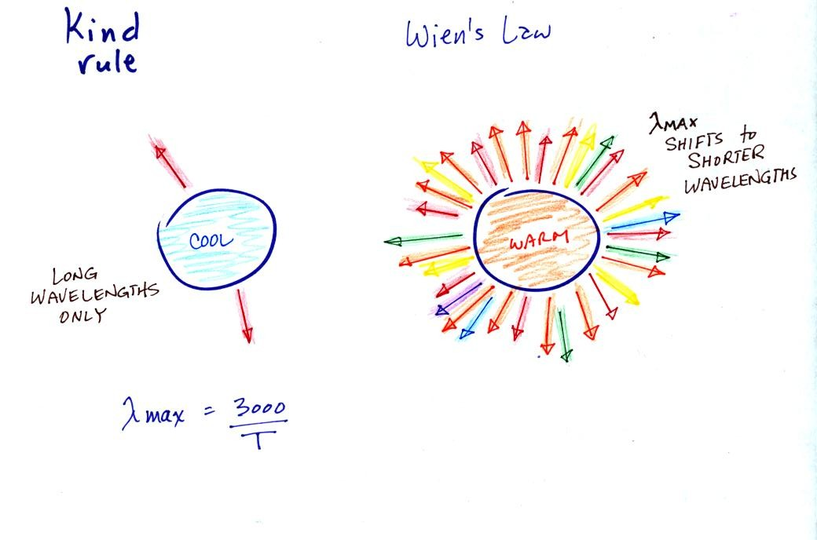
The following graphs (at the bottom of p. 65 in the photocopied Class Notes) also help to illustrate the Stefan-Boltzmann law and Wien's law.
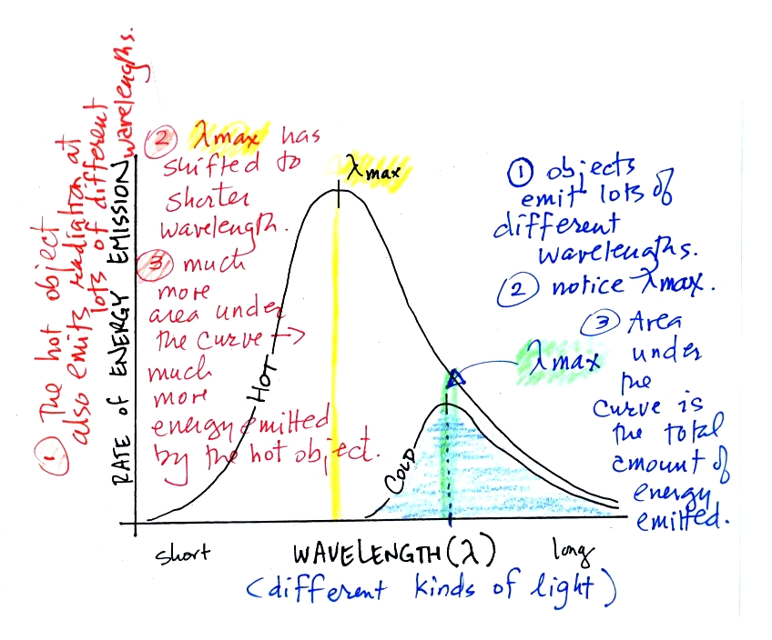
Notice first that both and warm and the cold objects emit radiation over a range of wavelengths.
The area under the warm object curve is much bigger than the area under the cold object curve. The area under the curve is a measure of the total radiant energy emitted by the object. This illustrates the fact that the warmer object emits a lot more radiant energy than the colder object.
Lambda max has shifted toward shorter wavelengths for the warmer object. This is Wien's law in action. The warmer object is emitting a lot of short wavelength radiation that the colder object doesn't emit.

Now before moving on to the main event of the day (climate at a point near the Equator in the middle of the Pacific Ocean) we quickly reviewed some of the factors that cause seasonal changes in climate. The two main factors are the angle of the sun in the sky (how high is the sun above the horizon at noon), and the length of the day. In the summer, the sun is high in the sky, the sunlight reaching the ground is intense, and the incoming sunlight warms a relatively small area on the ground. In the summer, there are also more hours of daylight than in the winter. You should read through the section Causes of the Seasons on your own.

At the equator, the sun is always high in the sky (not always overhead at noon, but always high in the sky). At the equator the days are always 12 hours long. So the amount of incoming sunlight energy stays relatively constant throughout the year at the equator. You may remember that water moderates climate (it doesn't get as hot in the summer and doesn't get as cold in the winter). This is largely because of the high specific heat of water.
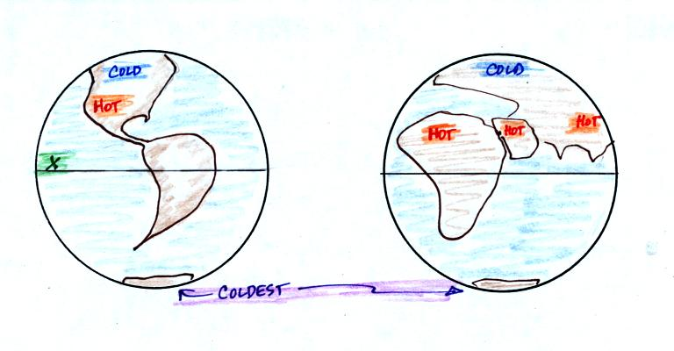
So the answer to the question "What is the climate like at Point X in the figure above at left" is that the climate is warm and moist. The most dramatic thing, however, is that there is essentially zero seasonal change in climate. It is pretty much summer all year.

Asking about the climate at Point X was really just an excuse for me to tell you about an amazing field experiment I took part in several years ago.
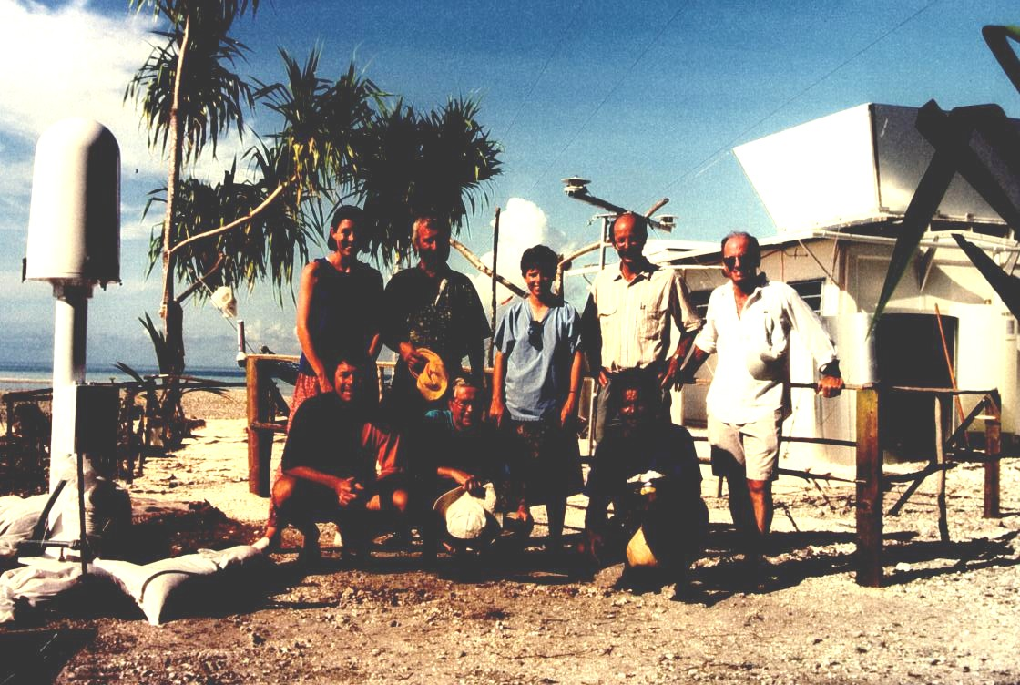
The photograph above appeared on the cover of the April 1994 issue of the Bulletin of the American Meteorological Society. If you look closely you'll notice your NATS 101 instructor (he had been given the nickname "Wilbur" by one of the members of the group, the other bald man's name was Orville). This photo was taken on Kapingamarangi Atoll (shown on the map below), shortly before all the men were about to board ship and leave Kapingamarangi. The two women (Erica at left, Maureen in the middle) were going to remain behind and operate all of the research equipment. The scene looks happy enough, but "Wilbur" revealed that he had fallen in love with one of the two women and was anything but happy.
What we were doing on Kapingamarangi? We were a small part of a much larger field experiment. Wilbur and Orville's job was to install the tall white lightning detector at the left edge of the photograph. They would later travel to Rabaul (on New Britain island) and Kavieng (New Ireland island) in Papua New Guinea and install two more detectors. Papua New Guinea would turn out to be a very different place. Until recently some of the highland tribes there practiced cannibalism. Malaria is also endemic in Papua New Guinea.
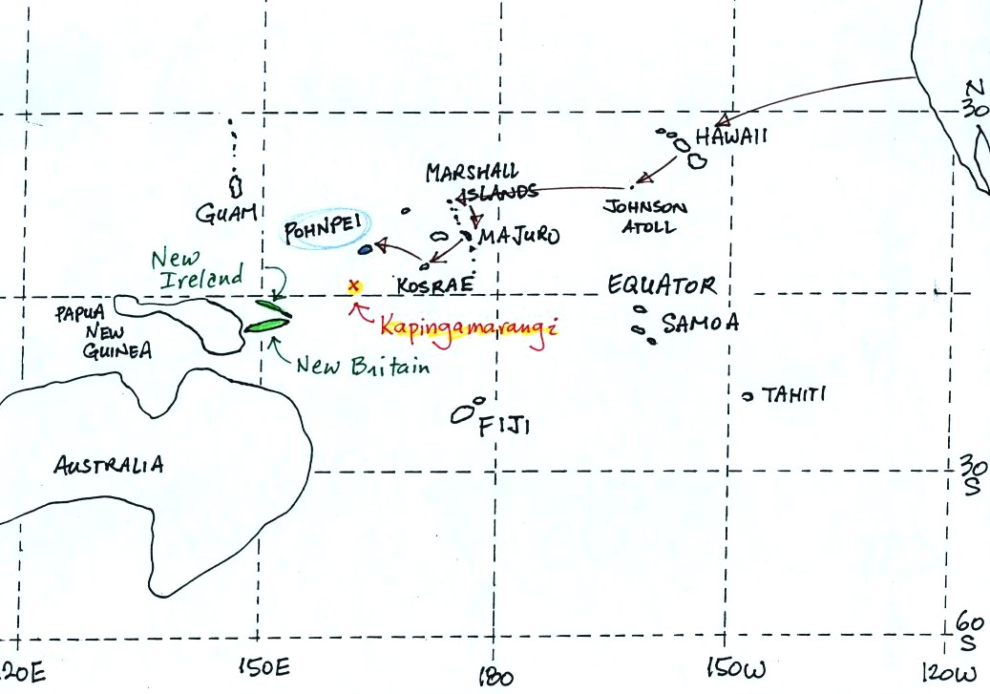
To get to Kapingamarangi you first need to fly to Pohnpei (an island in the Federated States of Micronesia). The route is shown above. Then you take a cargo ship for the 4 day sail to Kapingamarangi. We had intended to fly to Pohnpei, set sail for Kapinga the next day, and then spend about a month on Kapingamarangi. The ship however was delayed 3 weeks. That gave us plenty of time to visit the island of Pohnpei but ultimately meant we could only spend a few days on Kapingamarangi..
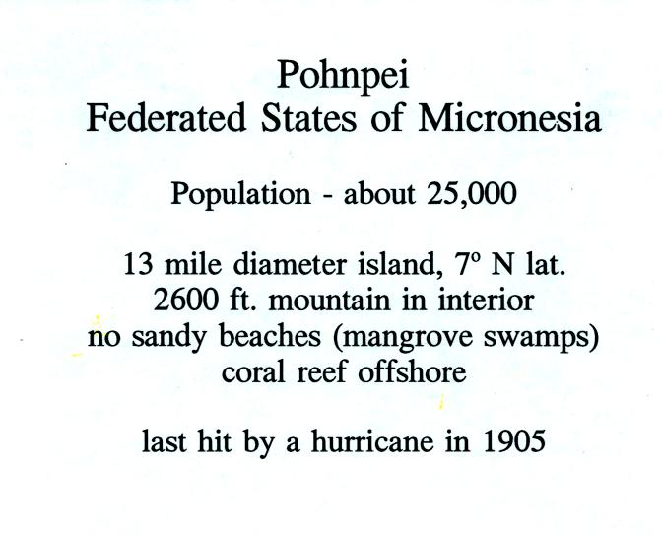
Pohnpei is a fairly large island and, together with some of the other Micronesian islands, is a popular, world-class, snorkeling and scuba diving destination. Pohnpei also has a weather station that is operated by the US National Atmospheric and Oceanic Administration (NOAA).
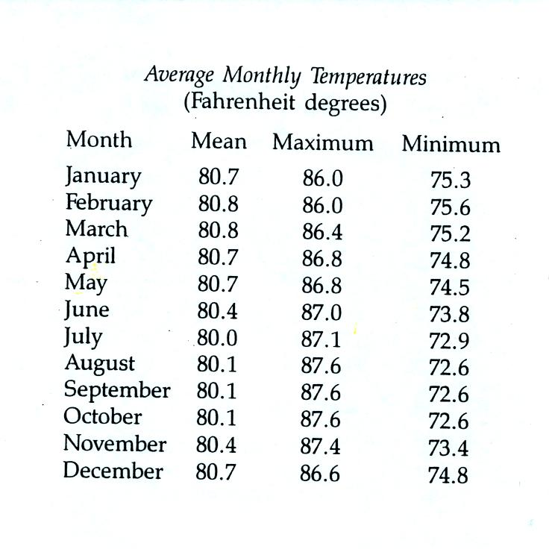
Because of its low latitude and the fact that it is surrounded by water you would expect a small annual range of temperature at Pohnpei. You can see in the table above just how small the annual range is: the average monthly temperatures in Pohnpei range from 80.8 F in February and March to 80.0 F in July. The annual range is less than 1 F. By comparison, the annual range in Tucson is about 34 F (52 F in December and January to 86 F in July).
The following precipitation data show that Pohnpei is one of the rainiest locations on earth
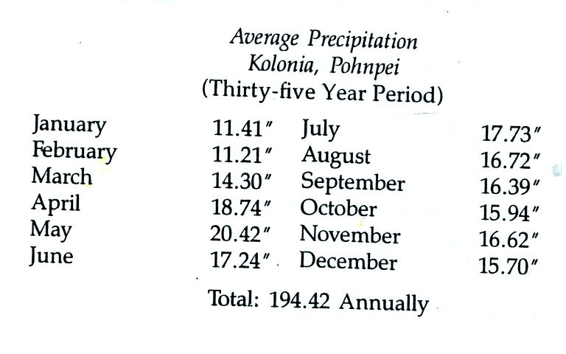
Close to 400 inches of rain may fall in the interior of Pohnpei. The rainiest location on earth is in Hawaii with about 460 inches of rain per year.
Pigs played an important part in the story told in class. Pigs are also an important part of daily life on Kapingamarangi and Pohnpei (as well as the other islands in Micronesia)
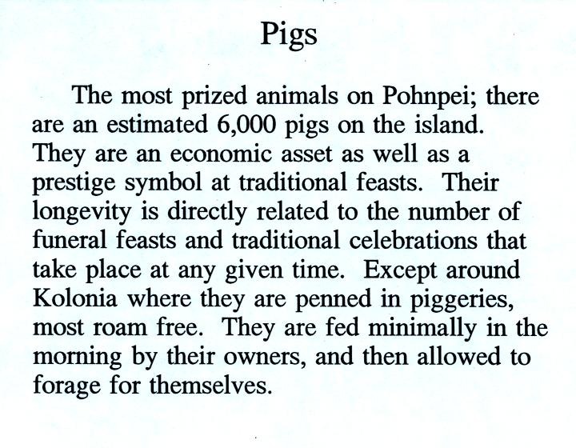
The Micro Glory (shown below) sails back and forth between Pohnpei and Kapingamarangi about once a month. The ship carries supplies to the people on Kapingamarangi. They pay for the supplies with pigs (the pigs are sold on Pohnpei). We shared deck space on the Micro Glory on the trip back to Pohnpei with 20 to 30 pigs (they were hoisted aboard in nets)
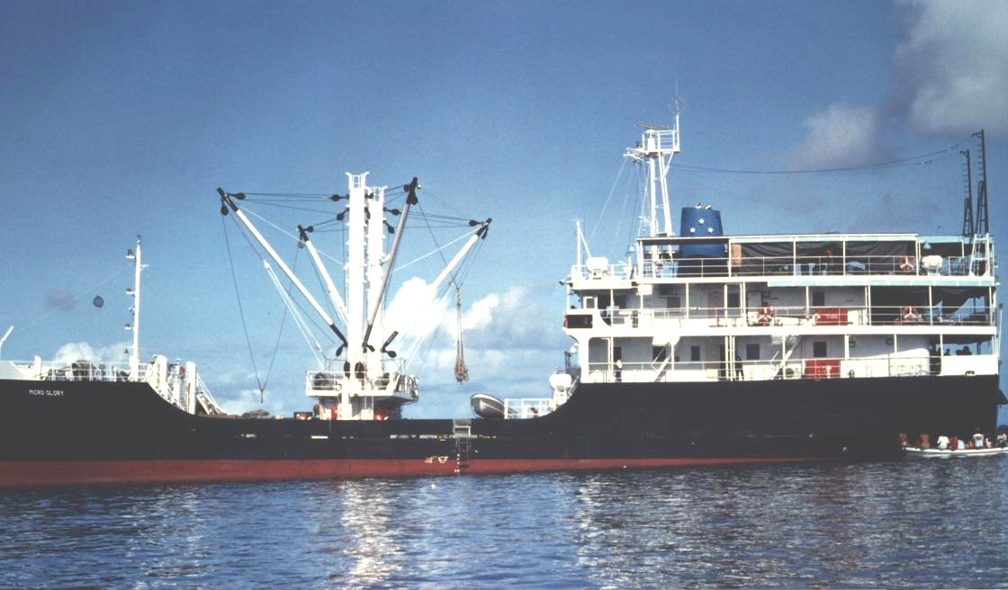
Most of the low deck in the photo above (under the hoists) was occupied by pigs on the return trip.
We also had a chance to sample some of the local beverages.
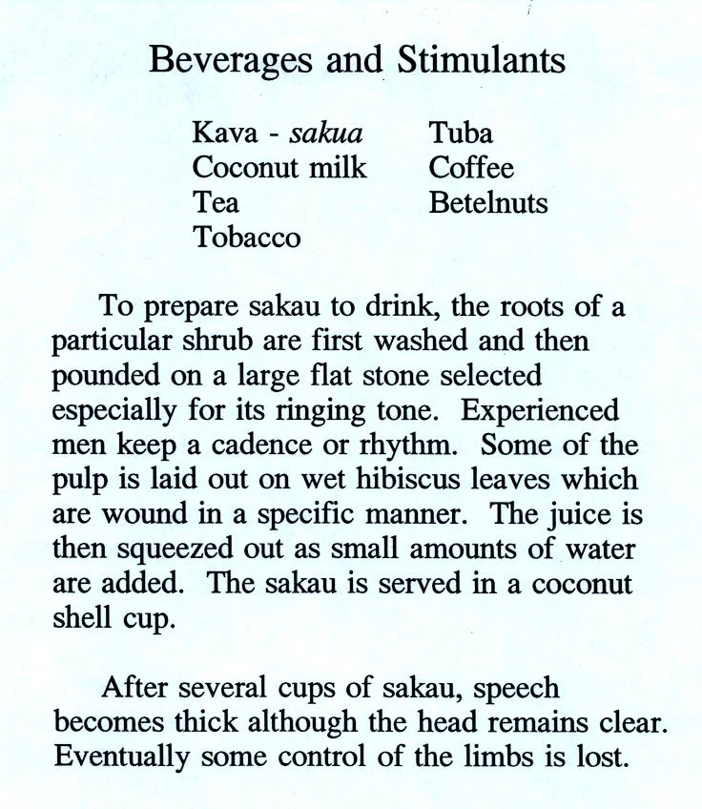
Drinking sakau (as it is called on Pohnpei) turns your mouth and throat numb. It is supposed to relax you, make you sleep more fully, and doesn't leave any after effects. Until fairly recently you could buy kava in pill form at local supermarkets. However, because of reports that it can cause serious liver problems, that is no longer the case. There are no reports of liver problems when drinking kava that has been prepared in the traditional way. Here is a link to a Wikipedia article on kava.
We never tried betelnut. Areca nuts are wrapped in betel leaves and chewed together with lime (lime is pretty caustic, that is the reason I didn't try betelnut). The resulting mixture is a mild stimulant (some people add tobacco to the mix). The most interesting aspect, however, is that chewing betelnut colors your mouth bright red. You don't swallow betelnut, you spit it out. You see the bright red stains on sidewalks and the ground wherever you go. Most hotels will also have a large sign near the entrance reminding guests not to chew betelnut inside the hotel. You can read more about betelnut here.

Class ended with a proud display of my collection of carved wooden pigs (remember they are a symbol of wealth). The pigs were purchased in Rabaul, on New Britain island, in Papua New Guinea.

