Tuesday Oct. 28, 2008
A couple of songs from Pink Martini were featured before class today. The first was "Let's never stop falling in love," (no dancing in that video, if you want dancing look at this video, I'm not sure what was going on in this video). We had time for a second song "Lilly."
The humidity optional assignment was collected in class today. You'll get a detailed set of answers to the questions on that assignment in class on Thursday.
The first part of the Quiz #3 Study Guide is now available online. This study guide is a little more interactive than previous study guides and includes a lot of example problems (with answers). The 2nd part of the Quiz #3 Study Guide is now online also. The 3rd and final part will be added later this week.
There are still a few sets of Experiment #4 materials available for checkout. The Experiment #3 reports are due Tuesday next week (election day). Plan to collect your data this week so that you can return the materials and pick up the supplementary information sheet.

Today's class will be devoted almost entirely to identifying and naming clouds (there is also a short section on fog).
The ten main cloud types are listed below (you'll find this list on p. 95 in the photocopied class notes).
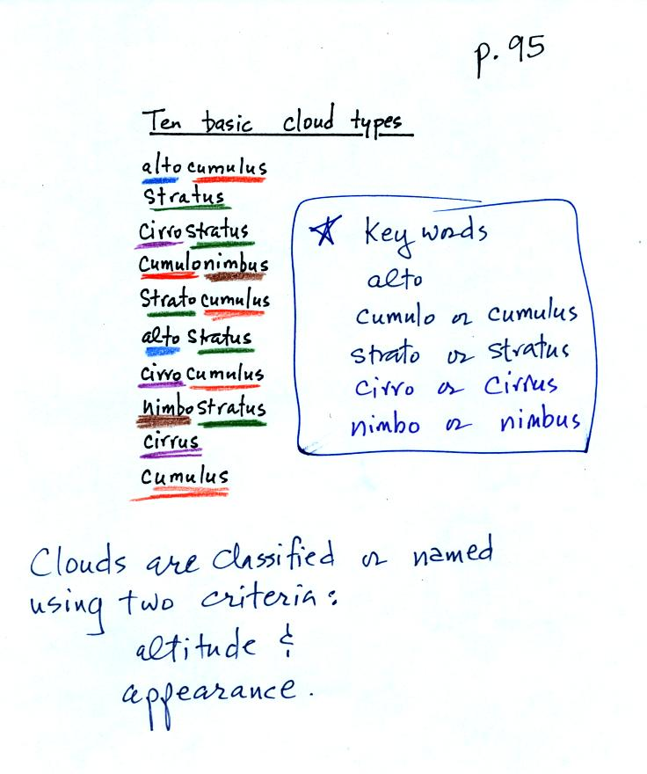
You should try to learn these 10 cloud names. Not just because they might be on a quiz (they will) but because you will be able to impress your friends with your knowledge. There is a smart and a not-so-smart way of learning these names. The not-so-smart way is to just memorize them. You will inevitably get them mixed up. A better way is to recognize that all the cloud names are made up of key words. The key words, we will find, tell you something about the cloud altitude and appearance.
Drawing a figure like this on a blank sheet of paper is a good way to review cloud identification and classification.

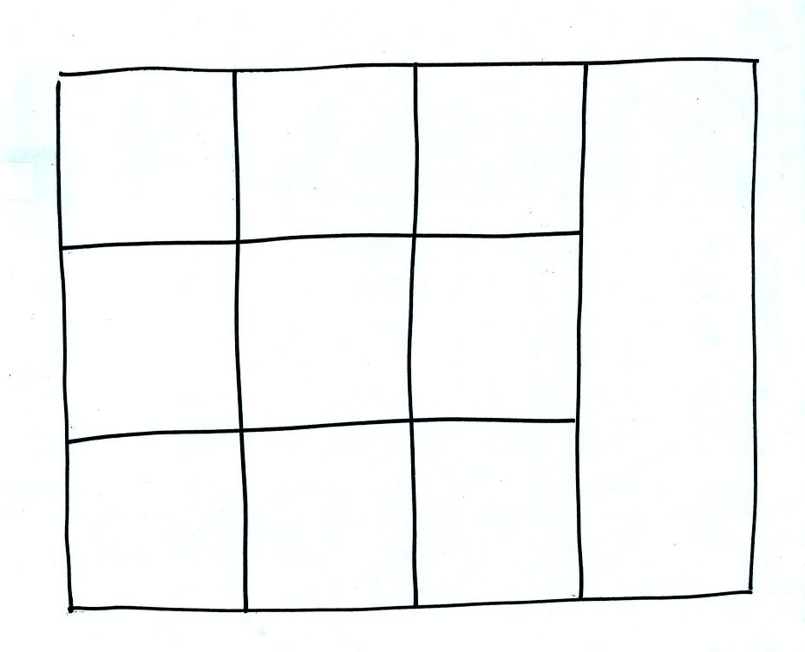
Each of the clouds above has a box reserved for it in the figure.
Clouds are classified according to the altitude at which they form and the appearance of the cloud. There are two key words for altitude and two key words for appearance.
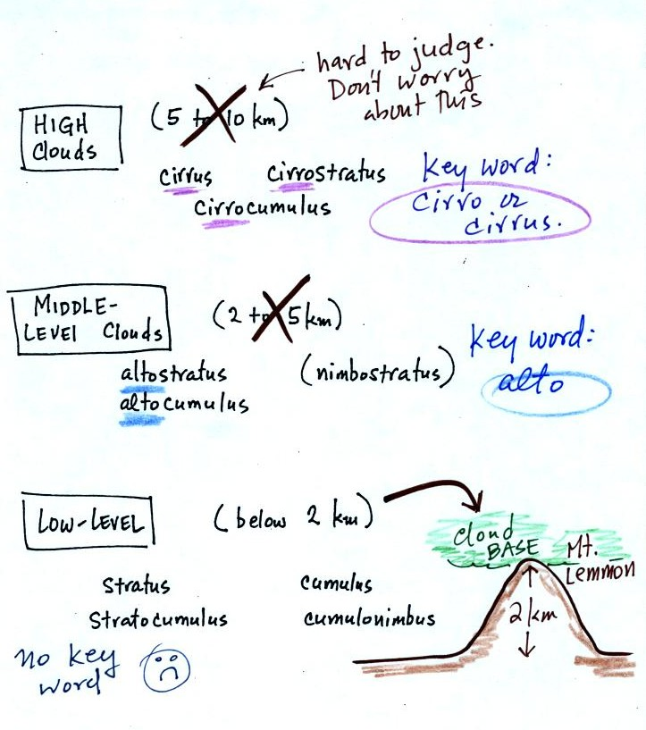
Clouds are grouped into one of three altitude categories: high, middle level, and low.
Cirrus or cirro identifies a high altitude cloud. There are three types of clouds found in the high altitude category..
Alto in a cloud name means the cloud is found at middle altitude. The arrow connecting altostratus and nimbostratus indicates that they are very similar. When an altostratus cloud begins to produce rain or snow its name is changed to nimbostratus. A nimbostratus cloud is also often somewhat thicker and lower than an altostratus cloud.
It is very hard to just look up in the sky and determine a cloud's altitude. You will need to look for other clues to distinquish between high and middle altitude clouds. We'll learn about some of the clues when we look at cloud pictures later in the class.
There is no key word for low altitude clouds. Low altitude clouds have bases that form 2 km or less above the ground. The summit of Mt. Lemmon in the Santa Catalina mountains north of Tucson is about 2 km above the valley floor. So low altitude clouds will have bases that form at or below the summit of Mt. Lemmon.
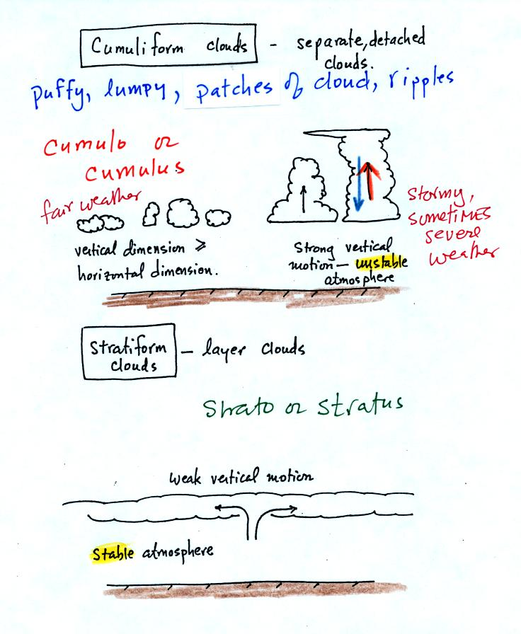
Now we will look at cloud appearance.
Clouds can have a patchy of puffy (or lumpy or wavy) appearance. These are cumuliform clouds and will have cumulo or cumulus in their name. In an unstable atmosphere cumuliform clouds will grow vertically.
Stratiform clouds grow horizontally and form layers. They form when the atmosphere is stable.
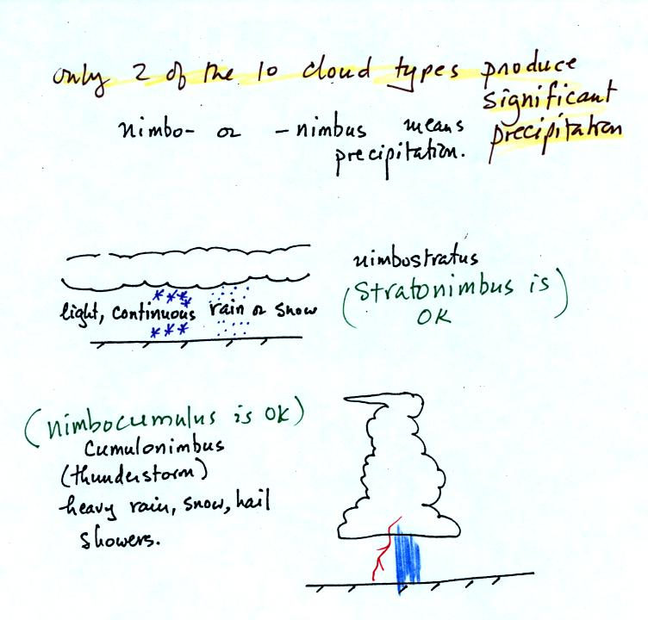
The last key word, nimbo or nimbus, means precipitation. Two of the 10 cloud types are able to produce (significant amounts of) precipitation.
Nimbostratus clouds tend to produce fairly light precipitation over a large area. Cumulonimbus clouds produce heavy showers over localized areas. Thunderstorm clouds can also produce hail, lightning, and tornadoes. Hail would never fall from a Ns cloud.
While you are still learning the cloud names you might put the correct key words together in the wrong order (stratonimbus instead of nimbostratus or nimbocumulus instead of cumulonimbus). You won't be penalized for those kinds of errors in this class.
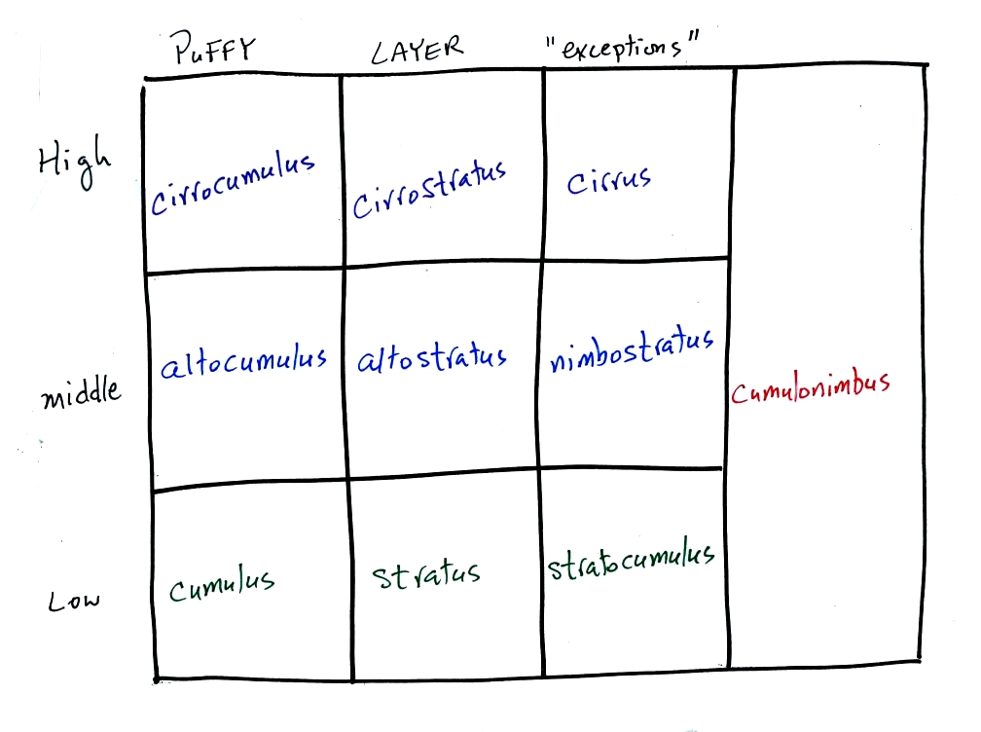
Here's the cloud chart from earlier. We've added the three altitude categories along the vertical side of the figure and the two appearance categories along the top. By the end of the class we will add a picture to each of the boxes.

Before looking at some slide photographs of clouds, there are two types of fog that you might occasionally see in Tucson (fog is fairly infrequent because the air is so dry)
To produce fog you first need to increase the relative humidity (RH) to 100%
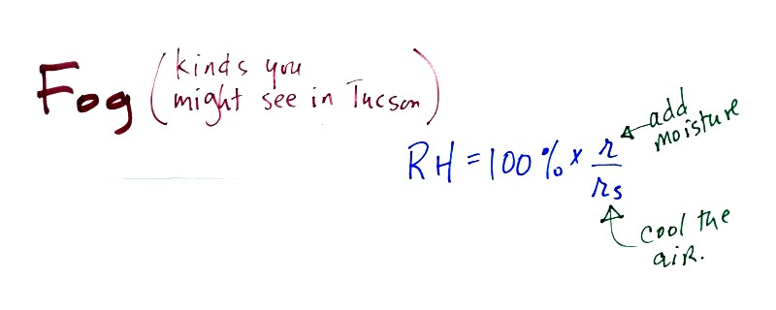
You can do this either by cooling the air or adding moisture to and saturating the air (both will increase the ratio in the RH formula above).
The ground cools during the night by emitting IR radiation (left figure below). The ground cools most rapidly when the skies are free of clouds and the air is dry (except for a thin layer next to the ground). These are the conditions that favor the formation of radiation fog.
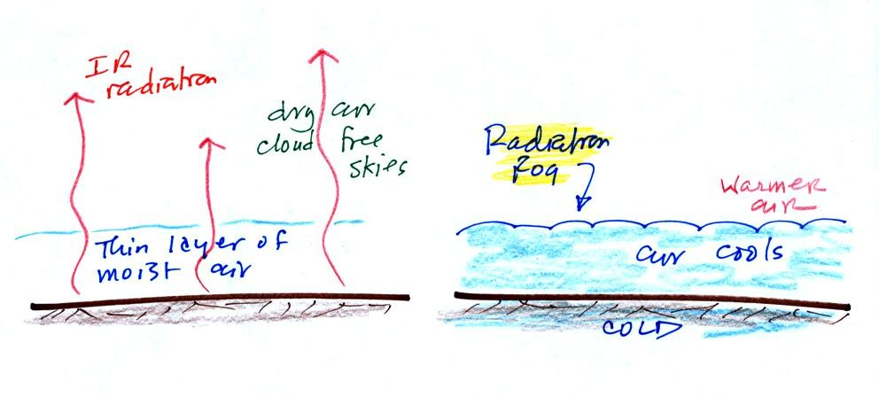
Air in contact with the ground cools and radiation fog can form (right figure above). Because the fog cloud is colder than the air right above, this is a stable situation. The fog clouds "hugs" the ground.
Radiation fog is sometimes called valley fog.
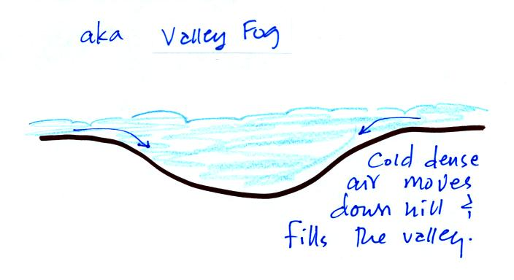
The cold dense air will move downhill and fill low lying areas with fog cloud. It is often difficult for the sun to warm the air and dissipate thick clouds of valley fog.
Steam fog (aka evaporation fog or mixing fog) is commonly observed on cold mornings over the relatively warm water in a swimming pool.
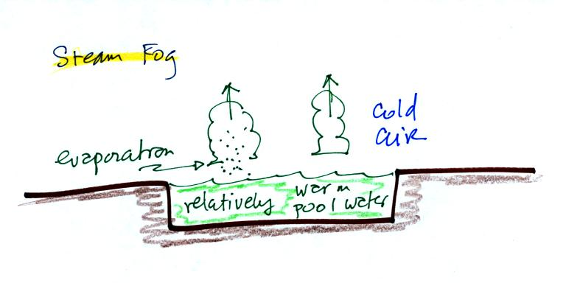

Water evaporating from the pool saturates the cold air above. Because the fog cloud is warmer than the cold surrounding air, the fog clouds float upward.
When you "see your breath" on a cold day

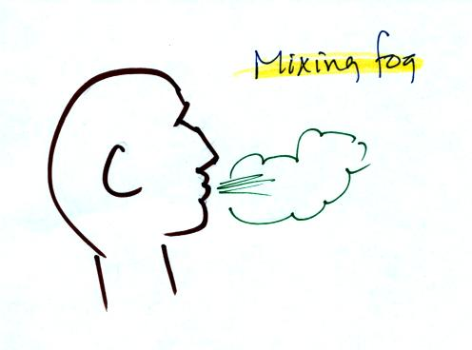
you're seeing mixing fog. Warm moist air from your mouth mixes with the colder air outside. The mixture is saturated and a fog cloud forms.

Next we looked at 35 mm slides of most of the 10 cloud types. There are also some good photographs in Chapter 6 in the text. You'll find the written descriptions of the cloud types in the images below on pps 97-98 in the photocopied notes.
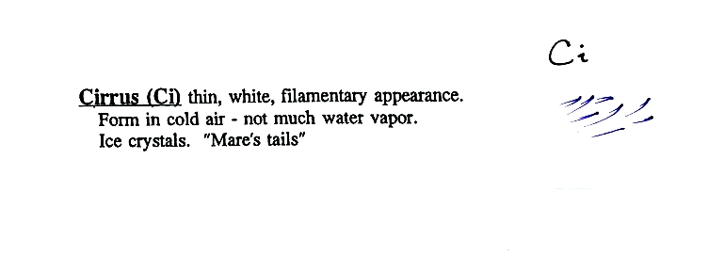
High altitude clouds are thin because the air at high altitudes is very cold and cold air can't contain much moisture (the saturation mixing ratio for cold air is very small). These clouds are also often blown around by fast high altitude winds. Filamentary means "stringy" or "streaky". If you imagine trying to paint a Ci cloud you would dip a small pointed brush in white paint brush it quickly and lightly across a blue colored canvas.
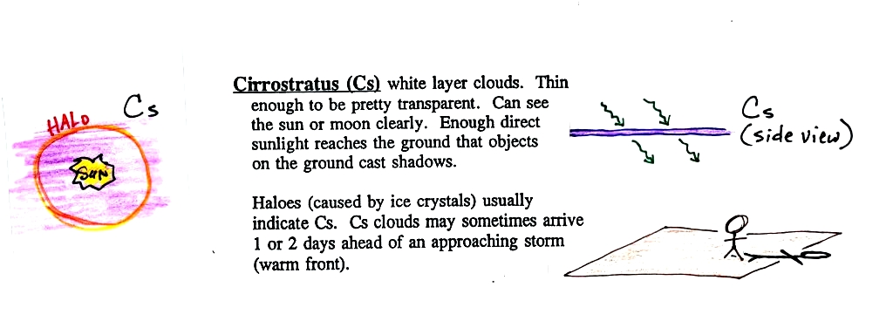
A cirrostratus cloud is a thin uniform white layer cloud (not purple as shown in the figure) covering part or all of the sky. They're so thin you can sometimes see blue sky through the cloud layer. Haloes are a pretty sure indication that a cirrostratus cloud is overhead. If you were painting Cs clouds you could dip a broad brush in white paint (diluted perhaps with water) and then paint back and forth across the canvas.
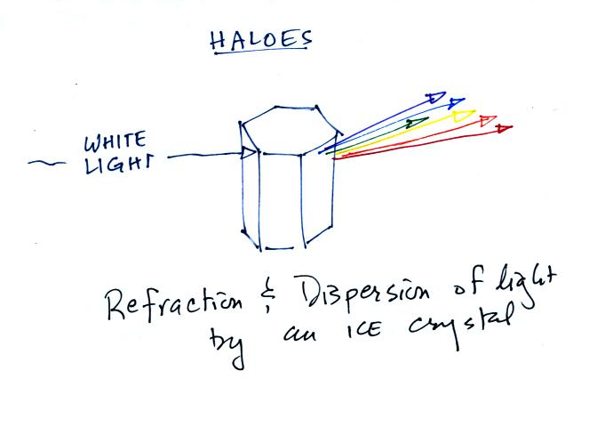
Haloes are produced by white light entering a 6 sided ice crystal is bent (refraction). The amount of bending depends on the color (wavelength) of the light (dispersion). The white light is split into colors just as light passing through a glass prism. This particular crystal is called a column and is fairly long.
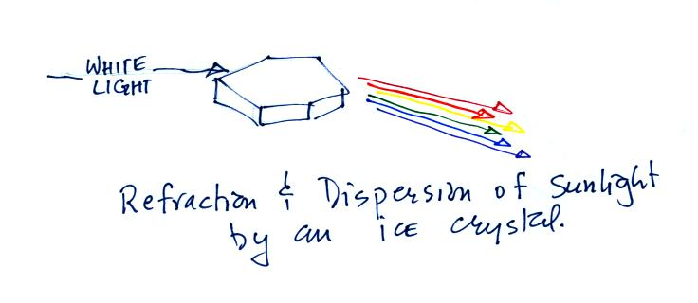
This is a flatter crystal and is called a plate. These crystals tend to all be horizontally oriented and produce sundogs. A sketch of a sundog is shown below.
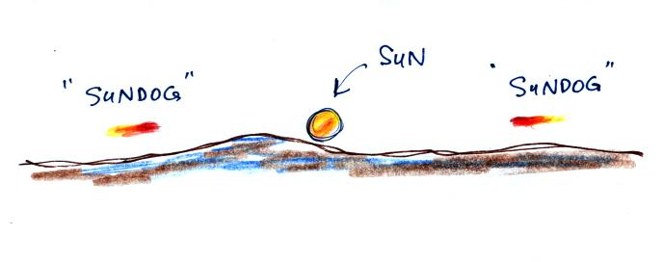
Sundogs are pretty common and are just patches of light seen to the right and left of the rising or setting sun.
Cirrus and cirrostratus clouds are fairly common. Cirrocumulus clouds are a little more unusual.
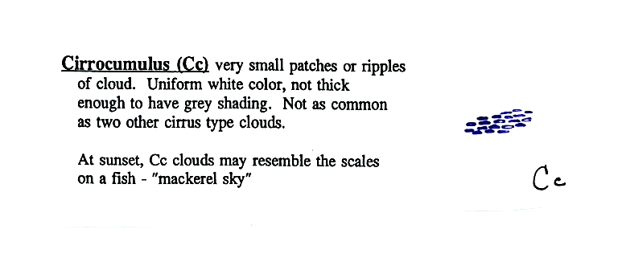
To paint a Cc cloud you would dip a sponge in white paint and press it gently against the canvas. You would leave a patchy, splotchy appearing cloud (sometimes you might see small ripples). It is the patchy (or wavy) appearance that makes it a cumuliform cloud.
If you spend enough time outside looking, you will see all of these types of clouds.
Though, it's like wild animals, some are much more common than others.
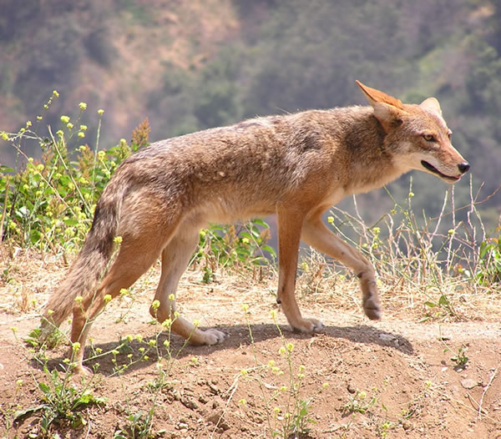 | 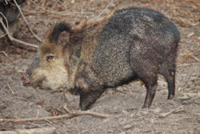
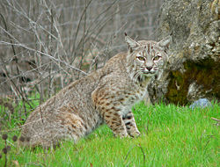 | 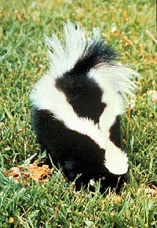
Here are some animals that you are likely to see outdoors in the Tucson area. Coyotes and javelina are pretty common. Bobcats and skunks are a little less common. There were quite a few students in class that had seen all of these animals.
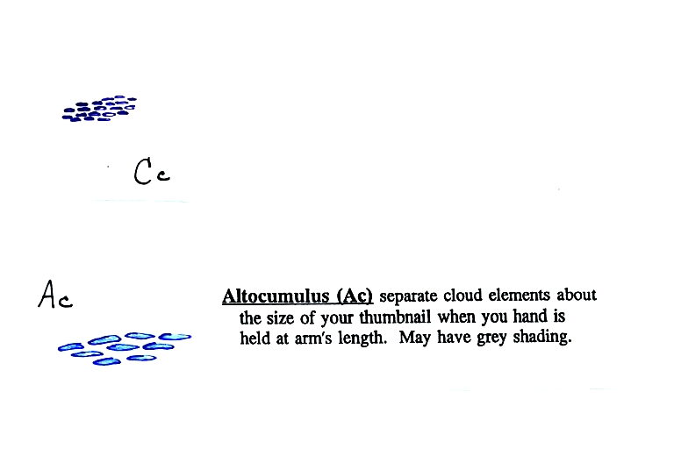
Altocumulus clouds are pretty common. Note since it is hard to accurately judge altitude, you must rely on cloud element size (thumbnail size in the case of Ac) to determine whether a cloud belongs in the high or middle altitude category. The cloud elements in Ac clouds appear larger than in Cc because the cloud is closer to the ground.
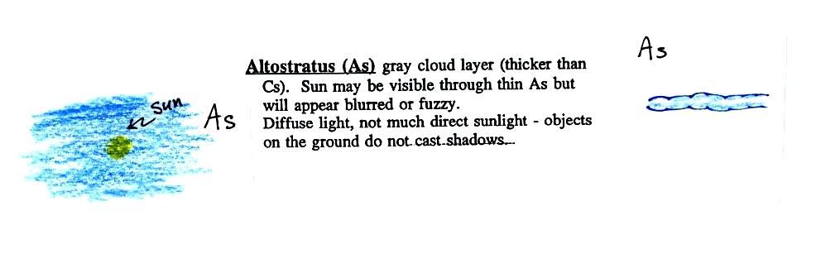
Altostratus clouds are thick enough that you probably won't see a shadow if you look down at your feet. The sun may or may not be visible through the cloud. When (if) an altostratus cloud begins to produce precipitation, its name is changed to nimbostratus.
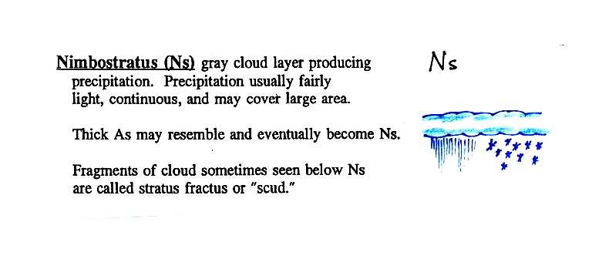

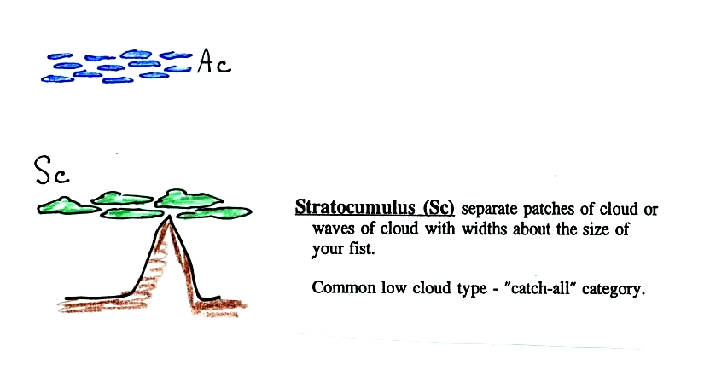
This cloud name is a little unusual because the two key words for cloud appearance have been combined. Because they are closer to the ground, the separate patches of Sc are about fist size. The patches of Ac, remember, were about thumb nail size.
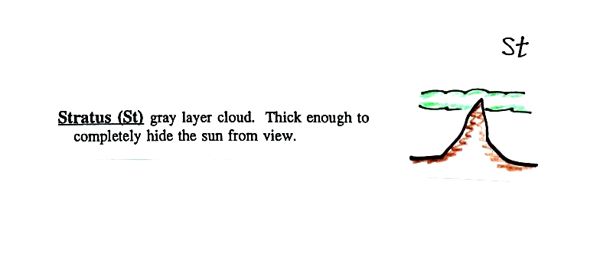
No pictures of stratus clouds were shown in class.
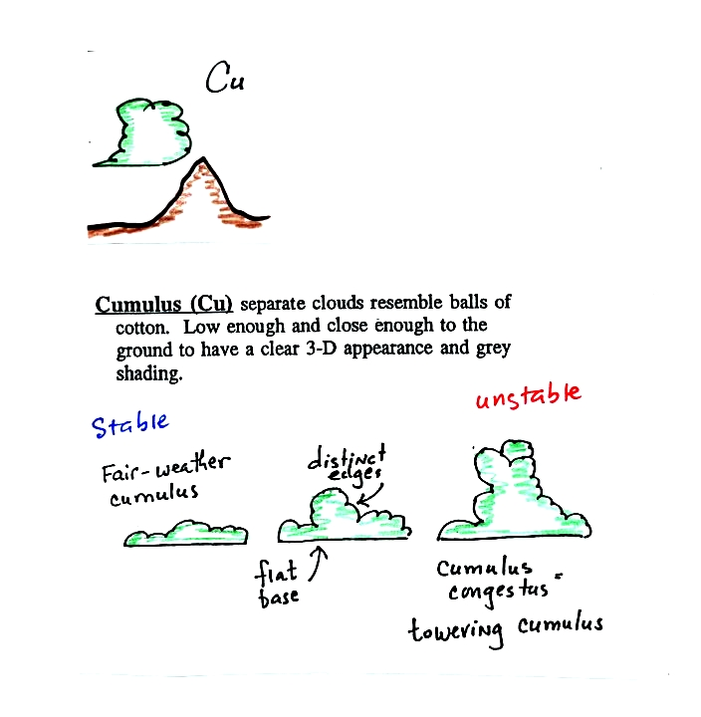
Cumulus clouds come with different degrees of vertical development. The fair weather cumulus clouds don't grow much vertically at all. A cumulus congestus cloud is an intermediate stage between fair weather cumulus and a thunderstorm.
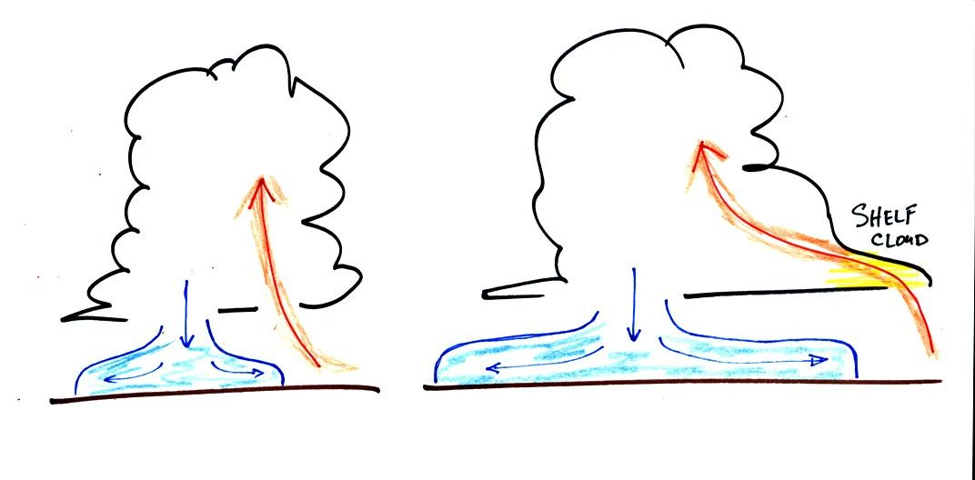
There are lots of distinctive features on cumulonimbus clouds including the flat anvil top and the lumpy mammatus clouds sometimes found on the underside of the anvil. Cold dense downdraft winds hit the ground below a thunderstorm and spread out horizontally underneath the cloud. The leading edge of these winds produces a gust front (dust front might be a little more descriptive). Winds at the ground below a thunderstorm can exceed 100 MPH, stronger than many tornadoes. The top of a thunderstorm is cold enough that it will be composed of just ice crystals. The bottom is composed of water droplets. In the middle of the cloud both water droplets and ice crystals exist together at temperatures below freezing (the water droplets have a hard time freezing). Water and ice can also be found together in nimbostratus clouds. We will see that this mixed phase region of the cloud is important for precipitation formation. It is also where the electricity that produces lightning is generated.
Here's one final feature to look for at the bottom of a thunderstorm.

Cold air spilling out of the base of a thunderstorm is just beginning to move outward from the bottom center of
the storm in the picture at left. In the picture at right the cold air has moved further outward and has begun to get in the way of the updraft. The updraft is forced to rise earlier and a little ways away from the center of the thunderstorm. Note how this rising air has formed an extra lip of cloud. This is called a shelf cloud.
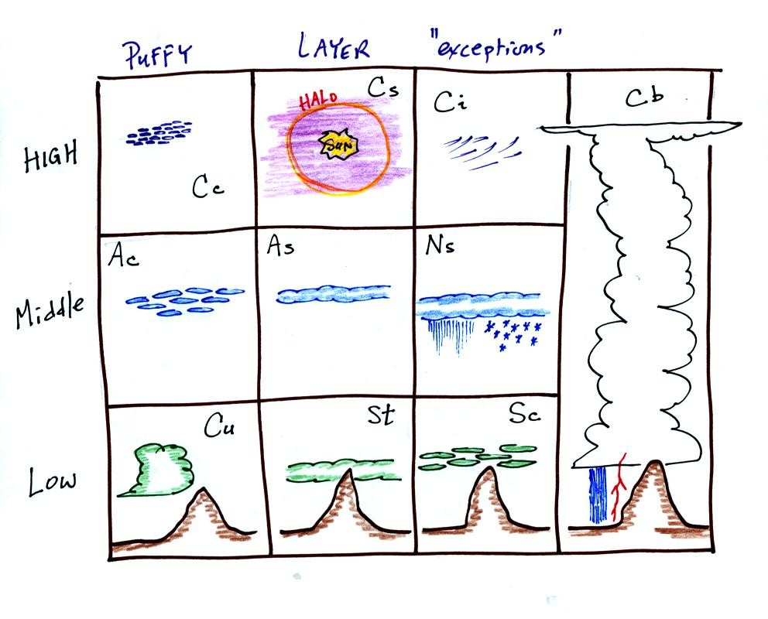
Here's the completed cloud chart.

