Tuesday., Sep. 9, 2008
Today's musical selection "Entre de los Aguas" was from a local group: Tesoro.
Hurricane Ike is going to miss Florida, it now appears to be headed for the coast of Texas.
Now some good news, a Bonus 1S1P Assignment.

We quickly reviewed the natural and anthropogenic processes that add carbon dioxide to the atmosphere and remove CO2 from the atmosphere. You'll find these at the end of Thurs. Sept. 4 notes.
To really understand why human activities are causing atmospheric CO₂ concentration to increase we need to look at the relative amounts of CO₂ being added to and being removed from the atmosphere (like amounts of money moving into and out of a bank account and their effect on the account balance). A simplified version of the carbon cycle is shown below.
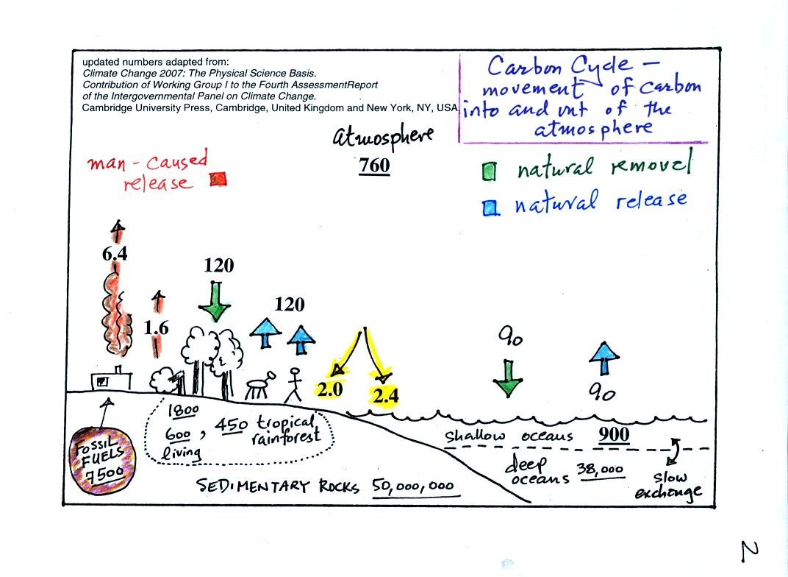
Here are the main points to take from this figure:
1. The underlined numbers show the amount of carbon stored in "reservoirs." For example 760 units* of carbon are stored in the atmosphere (predominantly in the form of CO₂, but also in small amounts of CH₄ (methane), CFCs and other gases; carbon is found in each of those molecules). The other numbers show "fluxes," the amount of carbon moving into or out of the atmosphere every year. Over land, respiration and decay add 120 units* of carbon to the atmosphere every year. Photosynthesis (primarily) removes 120 units every year.
2. Note the natural processes are in balance (over land: 120 units added and 120 units removed, over the oceans: 90 units added balanced by 90 units of carbon removed from the atmosphere every year). If these were the only processes present, the atmospheric concentration (760 units) wouldn't change.
3. Anthropogenic (man caused) emissions of carbon into the air are small compared to natural processes. About 6.4 units are added during combustion of fossil fuels and 1.6 units are added every year because of deforestation (when trees are cut down they decay and add CO₂ to the air, also because they are dead they aren't able to remove CO₂ from the air by photosynthesis)
The rate at which carbon is added to the atmosphere by man is not balanced by an equal rate of removal: 4.4 of the 8 units added every year are removed (highlighted in yellow in the figure). This small imbalance (8 - 4.4 = 3.6 units of carbon are left in the atmosphere every year) explains why atmospheric carbon dioxide concentrations are increasing with time.
4. In the next 100 years or so, the 7500 units of carbon stored in the fossil fuels reservoir (lower left hand corner of the figure) will be dug up or pumped out of the ground and burned. That will add 7500 units of carbon to the air. The big question is how will the atmospheric concentration change and what effects will that have on climate?

So here's where we're at in our discussion of climate change and global warming:
Atmospheric CO₂ concentration was fairly constant between 1000 AD and the mid 1700s.
CO₂ concentration has been increasing since the mid 1700s (other greenhouse gas concentrations have also been increasing).
The concern is that this might enhance or strengthen the greenhouse effect and cause global warming.
The obvious question is what has the temperature of the earth been doing during this period? In particular has there been any warming associated with the increases in greenhouse gases that have occurred since the mid 1700s?
We must address the temperature question in two parts.

First part:
Actual accurate measurements of temperature (on land and at sea)
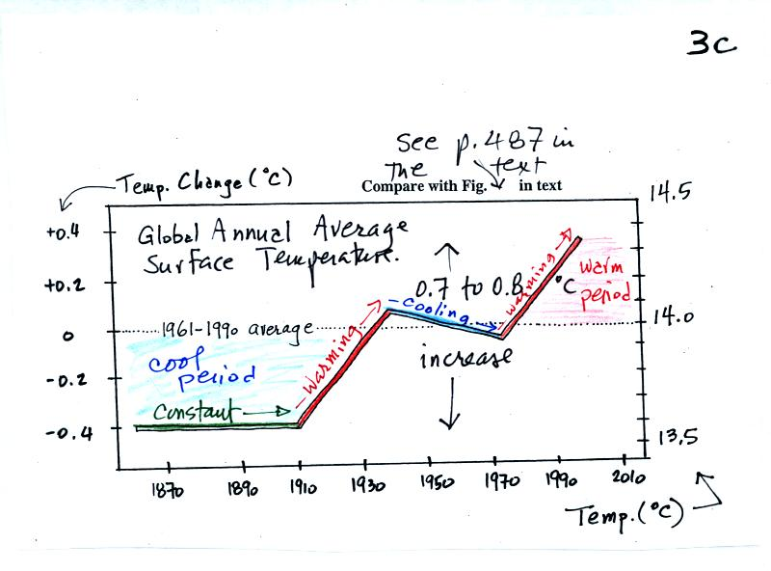
This is based on actual measurements of temperature made (using thermometers) at many locations on land and sea around the globe.
Temperature appears to have increased 0.7º to 0.8º C during this period. The increase hasn't been steady as you might have expected given the steady rise in CO₂ concentration; temperature even decreased slightly between about 1940 and 1970.
It is very difficult to detect a temperature change this small over this period of time. The instruments used to measure temperature have changed. The locations at which temperature measurements have been made have also changed (imagine what Tucson was like 130 years ago). About 2/3rds of the earth's surface is ocean. Sea surface temperatures can now be measured using satellites. Average surface temperatures naturally change a lot from year to year.
The year to year variation has been left out of the figure above so that the overall trend could be seen more clearly. The figure below does show the year to year variation (dotted black line) and the uncertainties (green bars, note how the uncertainty is lower in recent years) in the yearly measurements.
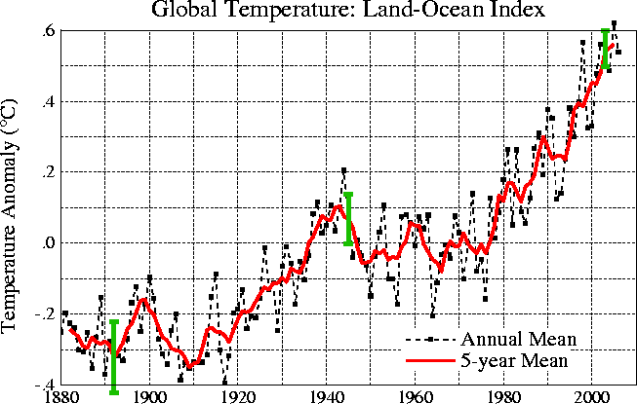
These data are from the NASA Goddard Institute for Space Studies site. Temperatures here are compared to the 1951-1980 mean.
The green bars are estimates of uncertainty.
Here's another plot of global temperature change over a slightly longer time period from the University of East Anglia Climatic Research Unit
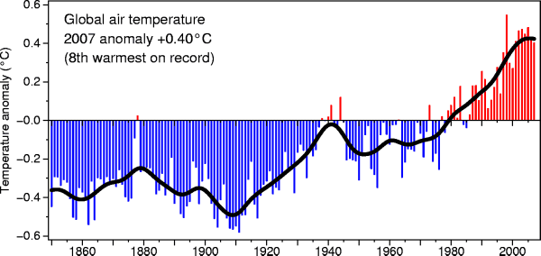

2nd part
Now it would be interesting to know how temperature was changing prior to the mid-1800s. This is similar to what happened when the scientists wanted to know what carbon dioxide concentrations looked like prior to 1958. In that case they were able to go back and analyze air samples from the past (air trapped in bubbles in ice sheets).
That doesn't work with temperature.
Imagine putting some air in a bottle, sealing the bottle, putting the bottle on a shelf, and letting it sit for 100 years. In 2108 you could take the bottle down from the shelf, carefully remove the air, and measure what the CO2 concentration in the air had been in 2008 when the air was sealed in the bottle. You couldn't, in 2108, use the air in the bottle to determine what the temperature of the air was when it was originally put into the bottle in 2008.
With temperature you need to use proxy data. You need to look for something else whose presence, concentration, or composition depended on the temperature at some time in the past.

Here's a proxy data example.
Let's say you want to determine how many students are living in a house near the university.
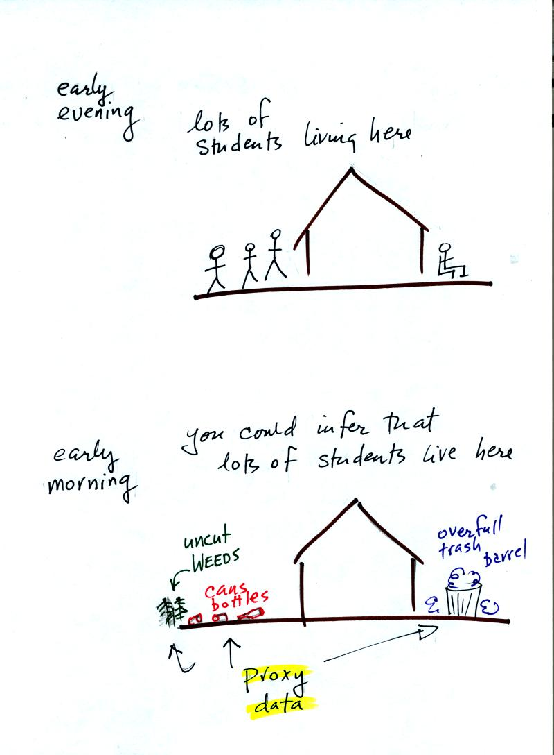

You could walk by the house late in the afternoon when the students might be outside and count them. That would be a direct measurement (this would be like measuring temperature with a thermometer). There could still be some errors in your measurement (some students might be inside the house and might not be counted, some of the people outside might not live at the house).
If you were to walk by early in the morning it is likely that the students would be inside sleeping (or in one of the 8 am NATS 101 classes). In that case you might look for other clues (such as the number of empty bottles in the yard) that might give you an idea of how many students lived in that house. You would use these proxy data to come up with an estimate of the number of students inside the house.
In the case of temperature scientists look at a variety of things. They could look at tree rings. The width of each yearly ring depends on the depends on the temperature and precipitation at the time the ring formed. They analyze coral. Coral is made up of calcium carbonate, a molecule that contains oxygen. The relative amounts of the oxygen-16 and oxygen-18 isotopes depends on the temperature that existed at the time the coral grew. Scientists can analyze lake bed and ocean sediments. The types of plant and animal fossils that they find depend on the water temperature at the time. They can even use the ice cores. The ice, H₂O, contains oxygen and the relative amounts of various oxygen isotopes depends on the temperature at the time the ice fell from the sky as snow.
Here's an idea of how oxygen isotope data can be used to determine past temperature.
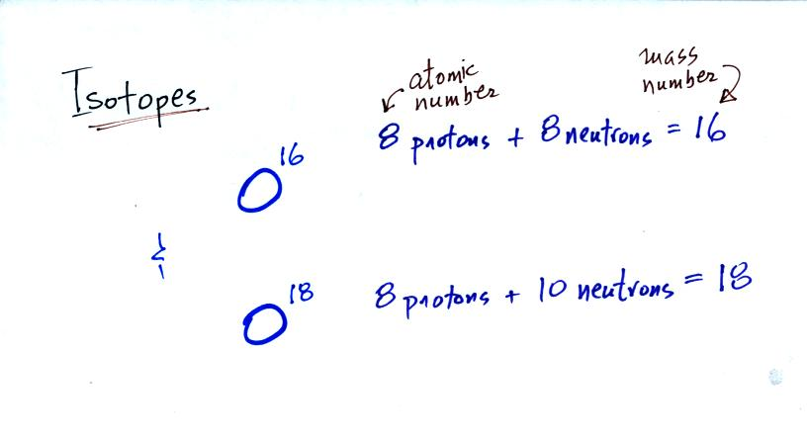
The two isotopes of oxygen contain different numbers of neutrons in their nuclei. Both atoms have the same number of protons.
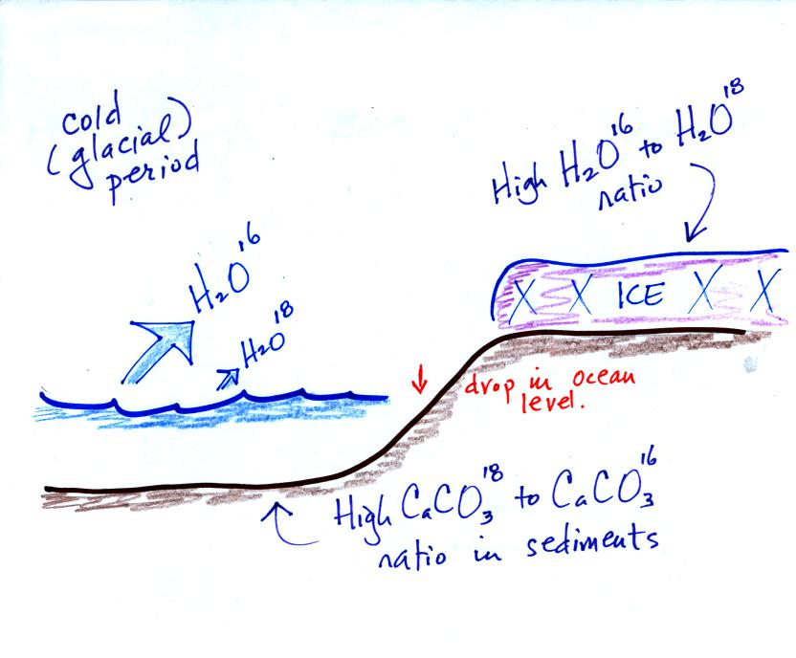
During a cold period, the H₂O¹⁶ form of water evaporates more rapidly than the H₂O¹⁸ form. You would find relatively large amounts of O¹⁶ in glacial ice. Since most of the H₂O¹⁸ remains in the ocean, it is found in relatively high amounts in calcium carbonate in ocean sediments.
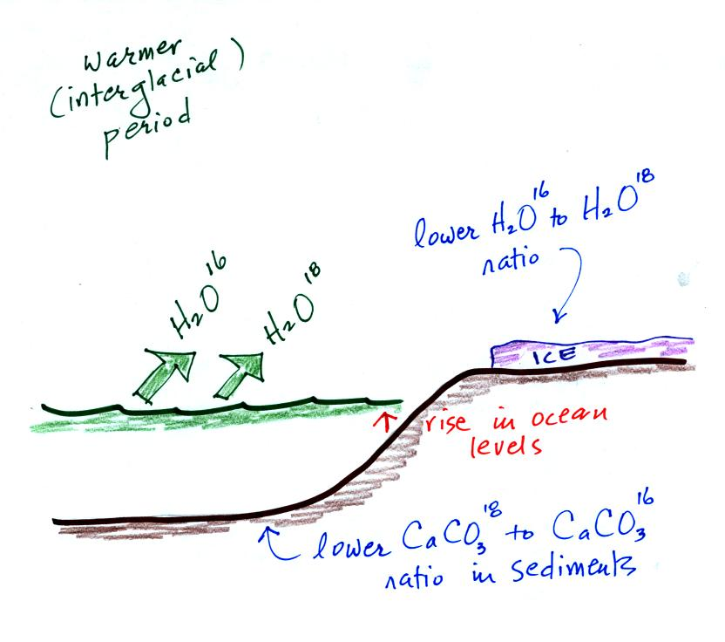
The reverse is true during warmer periods.
Using proxy data scientists have been able to estimate average surface temperatures for 100,000s of years into the past. The next figure (bottom of p. 3 in the photocopied Classnotes) shows what temperature has been doing since 1000 AD. This is for the northern hemisphere only, not the globe.
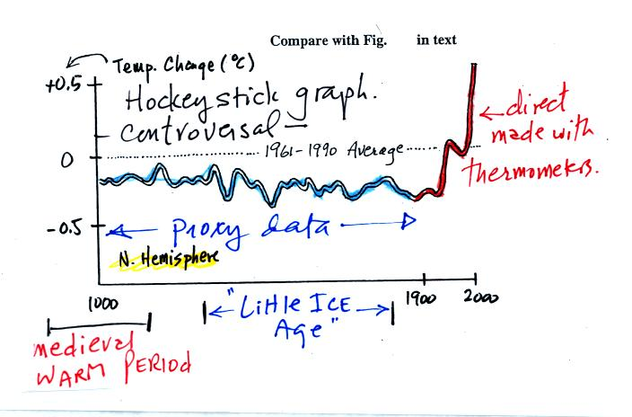
The blue portion of the figure shows the estimates of temperature (again relative to the 1961-1990 mean) derived from proxy data. The red portion is the instrumental measurements made between about 1850 and the present day. There is also a lot of year to year variation and uncertainty that is not shown on the figure above.
Many scientists would argue that this graph is strong support of a connection between rising atmospheric greenhouse gas concentrations and global warming. Early in this time interval when CO2 concentration was constant, there is little temperature change. Temperature only begins to rise in about 1900 when we know an increase in atmospheric carbon dioxide concentrations was underway.
There is historical evidence in Europe of a medieval warm period lasting from 800 AD to - 1200 AD or so and a cold period, the "Little Ice Age, " which lasted from about 1400 AD to the mid 1800s. These are not clearly apparent in the temperature plot above. This leads some scientists to question the validity of this temperature reconstruction. Scientists also suggest that if large changes in climate such as the Medieval warm period and the Little Ice Age can occur naturally, then maybe the warming that is occurring at the present time also has a natural cause.
Here's the figure that the sketch above was based on
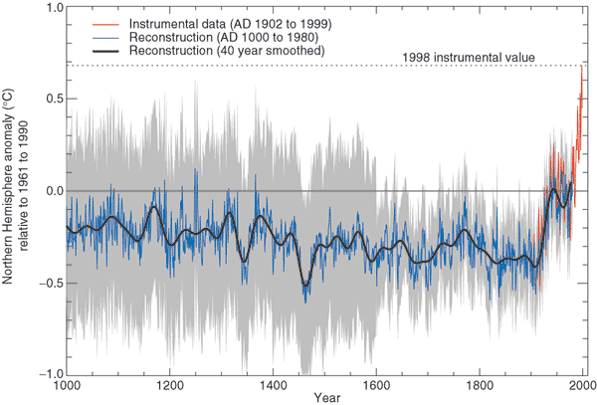
from
Climate Change 2001 - The Scientific Basis
Contribution of Working Group I to the 3rd Assessment Report of the
Intergovernmental Panel on Climate Change (IPCC)
Here's a comparison of several estimates of temperature changes over the past 1000 years or so
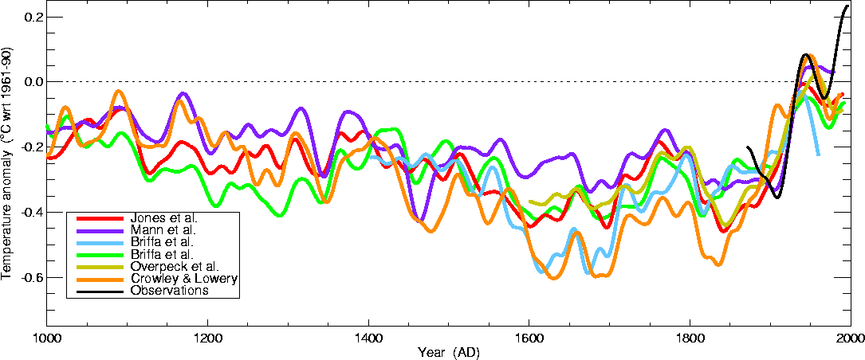
This is from the
University of East Anglia Climatic Research Unit again. Some of these curves do show a little bit more temperature variation between 1000 AD and 1900 AD than the hockey stick plot above.

That is where we will leave this topic for now, we've only covered a small part of a large and ongoing debate.
SUMMARY
There is general agreement that
Atmospheric CO₂ and other greenhouse gas concentrations are increasing and that
The earth is warming
Not everyone agrees
on the Causes (natural or manmade) of the warming,
how much additional warming there will be, or
on the Effects that warming will have on weather and climate in the years to come

We had a little bit of time left in the period so we were able to move into the middle part of Chapter 1 and start some new, completely different material. We will be looking at how atmospheric characteristics such as air temperature, air pressure, and air density change with altitude. In the case of air pressure we first need to understand what pressure is and what can cause it to change.
An iron bar was passed around at the beginning of class. You were supposed to guess how much it weighed.
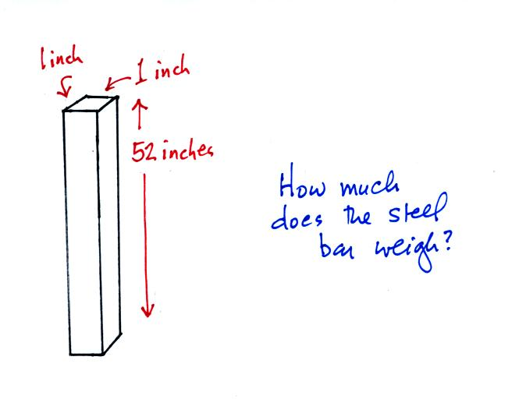
We come back to the iron bar at the end of class.
What follows is a little more detailed discussion of the basic concepts of mass, weight, and density than was covered in class.
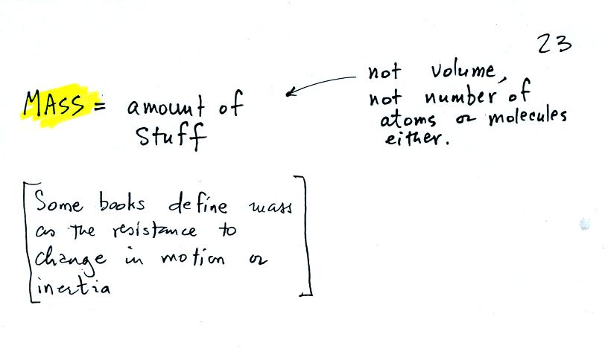
Before we can learn about atmospheric pressure, we need to review the terms mass and weight. In some textbooks you'll find mass defined at the "amount of stuff." Other books will define mass as inertia or as resistance to change in motion. The next picture illustrates both these definitions. A Cadillac and a volkswagen have both stalled in an intersection. Both cars are made of steel. The Cadillac is larger and has more steel, more stuff, more mass. The Cadillac is also much harder to get moving than the VW, it has a larger inertia (it would also be harder to slow down if it were already moving).
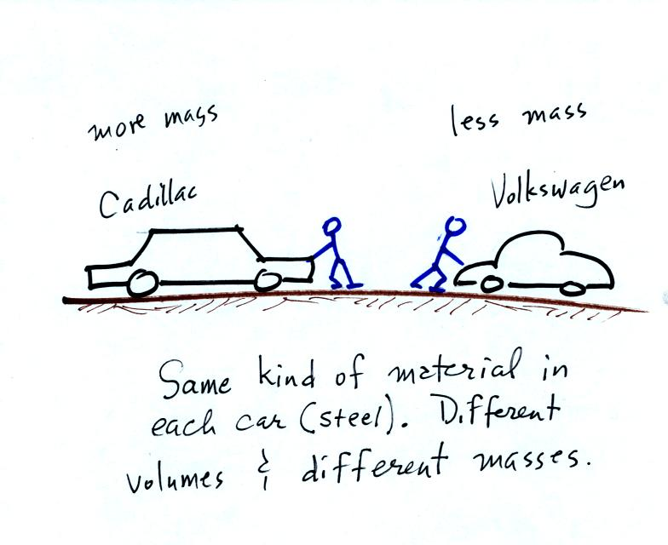
It is possible to have two objects with the same volume but very different masses. The bottles of water and mercury that were passed around class were an example (thanks for being so careful with the mercury).
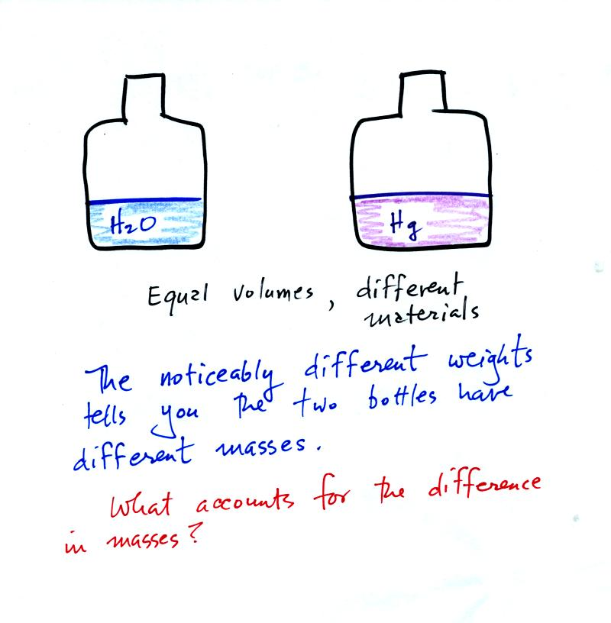
To understand why there is such a difference in mass and weight you need to look at the water molecules and mercury atoms on an atomic scale.
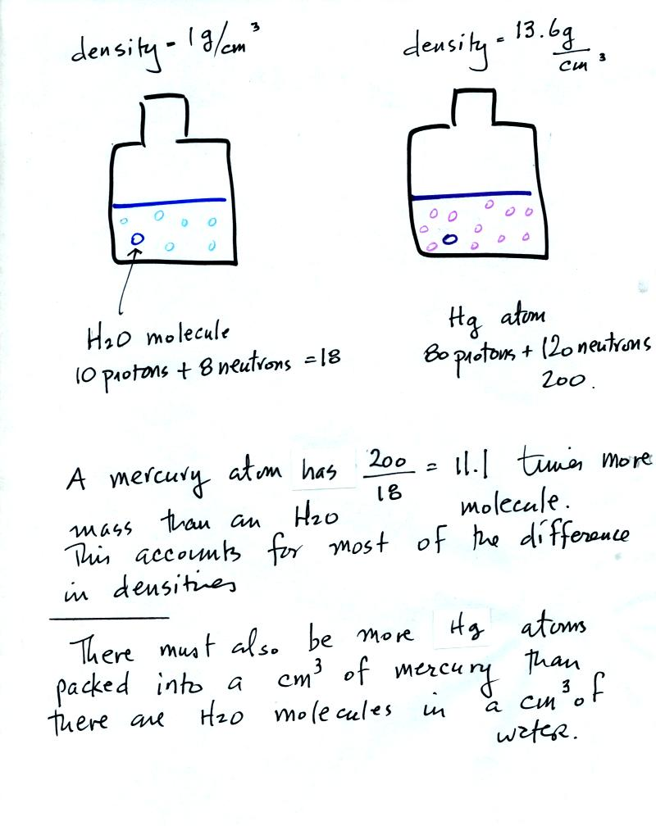
Mercury atoms are built up of many more protons and neutrons than a water molecule (also more electrons but they don't have nearly as much mass as protons and neutrons). The mercury atoms have 11.1 times as much mass as the water molecule. This doesn't quite account for the 13.6 difference in density. Despite the fact that they contain more protons and neutrons, the mercury atoms must also be packed closer together than the molecules in water.
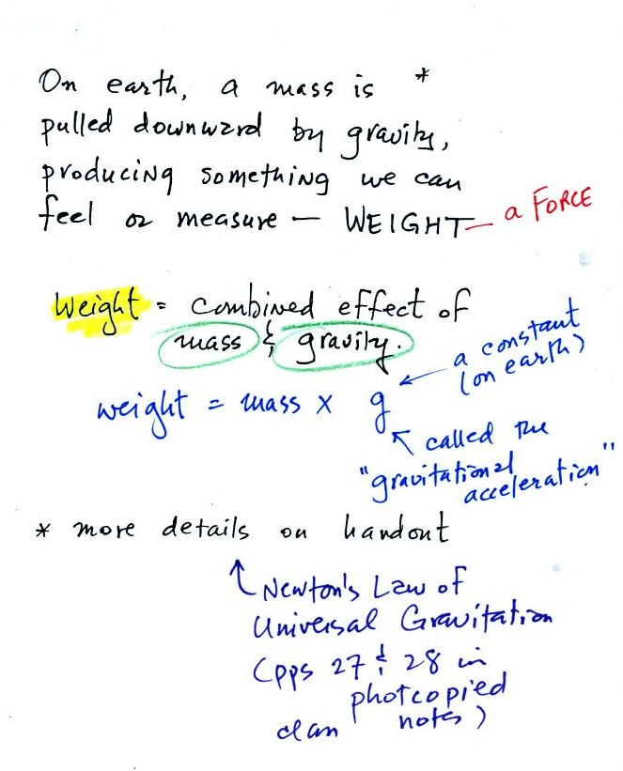
Weight is a force and depends on both the mass of an object and the strength of gravity.
We tend to use weight and mass interchangeably because we spend all our lives on earth where gravity never changes.
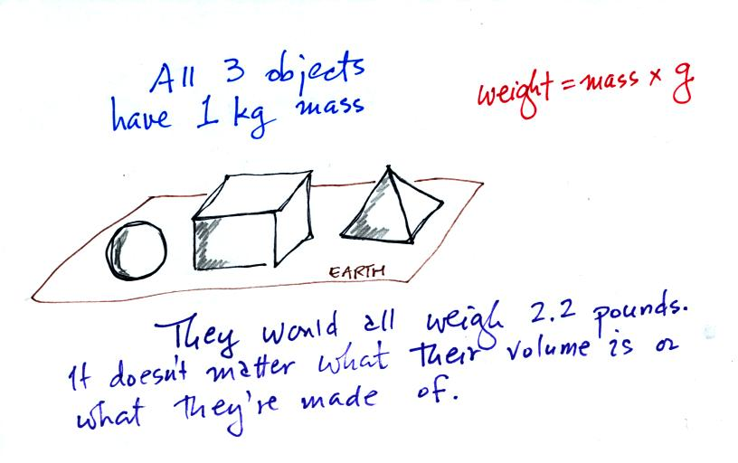
Any three objects that all have the same mass would necessarily have the same weight. Conversely
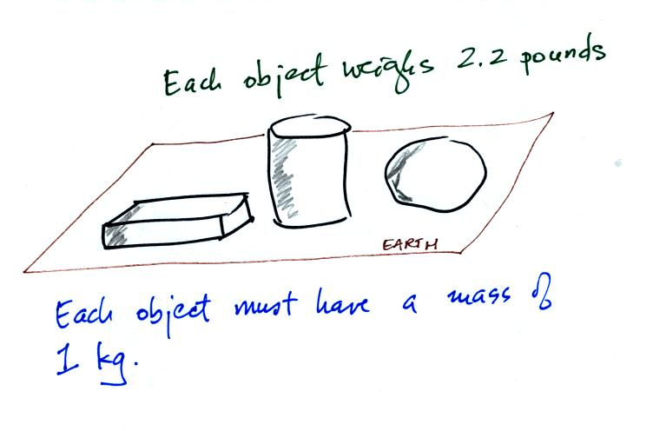
Three objects with the same weight would also have the same mass.
The difference between mass and weight is clearer (perhaps) if you compare the situation on the earth and on the moon.
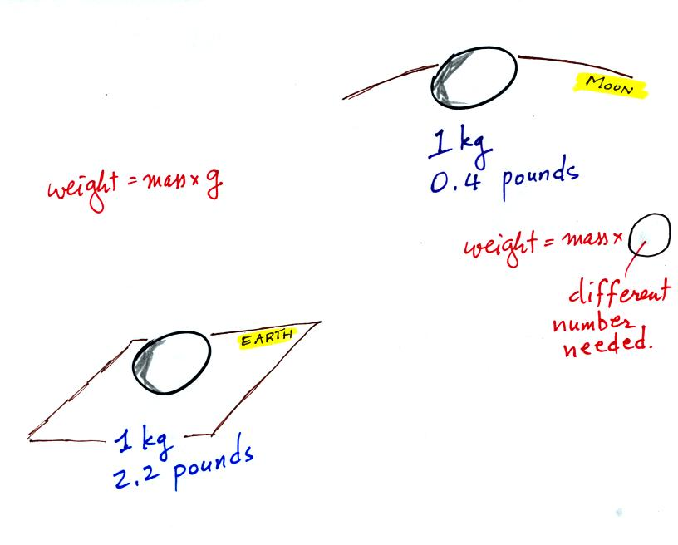
If you carry an object from the earth to the moon, the mass remains the same (its the same object, the same amount of stuff) but the weight changes because gravity on the moon is weaker than on the earth.

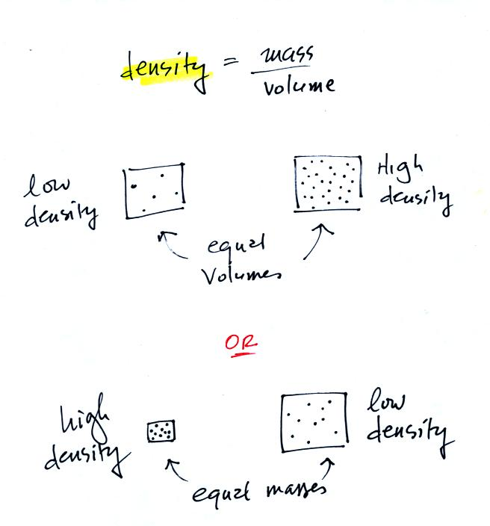
In the first example there is more mass (more dots) in the right box than in the left box. Since the two volumes are equal the box at right has higher density. Equal masses are squeezed into different volumes in the bottom example. The box with smaller volume has higher density.

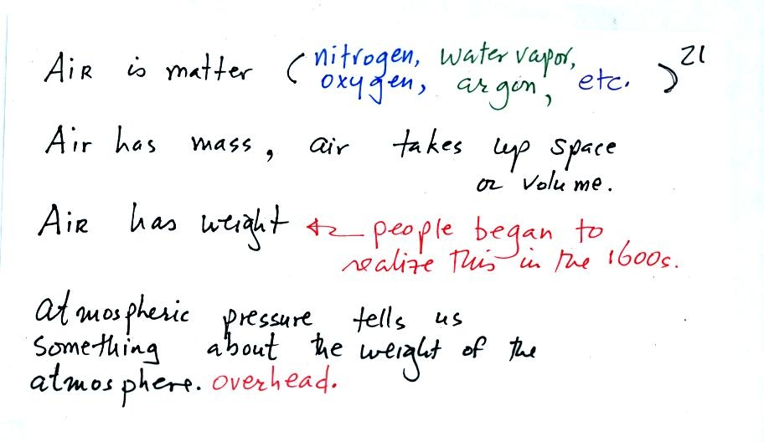
The air that surrounds the earth has mass. Gravity pulls downward on the atmosphere giving it weight. Galileo conducted (in the 1600s) a simple experiment to prove that air has weight.
Pressure is defined as force divided by area. Air pressure is the weight of the atmosphere overhead divided by the area the air is resting on. Atmospheric pressure is determined by and tells you something about the weight of the air overhead.
Under normal conditions a 1 inch by 1 inch column of air stretching from sea level to the top of the atmosphere will weigh 14.7 pounds. Normal atmospheric pressure at sea level is 14.7 pounds per square inch (psi, the units you use when you fill up your car or bike tires with air).
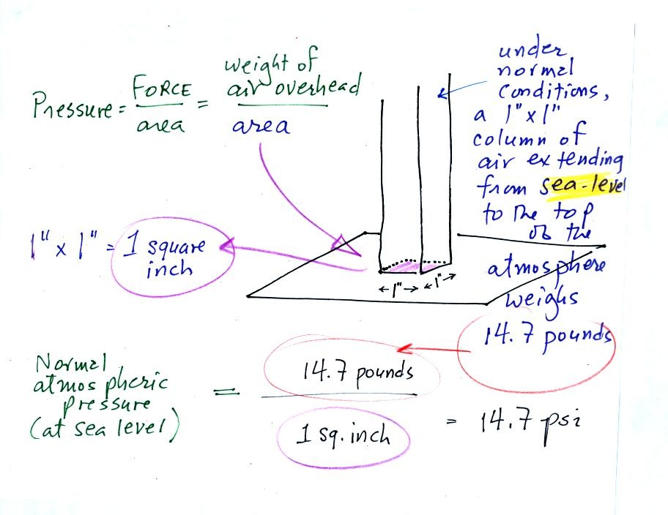

Here's the connection between the iron bar and air pressure. The iron bar also weighs exactly 14.7 pounds.

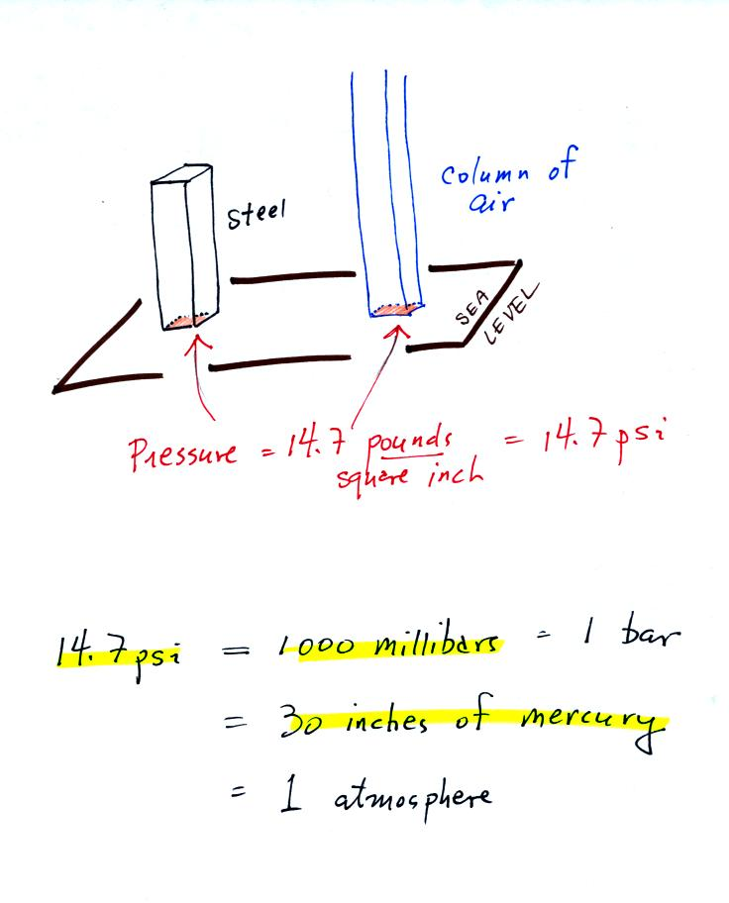
When it is standing on end the bar exerts a pressure of 14.7 pounds per square inch on the ground, the same as a 1 inch by 1 inch column of air at sea level altitude.
Some of the other commonly used pressure units are shown above. Typical sea level pressure is 14.7 psi or about 1000 millibars (the units used by meterologists) or about 30 inches of mercury (refers to the reading on a mercury barometer). If you ever find yourself in France needing to fill your automobile tires with air, remember that the air compressor scale is probably calibrated in bars. 2 bars of pressure would be equivalent to 30 psi.

The word "bar" is used in a lot of meteorological terms:
