Answers
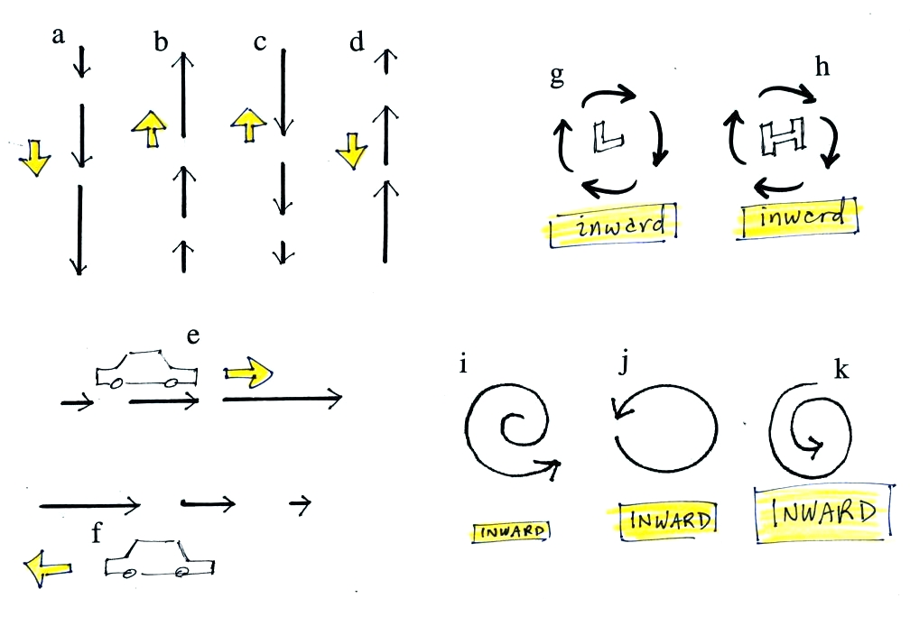
In (a) think of an object dropped from the roof of a building. Gravity will pull downward and cause it to fall faster and faster. In (d) think of a ball thrown up into the air. The downward pull of gravity will cause the ball to slow, to stop, and then to start falling back downward toward the ground.
The net force is inward anytime something moves in a circular path such as is shown in Figs. (g) and (h).
In (j) the amount of inward force is just right to keep an object moving in a circular path. In (k) the inward force is a little too strong and the object spirals inward. In (i) the inward force is a little too weak.

