Newton's 1st law of motion
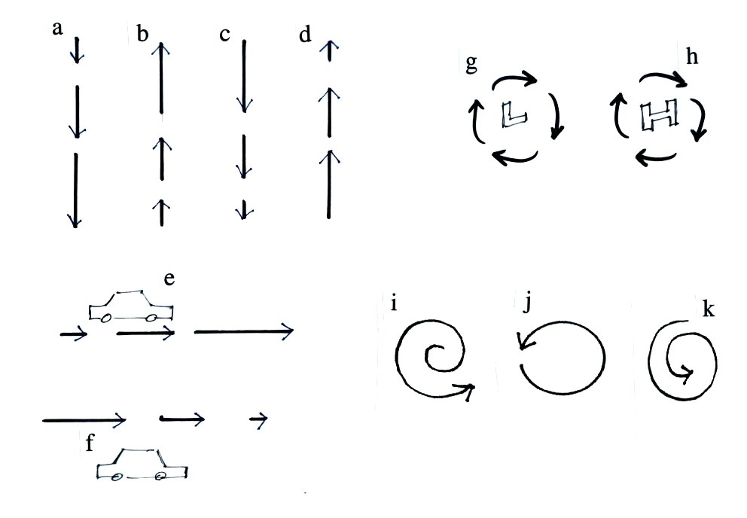
Determine the direction of the net force in each of the examples above. You can download the answers from the online study guide.

