Surface wind examples

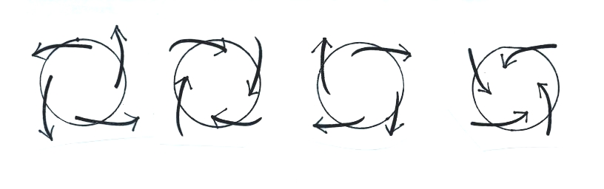
In each case determine whether the winds are blowing around a center of high or low pressure. Does each example show winds in the northern or southern hemisphere. Where would you expect to find rising and sinking air motions? You can download the answers from the online study guide.

