NATS 101 Name_______________________________
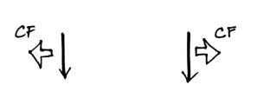
Optional Assignment

1. Circle the figure at right that shows winds
blowing in the southern hemisphere.

2. Sinking air inhibits cloud formation. You would therefore expect to find clear skies and infrequent rainfall at (select 3 of the following).
a. belts of high pressure b. 30º latitude c. doldrums
d. belts of low pressure e. 60º latitude f. horse latitudes
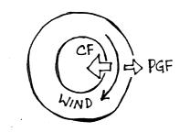
3. The direction of the PGF in the figure at right
tells you that this is a center of HIGH LOW
pressure. The direction of the CF is the the
RIGHT LEFT of the wind which indicates that
this is a NORTHERN SOUTHERN hemisphere
chart. Winds blowing parallel to the contours
mean this is a(n) SURFACE UPPER-LEVEL map.

4. You observe a large storm system on a satellite photograph that is moving from east to west and spinning in a clockwise direction. This would most likely indicate (circle 3 choices below)
a. northern hemisphere b. middle latitude c. anticyclone
c. southern hemisphere d. tropical e. cyclone

5a. In the figure below (showing surface winds in two different portions of the 3-cell model), you would expect to find a belt of low pressure at
a. A only b. B only c. both A and B d. neither A or B

5b. Would you expect to find wind pattern A or wind pattern B at the intertropical convergence zone?
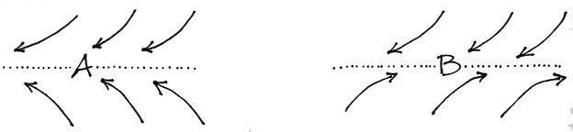

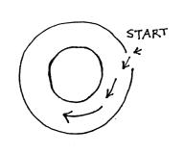
6. The direction of the initial motion in the figure
at right means this is a center of HIGH LOW
pressure. Rather than go straight toward the
center of the picture, the wind starts to turn toward
the left. The direction of this bending indicates
that this is a NORTHERN SOUTHERN
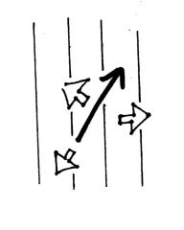
hemisphere map.

7. Does the figure at right show SURFACE or UPPER-LEVEL
winds. Identify the three forces shown on the figure. Is low
pressure found at the TOP RIGHT BOTTOM or LEFT
side of the figure? Is this a NORTHERN or SOUTHERN
hemisphere map?

8. In the northern hemisphere clouds are associated with RISING SINKING air motions found in LOW HIGH pressure centers. In the southern hemisphere you find cloud produced by RISING SINKING air motions associated with centers of LOW HIGH pressure.
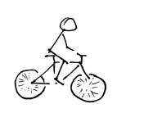
9. You’re riding your bicycle along a flat level road
and you stop pedaling. Will you continue to move in
a straight line at constant speed? If not, draw an arrow
on the picture at right to show the direction of the net
force that would be exerted on the bicycle. What is
the name or cause of this force?

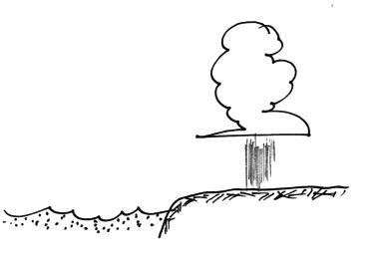
10. Assume that the cloud and showers in the picture are
being produced by a thermal circulation. Would the
surface winds blow from the SEA or the LAND?
Would you expect to find that the land is WARMER
or COLDER than the ocean water. Would clouds
like this be more likely during the DAY or at NIGHT?

