NATS 101 Name_________Answers______________
Optional Assignment #1

1. Bicycle tires on a “road” bike are normally inflated to a pressure of 90 psi or so. About how many bars of pressure would that be? Normal sea level pressure is 14.7 pounds per square inch (about 15 psi) which is about 1000 mb or 1 bar. So 90 psi would be about 6 bars.
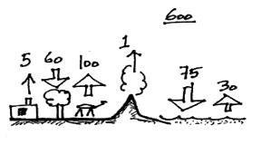

2. The figure at right shows fluxes of carbon
dioxide into and out of the atmosphere.
Based on the information in the figure would
you expect the atmospheric CO₂ concentration
to INCREASE, DECREASE or remain
CONSTANT over time?
5 + 100 + 1 + 30 = 136 units of CO₂ are being added to the atmosphere.
60 + 75 = 135 units are being removed. Since more CO₂ is being added than removed the atmospheric concentration will increase.

3. Average sea level pressure is about ___1000_____ millibars which is about 30 inches of mercury. A pressure reading of 900 mb (10 % lower) would be about ____27______ inches of mercury.

4. Water vapor is an invisible gas. We can see clouds because clouds are composed of
____water droplets ___ and/or ____ice crystals___________ which scatter light.

5. During combustion, fossil fuels and ___b____ react to form __d_____ and ___e____.
a. nitrogen b. oxygen c. argon
d. water vapor e. carbon dioxide f. ozone

6. The amount of carbon dioxide in the air varies slightly over the course of a year. Near the ground it also changes slightly during the day. Would you expect to observe the highest CO₂ concentration during the DAY or at NIGHT?
There will be less removal of CO₂ during the night because without sunlight, plants won’t be able to photosynthesize.

7. The combustion of coal would probably not produce any ___c____.
a. CO₂ b. CO c. O₃ d. SO₂ e. H₂O
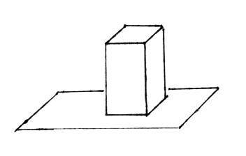
8. The figure at right shows a brick standing on its end.
If you multiplied the area of the end of the brick by the height of the brick you would get the brick’s ___volume______. If you divided the mass of the brick by its volume you would get the brick’s ___density_____. The weight of the brick divided by the area of the end of the brick would be the __pressure_____ exerted by
the brick on the surface supporting it.

9. The liquids in the bottles of mercury and water passed around in class had the same
a. density b. mass c. volume d. weight
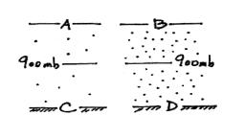
10. Based on the air density information shown in the
figure at right, the air pressure at Point A is
GREATER EQUAL LESS than(to) the pressure
at Point B. The pressure at Point C is GREATER
EQUAL LESS than(to) the pressure at Point D.
Pressure will change most rapidly as you move through high density air. Thus pressure will only drop a little bit when moving up from 900 mb to Point A. It will drop more when you move from 900 mb to Point B. Point A will have higher pressure than Point A. Pressure will increase a little bit when moving from 900 mb to Point C. It will increase more when moving from 900 mb to Point D. Point C will have lower pressure than Point D.

11. Photodissociation of molecular oxygen O₂ + UV light → O + O
is the first step in
a. the formation of stratospheric ozone b. the formation of acid rain
c. photosynthesis d. the greenhouse effect
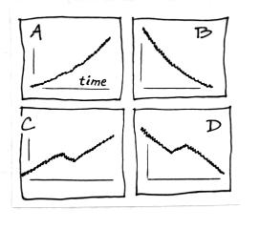

12. Figure __A____ at right best describes how the
atmospheric CO₂ concentration has changed since
the mid-1800s. Figure __C____ best describes
the change in global annual average surface
temperature on the earth during the same period.

13. ___Radon_______ is the leading cause of lung cancer among non smokers in the United States. (ref: www.epa.gov/radon)

14. The concentration of ____water vapor_____ in the air can range from near 4% in the tropics to a small fraction of a percent in cold polar regions.

15. Pressure DECREASES INCREASES with increasing altitude in the atmosphere. Is the rate of change at ground level GREATER than the SAME as LESS than at higher altitude? Pressure decreases most rapidly with increasing altitude in the densest air next to the ground.

16. Does an object with a volume of 3 cm³ and a mass of 4.5 grams have a HIGHER a LOWER or the SAME density than(as) an object with a mass of 15 grams and a volume of 6 cm³?
( 4.5 g ) / ( 3 cm³ ) = 1.5 g/cm³ ( 15 g ) / ( 6 cm³ ) = 2.5 g/cm³

