NATS 101 Name________Answers_______________
Optional Assignment

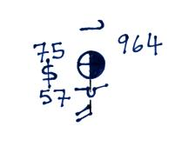
1. Show at right how the following weather
observations would be plotted using the
station model notation.
Temperature = 75º F cloud cover = 5/8
Pressure = 996.4 mb dew point = 57º F
Wind direction & speed = south at 20 knots
Low clouds = stratocumulus clouds
High altitude clouds = filaments of cirrus clouds
Dust or sand raised by the wind at the time
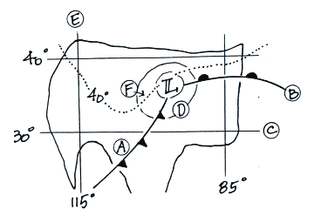
of observation.

2. Find an example of each of the following on
the surface weather map at right.

line of constant latitude___C___

isobar___D__ warm front___B___

cold front___A___ isotherm___F___

line of constant longitude___E___

3. The large L symbol that you see on a surface weather map indicates a region of low __c__.
a. altitude b. air density c. air pressure d. air temperature

4. Use the figure at right to fill in the values of the following weather variables.
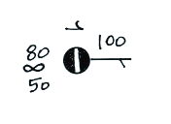
Temperature___80 F__ cloud cover_7/8ths__

Pressure___1010.0 mb__ dew point__50 F___

Wind direction_(from) East_ Wind speed__5 knots__

Present weather conditions__hazy____

5. Which of the following does not produce rising air motions?
a. cold front b. surface high pressure c. surface low pressure d. warm front
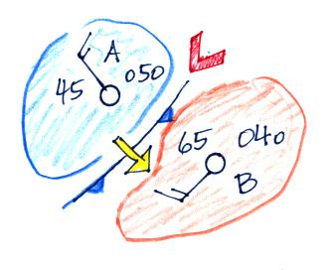
6. Weather conditions at two cities and a front are shown in
the figure at right. Using what you know about the direction
the winds blow around surface centers of low pressure, would
you expect the front to be moving toward CITY A or CITY B?
Would this be a COLD or WARM front?
In question 6 remember that winds spin counterclockwise (CCW) around surface low pressure centers and that fronts are like spokes on a wheel. The front will rotate CCW around the L. Cold air behind the front makes this a cold front.

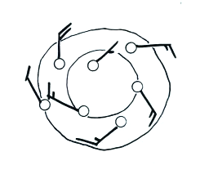

7. Are the winds spinning in a CLOCKWISE or
COUNTERCLOCKWISE direction in the figure
at right. Are the winds CONVERGING or
DIVERGING. Does the figure show a surface
LOW or HIGH pressure center?

8. Upper air weather data are collected (using radiosondes) twice each day, at 00Z and 12Z.
(a) 00Z = 24Z 24:00 Z – 7 = 17:00 MST or 5:00 pm MST
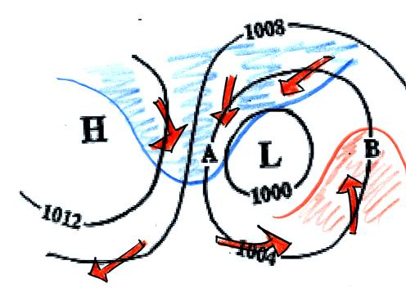
(b) 12:00 Z – 7 = 5:00 am MST

9. Would the surface winds blow from the north at
POINT A or POINT B in the figure at right?
Would the strongest winds be found at POINT A
or POINT B? Would you expect to find the
warmest temperatures at POINT A or POINT B?
The red arrows show the winds, counterclockwise
around L and clockwise around H. The blue and red
show how the winds move cold air toward the south on
the west side of the L. Warm air moves northward on the east side of the L.

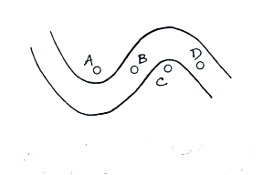
10. Point___A___on the upper level chart at right is in a
trough. The warmest air would probably be found
below Point __C___.

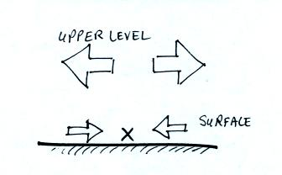
11. Surface winds are converging and the upper level winds
are diverging in the crossectional figure at right. Would
you expect to find surface LOW or HIGH pressure at
Point X in the figure? Based on the relative amounts of
convergence and divergence would you expect the pressure
at Point X to INCREASE or DECREASE? Would you
expect the surface convergence to STRENGTHEN or
WEAKEN given the expected change in pressure at Point X?
Upper level divergence exceeds surface convergence. More air is being removed than is being added → surface pressure will decrease.
12. ___d___ below is the symbol for a northern hemisphere hurricane. ___c___ is the symbol for a southern hemisphere tropical storm. Hurricanes have low pressure centers. Winds spin counterclockwise around low pressure in the northern hemisphere as in (a) and (d). The symbols with blackened in centers are hurricanes. (a) is a northern hemisphere tropical storm and (b) is a southern hemisphere hurricane.
