NATS 101 Hidden Name_______ANSWERS_____________
Optional Assignment

1. A mixing ratio of 6 g/kg means there are 6 grams of _______water vapor____________
mixed in
with 1 kilogram of _________dry air__________________.

2. If you know the air's temperature you can look up the value of the __b___ in a table.
a. mixing ratio b. saturation mixing ratio c. relative humidity d. dew point

3. Adding water vapor to the air will not increase the ___b____.
a. mixing ratio b. saturation mixing ratio c. relative humidity d. dew point

4. 90º F air can potentially hold ___c___ times as much water vapor as 45º F air (consult the table on p. 86 in the photocopied ClassNotes)
a. 2 b. 4 c. 5 d. 10
the saturation mixing ratios for 45º F and 90º F air are 6 g/kg and 30 g/kg, respectively

5. To calculate the relative humidity you need to know the ___a___ and the ___b___.
a. mixing ratio b. saturation mixing ratio c. air temperature d. dew point

6. The value of the ___c___ will tell you whether moist air is saturated or not.
a. mixing ratio b. saturation mixing ratio c. relative humidity d. dew point

7. Based on the data in the figure below, does the parcel of 70º F air have MORE LESS or the SAME amount of water vapor than(as) the 85º F air?

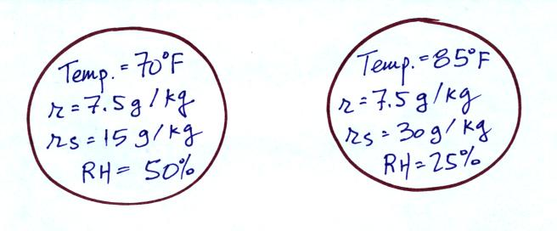

the mixing ratio tells you how much water vapor is actually in the air. The mixing ratio values are the same in the two parcels of air – both parcels contain the same amount of water vapor

8. Which two of the following have the same job, telling you how much water vapor is actually in the air?
a. mixing ratio b. saturation mixing ratio c. relative humidity d. dew point

