Equivalent Potential Temperature

The equivalent potential temperature, θ_{e}, is the potential temperature that would result if all of the water in the air parcel were condensed and rained out by raising the air upwards and then lowering the air parcel to the surface dry adiabatically. The θ_{e}, of an air parcel would be conserved if the condensed water did not rain out but instead stayed with the air parcel.

“The equivalent potential temperature is the temperature a parcel at a specific pressure level and temperature would have if it were raised to 0 mb, condensing all moisture from the parcel, and then lowered to 1000 mb.” (from www.srh.noaa.gov/ffc/html/gloss1.shtml )
I disagree with the 0 mb part of this definition. The air needs to be lifted up high enough and cold enough that virtually all of the water in the air condenses out which means a temperature of 200 K or so.

Using a skew-T plot we can illustrate the concept graphically.

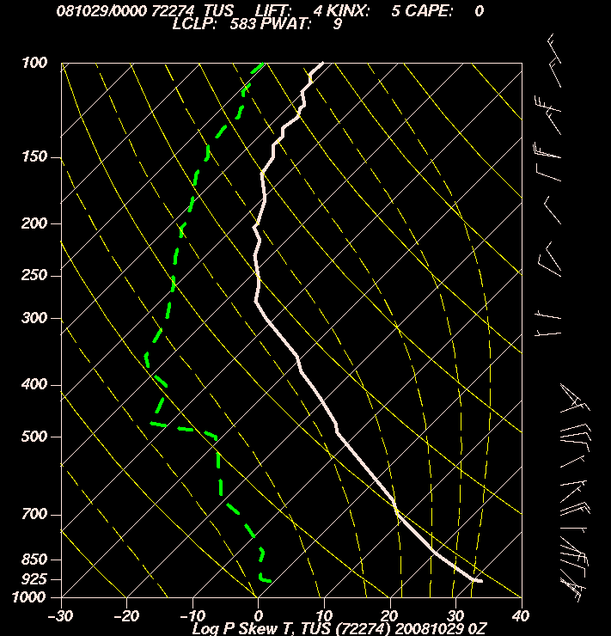

Notice that θ_{e} is conserved for reversible moist adiabatic processes, that is processes where the condensed water does not fall out of the air parcel.

Energy transfer from latent heat to sensible heat

Heating up the air by condensing out the water vapor yields a temperature increase defined by the following energy balance equation
$L_{v}ρ_{H_{2}O}=\left(C_{p−\text{dry}}ρ_{\text{dry}}+C_{H_{2}O−\text{liq}}ρ_{H_{2}O}\right)DT=ρ_{\text{dry}}\left(C_{p−\text{dry}}+C_{H_{2}O−\text{liq}}r\right)DT$ (1)
Note that this equation assumes all of the water vapor in the air parcel has condensed out. The temperature increase due to latent heat conversion to sensible heat when the water condenses is therefore
$DT=\frac{ρ_{H_{2}O}}{ρ_{\text{dry}}}\frac{L_{v}}{\left(C_{p−\text{dry}}+C_{H_{2}O−\text{liq}}r\right)}=\frac{L_{v}r}{\left(C_{p−\text{dry}}+C_{H_{2}O−\text{liq}}r\right)}$ (2)
Notice that the heat capacity used here is a combination of the heat capacity of dry air and condensed water. This is because in equilibrium following the release of latent heat, the air and the condensed water will be at the same temperature.
Because r is small, the following approximation is often made:
$DT@\frac{L_{v}}{C_{p−\text{dry}}}r$ (3)
Note that this approximation systematically overestimates ΔT fractionally by
$\frac{e_{DT}}{DT}=\frac{DT'−DT}{DT}=\frac{\frac{L_{v}r}{\left(C_{p−\text{dry}}\right)}−\frac{L_{v}r}{\left(C_{p−\text{dry}}+C_{H_{2}O−\text{liq}}r\right)}}{\frac{L_{v}r}{\left(C_{p−\text{dry}}+C_{H_{2}O−\text{liq}}r\right)}}=\frac{\left(C_{p−\text{dry}}+C_{H_{2}O−\text{liq}}r\right)}{\left(C_{p−\text{dry}}\right)}−\frac{\left(C_{p−\text{dry}}+C_{H_{2}O−\text{liq}}r\right)}{\left(C_{p−\text{dry}}+C_{H_{2}O−\text{liq}}r\right)}$
$\frac{e_{DT}}{DT}=\frac{\left(C_{p−\text{dry}}+C_{H_{2}O−\text{liq}}r\right)}{\left(C_{p−\text{dry}}\right)}−1=\frac{C_{H_{2}O−\text{liq}}}{C_{p−\text{dry}}}r»4r$ (4)
If r =1%, the fractional error in the latent heat temperature is 4%.

Simple Equation for θ_{e}.

The simplest (and least accurate) equation for θ_{e} is derived as follows. We simply plug the temperature increase associated with condensation into the potential temperature equation
$q=T{\left(\frac{P_{0}}{P}\right)}^{\frac{R}{C_{p}}}$ (5)
to yield an equation for the equivalent potential temperature
$q_{e}=T_{e}{\left(\frac{p_{0}}{p}\right)}^{\frac{R_{d}}{C_{p}}}»\left(T+\frac{L_{v}}{C_{p}}r\right){\left(\frac{p_{0}}{p}\right)}^{\frac{R_{d}}{C_{p}}}$ (6)
P₀ is a reference pressure usually taken to be 1000 mb. The problem with this approximate equation is that it assumes all of the water vapor is condensed out and converted to sensible heat at the present pressure of the air parcel. This is incorrect because the water condenses out as the air parcel is lifted into the uppermost troposphere where the pressure is lower such that the adiabatic compression when the air is brought to the surface will be larger. So we can anticipate this equation will systematically underestimate θ_{e}.

Better Equation for θ_{e}.

Wallace and Hobbs give the following derivation.
The ideal gas law is P = ρRT so Pα = RT where α is specific volume = 1/ρ. One of the many forms that we can write the 1st law of thermodynamics is
$\text{dQ}=C_{v}\text{dT}+d\left(Pα\right)−α\text{dP}$ (7)
From the ideal gas law, d(Pα) = R dT, so
$\text{dQ}=C_{v}\text{dT}+\text{RdT}−α\text{dP}=C_{p}\text{dT}−α\text{dP}$ (8)
Therefore
$\frac{\text{dQ}}{T}=C_{p}\frac{\text{dT}}{T}−\frac{α}{T}\text{dP}=C_{p}\frac{\text{dT}}{T}−R\frac{\text{dP}}{P}$ (9)
The potential temperature is defined as in (5) such that
$\text{ln}q=\text{ln}T+\frac{R}{C_{p}}\left(\text{ln}P_{0}−\text{ln}P\right)$ (10)
The derivative is
$C_{p}\frac{dq}{q}=C_{p}\frac{\text{dT}}{T}−R\frac{\text{dP}}{P}$ (11)
Plugging (9) into (11) yields
$C_{p}\frac{dq}{q}=\frac{\text{dQ}}{T}$ (12)
The next step is to convert the latent heat associated with condensation into raising the air parcel temperature.
${\text{dQ}}_{s}\text{=-}L_{v}{\text{dw}}_{s}\text{=-}L_{v}{\text{dr}}_{s}$ (13)
where w_{s} = r_{s} = ρ_{vs}/ρ_{d} is the saturation (mass) mixing ratio and ρ_{vs} and ρ_{d} are the densities of the water vapor at saturation and dry air. (I am not sure why W&H use w_{s} rather than r_{s}). Notice that this heat input is the latent heat input per mass of dry air. Combining this with the previous equation yields
$C_{p}\frac{dq}{q}\text{=-}\frac{L_{v}{\text{dw}}_{s}}{T}$
$\frac{dq}{q}\text{=-}\frac{L_{v}{\text{dw}}_{s}}{C_{p}T}$ (14)
The next “trick” is the following approximation
$\frac{L_{v}{\text{dw}}_{s}}{C_{p}T}@d\left(\frac{L_{v}w_{s}}{C_{p}T}\right)$ (15)
So given this approximation,
$\frac{dq}{q}=d\text{ln}q\text{=-}\frac{L_{v}{\text{dw}}_{s}}{C_{p}T}\text{@-}d\left(\frac{L_{v}w_{s}}{C_{p}T}\right)$ (16)
$−\frac{L_{v}w_{s}}{C_{p}T}|_{T_{1}}^{T_{2}}=\text{ln}q|_{q\left(T_{1}\right)}^{q\left(T_{2}\right)}$ (17)
$−\frac{L_{v}\left(T_{2}\right)w_{s}\left(T_{2}\right)}{C_{p}\left(T_{2}\right)T_{2}}+\frac{L_{v}\left(T_{1}\right)w_{s}\left(T_{1}\right)}{C_{p}\left(T_{1}\right)T_{1}}=\text{ln}q\left(T_{2}\right)−\text{ln}q\left(T_{1}\right)$ (18)
The question now is what to choose as the constant. We know that at the extremely low w_{s} which occurs in very cold air in the high altitudes where there is virtually no water left to condense out, θ_{e} = θ. We use this limit to do the following
$\frac{L_{v}\left(T_{1}\right)w_{s}\left(T_{1}\right)}{C_{p}\left(T_{1}\right)T_{1}}=\text{ln}q_{e}\left(T_{2}\right)−\text{ln}q\left(T_{1}\right)$ (19)
where T₂ represents the temperature of the air parcel after it has been lifted into the upper troposphere which is sufficiently cold to set the w_{s}(T₂) ~0.
$q_{e}=q\text{exp}\left(\frac{L_{v}w_{s}}{C_{p}T}\right)$ (20)
This expression is actually quite accurate despite the approximation made in getting (15).

We can evaluate the accuracy of the two equations for potential temperature using the moist adiabat spreadsheet we generated earlier. The blue line in the figure is the potential temperature along a moist adiabat from the spreadsheet The green line with the x’s is the simpler θ_{e} equation, (6). The red dashed line is the estimate of θ_{e} from equation (20). The light green line with the ‘+’ is the Moist Static Energy (MSE) (defined below) divided by the heat capacity of the air to create a temperature-like variable to plot here. In the example in the figure, (6) yields an estimate at the surface that is 6.5 K lower than the actual θ_{e} at the top of the moist adiabat in the upper troposphere. (20) yields an estimate of θ_{e} near the surface that is ~2 K too low. So the θ_{e} estimate from (20) is a pretty good and is better at higher altitudes. MSE is very close to constant along the moist adiabat and therefore conserved varying by only 0.26K over the 0 to 14 km interval.

Using the skew-T plot above we can illustrate the concept graphically.

For a more detailed definition of θ_{e} see
http://amsglossary.allenpress.com/glossary/search?id=equivalent-potential-temperatur1
I think there is a typo in this equation (the H doesn’t make sense) but the Kerry Emanuel text referenced that has the correct definition. This definition carefully considers the heat capacity with is more complicated than just the dry air heat capacity.

Stability
One key area of relevance of θ_{e} is in terms of stability. Stability is defined analogous to potential temperature
$\frac{{\text{¶q}}_{e}}{¶z}>0$ stable
$\frac{{\text{¶q}}_{e}}{¶z}<0$ unstable
assuming that water condenses out. This dependence on whether or not the water condenses out is known as conditional stability, that is the stability is conditional on whether or not the water in the air condenses out. Note that to be applicable, the air must reach saturation. So θ_{e} is really relevant at cloud base and above.

Lifting Condensation Level (LCL)
= cloud base. As discussed, the easiest way to estimate for a well mixed boundary layer is simply
$z_{\text{LCL}}\text{=-}\frac{\left(T−T_{d}\right)}{\left({\frac{\text{dT}}{\text{dz}}}_{\text{dry}−\text{adia}}−{\frac{{\text{dT}}_{d}}{\text{dz}}}_{\text{mixed}}\right)}\text{@-}\frac{\left(T−T_{d}\right)}{\left(−9\text{.}8−\left(−1\text{.}7\right)\right)}@\frac{\left(T−T_{d}\right)}{8}$ (in km)

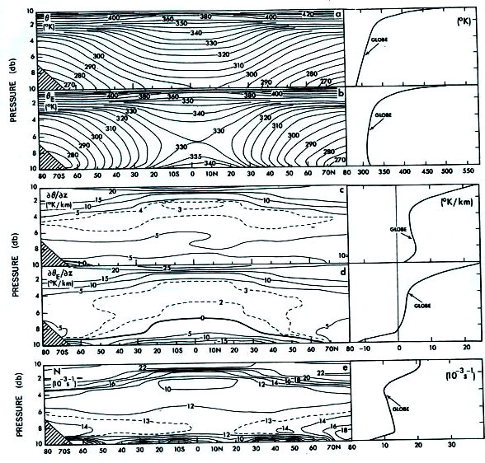

We see from the figure from Peixoto and Oort that $\frac{{\text{¶q}}_{e}}{¶z}<0$ through much of the lower troposphere.

θ_{e} at low altitudes determines how high into the troposphere a parcel of air lifted from the lower troposphere can rise moist adiabatically assuming no mixing on the way up. As the figure below from Pexioto and Oort shows, the dθ_{e} /dz in the upper troposphere is typically 2 to 3 K/km. Therefore the 6.5 K error in the simple θ_{e} equation example given above would translate to underestimating the height to which an air parcel could rise to by ~3 km. So the systematic inaccuracy of equation (6) really makes it unusable in this context.

Vertical coordinates: P, z and θ.

When using height as the vertical coordinate instead of pressure, there are variables that are analogous to θ and θ_{e}.

Dry Static energy
DSE = C_{p}T + Φ
DSE is the equivalent of potential temperature when altitude rather than pressure is used as the vertical coordinate. DSE is conserved for dry adiabatic processes. Proof: Take the vertical derivative of DSE and set it to 0. The result will be the dry adiabatic lapse rate showing DSE does not change vertically under dry adiabatic processes.

Moist static energy:
MSE = C_{p}T + Φ + L_{v}q
MSE is the equivalent of equivalent potential temperature when altitude rather than pressure is used as the vertical coordinate. MSE is conserved for reversible moist adiabatic processes.

θ as a vertical coordinate
θ is very effective as a vertical coordinate in stable regions. This is because in the absence of diabatic heating and cooling, θ is conserved. So air parcels moving around relatively quickly move on surfaces of constant θ. This allows one to better see how air moves around. Models do use θ as a vertical coordinate in the stratosphere where the air is quite stable. In the troposphere it is tricky because of the boundary layer where dθ /dz can often be 0 such that θ no longer increases monotonically with altitude.

