1. Pluto’s orbit is far more eccentric than those of the major planets’ orbits:
Aphelion: 7,375,927,931 km
Perihelion: 4,436,824,613 km
- Determine the solar flux (watts/m²) at each of these distances.
$F_{\text{planet}}=\frac{F_{\text{sun}−\text{total}}}{4{pR}_{\text{planet}−\text{orbit}}^{2}}=\frac{{sT}_{\text{sun}}^{4}4{pr}_{\text{sun}}^{2}}{4{pr}_{\text{planet}−\text{orbit}}^{2}}={sT}_{\text{sun}}^{4}\frac{r_{\text{sun}}^{2}}{r_{\text{planet}−\text{orbit}}^{2}}$ (W/m²)
Aphelion: 0.56 W/m²
Perihelion: 1.56 W/m².
These are roughly 1/1,000 of the solar flux at the Earth

- Assume the albedo is 0.7 in both cases. Determine the radiative equilibrium temperature at both distances.

So the radiative equilibrium temperature of the planet, T_{planet}, is given as
$T_{\text{planet}}=T_{\text{sun}}{\left[\frac{r_{\text{sun}}}{2r_{\text{planet}−\text{orbit}}}\right]}^{1/2}{\left(1−A_{\text{planet}}\right)}^{1/4}$ (K) (7)
Aphelion: 29.4K
Perihelion: 37.9K

While these may seem like very similar small temperatures, the higher temperature is about 30% higher than the low temperature. This turns out to be very important for the size of Pluto’s atmosphere because its pressure likely depends very strongly on temperature via the Clausius Clapeyron equation that we will study later that determines how much water vapor Earth’s atmosphere can hold. The atmosphere of Pluto is likely in vapor pressure equilibrium with N2 ice on the surface of Pluto.

The boiling point of molecular Nitrogen in Earth’s atmosphere is 77.36 K.
Latent heat of vaporization is 5.56 kJ/mol
Latent heat of fusion is 0.72 kJ/mol
The saturation vapor pressure of N2 at 37.9 K is about 1.7 Pa
The saturation vapor pressure of N2 at 29.4 K is about 0.003 Pa
The ratio of the two is about 500. So the vapor pressure of Pluto’s nitrogen atmosphere is about 500 times larger at perihelion than it is at apehelion

New Horizons mission to Pluto

2. Titan vs. Earth atmospheric mass
How much mass is in a column of Titan’s atmosphere relative to a column of Earth’s air?
Assume the two atmospheres are made up of the same gases (which is almost true because both are dominated by N₂). Assume Titan’s surface pressure is 1.5 bars and its surface gravity is 1.35 m/s².

The hydrostatic relation says that $\text{dP}\text{=-}gρ\text{dz}$ such that the surface pressure is
$$P_{\text{surf}}=\int_{0}^{P_{\text{surf}}}{\text{dP}}\text{=-}\int_{¥}^{0}{gρ\text{dz}}=\int_{0}^{¥}{gρ\text{dz}}@g\int_{0}^{¥}{ρ\text{dz}}$$
So the mass in the atmospheric column is $\int_{0}^{¥}{ρ\text{dz}}=\frac{P_{\text{surf}}}{g}$
For Earth, P_{surf} = 1013 hPa = 100,000 Pa and g = 9.81 m/s². Therefore the mass in an Earth atmospheric column is about 1.03x10⁴ kg/m².

For Titan, P_{surf} = 1500 hPa = 150,000 Pa and g = 1.35 m/s². Therefore the mass in a column of Titan’s atmosphere is 1.1x10⁵ kg/m².
So even though the surface pressure of Titan is only 50% higher than that of the Earth, there is approximately 11 times as much mass of nitrogen in a column of Titan’s atmosphere as there is in a column of Earth’s atmosphere.

3. Calculate the heat capacities (both C_{v} and C_{p}) of He, H₂ and N₂ in both J/mole/K and in J/kg/K.

 | mass | C_{v}'/R* | C_{p}'/R* | C_{v}' | C_{p}' | C_{v} | C_{p}
Constituent | g/mole |  |  | J/K/mole | J/K/mole | J/K/kg | J/K/kg
He | 4 | 1.5 | 2.5 | 12.47 | 20.79 | 3118 | 5197
H₂ | 2 | 2.5 | 3.5 | 20.79 | 29.10 | 10390 | 14550
N₂ | 28 | 2.5 | 3.5 | 20.79 | 29.10 | 742.4 | 1039

4. Rotational energy levels of a diatomic molecule

In the simple 2 atom dumbbell molecule, the rotational energy levels are
$E=\frac{h^{2}}{8p^{2}I}j\left(j+1\right)$
where I is the Moment of inertia: $I=\int{r^{2}ρ\text{dV}}=\sum_{i}{m_{i}}r_{i}^{2}$
z
y

x

r

a. Calculate the first 4 energy levels of each of the 3 rotational modes of N₂.

The first step is to determine the rotational moment of inertia for each of the three modes. Note that modes 1 and 2 where the N₂ barbell rotated around the y and z axes are identical. Mode 3, where the barbell rotates around the x-axis which is the axis that runs between the center of the two nitrogen atoms is quite different as we discussed in class.

MASS:
The mass of an atom of nitrogen is approximately 0.014 kg/mole / N_{A} = 2.3e-26 kg.

Radius:
We need to determine the distances of the center of masses from rotational axis for each mode. As discussed in class, in two of the modes the distance of the two nitrogen atoms from the rotational axis are identical. In the third mode, the distance is much smaller and the energy levels are therefore much higher. In fact, in the 3rd mode the nuclear distance from the spin axis is so small, we need to consider the electrons separate from the protons and neutrons.

1st & 2nd modes
Molecular nitrogen has a covalent bond of length 1.09 Å which runs from the center of one nitrogen atom to the center of the other. Therefore, for the first 2 modes, the radial distance from the spin axis to the center of mass of one nitrogen atom is half the bond length which is r = 0.545 Å = 5.45x10⁻¹¹ m.
The moment of inertia is 2 m_{N} r² = 1.38e-46 kg m².

3rd mode
For the third rotational mode, the spin axis runs through the center of the two nitrogen atoms. The moment of inertia actually has two contributions, the contribution from the nucleus of each nitrogen atom plus each electron cloud.
Nucleus contribution: The radius of the nucleus is extremely small, approximately 3e-15 m. The contribution from the nucleus of each atom is therefore approximately 2.3e-26 kg (3e-15 m)² = 4.2e-55 kg m².
Electron contribution: The mass of an electron is approximately 1/1836 that of a proton. There are 7 electrons in a nitrogen atom. The mass of electrons in a nitrogen atom is 6.3e-30 kg. The radius of the electrons around the spin axis is approximately the radius of the atom, 6.5e-11 m. The moment of inertia due to the electrons is 6.3e-30 kg (6.5e-11 m)² = 5.35e-50 kg m². This is much larger than the moment of inertia of the nucleus.
So the moment of inertia of the third mode is actually associated with the electrons rather than the nucleus such that the energy constant $\frac{h^{2}}{8p^{2}I}$ for the third mode is approximately 2 x 1836 = 3600 times larger than the first two modes.
In the table below is shown both the nucleus and the electron contributions in order to give credit for the nuclear estimates. However, the true answer for mode 3 is the electron column.

j | E(J) modes 1&2 | Mode 3: E(J) nucleus | Mode 3: E(J) electron
0 | 0.00E+00 | 0.00E+00 | 0.00E+00
1 | 8.05E-23 | 2.64E-14 | 2.08E-19
2 | 2.42E-22 | 7.91E-14 | 6.24E-19
3 | 4.83E-22 | 1.58E-13 | 1.25E-18

1 electronvolt = 1 eV = 1.602×10⁻¹⁹ J.
j | E(eV) modes 1&2 | Mode 3: E(eV) nucleus | Mode 3: E(eV) electron
0 | 0.00E+00 | 0.00E+00 | 0.00E+00
1 | 5.03E-04 | 1.64E+05 | 1.30E+00
2 | 1.51E-03 | 4.93E+05 | 3.89E+00
3 | 3.02E-03 | 9.87E+05 | 7.79E+00

Converted to Kelvin…
j | E(K) modes 1&2 | Mode 3: E(K) nucleus | Mode 3: E(K) electron
0 | 0.0 | 0.00E+00 | 0.00E+00
1 | 5.8 | 1.91E+09 | 1.51E+04
2 | 17.4 | 5.73E+09 | 4.52E+04
3 | 34.9 | 1.14E+10 | 9.06E+04

b. Use the Boltzmann distribution to show that one of the 3 modes will not be populated at typical Earth temperatures.

The Boltzmann distribution represents the probability of an energy level being populated. The probability of an energy level, E_{j}, being populated relative to the probability of the ground state, E₀, being populated is exp(-E_{j}/k_{B}T)/exp(-E₀/k_{B}T) = exp(-E_{j}/k_{B}T) because E₀ =0.
We’ll assume the atmospheric temperature is 250K. k_{B}T = 3.45e-21 J = 0.02 eV.
The table shows the probability of the energy levels being populated relative to the probability that the ground state energy level will be populated.

j | Modes 1&2 E_{j}/k_{B}T | Modes 1&2 probability of Population relative to ground state | Mode 3 Probability of population relative to ground state
0 | 0 | 1.00 | 1.00E+00
1 | 0.0234 | 0.98 | 6.78E-27
2 | 0.0701 | 0.93 | 3.11E-79
3 | 0.14 | 0.87 | 9.69E-158

We see that the probability of the lower energy states of Modes 1 & 2 being populated is high in fact nearly as high as the ground stat being populated, while the probability of Mode 3 energy states being populated in comparison to the ground state population is extremely low.
The sum of the relative probabilities must sum to unity because the total probability must equal 1. So the probability of each energy state is
$$P\left(E_{j}\right)=\frac{\text{exp}\left(−\frac{E_{j}}{k_{B}T}\right)}{\sum_{i=0}^{i\text{=¥}}{\text{exp}\left(−\frac{E_{i}}{k_{B}T}\right)}}$$
For the case at hand, $\sum_{i=0}^{i\text{=¥}}{\text{exp}\left(−\frac{E_{i}}{k_{B}T}\right)}$ = 8.225. Therefore the probability is
j | Modes 1&2 E_{j}/k_{B}T | Modes 1&2 probability of Population relative to ground state | Modes 1&2 probability of Population
0 | 0 | 1.00 | 0.122
1 | 0.0234 | 0.98 | 0.119
2 | 0.0701 | 0.93 | 0.113
3 | 0.14 | 0.87 | 0.106

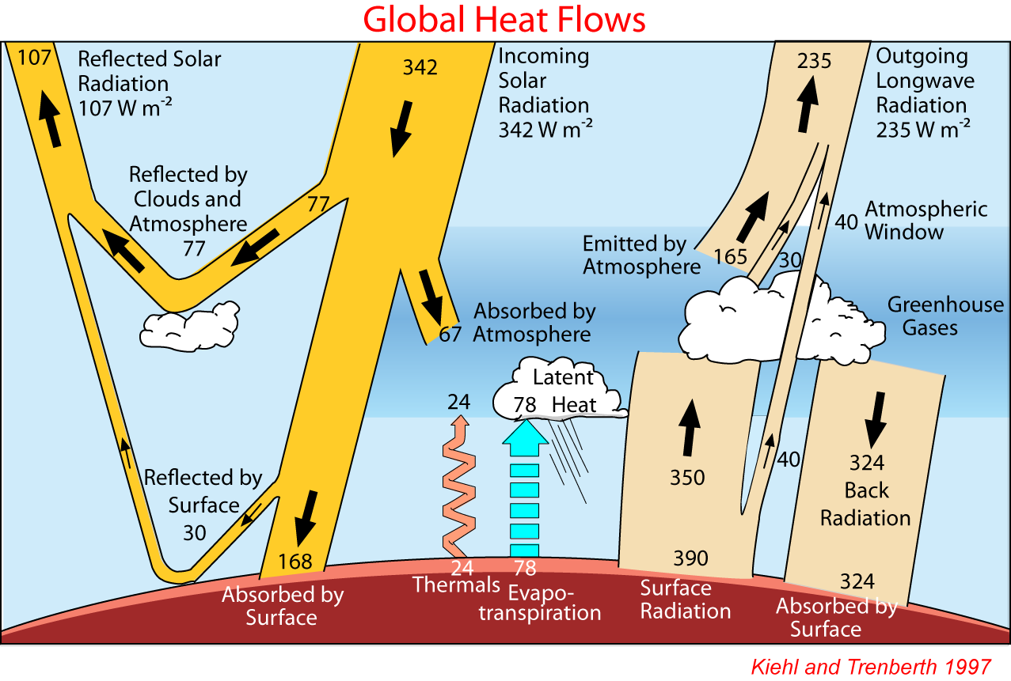

The impact of doubling CO₂ on Earth’s surface temperature

5. In the first figure in the notes on the motivation of studying atmospheric science, the IR radiative flux from Earth’s atmosphere into the surface is 324 watts/m².
- Based on the Stephan-Boltzmann law, what is the temperature of the atmospheric level that is radiating into the surface?

F = σT⁴. => T = (F/σ)^{1/4}
T = 274.9K = 1.8 ºC

- Assuming the Earth’s surface temperature is 288 K and the atmospheric temperature decreases vertically at a rate of 6.5 K/km, at what atmospheric altitude is the IR radiation into the surface coming from?

z = (T-T_{surf})/(dT/dz) = (274.9-288)/(-6.5K/km) = 2 km

6. The outgoing IR radiation to space of 235 watts/m² is composed of 3 terms: 165 watts/m² from the atmospheric gas, 30 watts/m² from the atmospheric clouds and 40 watts/m² from the surface.
- Take the atmospheric portion: 165 + 30 = 195 watts/m². Based on the Stephan-Boltzmann law, what is the temperature that it is radiated from?

242.17K

- Assuming the same atmospheric temperature structure as in the previous problem, what altitude in the atmosphere is this being radiated from?

7.05 km

- Assume that increasing CO₂ in the atmosphere causes the atmospheric portion of the IR watts/m² to decrease by 4 watts/m², how much cooler is the new radiating temperature?

240.91 K is 1.25 K colder than the original temperature

- How much higher is the new radiating altitude than the original?

The new height is 7.24 km which is 190 m higher in altitude. (1.25 K/ 6.5 K/km = 0.192 km)

7. Assuming the vertical temperature gradient remains at 6.5 K/km, how much must the surface temperature increase to bring the Earth back into equilibrium?

To get the outgoing IR back in balance with the incoming solar, the original temperature profile must shift upwards by 0.19 km. Therefore the original surface temperature will become the new temperature at 0.19 km altitude. So the new surface temperature will be
T_{surf-new} = T_{surf0} -z * dT/dz = 288K - 0.19km*(-6.5K/km) = 288 + 1.25K
So according to this simple exercise, doubling CO₂ should cause the surface temperature to increase by about 1.25K.
This does not include the additional effect of the expected increase in water vapor as temperatures warm. Water is the dominant greenhouse gas in the Earth’s atmosphere and its concentration depends on temperature. The positive water vapor feedback is thought to approximately double the effect of CO₂ alone, which, for the simple analysis done here indicates the surface temperature will increase by 2.5K.

“With CO2 at 550ppm (twice the pre-industrial, post-ice age level), average global temperatures would be between 2 and 4.5 C (3.6-8.1 F) higher than pre-industrial times, "with a best estimate of about 3 C (5.4 F)," says the (2008 IPCC) report.”

So our simple analysis is in the same range as the big boys. This is why the predicted range of temperature increases has not changed much over the past 20 years.

