Scattering of EM waves by spherical particles: Overview of Mie Scattering

Mie scattering refers to scattering of electromagnetic radiation by spherical particles. Under these conditions an exact set of relations can be derived. 2008 marked the 100 year anniversary of Mie’s original 1908 publication on the derivation of electromagnetic radiation scattering from spherical particles.

References: The material discussed in these notes is taken largely from
- Bohren & Huffman, Absorption and Scattering of Light by Small Particles, Wiley & Sons, 1983
- 2 sets of notes and Matlab code from Christian Mätzler available on the web.
- See also http://diogenes.iwt.uni-bremen.de/vt/laser/wriedt/index_ns.html for Mie codes on the web. This web site has a multitude of useful codes besides the Mie codes

The real and imaginary parts of the index of refraction
For a particle to cause scattering, the particle must have a different index of refraction than the medium in which it sits. Otherwise the EM wave won’t know a particle is present.
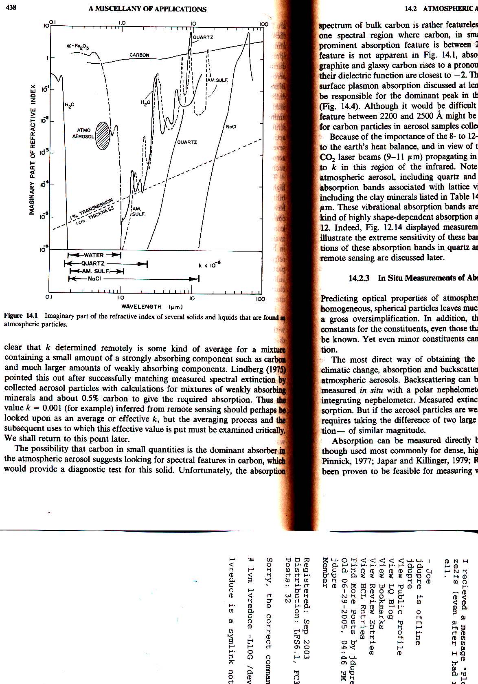
From Bohren and Huffman

Scattering wave Solutions
The solutions for the scattered field resulting from the interaction of the incident plane wave with the particle are as follows. The expansion of the scattered EM fields, E_{s} and H_{s}, well outside the particle are
$E_{s}=\sum_{n=1}^{¥}{E_{n}}\left({\text{ia}}_{n}N_{e\text{ln}}^{(3)}−b_{n}M_{o\text{ln}}^{(3)}\right)$ $H_{s}=\frac{k}{\text{wm}}\sum_{n=1}^{¥}{E_{n}}\left({\text{ib}}_{n}N_{o\text{ln}}^{(3)}+a_{n}M_{e\text{ln}}^{(3)}\right)$
Note the differences in the k’s and μ’s because the internal field is inside the particle and the scattered field is in the surrounding medium which have different index of refractions and possibly different magnetic permeabilities although we will likely never encounter a case in the atmosphere where the particle permeability differs from that of the atmosphere.
These series of terms represent the summation of contributions of normal modes.

Cross sections:
EM radiation cross-sections are conceptually like the cross sectional area of a sphere where simplistically one might expect a sphere of radius, a, and geometric crosssectional area πa² to absorb and therefore remove a portion of the flux of light in W/m² equal to its cross sectional area, πa². Conceptually this idea is somewhat correct but the cross section of the particle for interaction with electromagnetic radiation is in general not equal to its geometric crosssection. Its EM crossection can be somewhat larger, or much smaller if the wavelength of the light is much larger than the particle size and the light does not interact much with the particle. Generally the maximum EM crosssection occurs when the wavelength and particle radius are comparable.
There are two types of crosssections, scattering and absorption crosssections

Scattering and absorption efficiencies
One can write the crosssections as efficiencies relative to their geometric crosssections.
$Q_{i}=\frac{s_{i}}{{pa}^{2}}$ and $s_{i}=Q_{i}{pa}^{2}$
The efficiencies, Q_{i}, for the interaction of radiation with a scattering sphere of radius a are cross sections σ_{i} (called C_{i} in BH) normalized to the particle cross section, πa², where i stands for extinction (i=ext), absorption (i=abs), scattering (i=sca), back-scattering (i=b), and radiation pressure (i=pr).
Energy conservation requires that
Q_{ext} = Q_{sca} + Q_{abs} or σ_{ext} = σ_{abs} + σ_{sca} (3.25)

The scattering efficiency Q_{sca} follows from the integration of the scattered power over
all directions, and the extinction efficiency Q_{ext} follows from the Extinction Theorem
(Ishimaru, 1978, p. 14, van de Hulst, 1957, p. 31), also called Forward-Scattering
Theorem,

Switch to Christian Mätzler’s MATLAB Functions for Mie Scattering and Absorption

Note the critical variables: r, λ, m (= complex index of refraction), and directions
The normalized spatial variable is x = 2πa/λ where a is the particle radius and λ is the wavelength.

Note the BH estimate of the Maximum number of terms in the sum

Note that as the complex index of refraction, m, approaches 1, a_{n} and b_{n} vanish. The scattered field must go to 0 as it should as the particle disappears.
Bugs in radar

Rayleigh scattering efficiencies to of order x⁴:

Rayleigh scattering is Mie scattering in the limit where the particle is much smaller than the wavelength so x << 1.

$$Q_{\text{ext}}=4x\text{Im}\left\{\frac{m^{2}−1}{m^{2}+2}\left[1+\frac{x^{2}}{\text{15}}\left(\frac{m^{2}−1}{m^{2}+2}\right)\frac{m^{4}+\text{27}m^{2}+\text{38}}{2m^{2}+3}\right]\right\}+\frac{8}{3}x^{4}\text{Re}\left\{{\left(\frac{m^{2}−1}{m^{2}+2}\right)}^{2}\right\}$$
$Q_{\text{sca}}=\frac{8}{3}x^{4}{\left|\frac{m^{2}−1}{m^{2}+2}\right|}^{2}$
$$s_{i}=Q_{\text{scat}}{pa}^{2}=\frac{8}{3}{\left(\frac{2pr}{λ}\right)}^{4}{\left|\frac{m^{2}−1}{m^{2}+2}\right|}^{2}{pr}^{2}={\left|\frac{m^{2}−1}{m^{2}+2}\right|}^{2}\frac{2^{7}}{3}p^{5}\frac{r^{6}}{λ^{4}}$$
$$Q_{b}=4x^{4}{\left|\frac{m^{2}−1}{m^{2}+2}\right|}^{2}$$

$$Q_{\text{abs}}=4x\text{Im}\left\{\frac{m^{2}−1}{m^{2}+2}\right\}=4x\text{Im}\left\{\left(e'+ie\text{-1 right )\} over \{ left (e'+ie}+2\right)\left(e'−ie\text{+2 right )\} over \{ left (e'-ie}+2\right)\right\}$$
$$=4x\text{Im}\left\{e'^{2}−ie'e\text{+2e'+ie'e}+e\text{ rSup \{ size 8\{2\} \} +i2e}−1e'+ie{\text{-2\} over \{ left (e'+2 right ) rSup \{ size 8\{2\} \} +e}}^{2}\right\}$$
$$=4x\text{Im}$$
$$Q_{\text{abs}}=4x3e{\text{\} over \{ left (e'+2 right ) rSup \{ size 8\{2\} \} +e}}^{2}$$
$$s_{\text{abs}}=Q_{\text{abs}}{pa}^{2}=4x3e{\text{\} over \{ left (e'+2 right ) rSup \{ size 8\{2\} \} +e}}^{2}{pr}^{2}=8p^{2}r^{3}3e{\text{\} over \{ left (e'+2 right ) rSup \{ size 8\{2\} \} +e}}^{2}$$

The far field scattered components including the angular dependence are

S₁=3/2 a₁, and S₂=3/2 a₁ cosθ.

Examples
m1=1.1+0.001i
b=Mie_xscan(m1,12000,.01);
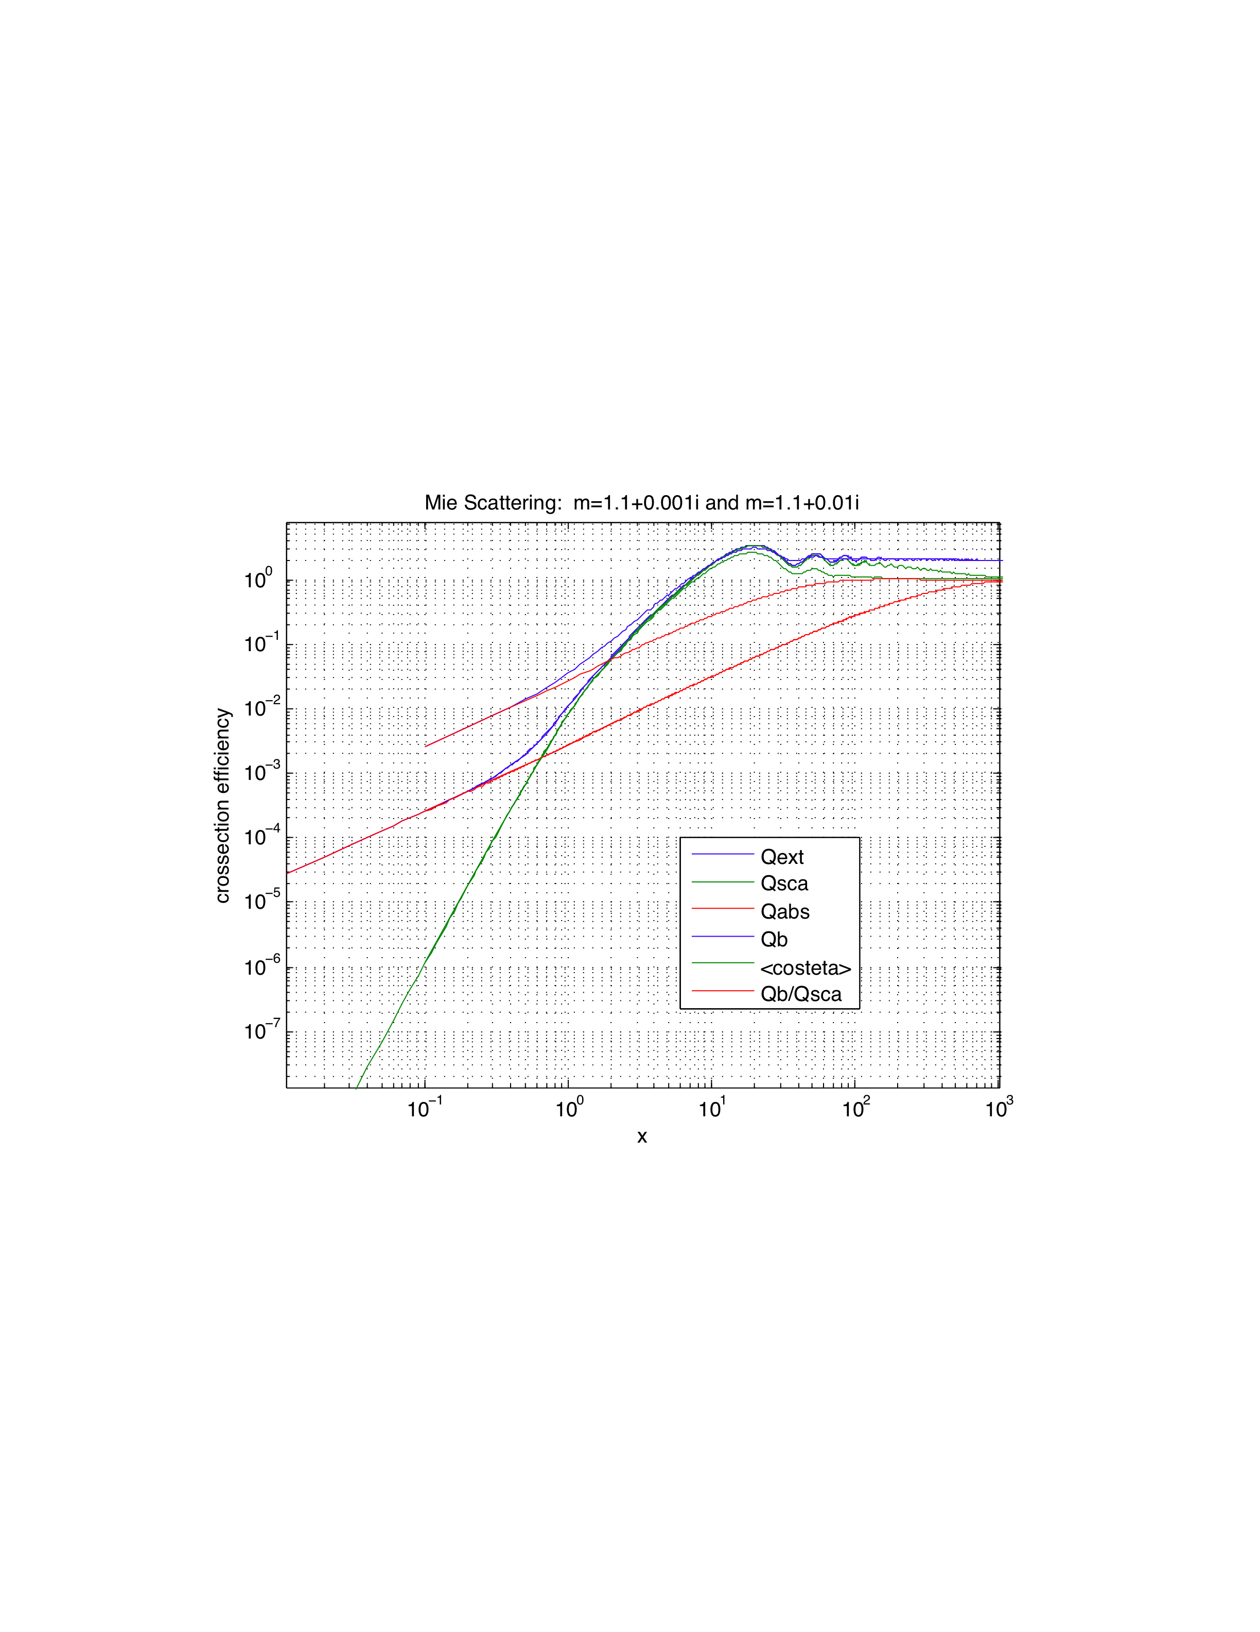
Rayleigh scattering
Rayleigh absorption
Geometric Optics
Figure showing Mie scattering dependence over 5 decades of x behavior. At small x, scattering is Rayleigh scattering and absorption. At large x, scattering is described by geometric optics.

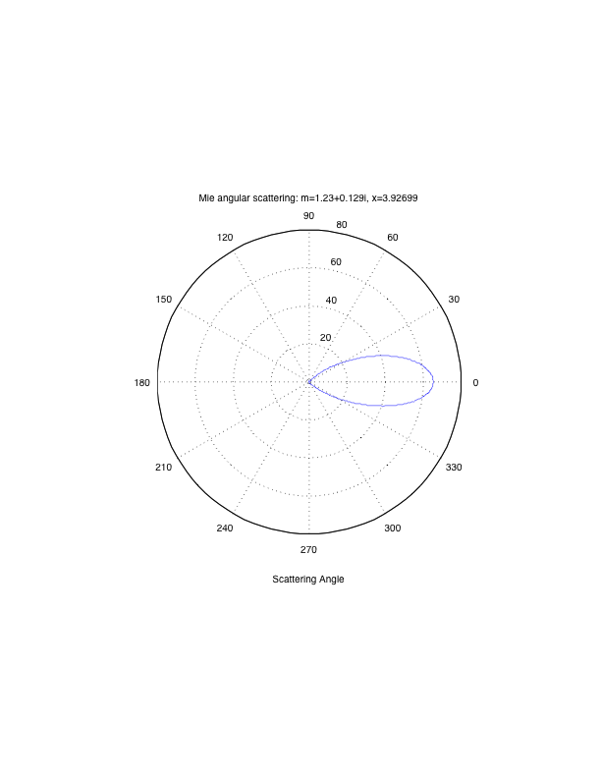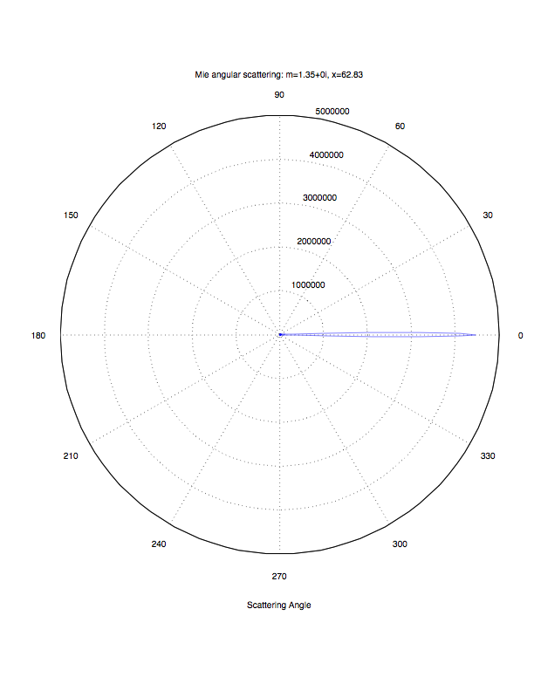
5 μ radius cloud scattering: 10 micron light 0.5 micron light (FWHM~4 deg)

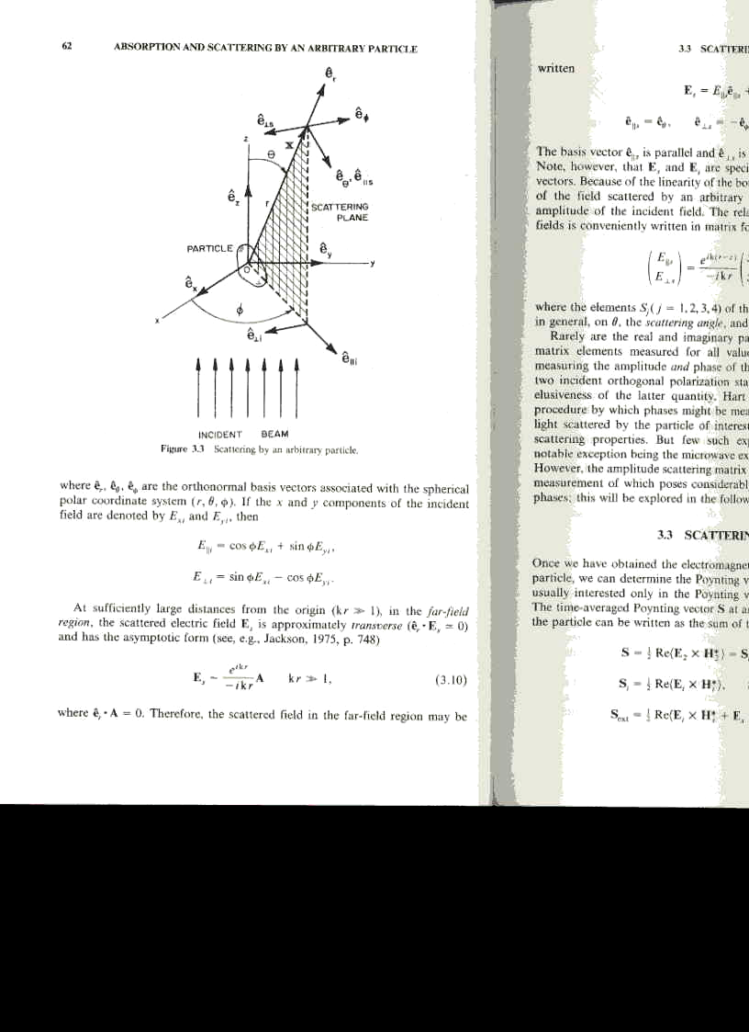
The figure defines the directions and the “scattering plane”. The incident beam is traveling in the +z direction. The scattering plane is defined by the plane with the // electric field and the direction of the scattered radiation. The two components of the electric field in the incident beam are the // and orthogonal component, ⊥, where the // is in the scattering plane.

Equation for the width of the forward scattered beam:
The half power occurs when x sinθ = 1.5. Since x~60 so sinθ = 1/40 and θ = 0.025 radians = 1.4 degrees. So full width half max (FWHM) is approximately 3 degrees.

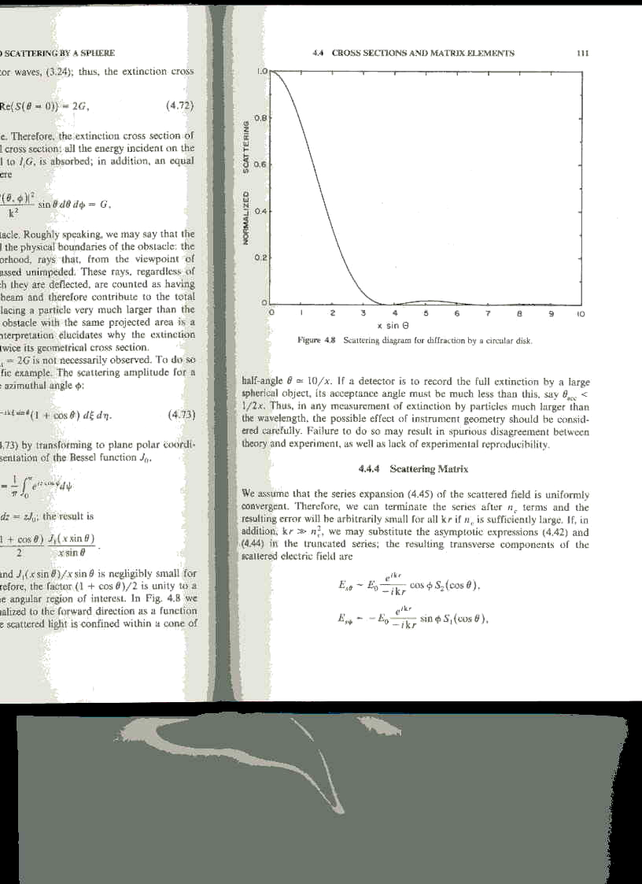

Dusty windshield: A dusty windshield looks so bright when the sun is nearly directly ahead because of this focused forward scattering effect when the particles are comparable to or larger than the wavelength of light. In fact, measuring the angle range over which the forward scattering is quite strong yields an estimate of the scattering particle size.

Reflection from clouds:
We know from experience that clouds are in general very bright reflectors of sunlight. However, the figure above indicates that most of the sunlight striking a cloud droplet is forward scattered. How is it that clouds look bright at almost any angle given that the light is forward scattered? The imaginary index of refraction of water is very small in the visible wavelength band. See fig 10.3 from page 275 of BH reproduced below.
Scattering by a single droplet only deflects the incident radiation by ~1.5 degrees. To have strong reflection at 180 degrees then requires roughly 100 scattering interactions. Each scattering occurs at a τ of ~1. So to be a bright reflector, a cloud must have a visible optical depth of order 100 or higher. Given the typical particle size, particle number density and the scattering efficiency we can calculate the necessary cloud thickness for a cloud to appear bright at visible wavelengths. At visible wavelengths and a spherical cloud droplet larger than the wavelength, Q_{sca} ~ 2. The reason the crosssection is a factor of 2 larger than the geometric crossection is due to diffraction. So under these conditions, the droplet Mie scattering crosssection is ~ 2 π a².

Assume a representative cloud water content (CWC) of 0.3 g/m³ and droplets of radius, a = 5 microns (see http://www-das.uwyo.edu/~geerts/cwx/notes/chap08/moist_cloud.html ) . The number of droplets per cubic meter is CWC/(4/3 π a³ ρ_{h2o}). The mass in each droplet is 5e-10 g so the number of particles per cubic meter is 6e8. The scattering crosssection per particle is 1.6e-10 m². The scattering crossectional area per cubic meter is therefore 1.6e-10 m²/droplet 6e8 droplets/m³ = 0.09 m⁻¹. So achieving an optical depth of 1 requires a cloud path of 11 m. A scattering optical depth of 100 requires an optical path through the cloud of ~1 km. This pathlength includes the path on the way down into the cloud and the path on the way back up and out of the cloud.
The reason a cloud can be so reflective with such a high optical depth is the imaginary part of the dielectric constant of water at visible wavelengths is very small with log(ε”)~ -8 so ε” ~ 0.0003, so there is almost no absorption. The scattered light passes through approximately 100 droplets or a total amount of water of ~1 mm.
Note that cloud ice crystals may have a larger cross-section per unit particle mass if the surface area to volume is larger than a sphere as it can be depending on the type of crystal. Remember, what we have been doing is Mie scattering which is applicable to spherical particles.
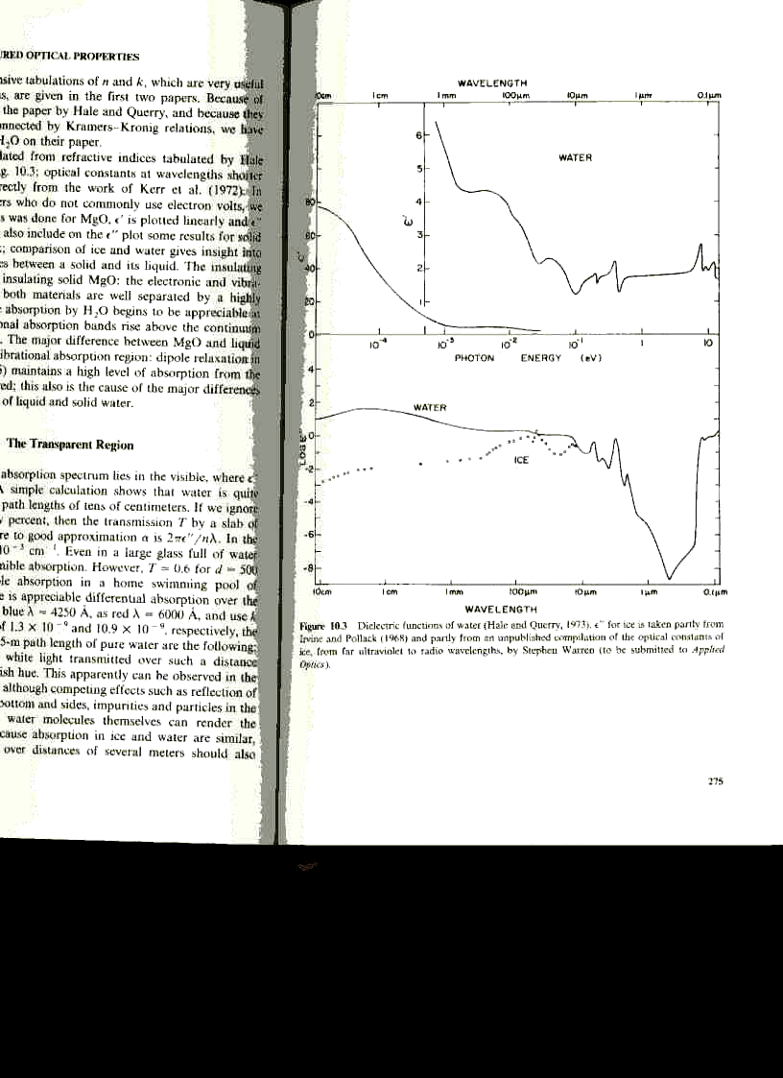
This figure shows the complex dielectric of water over an enormous range of wavelengths. The complex dielectric is ε = ε’ + iε”. Note that these values in the figure are the relative dielectric or permittivity, that is the permittivity relative to the permittivity in a vacuum, ε₀ = 8.854x10⁻¹² farads/meter.

Ice vs. water: Also note that the microwave permittivity, ε’, of ice is ~3.2. So the curve in the upper panel of the figure is for liquid water, not ice.

Note that the values of ε” are given as log₁₀(ε”) rather than ε”. So for water ice, near 1 mm wavelength, ε” = 10^{-1.75} = 0.018

The Mie scattering equations are written in terms of the complex index of refraction whereas the figure above is the complex dielectric of water. So we must convert between the two.

Relation between complex dielectric constant and complex index of refraction
Following the variables defined in BH, the complex index of refraction, N, is
$N=\sqrt{\frac{\text{em}}{e_{0}m}}$ and N=n+ik
where n and k are nonnegative. The absorption coefficient in the material is
α = 4πk/λ.

The relation between complex n and complex ε follows from (n+ik)² = ε’+i ε”:
$n+\text{ik}=\sqrt{e}=\sqrt{e'+e{\text{\} = \{ \{ sqrt \{ sqrt \{e' rSup \{ size 8\{2\} \} +e}}^{2}}+e'\frac{}{\sqrt{2}}±i\sqrt{\frac{\sqrt{e'^{2}+e{\text{ rSup \{ size 8\{2\} \} \} -e'\} \} over \{ sqrt \{2\} \} \} = \{ \{ left ( sqrt \{e' left ( sqrt \{1+ \{ \{e}}^{2}}}{e'^{2}}}+1\frac{}{\sqrt{2}}±i\sqrt{e'}$If ε’>> ε”, then this simplifies to
$$n+\text{ik}=\sqrt{e'\left(1+\frac{e{\text{ rSup \{ size 8\{2\} \} \} over \{4e' rSup \{ size 8\{2\} \} \} \} right )\} +- i sqrt \{ left ( \{ \{e}}^{2}}{4e'}\right)}=\sqrt{e'}$$

This relation allows us to use the figure above to plug in values of the complex index of refraction of water liquid and ice over a wide range of wavelengths into the Mie code to determine the scattering properties of individual spherical droplets

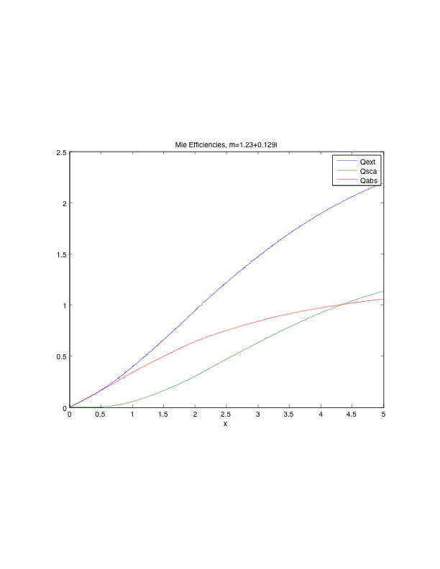
5 micron cloud droplet: Mie efficiencies at IR wavelengths. x=5: λ=6 microns, Absorption is larger at longer wavelengths. The index of refraction varies somewhat over this frequency range so this efficiency spectrum should be viewed as representative.

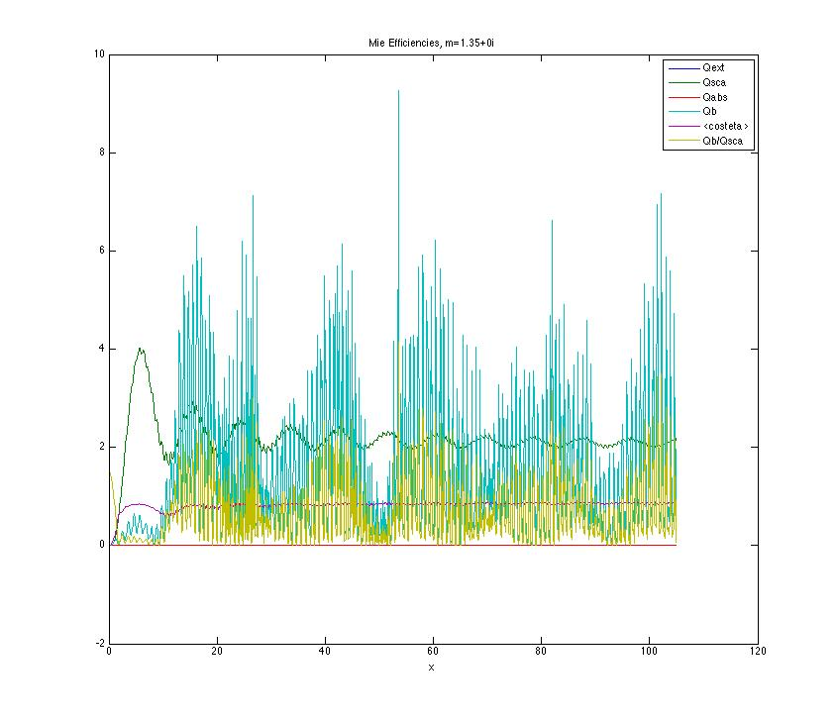
5 micron cloud droplet Mie efficiencies at visible wavelengths: Scattering dominates. The rapid variation with x is the interference pattern. With a distribution of particle sizes the fine scale structure will smooth out. x= 78.5: λ=0.4 microns (violet light). x=63: λ=0.5 microns (green light). x=45: λ=0.7 microns (red light).

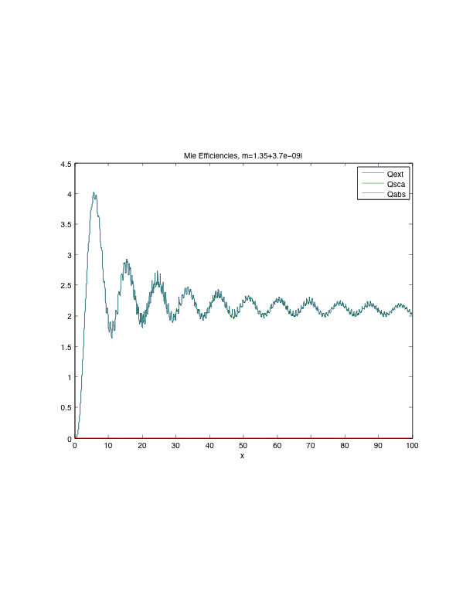
Same figure as above but with a (barely) finite imaginary index of refraction and only Q_{ext}, Q_{sca} and Q_{abs}.

At its minimum in the visible band, log₁₀(ε”) is -8 in Figure 10.3 from BH and ε” = 1e-8. The imaginary index of refraction (k) is therefore $k=e\text{\} over \{2 sqrt \{e'\} \} \} \} \{}$ = 3.7e-9 which is used in the figure above. The result is still essentially no absorption.

Backscatter Efficiency: definition problem with 4π factor
Comparison of the backscatter and scattering efficiencies reveals that the backscatter efficiency is larger. This should seem strange because the scattering efficiency is the efficiency of scattering integrated over all angles whereas the backscattering efficiency is only over the backward direction. So how can the efficiency of scattering over one direction be larger than the efficiency integrated over all directions? The answer is it can’t and the problem is an inconsistency in definition. The backscatter efficiency has been multiplied by 4π to create an equivalent efficiency as though the backscatter were true in all directions rather than just the back.

Wavelength dependence of the index of refraction
As BH point out, many figures have been produced where the index of refraction is constant and independent of wavelength which is in general a poor assumption. These figures are created because they are easy to generate. The figure below is much more work but physically far more correct because it includes the variation of index of refraction with wavelength.

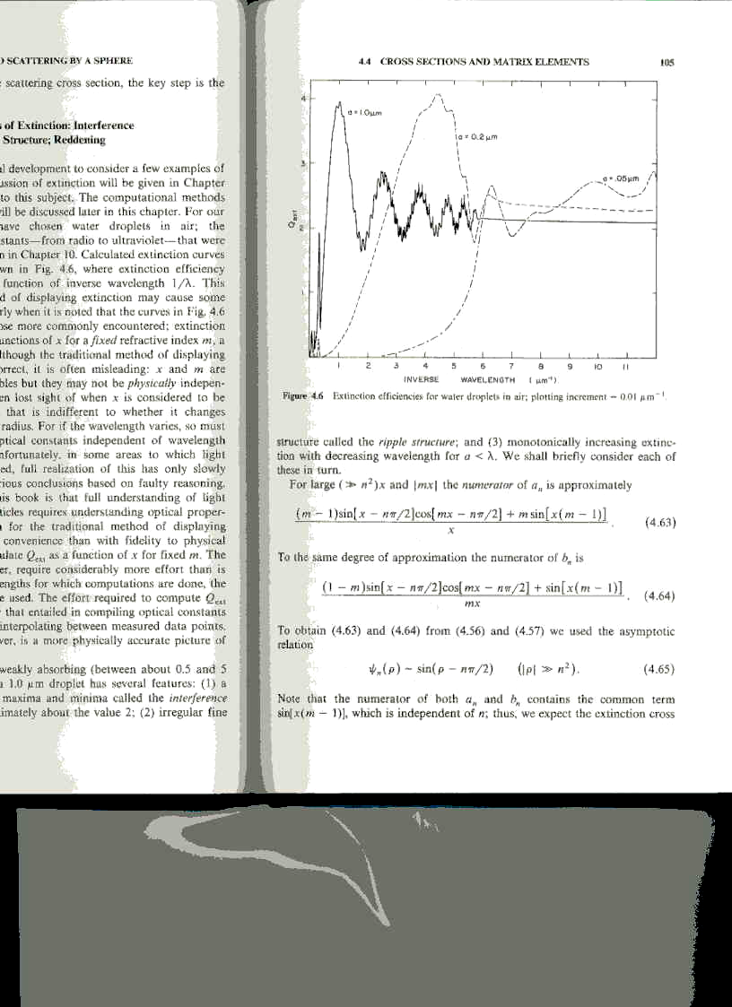

Effect of clouds near the 22 GHz and 183 GHz water lines

These lines probed by ATOMMS and other remote sensing systems.

m = 6+3i
5 micron radius cloud droplet
Q_{abs} ~ 0.0004

Peter Ray: Broadband Complex Refractive Indices of liquid water

Scattering at ATOMMS wavelengths
To obtain an estimate of the absorption caused by cloud ice particles for the ATOMMS measurements we consider a cloud of spherical water ice particles of 5 micron radius and larger. Now what are the absorption and scattering crosssections of the particles as a function of wavelength?
According to BH Figure 10-3, for a wavelength of 1.5 mm, ε” ~ 0.016 according to figure 10-3 of BH and for ε’ = 3.2, the imaginary part of the index of refraction of water ice, k, is 0.044 and the real part is 1.79. This is consistent with Jiang and Wu (2004) which indicate that ε” = 0.015 or lower at lower temperatures in which case the imaginary part of the index of refraction of water ice, k, is 0.0042 and the real part is still 1.79. Using a spherical ice particle of radius 5 microns, the particle’s absorption efficiency is 1.4663e-04 via Mie calculations and 0.000147 via Rayleigh scattering. Given the geometric cross-section of 7.85e-11 m², the electromagnetic crosssection is 1.15e-14 m².
The extinction coefficient in units of inverse length is the crosssection per particle times the number density of particles.
$$k_{\text{ext}}=n_{\text{part}}s_{\text{ext}}=n_{\text{part}}\left(s_{\text{abs}}+s_{\text{sca}}\right)=k_{\text{abs}}+k_{\text{sca}}$$
Assuming all the particles are the same size, the number density of particles is the mass of ice per unit volume (= ice water content, ‘IWC’) divided by the mass per particle which is the mass density of water ice times the particle volume. So the number density of particles is IWC/(ρ_{ice}*4/3πa³). For an IWC of 0.05 g/m³ (Davis et al., 2007) and a 5 micron radius particle volume of 5.24e-10 cm³, the number density of ice particles is 9.55e7 particles/m³. Under these conditions, the absorption coefficient, k_{abs}, at 1.5 mm due to water ice particles 5 microns in radius is 1.15e-14 m²/particle * 9.55e7 particles/m³ = 1.11e-6 m⁻¹.
So the optical depth through a cloud that extends 100 km would be
τ = 1.11e-6 m⁻¹ 1e5 m = 0.11.
Jiang and Wu (2004) report the largest effect on MLS observations comes from ice particles in the size range of 100-300 microns in diameter. This needs to be examined with Mie scattering because these sizes are not really in the Rayleigh range as we’ll see from the far field angular plots.

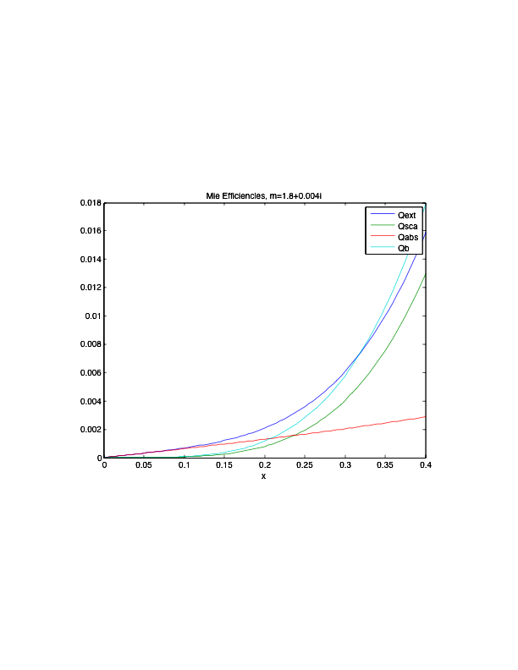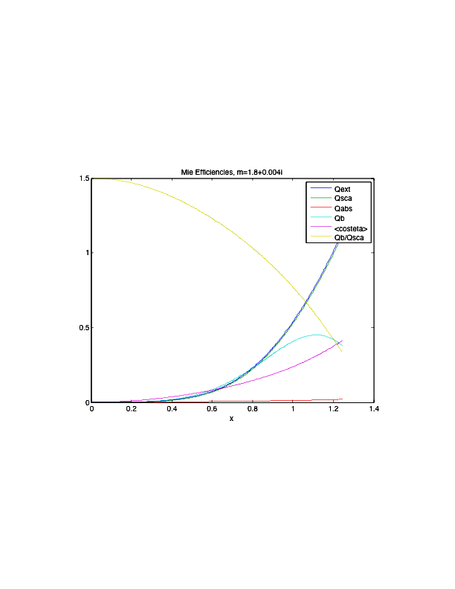
Fig. Mie scattering for pure water ice with m=1.8+0.004i (based on Jiang and Wu, 2004) and a 1.5 mm wavelength. The ice particle radius varies from 0 to 100 microns in Panel a and 0 to 300 microns in Panel b. Clearly scattering dominates over absorption for larger particles (larger x). In a, the transition from absorption-dominated extinction for smaller particles to scattering-dominated extinction for larger particles occurs at x=0.24 where particle radius is 60 microns. Over this range, the behavior is approximately Rayleigh scattering.

$$\left(\begin{matrix}E_{\text{//}s} \\ E_{\hat{s}}\end{matrix}\right)=\frac{e^{\text{ik}\left(r−z\right)}}{−\text{ikr}}\left(\begin{matrix}S_{2} & 0 \\ 0 & S_{1}\end{matrix}\right)\left(\begin{matrix}E_{\text{//}i} \\ E_{\hat{i}}\end{matrix}\right)$$
where
$S_{1}=\sum_{n}{\frac{2n+1}{n\left(n+1\right)}}\left(a_{n}p_{n}+b_{n}t_{n}\right)$
$S_{2}=\sum_{n}{\frac{2n+1}{n\left(n+1\right)}}\left(a_{n}t_{n}+b_{n}p_{n}\right)$

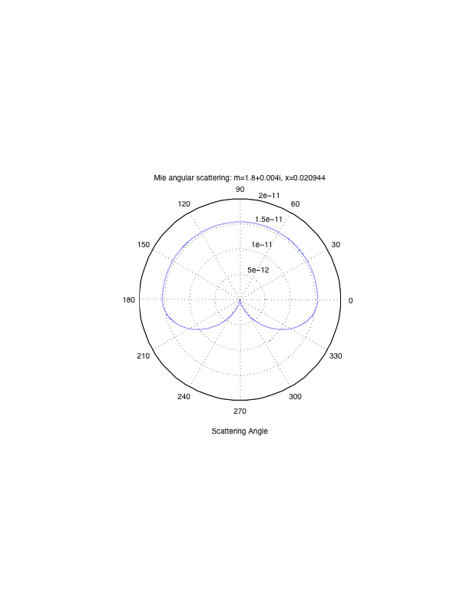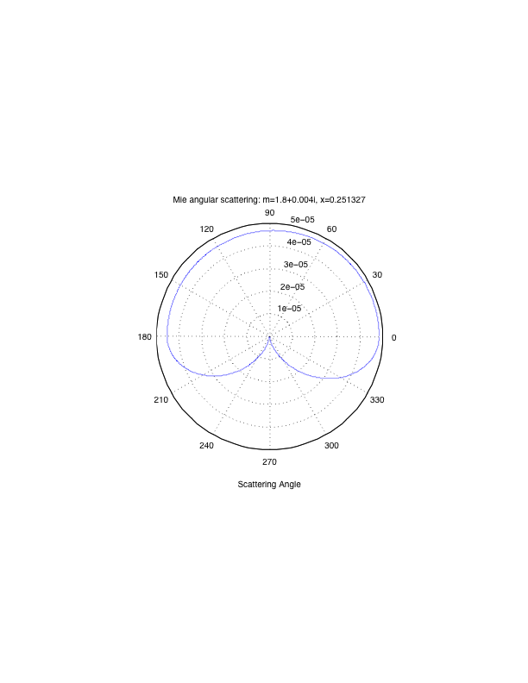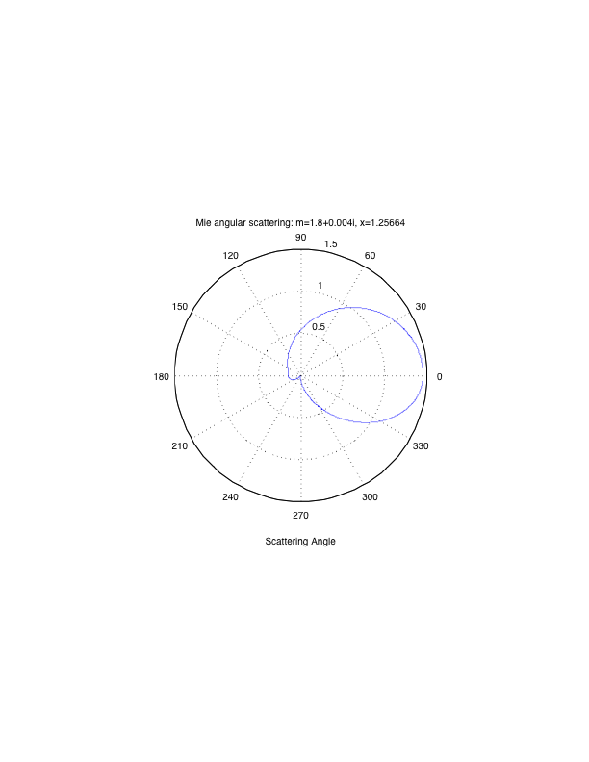
At 5 and 60 microns the scattering is well approximated as Rayleigh. At 300 microns the angular plot shows the scattering is NOT Rayleigh.

Extinction coefficient for mono-dispersion particle distribution
Assuming all particles have the same radius which gives the maximum particles at that radius for a given Ice Water Content (IWC) then the extinction coefficient is
$$k_{\text{ext}}=n_{\text{part}}s_{\text{ext}}=\frac{\text{IWC}}{ρ_{\text{ice}}\frac{4}{3}{pa}^{3}}Q_{\text{ext}}{pa}^{2}=\frac{3}{4}\frac{\text{IWC}}{ρ_{\text{ice}}a}\left(Q_{\text{abs}}+Q_{\text{scat}}\right)$$

Example: For λ=1.5 mm, a=300 microns, and IWC =0.05 g/m³, Q_{scat}~1 and Q_{abs} ~0.02 so that
k_{ext} = 1.25e-4 m⁻¹ (=0.75 * 5e-2 g/m^3 / 1e6 g/m^3 / 3e-4 m)
Through a cloud 100 km in extent, the scattering optical depth would be 1.25e-4 m⁻¹ 1e5 m = 12.5 which is quite large. So the signal intensity would be reduced by a factor of e^{-12.5} to be 4e-6 times smaller than the intensity in the absence of the cloud. This is an overestimate because 300 micron cloud particles are unusually large and it is unlikely the cloud particle size distribution would be dominated by cloud particles of this size.

In the Rayleigh regime, Q_{abs} scales linearly with x and therefore a for a fixed wavelength whereas Q_{scat} scales as x⁴ therefore with a⁴ for a fixed wavelength.
$$k_{\text{ext}}=\frac{3}{4}\frac{\text{IWC}}{ρ_{\text{ice}}a}\left(Q_{\text{abs}}+Q_{\text{scat}}\right)=\frac{3}{4}\frac{\text{IWC}}{ρ_{\text{ice}}a}\left(\frac{8pa}{λ}\text{Im}\left\{\frac{m^{2}−1}{m^{2}+2}\right\}+\frac{8}{3}{\left[\frac{2pa}{λ}\right]}^{4}{\left|\frac{m^{2}−1}{m^{2}+2}\right|}^{2}\right)$$
$$k_{\text{ext}}=\frac{3}{4}\frac{\text{IWC}}{ρ_{\text{ice}}}\left(\frac{8p}{λ}\text{Im}\left\{\frac{m^{2}−1}{m^{2}+2}\right\}+\frac{8}{3}{\left[\frac{2p}{λ}\right]}^{4}a^{3}{\left|\frac{m^{2}−1}{m^{2}+2}\right|}^{2}\right)$$
So, for a fixed wavelength and a mono-dispersed particle size distribution in the Rayleigh regime, the absorption portion has no dependence on the particle size and the scattering portion depends on a³ and is therefore proportional to the particle volume.

Wavelength dependence
While there is a weak wavelength dependence of ε”, the absorption crosssection of the particle depends inversely on the wavelength in the Rayleigh regime because the particle absorption efficiency depends linearly on x in the Rayleigh regime. For a wavelength 3% longer than 1.5 mm, the particle absorption efficiency changes to 6.7e-5 and the absorption coefficient is 5.03e-7 m⁻¹ which represents a fractional change of 3%. This inverse linear dependence on wavelength is larger than we would like for ATOMMS but, at least at 5 micron particle sizes, the absorption is quite small.

References
Davis, S. M., L. M. Avallone, E. M. Weinstock, C. H. Twohy, J. B. Smith, and G. L. Kok, Comparisons of in situ measurements of cirrus cloud ice water content, JOURNAL OF GEOPHYSICAL RESEARCH, VOL. 112, D10212, doi:10.1029/2006JD008214, 2007
Jonathan H. Jiang* and Dong L. Wu, Ice and water permittivities for millimeter and sub-millimeter remote sensing applications, Atmos. Sci. Let. 5: 146 – 151 (2004), Published online 15 November 2004 in Wiley InterScience (www.interscience.wiley.com). DOI: 10.1002/asl.77
SOFTWARE: A very useful website containing a wide array of electromagnetic scattering programs has been assembled by Thomas Wriedt at the University of Bremen:
http://diogenes.iwt.uni-bremen.de/vt/laser/wriedt/index_ns.html

