Radiative Transfer
Radiative transfer refers to the propagation, emission, absorption and scattering of light in the atmosphere, oceans and land. Its original purpose was to understand the transfer of energy thru and into the atmosphere and Earth to understand the transfer of energy radiatively into, within and out of the Earth. An understanding of radiative transfer is also critical to remote sensing of Earth’s atmosphere, surface and oceans which is increasingly useful and important for monitoring and predicting weather and climate.
Radiative transfer is fundamental to atmospheric science because the energy absorbed from the Sun largely determines the temperature of the Earth, which then determines the distribution of water between its three phases (ice and water vapor in particular) (which then affects the temperature of the Earth and so on…). The absorption of solar energy provides the kinetic energy available to do work (remember the heat engine concept) which drives Earth’s circulation. It also drives photochemistry such as ozone production and destruction and photochemical smog. When combined with the tilt, spin and orbit of the Earth, the absorption of solar energy drives the seasonal and diurnal cycles. The sun also has a coupled convection-magnetic field cycle that we call the 11 or 22 year solar cycle (solar cycle web site) that dramatically alters the UV output of the Sun directly and dramatically affecting temperatures in the thermosphere and less so in the stratosphere, and ozone amounts and may affect climate (e.g., solar v. climate).
Our motivation begins with the need to understand the basic energy balance of the planet, a version of which is shown in the Kiehl and Trenberth figure below. Understanding the fundamental energy flow and balance requires that we understand radiative transfer particularly at visible and IR wavelengths. In the stratosphere and above, Solar UV is also very important as an energy source. For remote sensing, the range of useful wavelengths spans (at least) microwave to UV. In this class, we introduce the basics of radiative transfer which represent a large topic of research in atmospheric science. Key elements of radiative transfer include how the radiative energy is emitted, transmitted, scattered and absorbed.

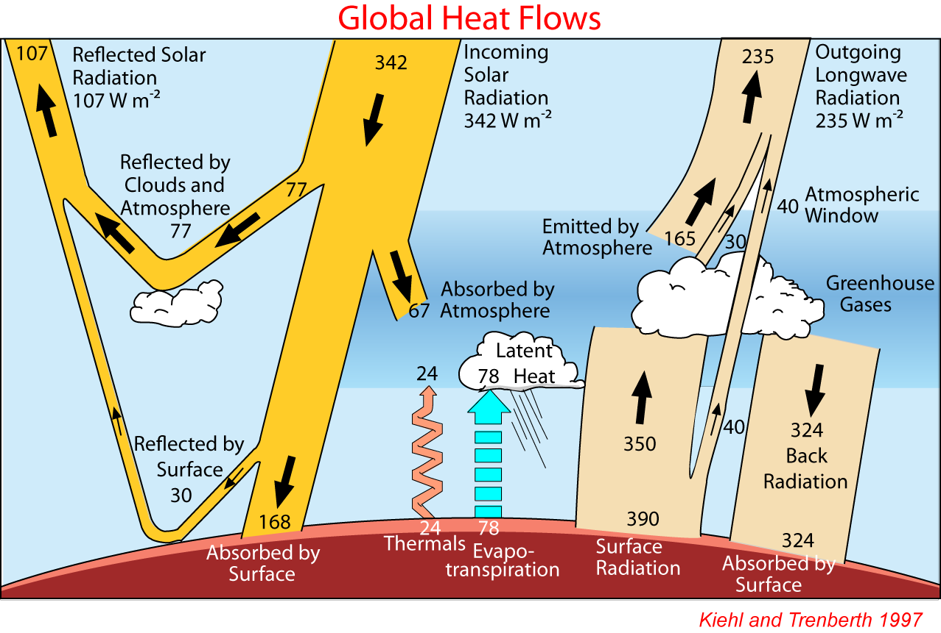
We begin with natural sources of radiation, focusing on the Planck function (“black body radiation”) that describes the spectrum of most of the solar radiation output and the thermal radiation emitted by the Earth. Then we will introduce the concept of optical depth which defines how light is attenuated as it propagates through a medium. It is also one of the key variables that determines how light is emitted by a medium. As we do this we will introduce the spectral properties of gases which require a more complex representation than the Planck function.
The Figure below shows the normalized black body curves for the Sun and Earth spanning UV, visible, near-IR, mid-IR, into the sub-mm spectral range. It also shows the gaseous (non-cloud) atmospheric absorption across this spectral range at two altitudes, the surface and 11 km altitude which is above about 75% of the atmosphere. It is evident that most of the solar radiation gets thru the atmosphere (under clear conditions) while much of the IR is absorbed by the atmosphere which leads to the greenhouse effect.

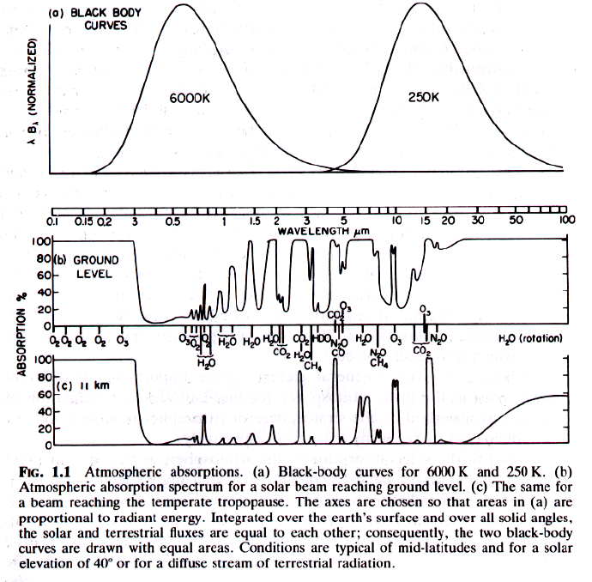
From Goody & Yung

