Gravity, Geopotential, Geoid and Satellite Orbits

Much of this introductory material on gravity comes from Turcotte and Schubert (1982). The satellite orbit material comes from Elachi and van Zyl (2006).

Gravitational acceleration
The gravitational force between two point masses, M and m, pulling on one another is:
${\vec{F}}_{g}\text{=-}\frac{\text{GMm}}{r^{2}}\hat{r}$
where G is the gravitational constant = 6.67300 × 10⁻¹¹ m³ kg⁻¹ s⁻² and r is the distance between the centers of the two masses in meters. The minus sign means the force of gravity pulls the masses toward one another. Since F = ma, the gravitational acceleration felt by mass, m, is simply
a = GM/r² (1)
Consider Earth’s surface gravity. We assume at first that Earth is a perfect sphere so that it can be treated as a point mass. Given Earth’s mass =5.9736e24 kg and its average radius of 6.37101x10⁶ m. The resulting surface gravity is 9.820660317 m/s². This is quite close to the standard average surface gravity of 9.80665 m/s².
Note: GM is known far better than G or M.

Issues related to Earth Spin…

Earth is not a sphere
The Earth gravitational acceleration we feel includes the effects of the Earth’s spin. There are two first order effects to be considered, the Earth is no longer a sphere and cannot be rtreated as a point mass and there is centrifugal force to be considered. Because of the spin of the Earth, the Earth has an equatorial bulge such that its equatorial radius is larger than its polar radius by about 20 km. This means a location at the pole is actually slightly closer to the Earth’s center than a location on the equator. Therefore we can anticipate that the surface gravity at the pole is slightly larger than the surface gravity at the equator (see Table below).
The acceleration at the surface of Earth due to the force of gravity (which includes the effect of the greater radius at the equator) is
$g\text{=-}\frac{\text{GM}}{r^{2}}+\frac{3{\text{GMa}}^{2}J_{2}}{2r^{4}}\left(3{\text{sin}}^{2}f−1\right)$
where a is Earth’s equatorial radius and φ is the latitude and J₂ is the second spherical harmonic of Earth’s gravitational field (=1.08263e-3) which is a measure of Earth’s equatorial bulge.
Notice in this simple treatment there is no longitudinal dependence. In a more complex treatment of the gravity there is longitudinal dependence as well.

Centrifugal force
From the simple harmonic oscillator, we know the centrifugal force felt at the surface of the Earth due to the rotation of the Earth is
$g_{w}=w^{2}s$
where ω is the angular velocity (=2 π /86164 seconds = 7.29e-5 radians/sec) and s is the perpendicular distance from the spin axis which is given as
s = r cos φ
where r is the distance from the center of the Earth to the surface location being considered and φ is again the latitude. Therefore the centrifugal acceleration at Earth’s surface is
$g_{w}=w^{2}r\text{cos}f$
The magnitude of this centrifugal acceleration is largest at the equator where it is equal to 0.0339 m/s². This is about 0.35% of the acceleration due to the force of gravity. The gravitational acceleration we feel at the surface defines the apparent local radial direction. So the component that is relevant to gravity is the radial component which is
$g_{r}'=g_{w}\text{cos}f=w^{2}r{\text{cos}}^{2}f$
Note that this is positive because it is an outward or upward acceleration so it decreases the acceleration due to the force of gravity.
The full equation of gravity that includes the first order effect of spin is
$g\text{=-}\frac{\text{GM}}{r^{2}}+\frac{3{\text{GMa}}^{2}J_{2}}{2r^{4}}\left(3{\text{sin}}^{2}f−1\right)+w^{2}r{\text{cos}}^{2}f$
I have compared this equation to a far more sophisticated equation of gravity derived from many years of satellite data and found it to be good to several parts in 10⁴.
The table below shows the contributions of the three terms.

 | equatorial | polar | Units
radius | 6378.139 | 6356.7523 | km
latitude | 0 | 1.570796 | radians
GM/r^2 | -9.798280 | -9.864322 | m/s²
3GMa²J₂/2r⁴ | -0.015912 | 0.032038 | m/s²
centrifugal | 0.033916 | 0 | m/s²
Total gravity | -9.780277 | -9.832284 | m/s²
So the equatorial gravity is indeed less than the polar gravity but not as much as the GM/r² term would imply by itself.

Sidereal day versus solar day (what’s my frame of reference)
In order to calculate the spin rate of the Earth for the centrifugal term, we need to know the length of a day. What is the length of a day? This may seem like an obvious question but actually it is not and the answer depends on the frame of reference you choose.
In what we normally call a year, the Earth rotates around the sun once per year. This number of days is actually one rotation less in comparison to the number of rotations relative to absolute space. A “sidereal” day is slightly shorter than a “solar day” because the Earth does not have to rotate quite as far to make a full revolution relative to absolute space as it does for the sun to come directly overhead again. So there are 366.25 sidereal days per year compared to 365.25 solar days per year. So the length of a sidereal day is 365.25/366.25 * 86,400 sec = 86,164 sec. (Note there is a slight mistake in Elachi and Van Zyl on page 528).

Points to a location in absolute space
Points to the sun

Change in gravity with altitude
We can examine the radial dependence of gravity by performing a Taylor expansion of the gravitational acceleration around the value at the surface.
$g\text{=-}\frac{\text{GM}}{r^{2}}+\frac{3{\text{GMa}}^{2}J_{2}}{2r^{4}}\left(3{\text{sin}}^{2}f−1\right)+w^{2}r{\text{cos}}^{2}f$
The vertical gradient of g is
$\frac{¶g}{¶r}\text{=+}2\frac{\text{GM}}{r^{3}}−\frac{6{\text{GMa}}^{2}J_{2}}{r^{5}}\left(3{\text{sin}}^{2}f−1\right)+w^{2}{\text{cos}}^{2}f$
The dominant term is the first term. Consider the fractional change in g with height.
$\begin{aligned}\frac{¶g}{g¶r}=\frac{¶\text{ln}g}{¶r}=\frac{−2\frac{\text{GM}}{r^{3}}+\frac{6{\text{GMa}}^{2}J_{2}}{r^{5}}\left(3{\text{sin}}^{2}f−1\right)−w^{2}{\text{cos}}^{2}f}{\frac{\text{GM}}{r^{2}}} \\ \text{=-}\frac{2}{r}+\frac{6a^{2}J_{2}}{r^{3}}\left(3{\text{sin}}^{2}f−1\right)−\frac{w^{2}{\text{cos}}^{2}f}{\frac{\text{GM}}{r^{2}}}\end{aligned}$
r is approximately 6,371,000 m.
 | Point mass term | J₂ term | Centrifugal term | Units
dlng/dr | -3e-7 | ~3e-9 | -5e-10 | m⁻¹

So at 10 km =10⁴ m altitude the fractional change in g relative to the surface is 0.3%. For many applications this can be ignored. For some high precision applications, it cannot.

Geopotential and the geoid
The potential energy of an object in Earth’s gravity field can be determined by integrating the work done by the gravitational force in taking the object from an infinite distance to a finite distance r from Earth
$\frac{DW}{m}=\frac{\int_{¥}^{r'}{\text{dW}}}{m}=\int_{¥}^{r'}{\text{gdr}}=\int_{¥}^{r'}{\left[−\frac{\text{GM}}{r^{2}}+\frac{3{\text{GMa}}^{2}J_{2}}{2r^{4}}\left(3{\text{sin}}^{2}f−1\right)\right]}\text{dr}$
$\frac{DW}{m}\text{=-}\frac{\text{GM}}{r}+\frac{{\text{GMa}}^{2}J_{2}}{2r^{3}}\left(3{\text{sin}}^{2}f−1\right)ºV\left(r\right)$
The centrifugal term has not been included in the integral because it assumes a rigid rotation with the spin of the Earth which, at a distance of infinity, produces an infinite and unphysical rotational velocity. V is known as the gravitational potential which is the gravitational potential energy of a mass divided by its mass.
A gravity potential, U, that accounts for both gravitation and rotation we can take the integral of the gravity equation:
$U\left(r\right)\text{=-}\frac{\text{GM}}{r}+\frac{{\text{GMa}}^{2}J_{2}}{2r^{3}}\left(3{\text{sin}}^{2}f−1\right)−\frac{1}{2}w^{2}r^{2}{\text{cos}}^{2}f$

The “equipotential” surface and why we care
As you move along a surface on which the gravitational potential energy changes as you move along it, you will feel a force either pushing against you or accelerating you. Unlike a solid surface whose strength can oppose this force (so long as the force is not stronger than the solid’s strength), a fluid surface will respond to this force by moving and adjusting until its surface shape changes and there is no remaining horizontal force. Therefore (in the absence of other forces) the ocean surface is a surface along which the gravitational potential energy is constant. Such a surface is a called an equipotential surface. The reference equipotential surface that defines sea level is called the geoid.
The equatorial sea level geopotential (where φ = 0) is
$U\left(r=a\right)\text{=-}\frac{\text{GM}}{a}−\frac{{\text{GMJ}}_{2}}{2a}−\frac{1}{2}w^{2}a^{2}{ºU}_{0}$
The polar sea level geopotential (where φ=π/2) is
$U\left(r=r_{\text{pol}}\right)\text{=-}\frac{\text{GM}}{r_{\text{pol}}}+\frac{{\text{GMa}}^{2}J_{2}}{r_{\text{pol}}^{3}}{ºU}_{0}$
The flattening or ellipticity of this geoid is defined by
$f=\frac{a−r_{\text{pol}}}{a}=1−\frac{r_{\text{pol}}}{a}$
$r_{\text{pol}}=a\left(1−f\right)$
We assume that the Earth’s sea level surface is a geopotential and set the equatorial and polar geopotentials equal to get
$−\frac{\text{GM}}{a}−\frac{{\text{GMJ}}_{2}}{2a}−\frac{1}{2}w^{2}a^{2}\text{=-}\frac{\text{GM}}{r_{\text{pol}}}+\frac{{\text{GMa}}^{2}J_{2}}{r_{\text{pol}}^{3}}$
$1+\frac{J_{2}}{2}+\frac{1}{2}\frac{w^{2}a^{3}}{\text{GM}}=\frac{a}{r_{\text{pol}}}−\frac{a^{3}J_{2}}{r_{\text{pol}}^{3}}=\frac{a}{r_{\text{pol}}}\left(1−\frac{a^{2}J_{2}}{r_{\text{pol}}^{2}}\right)$
Subbing $r_{\text{pol}}=a\left(1−f\right)$ and only using first order terms in f and J₂ which are both very small yields
$1+\frac{J_{2}}{2}+\frac{1}{2}\frac{w^{2}a^{3}}{\text{GM}}=\frac{a}{a\left(1−f\right)}\left(1−\frac{a^{2}J_{2}}{a^{2}{\left(1−f\right)}^{2}}\right)=\frac{1}{\left(1−f\right)}\left(1−\frac{J_{2}}{{\left(1−f\right)}^{2}}\right)$
$1+\frac{J_{2}}{2}+\frac{1}{2}\frac{w^{2}a^{3}}{\text{GM}}=\left(1+f\right)\left(1−\frac{J_{2}}{{\left(1−f\right)}^{2}}\right)=1+f−J_{2}$
$f=\frac{3J_{2}}{2}+\frac{1}{2}\frac{w^{2}a^{3}}{\text{GM}}$
Plugging in values of J₂ = 1.08270x10⁻³ and a³ω²/GM = 3.46775x10⁻³ yields a value of f of 3.3579x10⁻³. The true value, 3.35282x10⁻³, is quite close.

The shape of the model geoid is nearly that of a spherical surface. Defining r₀ as the distance to the geoid surface
$r_{0}=a\left(1−e\right)$
where ε << 1. Subbing this into
$U\left(r\right)\text{=-}\frac{\text{GM}}{r}+\frac{{\text{GMa}}^{2}J_{2}}{2r^{3}}\left(3{\text{sin}}^{2}f−1\right)−\frac{1}{2}w^{2}r^{2}{\text{cos}}^{2}f$
yields
$U_{0}\text{=-}\frac{\text{GM}}{a\left(1−e\right)}+\frac{{\text{GMa}}^{2}J_{2}}{2a^{3}{\left(1−e\right)}^{3}}\left(3{\text{sin}}^{2}f−1\right)−\frac{1}{2}w^{2}a^{2}{\left(1−e\right)}^{2}{\text{cos}}^{2}f$
We then set this equal to the value of U_{o} that we got at the equator
$U_{0}ºU\left(r=a\right)\text{=-}\frac{\text{GM}}{a}−\frac{{\text{GMJ}}_{2}}{2a}−\frac{1}{2}w^{2}a^{2}$
We then solve for ε.
$\frac{−\frac{\text{GM}}{a}−\frac{{\text{GMJ}}_{2}}{2a}−\frac{1}{2}w^{2}a^{2}}{\text{GM}}\text{=-}\frac{1}{a\left(1−e\right)}+\frac{J_{2}}{2a{\left(1−e\right)}^{3}}\left(3{\text{sin}}^{2}f−1\right)−\frac{1}{2}\frac{w^{2}a^{2}}{\text{GM}}{\left(1−e\right)}^{2}{\text{cos}}^{2}f$
$−\frac{1}{a}−\frac{J_{2}}{2a}−\frac{1}{2}\frac{w^{2}a^{2}}{\text{GM}}\text{=-}\frac{1}{a\left(1−e\right)}+\frac{J_{2}}{2a{\left(1−e\right)}^{3}}\left(3{\text{sin}}^{2}f−1\right)−\frac{1}{2}\frac{w^{2}a^{2}}{\text{GM}}{\left(1−e\right)}^{2}{\text{cos}}^{2}f$
$−\frac{1}{a}−\frac{J_{2}}{2a}−\frac{1}{2}\frac{w^{2}a^{2}}{\text{GM}}\text{=-}\frac{1}{a\left(1−e\right)}+\frac{J_{2}}{2a\left(1−3e\right)}\left(3{\text{sin}}^{2}f−1\right)−\frac{1}{2}\frac{w^{2}a^{2}}{\text{GM}}\left(1−2e\right){\text{cos}}^{2}f$
$−1−\frac{J_{2}}{2}−\frac{1}{2}\frac{w^{2}a^{3}}{\text{GM}}\text{=-}\left(1+e\right)+\frac{J_{2}\left(1+3e\right)}{2}\left(3{\text{sin}}^{2}f−1\right)−\frac{1}{2}\frac{w^{2}a^{3}}{\text{GM}}\left(1−2e\right){\text{cos}}^{2}f$
$0\text{=-}1+1−e+\frac{J_{2}}{2}+\frac{J_{2}\left(1+3e\right)}{2}\left(3{\text{sin}}^{2}f−1\right)−\frac{1}{2}\frac{w^{2}a^{3}}{\text{GM}}\left(1−2e\right){\text{cos}}^{2}f+\frac{1}{2}\frac{w^{2}a^{3}}{\text{GM}}$
$0\text{=-}e+\frac{J_{2}}{2}\left[1+\left(1+3e\right)\left(3{\text{sin}}^{2}f−1\right)\right]+\frac{1}{2}\frac{w^{2}a^{3}}{\text{GM}}\left[1−\left(1−2e\right){\text{cos}}^{2}f\right]$
$e−e\frac{3J_{2}}{2}\left(3{\text{sin}}^{2}f−1\right)−2e\frac{1}{2}\frac{w^{2}a^{3}}{\text{GM}}{\text{cos}}^{2}f=\frac{J_{2}}{2}\left[1+3{\text{sin}}^{2}f−1\right]+\frac{1}{2}\frac{w^{2}a^{3}}{\text{GM}}\left[1−{\text{cos}}^{2}f\right]$
$e\left[1−\frac{3J_{2}}{2}\left(3{\text{sin}}^{2}f−1\right)−\frac{w^{2}a^{3}}{\text{GM}}{\text{cos}}^{2}f\right]=\frac{J_{2}}{2}\left[1+3{\text{sin}}^{2}f−1\right]+\frac{1}{2}\frac{w^{2}a^{3}}{\text{GM}}\left[1−{\text{cos}}^{2}f\right]$
$e=\frac{\frac{J_{2}}{2}\left[3{\text{sin}}^{2}f\right]+\frac{1}{2}\frac{w^{2}a^{3}}{\text{GM}}\left[1−{\text{cos}}^{2}f\right]}{\left[1−\frac{3J_{2}}{2}\left(3{\text{sin}}^{2}f−1\right)−\frac{w^{2}a^{3}}{\text{GM}}{\text{cos}}^{2}f\right]}$
$e=\frac{J_{2}}{2}\left[3{\text{sin}}^{2}f\right]+\frac{1}{2}\frac{w^{2}a^{3}}{\text{GM}}\left[1−{\text{cos}}^{2}f\right]=\frac{J_{2}}{2}\left[3{\text{sin}}^{2}f\right]+\frac{1}{2}\frac{w^{2}a^{3}}{\text{GM}}\left[{\text{sin}}^{2}f\right]$
$e=\left(\frac{3}{2}J_{2}+\frac{1}{2}\frac{w^{2}a^{3}}{\text{GM}}\right){\text{sin}}^{2}f$

So the surface of the geoid is defined as
$r_{0}=a\left[1−\left(\frac{3}{2}J_{2}+\frac{1}{2}\frac{a^{3}w^{2}}{\text{GM}}\right){\text{sin}}^{2}f\right]$
which is also
$r_{0}=a\left(1−f{\text{sin}}^{2}f\right)$
A better model is
$r_{0}=a{\left[1+\frac{\left(2f−f^{2}\right)}{{\left(1−f\right)}^{2}}{\text{sin}}^{2}f\right]}^{{−1}/2}$
with a = 6378.139 km and f = 1/298.256.
The actual geoid is known to much higher precision and is being updated most recently by the Gravity Recovery And Climate Experiment (GRACE). Note that GRACE actually measures the time-evolving gravity field and geoid.

See http://earthobservatory.nasa.gov/Library/GRACE_Revised/page3.html

The geoid is critical as a reference surface that determines what the surface of the ocean should be in the absence of any dynamics, that is ocean currents. One way currents reveal themselves to satellites is as topography on the ocean surface relative to the geoid. This is the result of geostrophic balance of the pressure gradient and the coriolis forces.

Satellite Orbits

For observing weather and climate related phenomena, there are 2 main classes of satellite orbits, geosynchronous (or geostationary) and low Earth orbit (LEO).
We will discuss circular orbits primarily. While it takes 6 orbital “elements” to uniquely define a satellite orbit, from our perspective, the main features of an orbit are its radius or altitude, orbital period, orbital velocity, inclination, times of day crossing the equator (“longitude of the ascending node”) and precession rate. These are not independent of one another.

Inclination
Inclination refers to the tilt of the orbital plane relative to the equatorial plane of the Earth. A 0º inclination has a plane coincident with the plane of Earth’s equator and orbits with the same rotation as the Earth’s spin. A 90º inclination is exactly a polar orbit, orthogonal to the Earth’s equatorial orbit. A 180º inclination is also coincident with Earth’s equatorial plane but the satellite orbits in the opposite direction as the Earth’s spin and is said to be a “retrograde” orbit. Getting into such an orbit is expensive energetically (=bigger launch vehicle) because the launch vehicle cannot take advantage of the momentum of the Earth’s spin (~0.5 m/sec) at launch.
Choice of inclination is often set by the desired latitudinal coverage. If you want coverage that extends from pole to pole, you need an inclination that is nearly polar or at least a high inclination of 70-110º. Repeat cycle is another important consideration.
Further refinement of the choice will also depend on if your instrument looks downward (nadir-viewing) or is looking at the Earth’s limb (limb-viewing). An orbit for a nadir viewing instrument will have to be closer to a polar orbit depending on how far off nadir the instrument looks as it scans. If it looks exactly nadir like the CloudSat cloud profiling radar and you want pole to pole coverage then the orbit would have to be exactly polar.
If the instruments are limb-viewing then a 70 degree orbit may suffice depending on the altitude of the orbit. For a given radius, what is the minimum inclination, I_{min}, necessary for a limb viewing instrument to see the pole from an orbit with altitude, h? The answer is
sin(I_{min}) = R_{E}/r = R_{E}/(R_{E} + h) = 1/(1 + h/R_{E})
where is R_{E} the Earth’s radius and r is the orbital radius = R_{E} + h.
Orbital plane, edge-on
For h=750 km, I_{min} = 63.5º. This is the minimum inclination to just see the pole, so the actual inclination used will be somewhat larger.
R_{E}
I
h
Equatorial plane, edge-on

Geostationary orbits
Geostationary orbits have a 24 hour period such that the satellite sits over the same longitude of the Earth and can see the entire diurnal cycle, particularly cloud tops. Circular geostationary orbits are equatorial orbits with an inclination of 0º.

LEO satellites
Low Earth orbits have altitudes typically ranging from 500 to 850 km and orbital periods are about 100 minutes. A special class of near-polar orbits is sun-synchronous so they always measure the same 2 times of day or more generally precessing where the local time of the observations drifts. (near-)polar orbiters are used to observe high latitudes.
The lower altitude limit of usable orbits is set by atmospheric drag which causes the orbital altitude to decay such that the orbit is not stable and the satellite will eventually reenter the Earth’s atmosphere. The density of the atmosphere at these altitudes varies with the 11 year solar cycle. The reason is as the sun emits more UV and higher energy radiation during the solar cycle maximum (due to a 22 year convective-magnetic field cycle on the sun), this energy is absorbed by the upper atmosphere causing the atmosphere to warm and expand. This pushes the atmospheric density structure to higher altitudes at the peak of the solar cycle causing more drag on spacecraft. The lowest altitude orbits are chosen to be closer to the surface, often for purposes of imaging resolution, to achieve higher signal to noise ratio (SNR) for active instruments with limited transmit power or increased sensitivity to variations in the Earth’s gravity field. Altitudes higher than ~1000 km are avoided when possible to avoid higher radiation levels there from energetic particles which drive up the cost of the instrument and satellite electronics.

Orbital period for circular orbits: Harmonic oscillator
The simple motion of a satellite in a circular orbit around spherical planet can be described in terms of sine and cosines.
y(t) = r sin(+2πt/T), x(t) = r cos(+2πt/T)
where T is the orbital period and r is the orbital radius and t is time. The + refers to the direction the satellite moves in its orbit, clockwise or counterclockwise. For the moment we are interested in magnitudes so we’ll drop the +. The velocities components are
v_{y}(t) = 2π r/T cos(2πt/T), v_{x}(t) = - 2π r/T sin(2πt/T) (2)
The centripetal accelerations are
a_{y}(t) = -r (2π/T)² sin(2πt/T), a_{x}(t) = - r (2π/T)² cos(2πt/T) (3)
We set the magnitude of this centripetal acceleration, r (2π/T)², equal to the gravitational acceleration to determine the orbital period versus radius
r (2π/T)² = GM/r²
from which we get Kepler’s famous law: r³ α T²:
T² = (2π)² r³/GM
Alternatively we can write the gravitational acceleration in terms of the surface gravitational acceleration, g_{s}, which on average is 9.81 m/sec² for the Earth.
a = GM/r² = g_{s} R_{E}²/r²
where R_{E} is the radius of the planet in general or in this case the Earth. Again for a circular orbit, the radial gravitational acceleration equals the magnitude of the centripetal acceleration
r³ (2π/T)² = g_{s} R_{E}²
In this form,
T = 2π (r^{3/2}/R_{E})/g_{s}^{1/2} or r = [g_{s} R_{E}²(T/2π)²]^{1/3} (4)
geostationary
GPS
LEO
LEO

Orbital Velocity
From equation (2), the magnitude of the orbital velocity, V₀, is 2π r/T. Combining this with (4) yields
V₀ = 2π r/T = 2π r g_{s}^{1/2} /[2π (r^{3/2}/R_{E})] = R_{E} r^{-1/2} g_{s}^{1/2} (5)
{Check units: m m^{-1/2} m^{1/2} s⁻¹ = m/s }

As the Figure shows, LEO velocities are around 7 km/sec (actually 7.5 km/sec for the typical altitude range of 500 to 850 km altitude). The velocity scales inversely with the square root of the orbital radius, so the velocity decreases as the orbital radius increases. The velocity of a geosynchronous orbit is about (7/42)^{1/2} or 40% of that of a LEO or 3 km/sec.
We care about orbital velocity because from LEO it limits how long we can view a location on Earth. Our instruments must be designed with this in mind.

Orbital Precession
The orientation of the orbital plane is defined relative to absolute space (NOT relative to the changing direction from the center of the Earth to the center of the sun). The orbital plane precesses in general depending primarily on the orbital inclination and the J₂ of the planet which is the second zonal harmonic of the Earth’s geopotential field. J₂ is essentially a measure of the equatorial bulge. The precession rate is given as
dΩ/dt = -3/2 J₂ R_{E}³ g_{s}^{1/2} cos(I)/r^{7/2} (6)
where Ω is the longitude of the ascending node, and I is the orbital inclination
check units: m³ m^{1/2} s⁻¹ m^{-7/2} = s⁻¹ = rad/sec
Additional points:
- Note that a perfectly polar orbit (I = 90º) does not precess.
- For an orbit to precess in the same direction as Earth’s spin, its inclination, I, must be larger than 90º.

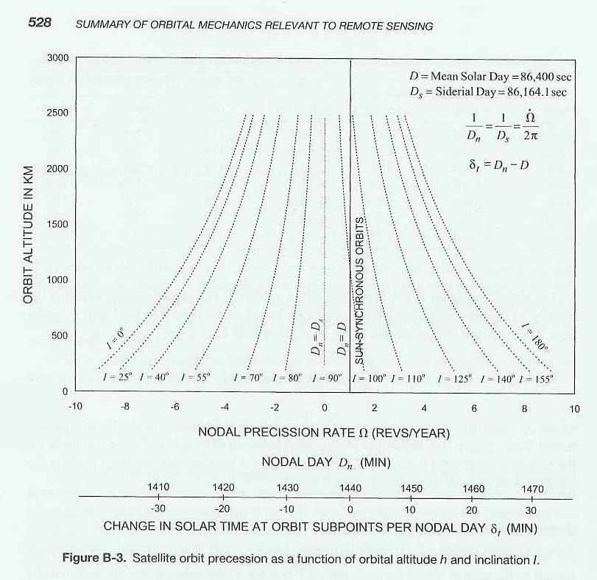

Sun synchronous orbits:
A sun synchronous orbit keeps the alignment of the orbital plane fixed relative to the line between the center of the Earth and the center of the Sun. Sun synchronous orbits are desirable for keeping the solar illumination the same from orbit to orbit which simplifies satellite and instrument designs.
WEATHER: Large, “polar-orbiting”, weather satellites carrying many instruments are often in sun synchronous orbits. Strictly speaking they are not in polar orbits but their inclination is close to 90º as we will see. Their orbits are often described by the time of day they cross the equator.
CLIMATE: They used to be the orbits of choice for LEO climate measurements because the observations don’t drift in local time of day so the diurnal cycle in theory does not enter into the long term measurements. However, sun synchronous orbits can drift slightly over time, causing the diurnal signal to alias into the long term climate signal causing a nightmare to try to remove such a subtle signal while looking for another subtle signal. Another problem is the diurnal cycle itself is predicted to change and is apparently changing as the climate warms. Such changes are guaranteed to alias into long term trends measured by sun synchronous orbits. In my opinion, orbiting observing systems should be designed to sample all times of day throughout the year so that the diurnal signal and the seasonal signal are captured as part of the climate signal. Then clever researchers can separate the different time dependent signals apart during their analysis as they try to unravel what the climate system is actually doing.
To make an orbit sun-synchronous, the orbit must precess one extra revolution in a year. So the precession rate is 360º in 366.25 sidereal days or about 1 degree per day or 0.2 microrad/sec. We set eqn. (7) equal to 1.99x10⁻⁷ rad/sec to get the Figure below.
Figure A. Inclination vs. orbital altitude for sun synchronous orbits

Example: CloudSat moves in a sun-synchronous orbit which has an equatorial altitude of approximately 705 km. This sun-synchronous orbit is nearly circular and is inclined with respect to the earth's equator at 98.2 degrees (see Figure A). The CloudSat orbit is stable for 20 to 30 years before drag will bring it down into the Earth’s atmosphere.

Sampling and coverage

Geosynchronous orbiters provide essentially continuous coverage of the region underneath them. Polar orbiters essentially sample two times per day (one day and one night) at the equator, as the orbit slowly precesses and the Earth rotates underneath the orbital plane. For sun synchronous orbits, the solar times are fixed. For all other LEOs, the solar time of the two equatorial crosses drifts with time.
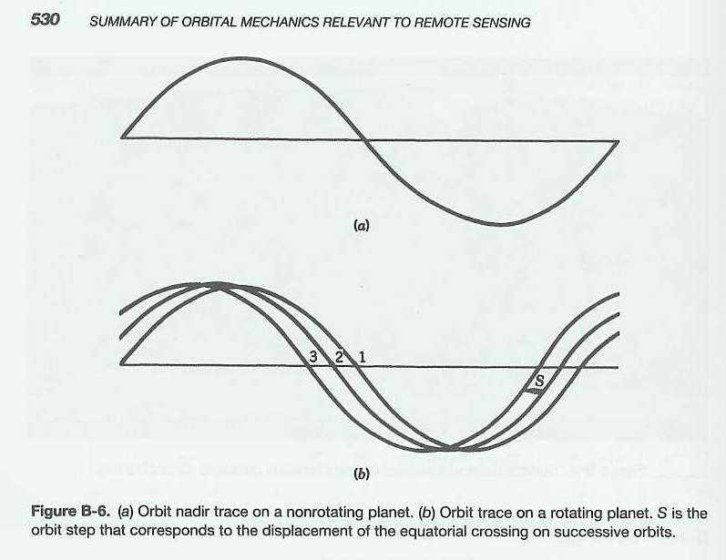

For orbital altitudes between 500 and 1500 km, the orbital period varies from about 95 to 115 minutes. Since a solar day is 1440 minutes in length, the number of daytime equatorial crossings per day is about 13-15.
For an altitude of 550 km, the number of orbits per day is about 15. So the spacing between daytime (or nighttime) equatorial crossings is 360º/15 = 24º of longitude. So if your nadir-viewing instrument can sweep back and forth by +12 degrees of longitude, your instrument could sample the entire globe every day. 1º of longitude at the equator is about 111 km so 12º is 1332 km. The look angle off nadir would have to be tan(θ) = 1332/550 so θ = +68º which is quite large. A higher orbit would achieve full global coverage (at a cost of resolution because it is higher above the Earth). Because of the wide swaths required to achieve full coverage each day, there is typically a gap between consecutive swaths at the equator.

AIRS example
The Atmospheric InfraRed Sounder (AIRS) is a nadir-viewing, high resolution IR spectrometer on NASA’s AQUA satellite in the A-train (see below) flying at 705 km altitude in a sun synchronous orbit. The AIRS infrared bands have an instantaneous field of view (IFOV) of 1.1º (=19 mrad) and FOV = ± 49.5º (=0.86 rad) scanning capability perpendicular to the spacecraft ground track. So the horizontal resolution is tan(0.019)*705 km = 13.5 km at nadir and the swath width = 2*tan(0.086)*705 km = 1650 km.
Does this swath width allow AIRS to sample the entire equator each day? At 705 km altitude, the orbital period is 98 minutes. In 98 minutes the Earth rotates 24.5 degrees of longitude which means the location under AIRS has moved 24.5*111 km = 2720 km. So each day AIRS samples the atmosphere about 1650/2720 = 60% of the equatorial area.
The combined high spatial resolution and wide swath width combined with the fast orbital motion of 7.5 km/sec means there is not a lot of time for each measurement. The measurement integration time for each 13.5 km sounding of the atmosphere must be quite short given the 7.5 km orbital velocity of AQUA and AIRS. The time it takes the satellite to move 13.5 km along its orbital track is 1.8 seconds. This is the time available to do a scan across the full swath width. So the number of individual 1.1º footprint soundings per swath width scan is 90 and the time of data measurement per sounding is 1.8 seconds/90 = 20 msec. The actual integration time is 22.41 ms for each footprint of 1.1º in diameter. This short time likely hurts the signal to noise ratio (SNR) a bit and reduces the accuracy of the individual profiles but AIRS is trying to do a lot and tradeoffs must be made.
AIRS is a very powerful sounder sampling a large portion of the global atmosphere each data. However, since AIRS is an IR instrument, it requires clear sky to derive atmospheric profiles and about 95% of the AIRS footprints are cloud contaminated (Joanna Joiner, pers. comm.) which reduces its actual coverage to about 5% of its theoretical coverage. In regions that are systematically cloudy, AIRS may have trouble profiling the atmosphere. Still AIRS is a VERY powerful atmospheric sounder for temperature, water vapor and other trace constituents in the atmosphere.

Orbital Repeat Period

Elachi and van Zyl (EvZ)’s Figure B-7 shows repeat periods for LEO sun synchronous orbits, that is, the time and the number of orbits between which the satellite flies exactly over the same location again. The easiest way to understand this figure is to start with lowest row of numbers that has 5 items reading R=16 R=15 R=14 R=13 R=12. This row coincides/aligns with the y-axis cycle period of 1 day. This means that at R=16, a satellite with an orbital altitude of approximately 270 km will fly over exactly the same locations on the Earth one day later after the satellite has gone around the Earth 16 times.
The second row has entries 31 29 27 and 25. The 29 means that for an altitude of about 710 km, the satellite will fly over the exact same locations every 2 days after orbiting the Earth 29 times.
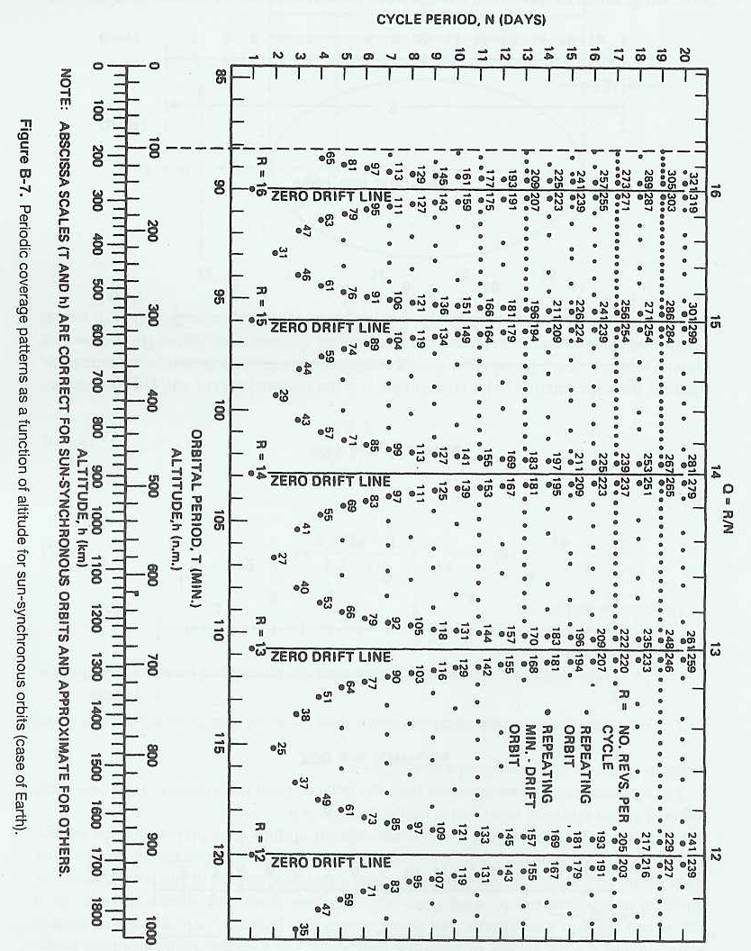

Semi-arid satellite mission?
This past summer we looked briefly at the feasibility and utility of a semi-arid land LEO satellite that would sample the North American Southwest as well as other semi-aird and arid regions of the globe as often as possible. From EvZ’s figure B-7, the fastest repeat time for a LEO in the 500 to 900 km range is once per day at either 560 km (15 orbits per day) or 900 km (14 orbits per day). A basic problem is that an enormous amount of funds (several hundred million dollars) would be required to bring such a mission to reality and only two times of day would be sampled in a region where the diurnal cycle is very large and very important. Geosynchronous satellite would be better in terms of coverage but far more expensive and would have to confront the standard problem of fine horizontal resolution from 36,000 km in space. Particularly during the monsoon, the observations that could penetrate the cloud cover would be quite limited. We discussed stratospheric, lighter than air platforms being developed for telecom and Star Wars applications but they still have some serious technical problems to overcome.

Repeating orbits for calibration: TOPEX and JASON
Systematically flying over the exact same location every so often can be very important for calibration of the satellite observations. TOPEX and its successor, JASON, carry altimeters to measure the ocean topography for inferring ocean currents and warm and cold regions for severe weather, and large scale waves like Kelvin waves associated with the El Nino-Southern Oscillation (ENSO) cycle and the long term rise in sea level predicted (with large error bars) to occur with global warming. In order to make sure the ocean sea level measurements are right, these orbits are designed to repeat every so often over locations with very precise sea level gauges whose measurements can be compared with the altimeters to quantify and understand the errors. This has worked quite well and satellite altimeter measurements of the sea level rise since 1992 when TOPEX launched are very good and indicate 2.8±0.4 mm/yr. Our understanding of what is contributing to the rise is less certain. The dominant contributor is probably thermal expansion of the upper oceans but how much is due to melting land ice is unclear.
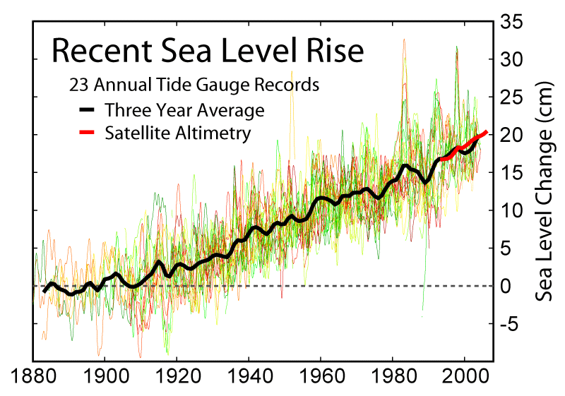
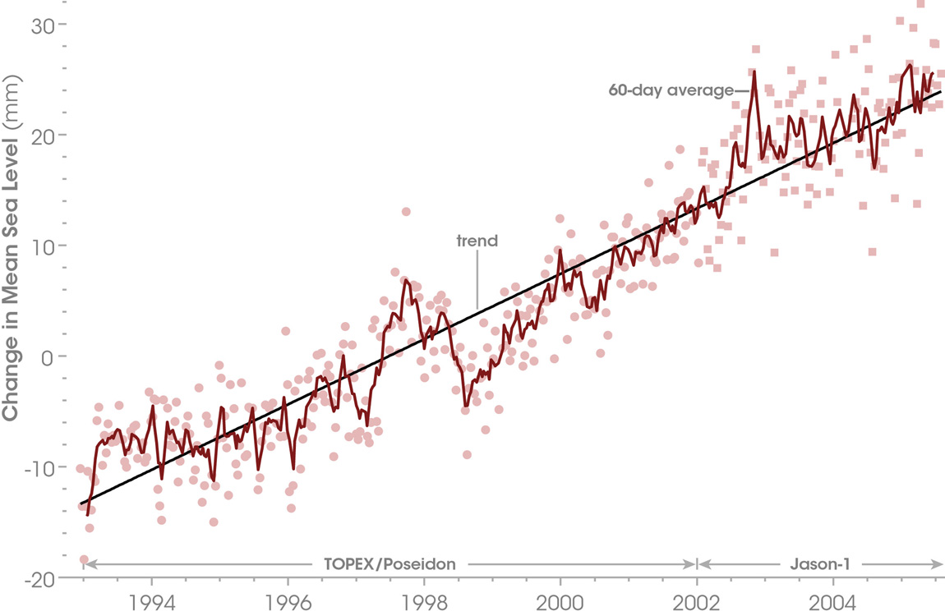

To see how the sea level has been changing by region, see also http://globalclimatechange.jpl.nasa.gov/news/index.cfm?FuseAction=ShowNews&NewsID=16

NASA’s A-train (see: http://events.eoportal.org/pres_AquaMissionEOSPM1.html) consists of several satellites each in the same orbit but slightly delayed with respect to one another. The orbit is summarized as Sun-synchronous circular orbit, altitude = 705 km (nominal), inclination = 98.2º, local equator crossing at 13:30 (1:30 PM) on ascending node, period = 98.8 minutes, the repeat cycle is 16 days (233 orbits). The repeat period allows flights over calibrating ground instruments every 16 days to help calibrate the orbiting instruments and refine retrieval algorithms.
The long time between repeat flights allows the Earth’s surface at the equator to be carved up into 233 longitude sections, the longitudinal width of which depends on each instrument. For a passive instrument like AIRS with its wide 1650 km or 15º of longitude coverage every orbit and 60% sampling of the globe each day, the 233 sections is not terribly important. But for the 94 GHz cloud profiling radar (CPR) on CloudSat (also in the A-train) which can only look straight down, carving the equatorial Earth into 233 longitudinally-narrow strips is quite relevant. The cross-track resolution of the CPR is 1.2 km. So every 16 days, the CPR covers 233*1.2 km = 280 km of longitude or about 0.7% or the equatorial region (systematically never sampling the rest of the equatorial longitudes).
The CALIOP LIDAR on CALIPSO (also in the A-train) has a 90 m instantaneous footprint which is smeared to 333 m in the along track direction by orbital motion over the LIDAR pulse duration. CALIOP looks straight down so there is no scanning to produce a larger swath width. So every 16 days, CALIOP covers 233*90 m = 21 km of longitude or about 0.05% or the equatorial region (again, systematically never sampling the rest of the equatorial longitudes).
The power of these instruments lies not in the horizontal coverage but rather the unique vertical information they provide. CPR provides 500 m vertical resolution and can penetrate through clouds to give the first 3D information on clouds globally. CALIOP provides 30 m vertial resolution profiling of aerosols and clouds, far better than the 1 to 4 km can be achieved with passive measurements. One hopes the sampling by these two high vertical resolution instruments, CPR and CALIOP, will produce a statistically representative sampling of the equatorial region. These are key examples of the tradeoffs one must make with orbiting active instruments.

References:
See Turcotte and Schubert.

