Try to read through this material before class on Mon., Mar. 23.
The following is an introduction to an important new topic: humidity (moisture in the air). This topic and the terms that we will be learning and using can be confusing. That's the reason for this introduction. We will be mainly be interested in 4 variables, what they are and what can cause their values to change. The variables are : mixing ratio, saturation mixing ratio, relative humidity, and dew point. You will find much of what follows on page 83 in the photocopied ClassNotes.
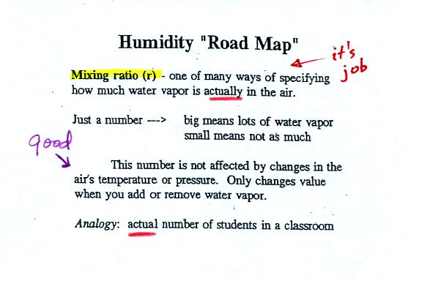
Mixing ratio tells you how much water vapor is actually in the air. Mixing ratio has units of grams of water vapor per kilogram of dry air (the amount of water vapor in grams mixed with a kilogram of dry air). It is basically the same idea as teaspoons of sugar mixed in a cup of tea. You may be tempted to click on the words highlighted in blue. Most of these aren't links. One of them is, it will take you to a hidden optional assignment.
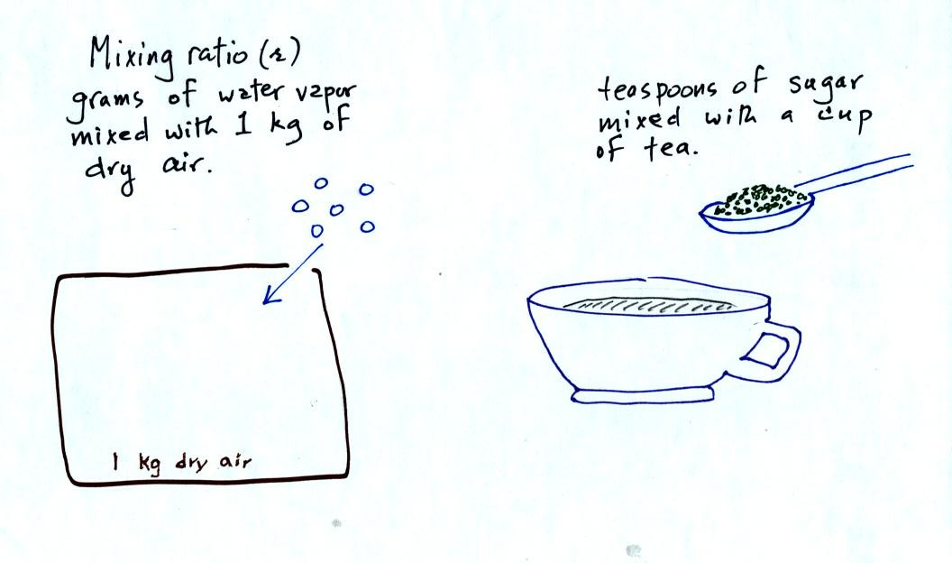
The value of the mixing ratio won't change unless you add water vapor to or remove water vapor from the air. Warming the air won't change the mixing ratio. Cooling the air won't change the mixing ratio (unless the air is cooled below its dew point temperature and water vapor starts to condense). Since the mixing ratio's job is to tell you how much water vapor is in the air, you don't want it to change unless water vapor is added to or removed from the air.
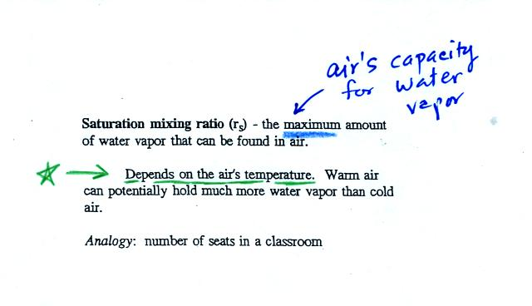
Saturation mixing ratio is just an upper limit to how much water vapor can be found in air, the air's capacity for water vapor. It's a property of air, it doesn't say anything about how much water vapor is actually in the air (that's the mixing ratio's job). Warm air can potentially hold more water vapor than cold air. This variable has the same units: grams of water vapor per kilogram of dry air. Saturation mixing ratio values for different air temperatures are listed and graphed on p. 86 in the photocopied class notes.
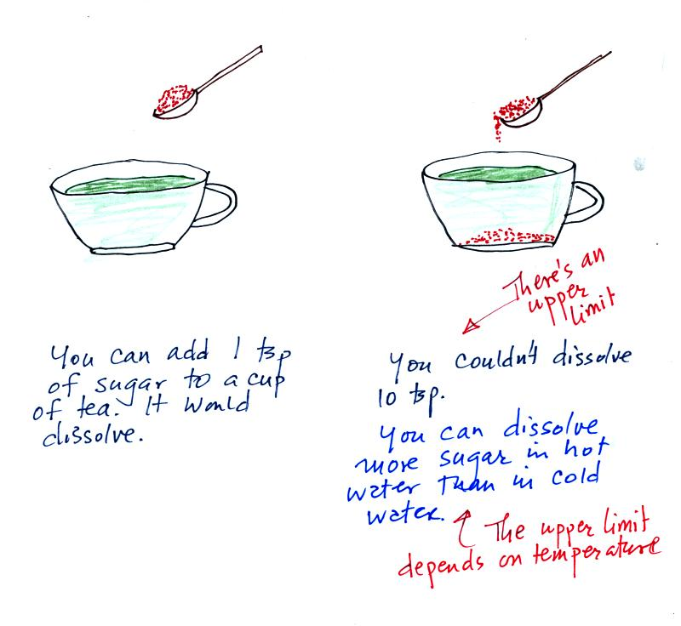
Just as is the case with water vapor in air,
there's a limit to how much sugar can be dissolved in a cup of hot water. You can dissolve more sugar in hot water than in cold water.
The dependence of saturation mixing ratio on air temperature is illustrated below:
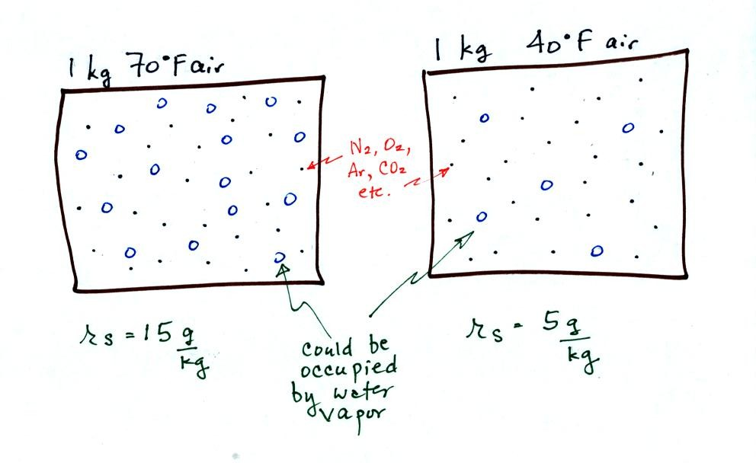
The small specks represent all of the gases in air except for the water vapor. Each of the open circles represents 1 gram of water vapor that the air could potentially hold. There are 15 open circles drawn in the 1 kg of 70 F air; each 1 kg of 70 F air could hold up to 15 grams of water vapor. The 40 F air only has 5 open circles; this cooler air can only hold up to 5 grams of water vapor per kilogram of dry air.
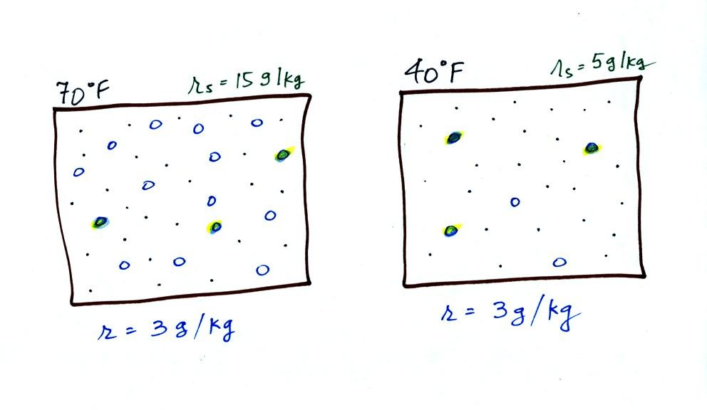
Now we have gone and actually put some water vapor into the volumes of 70 F and 40 F air. The same amount, 3 grams of water vapor, has been added to each volume of air. The mixing ratio, r, is 3 g/kg in both cases.
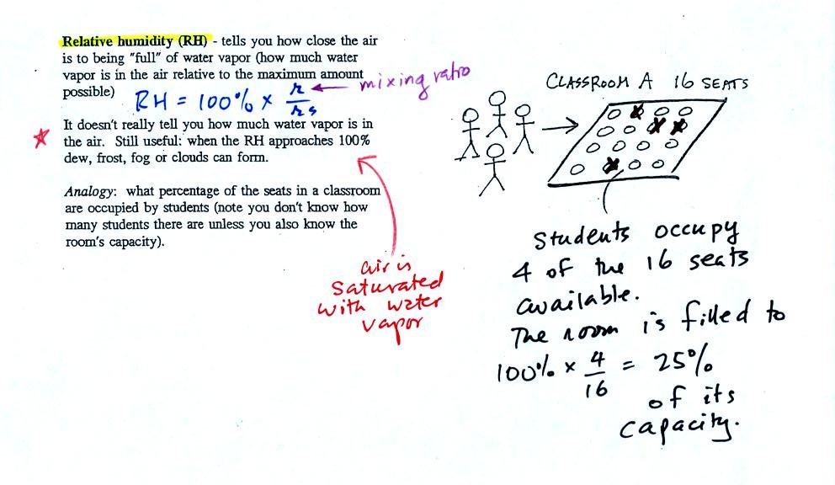
The relative humidity is the variable most people are familiar with, it tells you how "full" the air is with water vapor.
In the analogy (sketched on the right hand side of p. 83 in the photocopied notes) 4 students wander into Classroom A which has 16 empty seats. Classroom A is filled to 25% of its capacity. You can think of 4, the number of students, as being analogous to the mixing ratio. The classroom capacity is analogous to the saturation mixing ratio. The percentage occupancy is analogous to the relative humidity.
Instead of students and a classroom you could think of the 70 F and 40 F air that could potentially hold 15 grams or 5 grams, respectively of water vapor. Here is the Optional Assignment I mentioned I would hide in these notes. It will be due at the beginning of class on Mon., Mar. 23.
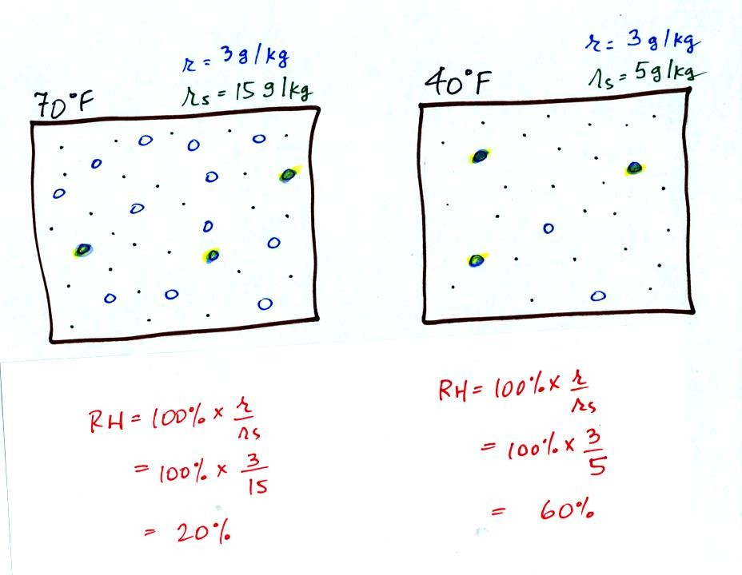
Here are the relative humidities of the 70 F and 40 F air that each contain 3 grams of water vapor. The 70 F air has a low RH because this warm air's saturation mixing ratio is large. The RH in the 40 F is higher even though it has the same actual amount of water vapor because the 40 F air can't hold as much water vapor and is closer to being saturated.
Something important to note: RH doesn't really tell you how much water vapor is actually in the air. The two volumes of air above contain the same amount of water vapor (3 grams per kilogram) but have different relative humidities. You could just as easily have two volumes of air with the same relative humidities but different actual amounts of water vapor.

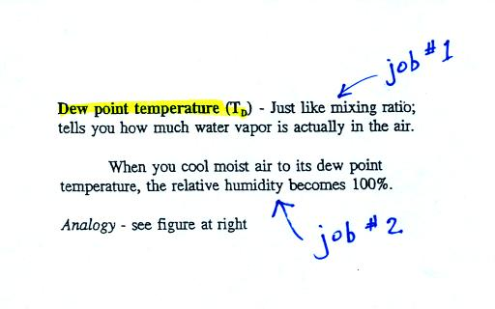
The dew point temperature has two jobs. First it gives you an idea of the actual amount of water vapor in the air. In this respect it is just like the mixing ratio. If the dew point temperature is low the air doesn't contain much water vapor. If it is high the air contains more water vapor.
Second the dew point tells you how much you must cool the air in order to cause the RH to increase to 100% (at which point a cloud, or dew or frost, or fog would form).
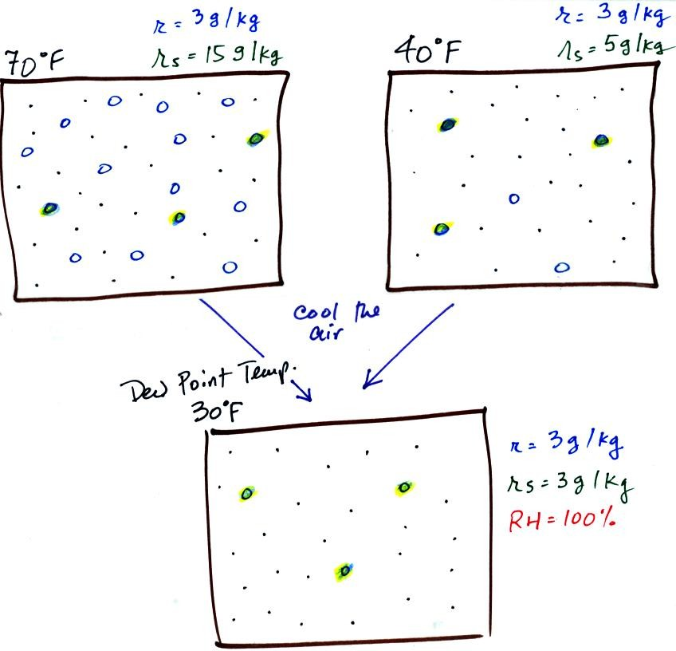
If we cool the 70 F air or the 40 F air to 30 F we would find that the saturation mixing ratio would decrease to 3 grams/kilogram. Since the air actually contains 3 g/kg, the RH of the 30 F air would become 100%. The 30 F air would be saturated, it would be filled to capacity with water vapor. 30 F is the dew point temperature for 70 F air that contains 3 grams of water vapor per kilogram of dry air. It is also the dew point temperature for 40 F air that contains 3 grams of water vapor per kilogram of dry air.Because both volumes of air had the same amount of water vapor, they both also have the same dew point temperature.
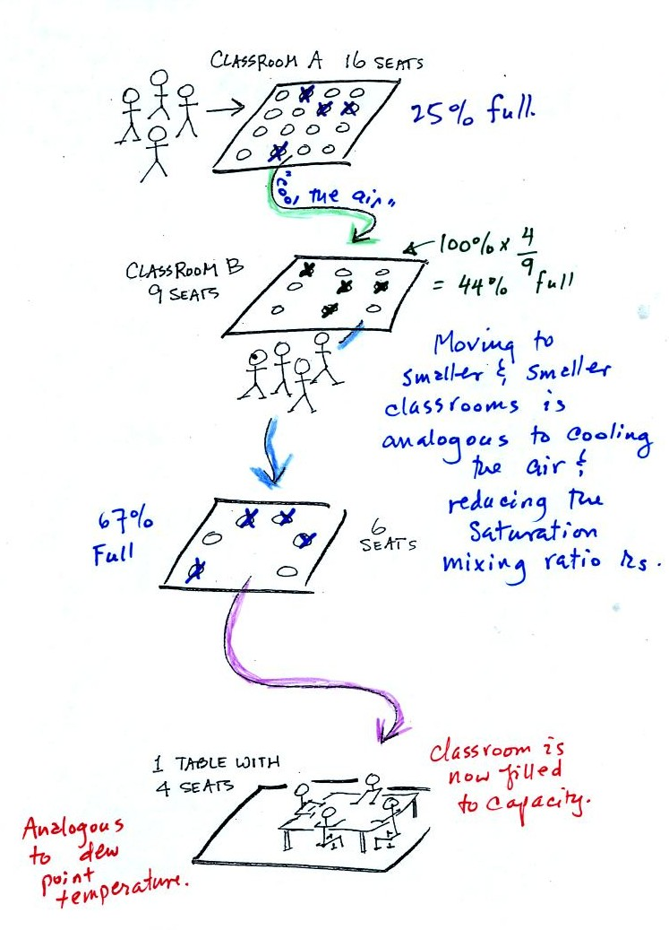
Now back to our students and classrooms analogy on the righthand side of p. 83. The 4 students move into classrooms of smaller and smaller capacity. The decreasing capacity of the classrooms is analogous to the decrease in saturation mixing ratio that occurs when you cool air. Eventually the students move into a classroom that they just fill to capacity. This is analogous to cooling the air to the dew point.
If the 4 students were to move to an even smaller classroom, they wouldn't all fit inside. The same is true of moist air. If you cool moist air below the dew point, some of the water vapor will condense.

