NATS 101 Name_______________________________
Optional (Extra Credit) Assignment

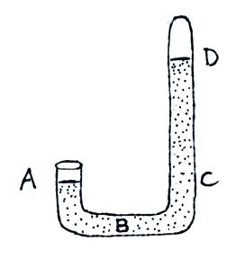
1. If you traveled from the Tucson valley (2500 ft. alt.) to the top of Mt. Lemmon (9000 ft alt.) you would expect to see a _______ in air temperature, a _______ in air density, and a _______ in air pressure. (fill in each blank with RISE or DROP)

2. The pressure at Point A and at Point ________
on the mercury barometer at right would be equal.
The pressure at Point ________ would be zero.

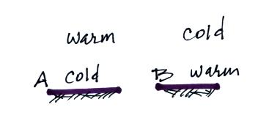
3. If the force of gravity on the earth were to increase but the amount (mass) of air in the atmosphere stayed the same, would the atmospheric pressure at sea level INCREASE, DECREASE, or remain CONSTANT?

4. Would stable atmospheric conditions
be found in FIG. A or FIG. B in the
picture at right?

5. The ideal gas law equation gives the relationship between the number (N), temperature (T), and pressure (P) of the air in a volume (V):
P = (N k T) / V
If N, V, and T were each to increase by a factor of 2, the pressure would
a. increase by 2 b. increase by 4 c. decrease by 2 d. decrease by 4
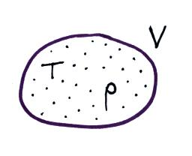
6. Which two of the variables in the figure at right
could you use to determine the pressure of the air
in the balloon? (V is volume, T is temperature, and
ρ is the density)

7. The atmosphere is split into layers (troposphere, stratosphere, mesosphere, etc.) according to how _______ changes with altitude.
a. composition b. density c. pressure d. temperature

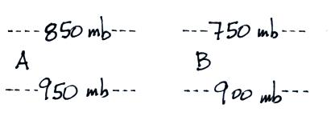
8. The two layers in the figure at right
have the same thickness. Is pressure decreasing
most rapidly in the RIGHT or LEFT layer?
Is the density of the air in the left layer GREATER
than, the SAME as, or LESS than the air density
in the right layer?
9. Use the figure at right to fill in the values of the following weather variables.

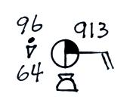
temperature __________ cloud cover __________

pressure __________ dew point __________

wind direction __________ wind speed __________

present weather conditions (if any) __________

10. Which of the following does not cause rising air motions?
a. cold front b. surface high pressure c. warm front d. surface low pressure
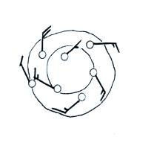
11. Are the winds spinning in a CLOCKWISE or
COUNTERCLOCKWISE direction in the figure
at right. Are the winds CONVERGING or
DIVERGING. Does the figure show a surface
HIGH or LOW pressure center.

12. _______ below is the symbol for a northern hemisphere hurricane. _______ is the symbol for a southern hemisphere tropical storm.
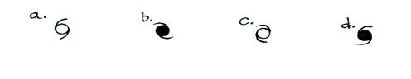

13. Use the altitude and pressure data in the figure below to
a. determine the station pressure at Point A
b. determine the sea level pressure for Station B
c. determine the altitude of Point C
(you can assume that pressure decreases at a rate of 1 mb per 10 meters of altitude gain)
