NATS 101 Name____________Answers_______________
Optional (Extra Credit) Assignment

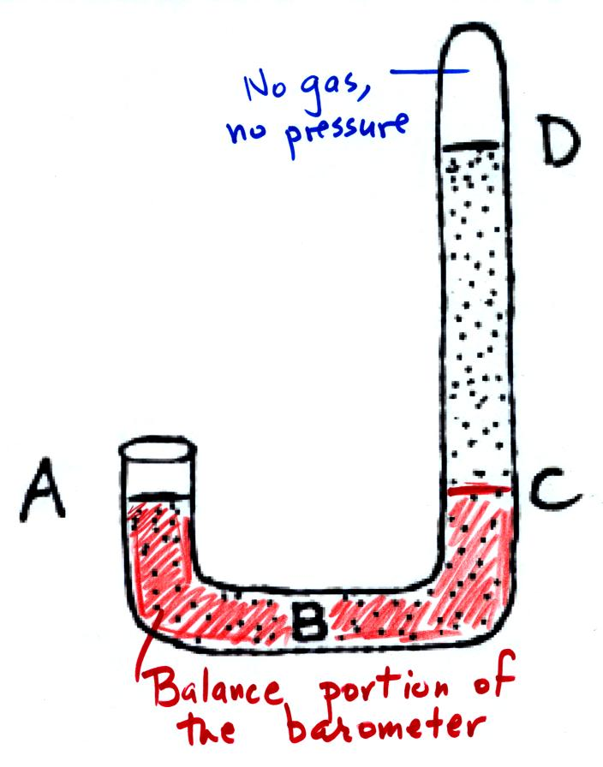
1. If you traveled from the Tucson valley (2500 ft. alt.) to the top of Mt. Lemmon (9000 ft alt.) you would expect to see a _DROP_ in air temperature, a _DROP_ in air density, and a _DROP_ in air pressure. (fill in each blank with RISE or DROP)

2. The pressure at Point A and at Point ___C___
on the mercury barometer at right would be equal.
The pressure at Point ___D___ would be zero.

The portion between A and C (red in the figure at right) is the balance
in the barometer. You are balancing a tall column of air with a much
shorter (distance between C & D) column of mercury. There is no gas
above Pt. D so there is not pressure there either.

3. If the force of gravity on the earth were to increase but the amount (mass) of air in the atmosphere stayed the same, would the atmospheric pressure at sea level INCREASE, DECREASE, or remain CONSTANT?
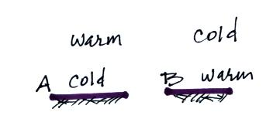
Pressure is determined by the weight of the air overhead. Weight depends on both mass and gravity. If gravity increases weight will also increase even if mass stays the same.

4. Would stable atmospheric conditions
be found in FIG. A or FIG. B in the
picture at right?

Increasing temperature with increasing altitude as shown in Fig. A is a temperature inversion which produces very stable conditions.

5. The ideal gas law equation gives the relationship between the number (N), temperature (T), and pressure (P) of the air in a volume (V):
P = (N k T) / V
If N, V, and T were each to increase by a factor of 2, the pressure would
a. increase by 2 b. increase by 4 c. decrease by 2 d. decrease by 4
An increase in N and T together would increase the pressure by a factor of 4.
An increase in volume will reduce the pressure by a factor of 2. The overall effect of increasing N, T, and V is to increase pressure by a factor of 4/2 = 2.

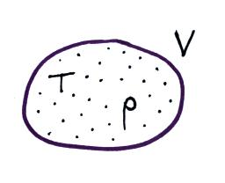
6. Which two of the variables in the figure at right
could you use to determine the pressure of the air
in the balloon? (V is volume, T is temperature, and
ρ is the density) T and ρ are enough to determine
the pressure using the equation P = ρ R T

7. The atmosphere is split into layers (troposphere, stratosphere, mesosphere, etc.) according to how ___d___ changes with altitude.
a. composition b. density c. pressure d. temperature

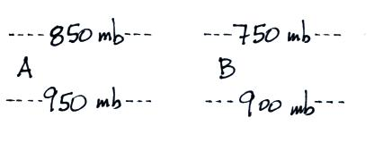
8. The two layers in the figure at right
have the same thickness. Is pressure decreasing
most rapidly in the RIGHT or LEFT layer?
Is the density of the air in the left layer GREATER
than, the SAME as, or LESS than the air density
in the right layer?
There is a 150 mb change in Layer B which is greater than the 100 mb change in Layer A. The most rapid rate of pressure change is in dense air.

9. Use the figure at right to fill in the values of the following weather variables.

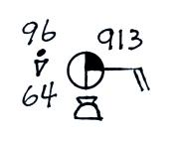
temperature ___96 F___ cloud cover __3/8ths__

pressure __991.3 mb__ dew point __64 F__

wind dir. __from the east__ wind speed __20 knots__

present weather conditions (if any) _rain shower_

10. Which of the following does not cause rising air motions?
a. cold front b. surface high pressure c. warm front d. surface low pressure
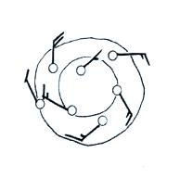
11. Are the winds spinning in a CLOCKWISE or
COUNTERCLOCKWISE direction in the figure
at right. Are the winds CONVERGING or
DIVERGING. Does the figure show a surface
HIGH or LOW pressure center.

12. ___d___ below is the symbol for a northern hemisphere hurricane. ___c___ is the symbol for a southern hemisphere tropical storm.
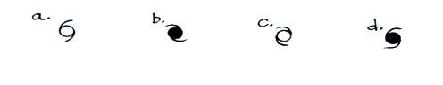

13. Use the altitude and pressure data in the figure below to
a. determine the station pressure at Point A
The station pressure will be 500 m x (1mb/10m) = 50 mb lower than the sea level pressure. 1003.7 mb – 50 mb = 953.7 mb.
b. determine the sea level pressure for Station B
The sea level pressure will be 750 m x (1mb/10m) = 75 mb higher than the station pressure. 935.1 mb + 75 mb = 1010.0 mb
c. determine the altitude of Point C
There is a 1005.9 – 915.9 = 90 mb pressure difference between the sea level and station pressure values at C. 90 mb divided by 1mb/10m = 900 meters altitude.
(you can assume that pressure decreases at a rate of 1 mb per 10 meters of altitude gain)
