Student question: What is another name for graupel?
My version: __________ is often mistaken for hail and is sometimes referred to as soft hail or snow pellets.

Student question: Is graupel TRANSPARENT or UNTRANSPARENT? Located INSIDE or OUTSIDE a cloud?
My version: Is graupel made of CLEAR ice or RIME ice?

Student question: What happens when an “ice storm hits a city or town?
My version: What is meant by the term “ice storm?” What kind of precipitation causes an ice storm?

Student question: In the mixed phase region, what is the correct term for the water droplets?
My version: Ice crystals and _______________ are found together in the mixed phase region of a cloud at temperatures ABOVE(warmer) BELOW(colder) than freezing.

Student question: What 2 humidity statistics tell you the actual amount of water in the air?
a. mixing ratio b. saturation mixing ratio c. dew point
d. relative humidity e. air temperature
My version: What 2 humidity variables tell you the actual amount of water vapor in the air?
a. mixing ratio b. saturation mixing ratio c. dew point
d. relative humidity e. air temperature

Student question: What happens to ice crystals that undergo more condensation than evaporation?
My version: The water droplet is in equilibrium with its surroundings in the figure below. When it is found in the same surroundings would you expect an ice crystal to GROW or WITHER away?
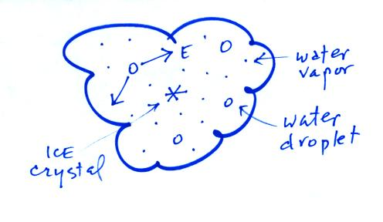

Follow up question: You would expect to find _______ arrows of condensation going to the water droplet, _______ arrows of evaporation from the ice crystal, and _______ arrows
of condensation (deposition) going to the ice crystal. (fill in each blank with 0, 1,
2, or 3; answers can be used more than once)

