NATS 101 Sect. 17 Name______________________________
Quiz #1 Sept. 20, 2000

1. (20 pts) Identify the gases being described below.
Oxygenated compounds are added to gasoline in the winter in Tucson to reduce the atmospheric concentration of _______________, a colorless, odorless, toxic gas. Burning coal can produce _______________, which will react with water in clouds to form acid rain. High levels of this gas were also present during the Great London Smog of 1952. Freon is the common trade name given to _______________, molecules of which are normally stable, unreactive, and able to remain in the atmosphere for upwards of 100 years. The amount of _______________ in the air has increased from 315 ppm to about 365 ppm in the last 40 years or so; continued buildup of this greenhouse gas could lead to global warming. Levels of _______________, a secondary pollutant, peak on summer afternoons.

2. (5 pts) Rain contains dissolved carbon dioxide which lowers the pH value from 7 to between 5 and 5.6. This means rain is normally slightly ACIDIC BASIC.

3. (5 pts) Which of the following would be true if you carried an object from the earth to the moon.
a. the object's mass and weight would both change
b. the object's mass would change but the weight would stay the same
c. the object's mass would stay the same but the weight would change
d. the object's mass and weight would both remain the same

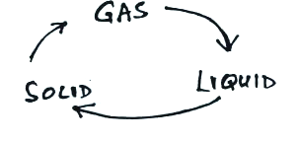
4. (15 pts) Photodissociation of O₂ by ultraviolet light ( O₂ + UV ---> O + O ) is the first step in the formation of STRATOSPHERIC TROPOSPHERIC ozone. Temperatures increase with increasing altitude in the STRATOSPHERE TROPOSPHERE which makes that layer very STABLE UNSTABLE. At 30,000 feet altitude, a commercial jet is near the top of the TROPOSPHERE STRATOSPHERE and is ABOVE BELOW the ozone layer.

5. (5 pts) Energy is released to the surroundings by
_______ of the phase changes in the figure at right.
(fill in the blank with 0, 1, 2, or 3)

6. (5 pts) Measurements made at 1 pm local time in Hawaii are plotted on the 23 GMT map. There is a _______ hour time zone difference between Hawaii and Greenwich, England.
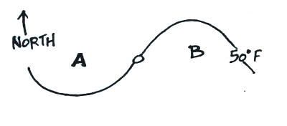
7. According to the map at right, the air at A is WARMER COLDER than at B. A center of HIGH LOW pressure at the point in the center of the map would produce the CLOCKWISE COUNTERCLOCKWISE winds needed
to produce this temperature pattern.

8. (5 pts) The contour lines connecting points on
a surface map with the same pressure are called ____________________.

9. You generally find CLEAR CLOUDY skies associated with surface centers of high pressure because air in the center of the high RISES SINKS and COOLS WARMS.

10. Match the units in the top list with the appropriate quantity from the list below.
knot _______ kilometer_______ bar_______
a. distance b. speed c. pressure
Name__________________________________
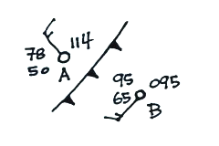
11. Is the front in the figure at right moving toward POINT A
or POINT B? Is the coldest air found at A or B? Are the
winds blowing from the southwest at POINT A or POINT B? Is
this a WARM or COLD front?

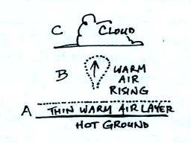
12. Three energy transport processes (conduction, convection,
and latent heat) are illustrated in the figure at right. Fill in the
blanks below to show where each process is best illustrated.
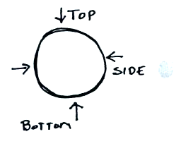
conduction_______ convection _______
latent heat _______

13. Pressure from the surrounding atmosphere pushes against
the top, bottom, and sides of an air parcel as shown at right.
Explain why the total or net presure force points upward.

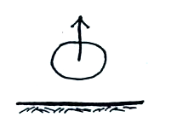
14. The air parcel at right will rise freely if the _______ inside
the parcel is lower than that of the surrounding air.
a. pressure b. temperature c. density d. relative humidity

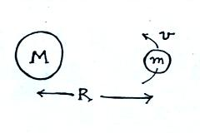
15. Which of the variables at right is found in the
denominator of Newton's Law of Universal Gravitation?
Which of the variables is not in the
Law of Universal Gravitation equation?

16. (5 pts) Which of the following equations shows the correct ideal gas law relationship between pressure (P), density (ρ), and temperature (T)?
a. P = ρ / T b. P = ρ x T c. P = T / ρ d. P = 1 / (ρ x T )

17. In the troposphere, pressure INCREASES DECREASES with increasing altitude, density INCREASES DECREASES with increasing altitude, and temperature INCREASES DECREASES with increasing altitude.

Extra Credit (maximum of 10 pts)
1. Houston, Texas, is apparently now the _______ city in the United States.
a. most humid b. smoggiest c. most populated d. least polluted

2. The flat top of a thunderstorm cloud indicates where the growing storm encountered
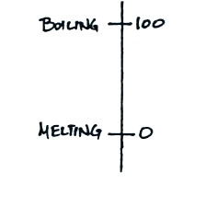
a. dry air b. cold air c. stable air d. high energy ultraviolet light

3. It is now more common to refer to the
centrigrade scale shown at right as the _________________________ scale.

