NATS 101 Sect. 17 Name_______________________________
Quiz #4 Nov. 8, 2000

1. (10 pts) Objects on the ground usually will cast shadows when a(n) ALTOSTRATUS CIRROSTRATUS cloud is overhead because this cloud is THIN THICK.

2. (5 pts) Newton's first law of motion says that as long as no net force is exerted on an object it will move in a straight line at constant speed. What else is also possible?

3. (5 pts) When a force is applied to an object with a lot of inertia, the object will slowly accelerate. From this you could conclude that inertia is just another word for

4. (15 pts) Match the cloud name prefixes below a. layer b. rain c. high
with the appropriate word from the list at right. d. middle e. low f. grey

nimbo_______ cirro_______ alto_______ strato______

5. (5 pts) The isobaric charts used by meteorologists to depict upper-level conditions in the atmosphere are similar to topographic charts in that both have contour lines that show changes in

6. (5 pts) How many 200 μm drizzle drops would be needed to make one 2000 μm raindrop?
a. 1,000,000 b. 1,000 c. 100 d. 10
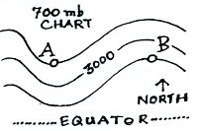
7. (15 pts) Points A and B are at the same latitude on the map
at right. Would the warmest air be found below Point A or
Point B? Is Point B in a RIDGE or a TROUGH? The
altitude at Point A is probably GREATER than, LESS than,
EQUAL to 3000 meters.

8. (5 pts) IR satellite photographs are often color enhanced. Red on an IR satellite image means
a. the cloud is growing and moving upward b. supercooled water droplets are present
c. the top of the cloud is high and cold d. the cloud is producing a lot of rain

9. (10 pts) Which two of the following are true in the mixed phase region of a cold cloud where precipitation is being produced by the ice crystal process?
a. water vapor is condensing onto the droplets and depositing onto ice crystals at equal rates
b. there are more water droplets than ice crystals
c. water droplets evaporate and ice crystals sublimate at equal rates
d. ice crystals are in equilibrium with the surroundings

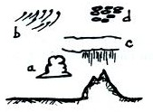
10. (15 pts) Name the clouds described below and sketched at right.
10a a low altitude
fair weather _______________
cloud resembles a ball of cotton
10b a high altitude
filamentary cloud _______________
10c middle altitude layer
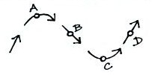
cloud producing rain _______________

11. (10 pts) Air is following the path shown at right and is
moving at constant speed. The net force will point
toward the bottom of the picture at Point _______ and
the net force will be zero at Point _______

12. (5 pts) Does the collision coalescence process works best when the cloud droplets are all DIFFERENT or all the SAME sizes.

13. (10 pts) The largest precipitation particles form when the DOWNDRAFTS UPDRAFTS in a cloud are WEAK STRONG.
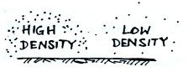
14. (10 pts) Pressure will decrease most rapidly in the LOW
HIGH density air in the picture at right. You would
expect to find an upper-level TROUGH RIDGE where
pressure is decreasing rapidly with increasing height.

15. (20 pts) Match the descriptions below with one of the precipitation names from the list at right.
15a a common type of snow crystal _______ a. virga
15b a small particle of rime ice often mistaken for hail _______ b. graupel
15c rain which evaporates c. sleet
before reaching the ground _______ d. dendrite
15d raindrops which freeze before reaching the ground _______ e. snow
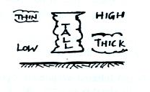
16. The tall thunderstorm cloud at right will appear
WHITE GREY on an infrared satellite photograph
and WHITE GREY on a visible satellite image.
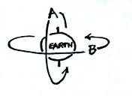
Extra Credit (up to 10 pts)
1. A geostationary satellite could follow
a. orbit A b. orbit B
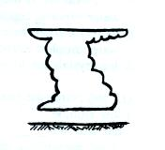
c. orbit A or B d. neither orbit

2. Which of the following is not shown on
the thunderstorm cloud sketched at right?
a. anvil cloud b. lenticular cloud
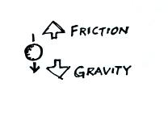
c. mammatus cloud d. cumulonimbus cloud

3. Name two factors that determine the strength of the
frictional force acting on the falling raindrop at right.

