NATS 101 Sect. 4 Name_______________________________
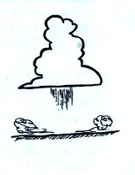
Quiz #6 April 28, 1999

1. Virga is shown below a cloud at right. What is virga?

Does the blowing dust at the ground indicate a strong
DOWNDRAFT or UPDRAFT is present? Would you
expect the virga to STRENGTHEN or WEAKEN the
vertical air motions below the cloud? Explain.

2. Match one of the terms at right with each of a. microburst
the descriptions below. b. wind shear
rotating thunderstorm updraft _______ c. suction vortex
changing wind speed or direction with distance_______ d. gust front
narrow, intense thunderstorm downdraft_______ e. mesocyclone

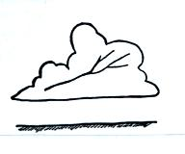
3. Does the branching in the figure at right indicate that this
intracloud discharge began with a leader that propagated from
LEFT to RIGHT or from RIGHT to LEFT?

4. Winds in most tornadoes are _______ MPH or a little less. There are about _______flashes of lightning per second on average over the globe. About _______ people are killed by lightning in the United States each year. Pressure in the center of a tornado is about _______ mb lower than the surrounding air. A typical air mass thunderstorm will last about _______ hour(s). The top of a thunderstorm reaches an altitude of about _______ km(s). (fill in each blank with 1, 10, 100, or 1000. Answers may be used more than once)

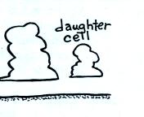
5. A thunderstorm cell has begun to weaken and a "daughter cell"
is forming. Is the daughter cell forming in a region where
surface winds and winds from the thunderstorm downdraft are
DIVERGING or CONVERGING? Would you expect to find
that the surface winds (that were present before the thunderstorm
formed) are blowing from the RIGHT or the LEFT?

6. If a parcel of air is rising adiabatically in the atmosphere does that mean that the temperature of the air in the parcel
a. can increase or decrease with increasing altitude
b. must be the same as that of the surrounding air
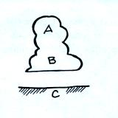
c. does not change with increasing altitude
d. can be different from the surrounding air

7. You would expect to find _____charge at C and _____ charge
at A in the storm at right [fill in each blank with + (positive)
or - (negative) ]

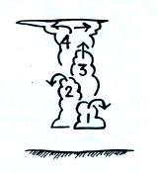
8. Cloud development during the day is sketched
at right. The level of free convection is found
a. between 1 & 2 b. between 3 & 4
c. between 2 & 3 d. above 4

9. Most cloud-to-ground lightning discharges begin with a(n)
UPWARD DOWNWARD propagating discharge that is
NEGATIVELY POSITIVELY charged. What is the name
of this discharge?

10. Which two of the following features are found at the top of a thunderstorm cloud?
a. shelf cloud b. wall cloud c. anvil cloud d. mammatus cloud

11. Is the hook echo signal on radar produced by a TORNADO or a THUNDERSTORM?

12. Dry air cools at a rate of 10º C/km. Unsaturated air cools __________. Saturated air cools __________. (fill in each blank with more RAPIDLY, more SLOWLY, or at the SAME rate)

13. The clear sky found in the centers of hurricanes and some tornadoes is caused by
a. St. Elmo's fire b. dry air c. expanding air d. sinking air

14. Most of the electric charge in thunderstorms is produced
a. when water vapor condenses b. by colliding precipitation particles
c. when ultraviolet light ionizes air d. by the earth's magnetic field

15. Some people are taught that the number of seconds between the flash of light from lightning and the thunder gives you the distance in miles (5 seconds would mean 5 miles, for example). Is this correct? If not, is the lightning really CLOSER or FURTHER away than this estimate would imply?

16. The strength of a tornado is usually determined by
a. measurements of the pressure in the core of the tornado
b. measurements of the speed of the tornado winds
c. assessment of the damage cause by the tornado
d. altitude of the thunderstorm cloud base above the ground

Extra Credit (up to 10 pts)
1. _______ tornadoes will destroy the outer walls of a well-built house but the leave interior walls standing.
a. violet (F4 & F5) b. strong (F2 & F3) c. weak (F0 & F1) d. all

2. Most summertime thunderstorms in southern Arizona are caused by
a. convergence into low pressure b. fronts
c. convection d. orographic lifting

3. The text shows a picture (taken in the Tucson area incidentally) of a car driving through the bottom of a dip in the road. What happened just 10 seconds later when the car neared the top of the other side of the dip?

