NATS 101 Name_______Answers_______________
In-class Optional Assignment

1. A mixing ratio of 6 g/kg means there are 6 grams of _____water vapor__________
mixed in
with 1 kilogram of __________dry air________________________.

2. If you know the air's temperature you can look up the value of the ___b___ in a table.
a. mixing ratio b. saturation mixing ratio c. relative humidity d. dew point

3. Adding water vapor to the air will not increase the ___b___.
a. mixing ratio b. saturation mixing ratio c. relative humidity d. dew point

4. 90º F air can potentially hold ___c___ times as much water vapor as 45º F air (consult the table on p. 86 in the photocopied ClassNotes)
a. 2 b. 4 c. 5 d. 10
90º F can hold up to 30 grams of water vapor per kilogram of dry air. 45º F can only hold a maximum of 6 grams per kilogram.

5. To calculate the relative humidity you need to know the ___b___ and the ___c___.
a. mixing ratio b. saturation mixing ratio c. air temperature d. dew point
The formula for relative humidity is RH = 100% x r/r_{S}

6. The value of the ___c___ will tell you whether moist air is saturated or not.
a. mixing ratio b. saturation mixing ratio c. relative humidity d. dew point

7. Based on the data in the figure below, does the parcel of 70º F air have MORE LESS or the SAME amount of water vapor than(as) the 85º F air?
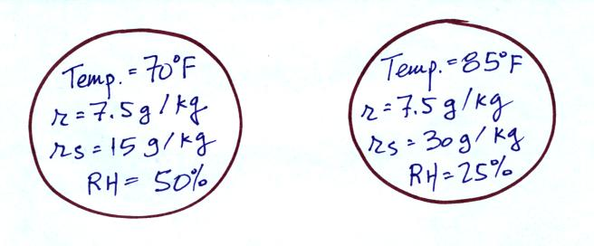

Both volumes of air have the same mixing ratio meaning they both have the same actual amount of water vapor (they would both also have the same dew point temperature 50º F)
8. Which two of the following have the same job, telling you how much water vapor is actually in the air?
a. mixing ratio b. saturation mixing ratio c. relative humidity d. dew point

