NATS 101 In-class Optional Assignment Name__ANSWERS___________
If you don’t see a score marked on your paper you received full credit (0.25 extra credit points)

1. How much of sunlight is visible light?
a. <10% b. about 25% c. between 40 & 60% d. about 75% e. > 90%
About 44% of sunlight is visible light, 37% is near IR & 12% is far IR, only 7% is ultraviolet light
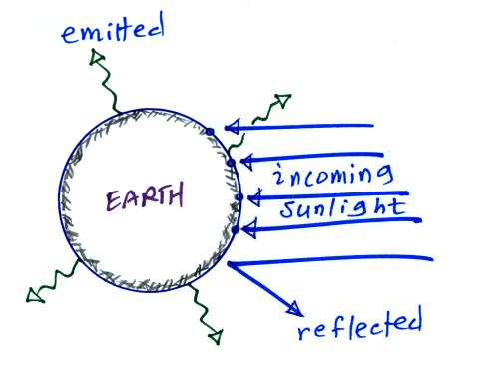

2a The earth is reflecting 1 of the incoming arrows of
sunlight in the figure at right. If the earth suddenly started reflecting 2 arrows would the earth’s temperature of radiative equilibrium INCREASE DECREASE or remain the SAME?
Once the earth starts to reflect 2 of the incoming arrows it
will only be absorbing 3 arrows. It would be emitting more
than it was absorbing (4 emitted, 3 absorbed) and would start to cool. As it cooled it would start to emit less radiation. Eventually it would only be emitting 3 arrows and would once again be in energy balance.
2b If the earth suddenly started emitting 5 arrows
of infrared radiation but everything else in the picture
above stayed the same, would the earth WARM COOL or remain at the SAME temperature?
If the earth was emitting 5 arrows and only absorbing 4 arrows it would cool. As it cooled it would emit less radiation. Eventually it would cool enough that it would only be emitting 4 arrows and would be in energy balance.

3. We are able to see the moon at night because it EMITS REFLECTS INFRARED VISIBLE light. (circle two words)
First of all we can only see visible light. So when you see light coming from the moon you are seeing visible light, it is just a question of whether the moon is emitting it or reflecting it. The moon isn’t warm enough to be able to emit visible light, it emits infrared radiation. So we are seeing sunlight reflected by the moon.

4. The 5 most abundant gases in the earth’s atmosphere are listed below. ___d___ absorbs ultraviolet light, ___b___ and ___e___ absorb infrared light. (fill in the blanks)
a. argon b. carbon dioxide c. nitrogen
d. oxygen e. water vapor

5. The ground is absorbing _1 (a)___
unit(s) of radiation in the figure and
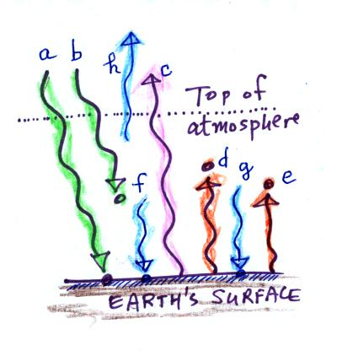
emitting 3 (c, d, & e) unit(s). To be in
energy balance the ground must be
receiving _3 (f & g)_ unit(s) of energy
coming from the atmosphere. The
atmosphere is absorbing 3 (b, d, & e)
units of energy. To be in energy balance
the atmosphere must emit ___1 (h)___
unit(s) of radiation upward and
__2 (f & g)__ unit(s) of radiation downward to
the ground.to the ground.

6. Compared to a bulb with a color temperature of 3000 K, the white light emitted by a bulb with a color temperature of 6000 K will have a BLUISH REDDISH tinge to it..

7. Is UVA (0.32-0.4 µm), UVB (0.28-0.32 µm), or UVC (0.10-0.28 µm) the most dangerous type of ultraviolet light?
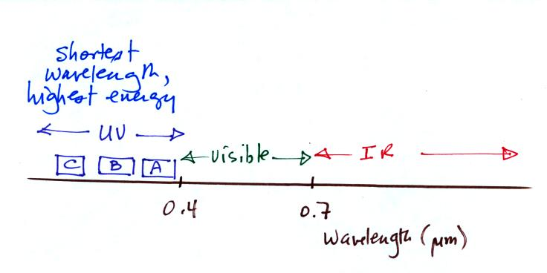

High energy radiation is the most dangerous form of EM radiation. UV-C has the shortest wavelength and is therefore the most dangerous. Fortunately all the UV-C in sunlight is absorbed by ozone in the stratosphere.

