NATS 101 In-class Optional Assignment Name_______________________________

1. How much of sunlight is visible light?
a. <10% b. about 25% c. between 40 & 60% d. about 75% e. > 90%
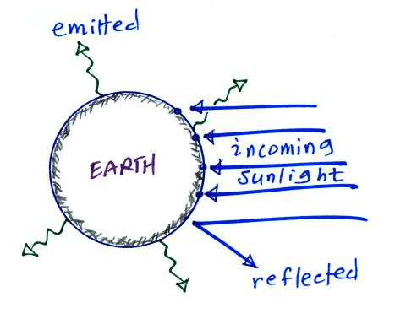

2a The earth is reflecting 1 of the incoming arrows of
sunlight in the figure at right. If the earth suddenly started reflecting 2 arrows would the earth’s temperature of radiative equilibrium INCREASE DECREASE or remain the SAME?
2b If the earth suddenly started emitting 5 arrows
of infrared radiation but everything else in the picture
above stayed the same, would the earth WARM COOL or remain at the SAME temperature?

3. We are able to see the moon at night because it EMITS REFLECTS INFRARED VISIBLE light. (circle two words)

4. The 5 most abundant gases in the earth’s atmosphere are listed below. _______ absorbs ultraviolet light, _______ and _______ absorb infrared light. (fill in the blanks)
a. argon b. carbon dioxide c. nitrogen d. oxygen e. water vapor
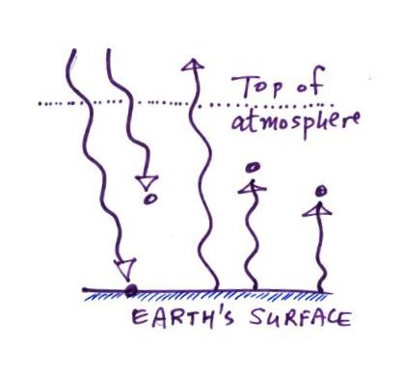
5. The ground is absorbing __________
unit(s) of radiation in the figure and
emitting __________ unit(s). To be in
energy balance the ground must be
receiving __________ unit(s) of energy
coming from the atmosphere. The
atmosphere is absorbing __________
units of energy. To be in energy balance
the atmosphere must emit __________
unit(s) of radiation upward and
__________ unit(s) of radiation downward to the ground.to the ground.

6. Compared to a bulb with a color temperature of 3000 K, the white light emitted by a bulb with a color temperature of 6000 K will have a BLUISH REDDISH tinge to it..

7. Is UVA (0.32-0.4 µm), UVB (0.28-0.32 µm), or UVC (0.10-0.28 µm) the most dangerous type of ultraviolet light?

