Monday Nov. 14, 2011
Three songs from Dar Williams, someone my sister told me about ("The One Who Knows", "Closer to Me", and "Comfortably Numb")
Part 1 of the Quiz #4 Study Guide is now online. It comes with several links that will allow you to test your understanding of the material. Quiz #4 is a little over two weeks away (the Wednesday after Thanksgiving).
The Scientific Paper and Experiment #4 reports (the ones that have been turned in) have all been graded. You can revise your report if you want to, revised reports are due on or before Mon., Nov. 28. Experiment #3 revised reports are due on or before Wed., Nov. 23. Please return your original report if you turn in a revised report.
The 1S1P Assignment #2 reports on the Santa Ana Wind have been graded. You can check on grading progress here. The following people have earned 45 1S1P points and don't need to write any more reports.
You have until 5 pm today to complete the Toilet Bowl Optional Assignment.

Here's an idea of what we'll cover in class today
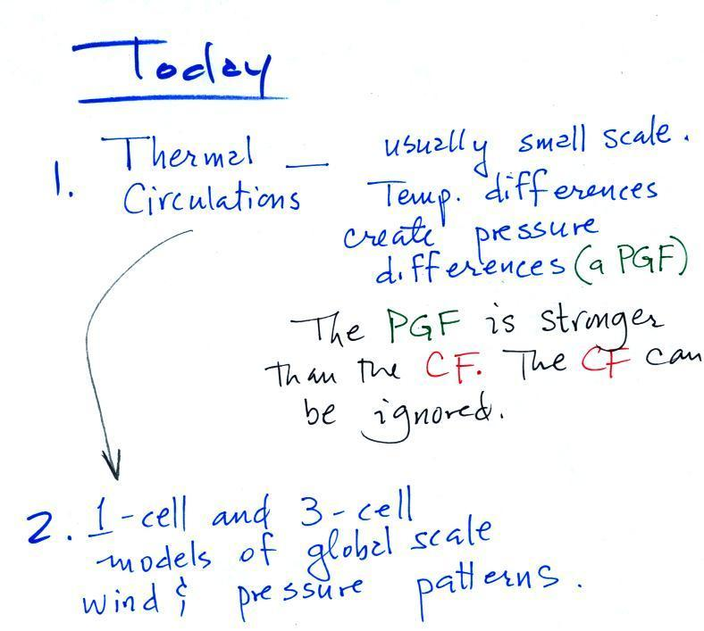
Thermal Circulations
Differences in temperature like you might find between a coast and the ocean or between a city and the surrounding country side can create horizontal pressure differences. The horizontal pressure gradient can then produce a wind flow pattern known as a thermal circulation.
When dealing with these usually small scale circulations, the pressure gradient force is often so much stronger than the Coriolis force that the Coriolis force can be ignored.
We will learn how thermal circulations develop and then apply to concept to the earth as a whole in order to understand large global scale pressure and wind patterns. You'll find this discussed on p. 131 in the photocopied Class Notes.
The figures below are more carefully drawn versions of what was done in class.

We've situated ourselves along a sea coast. There aren't any temperature differences yet in this picture (both the ocean and the land are shaded green), so the pressure at the ground and at some level above the ground are the same over the land and over the ocean.

A beach will often become much warmer than the nearby ocean during the day (the sand gets hot enough that it is painful to walk across in bare feet). The ocean is much harder to warm and won't change temperature much during the day. The warm ground will warm the air above. Pressure decreases more slowly as you move upward through warm low density air (this is something we covered early in the semester). As you move from the ground to the level of the green line in the picture above pressure decreases 90 mb in the warm air and a little more, 100 mb, in the cooler denser air over the ocean.

Here's another way of figuring out what happens. The warm air expands pushing the 900 mb pressure level to a higher level than it would normally be found. 910 mb pressure from a little lower altitude moves in to take its place.

The temperature differences at the ground have created an upper level pressure gradient (pressure difference), higher pressure (910 mb) on the left and lower pressure (900 mb) on the right. The resulting pressure gradient force (PGF) causes air to start to blow from left to right.
The upper level winds (which remove air from the left side of the picture and add it to the right) will affect the surface pressure pattern.

Air leaving the left side of the picture will lower the surface pressure (from 1000 mb to 990 mb). Adding air aloft to the right side of the picture will increase the surface pressure (from 1000 mb to 1010 mb). Surface winds will start to blow from right to left.

You can complete the circulation loop by adding rising air above the surface low pressure at left and sinking air above the surface high at right. The surface winds which blow from the ocean onto land are called a sea breeze (the name tells you where the winds come from). Since this air is likely to be moist, cloud formation is likely when the air rises over the warm ground. Rising air expands and cools. If you cool moist air to its dew point, clouds form (I'm not sure why I colored the cloud purple in this picture).
It is pretty easy to figure the directions of the winds in a thermal circulation without going through a long-winded development like we just done. Just
remember that warm air rises
Draw in a rising air arrow above the warm part of the picture, then complete the loop.
At night the ground cools more quickly than the ocean and becomes colder than the water (the water temperature didn't change at all in the picture below). Rising air is found over the ocean water because it is warmer than the land. The thermal circulation pattern reverses direction. Surface winds blow from the land out over the ocean. This is referred to as a land breeze.

Here are some additional examples of thermal circulations or large scale circulations that resemble thermal circulations. These figures weren't shown and we didn't discuss any of this class.

Cities are often warmer than the surrounding countryside, especially at night. This is referred to as the urban heat island effect. This difference in temperature can create a "country breeze." This will sometimes carry pollutants from a factory outside the city back into the city or odors from a sewer treatment plant outside of town back into town.
The Asian monsoon (monsoon refers to a seasonal change in the direction of the prevailing winds) is a large scale circulation pattern and is much more complex than a simple thermal circulation. However you can use the thermal circulation concept to get a general understanding of what to expect at different times of the year.

In the summer land masses in India and SE Asia become warmer than the oceans nearby. Surface low pressure forms over the land, moist winds blow from the ocean onshore, and very large amounts of rain can follow. A map view (view from above) is shown at left, a crossectional view is shown at right.

The winds change directions in the winter when the land becomes colder than the ocean.
You can also use the thermal circulation to understand some of the basic features of the El Nino phenomenon (you find a discussion of the El Nino on pps 135-139 in the photocopied Classnotes).
First here is what conditions look like in the tropical Pacific Ocean in non-El Nino years (top and side views again)

Cold ocean currents along the west coasts of N. America and S. American normally converge at the equator and begin to flow westward (see top view above). As the water travels westward it warms. Some of the warmest sea surface waters on earth are normally found in the western Tropical Pacific. A temperature gradient becomes established between the W. and E. ends of the tropical Pacific. The crossectional view above shows the normal temperature and circulation pattern found in the equatorial Pacific Ocean. You would find surface high pressure in the east and low pressure in the west. Note that the wind circulation pattern is the same as the simple thermal circulation we studied above.
During a La Nina event, waters in the Eastern Pacific are even colder than normal. This generally produces drier than normal conditions during the winter in the desert SW. This was the case last winter and La Nina conditions are again in effect this winter. You can read more about La Nina here.
Every few years El Nino conditions occur and the cold currents don't make it to the Equator. Warm water is carried from the western Pacific to the eastern Pacific. The temperature and pressure basically reverses itself.

Now surface high pressure is found in the west and surface low pressure and rising air is found in the E. Pacific (the reversal in the surface pressure pattern is referred to as the southern oscillation). Indonesia and Australia often experience drought conditions during El Nino events. In the desert SW we expect slightly wetter than normal conditions (perhaps 20% wetter than normal). Wetter conditions are also found in California and in the SE US.

The second main topic of the day: using the thermal circulation idea to learn something about global scale pressure and wind patterns on the earth. Ordinarily you couldn't apply a small scale phenomena like a thermal circulation to the much larger global scale. However if we make some simplifying assumptions, particularly if we assume that the earth doesn't rotate or only rotates slowly, we can ignore the Coriolis force and a thermal circulation could become established.
Some additional simplifications are also made and are listed below (p. 133 in the photocopied Classnotes). The figures are more carefully drawn versions of what was done in class.

Because the earth isn't tilted, the incoming sunlight shines on the earth most directly at the equator. The equator will become hotter than the poles. By allowing the earth to rotate slowly we spread this warmth out in a belt that circles the globe at the equator rather than concentrating it in a spot on the side of the earth facing the sun. Because the earth is of uniform composition there aren't any temperature differences created between oceans and continents.
You can see the wind circulation pattern that would develop. The term one cell just means there is one complete loop in the northern hemisphere and another in the southern hemisphere.
Next we will remove the assumption concerning the rotation of the earth. We won't be able to ignore the Coriolis force now.

Here's what a computer would predict you would now see on the earth. Things are pretty much the same at the equator in the three cell and one cell models: surface low pressure and rising air. At upper levels the winds begin to blow from the equator toward the poles. Once headed toward the poles the upper level winds are deflected by the Coriolis force. There end up being three closed loops in the northern and in the southern hemispheres. There are surface belts of low pressure at the equator (the equatorial low) and at 60 degrees latitude (the subpolar low). There are belts of high pressure (the subtropical high) at 30 latitude and high pressure centers at the two poles (the polar highs).
We will look at the 3-cell model surface features (pressure belts and winds) in a little more detail because some of what is predicted, even with the unrealistic assumptions, is actually found on the earth.
Here's a map view of the region between 30 S and 30 N latitude.

There's a lot of information on this picture, but with a little study you should be able to start with a blank sheet of paper and reproduce this figure. I would suggest starting at the equator. You need to remember that there is a belt of low pressure found there. Then remember that the pressure belts alternate: there are belts of high pressure at 30 N and 30 S.
Let's start at 30 S. Winds will begin to blow from High pressure at 30 S toward Low pressure at the equator. Once the winds start to blow they will turn to the left because of the Coriolis force. Winds blow from 30 N toward the equator and turn to the right in the northern hemisphere (you need to turn the page upside down and look in the direction the winds are blowing). These are the Trade Winds (northeasterly trade winds north of the equator and southeasterly trades south of the equator). They converge at the equator and the air there rises (refer back to the crossectional view of the 3-cell model). This is the cause of the band of clouds that you can often see at or near the equator on a satellite photograph.
The Intertropical Convergence Zone or ITCZ is another name for the equatorial low pressure belt. This region is also referred to as the doldrums because it is a region where surface winds are often weak. Sailing ships would sometimes get stranded there hundreds of miles from land. Fortunately it is a cloudy and rainy region so the sailors wouldn't run out of drinking water (they might well have run out of rum though which they probably felt was worse).
Hurricanes form over warm ocean water in the subtropics between the equator and 30 latitude. Winds at these latitudes have a strong easterly component and hurricanes, at least early in their development, move from east to west. Middle latitude storms found between 30 and 60 latitude, where the prevailing westerly wind belt is found, move from west to east.
You find sinking air, clear skies, and weak surface winds associated with the subtropical high pressure belt. This is also known as the horse latitudes. Sailing ships could become stranded there also. Horses were apparently either thrown overboard (to conserve drinking water) or eaten if food supplies were running low (after class I had a look at Wikipedia and found a different explanation of the origin of the term "horse latitudes"). Note that sinking air is associated with the subtropical high pressure belt so this is a region on the earth where skies are clear (Tucson is located at 32 N latitude, so we are strongly affected by the subtropical high pressure belt).
The winds to the north of 30 N and to the south of 30 S are called the "prevailing westerlies." They blow from the SW in the northern hemisphere and from the NW in the southern hemisphere. The 30 S to 60 S latitude belt in the southern hemisphere is mostly ocean. Because there is less friction over the oceans, the prevailing westerlies there can get strong, especially in the winter. They are sometimes referred to as the "roaring 40s" or the "ferocious 50s" (the 40s and 50s refer to the latitude belt they are found in).

We didn't have time in class for the following figure. But I'll insert it here anyways and come back to it briefly on Wednesday.

In this map we're looking from a little south of 30 N to a little bit past 60 N. Winds blowing north from H pressure at 30 N toward Low pressure at 60 N turn to the right and blow from the SW. These are the "prevailing westerlies." The polar easterlies are cold winds coming down from high pressure at the north pole. The subpolar low pressure belt is found at 60 latitude. This is also a convergence zone where the cold polar easterly winds and the warmer prevailing westerly winds meet. The boundary between these two different kinds of air is called the polar front and is often drawn as a stationary front on weather maps. A strong current of winds called the polar jet stream is found overhead. Strong middle latitude storms will often form along the polar front.
Here's a map that shows all of the 3-cell model surface features

This is analogous to the cloud chart that you studied prior to the last quiz. With a little practice you should be able to start with a blank sheet of paper and reproduce this figure.

