Tuesday Nov. 8, 2011
Music before class today was Caravan performed at the Django Reinhardt New York Jazz Festival in 2004
Photos of the All Souls Procession from the Arizona Daily Star
Quiz #3 has been graded and was returned in class. The average was a little low but that seems to be a normal occurrence for the 3rd quiz of the semester. Quiz scores from the some past classes and the MWF class are compared below.
 | Fall 2010 | Spring 2011 | Fall 2011(MWF) | Fall 2011 (T Th)
Quiz #1 | 78% | 80% | 78% | 73%
Quiz #2 | 74% | 75% | 74% | 75%
Quiz #3 | 76% | 71% | 71% | 69%
Quiz #4 | 79% | 80% | ? | ?
One way to boost your overall grade is to earn a high writing grade. Your writing grade should be near 100%. The writing grade is made up of your Experiment report score and the points you earn on the 1S1P Assignments. Speaking of which there is a new 1S1P Bonus Assignment (actually 2 Bonus Assignments by the time I got around to putting today's notes online) now available (due on or before Thu., Nov. 17)

In the next couple of classes we will be looking at how and why surface and upper level winds blow the way they do.
Some real world examples of where this occurs are shown in the figure below (found on p. 121 in the ClassNotes). The two largest types of storm systems, middle latitude storms (extratropical cyclones) and hurricanes (tropical cyclones), develop around surface centers of low pressure. Winds spin counterclockwise around cyclones (centers of low pressure) in the northern hemisphere and clockwise in the southern hemisphere.
Winds spin clockwise around "anticyclones" (high pressure) in the northern hemisphere and counterclockwise in the southern hemisphere.
Why do winds blow in opposite directions around high and low pressure. Why do the winds change directions when you move from the northern to the southern hemisphere. These are the kinds of questions we'll be addressing.

Storm systems in the tropics (0 to 30 degrees latitude) generally move from east to west in both hemispheres. At middle latitudes (30 to 60 degrees), storms move in the other direction, from west to east. To understand why this is true we need to learn something about the earth's global scale pressure and wind patterns. This is a topic we will be getting into later this week.

I've borrowed some more carefully drawn figures below from the Spring 2009 online notes. Step #1 is found on p. 122a in the ClassNotes.

Upper level winds spinning around high and low pressure in the northern and southern hemispheres are shown in the first set of four pictures. The first thing to notice is that upper level winds blow parallel to the contours. We will see that 2 forces, the pressure gradient force (PGF) and the Coriolis force (CF), cause the winds to blow this way. Eventually you will be able to draw the directions of the forces for each of the four upper level winds examples. There’s an example of what you’ll be able to do at the top of the next page.

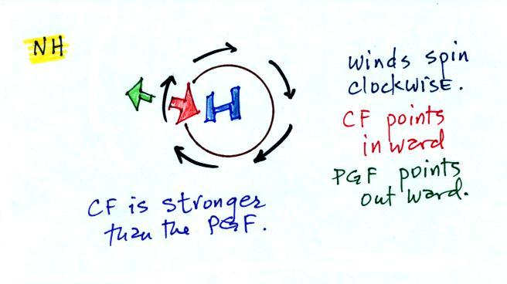

The four drawings at the bottom of the Step #1 page show surface winds blowing around high and low pressure in the southern hemisphere. These winds blow across the contour lines slightly, always toward low pressure. The frictional force is what causes this to occur. Below is an example of what you will be able to say about surface winds blowing around low pressure in the southern hemisphere.
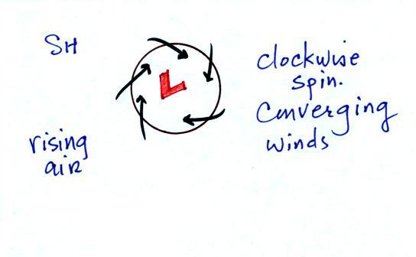

You should be able to look at an object's (or the wind's) motion and tell if there is a net force or not. The only time there is no net force is when the object is stationary or moving in a straight line at constant speed (both conditions must be met).

There aren't any forces at all acting on the object above at left. There are forces at right but they cancel each other out and the net force is zero. The objects below will continue to move in a straight line at constant speed. The pictures above and below weren't shown in class.

Another important point to take from Step #2 is that a net inward force is needed anytime an object is moving in a circular path even if the speed is constant. It doesn't matter what direction the object is moving and it doesn't matter what the object is circling around. Here are a few more examples. This figure wasn't shown in class.

A net inward force is needed to keep winds spinning around a center of low pressure, an inward force is needed to keep air moving in a circular path around high pressure, and a net inward force (gravity) is needed to keep a satellite in a circular orbit around the earth.
Quite a few people would say there is an outward force being exerted in the bottom picturebelow, but the force is inward in each of the cases.

It's just not the same amount of inward force. The amount of force is just right in the top figure, a little "too strong" in the middle figure, and "not quite strong enough" in the bottom figure.

Now we'll start to look at the forces that cause the wind to blow.

Air moving inward toward low pressure or outward away from high pressure is similar to a rock rolling down and away from the summit of a hill or inward toward the bottom of a depression. The pressure gradient force always points perpendicular to the contour lines on a map and toward low pressure. The PGF will cause stationary air to begin to move (it will always move toward low pressure).

The Coriolis force is caused by the rotation of the earth. We'll learn more about what causes the Coriolis force on Wednesday. The CF points perpendicular to the wind and can only change the wind's direction. It can't cause the wind to speed up or slow down. The direction of the CF depends on whether you're in the northern or southern hemisphere.

Time now to begin applying what we've learned.

We start with some stationary air at Point 1. The PGF at Point 1 starts stationary air moving toward the center of low pressure (just like a rock would start to roll downhill). Once the air starts to move, the CF causes it to turn to the right (because this is a northern hemisphere chart). The wind eventually ends up blowing parallel to the contour lines and spinning in a counterclockwise direction. Note that the inward PGF is stronger than the outward CF. This results in a net inward force, something that is needed anytime wind blows in a circular path.

We start again with some stationary air at Point 1 in this figure. See if you can figure out will happen next. You’ll find the analysis at the end of today’s notes.

With high pressure the air starts moving outward. In this example the wind takes a right turn and ends up blowing in a clockwise direction around the high. Note there is a net inward force here just as there was with the two previous examples involving low pressure.

Try this one on your own. You’ll find the completed analysis at the end of today’s notes.

2 steps left. Upper level winds blow parallel to the contour lines. Now we'll see how/why friction causes surface winds to blow across the contour lines (always toward low pressure).

The top figure shows upper level winds blowing parallel to straight contours. The PGF and CF point in opposite directions and have the same strength. The net force is zero. The winds would blow in a straight line at constant speed. Since the CF is perpendicular and to the right of the wind, this is a northern hemisphere chart.
We add friction in the second picture. It points in a direction opposite the wind and can only slow the wind down. The strength of the frictional force depends on wind speed (no frictional force if the wind is calm) and the type of surface the wind is blowing over (less friction when wind blows over the ocean, more frictional force when the wind is blowing over land).
Slowing the wind weakens the CF and it can no longer balance the PGF (3rd figure). The stronger PGF causes the wind to turn and start to blow across the contours toward Low. This is shown in the 4th figure. Eventually the CF and Frictional force, working together, can balance out the PGF.
What we've learned from the straight contour example, namely that the winds will blow across the contours toward low pressure can be applied to a curved contour pattern. The figure below wasn't shown in class.

If you take a small little piece of a curved pattern and magnify it, it will look straight. This is shown above.

Here is Step #10. It is easy to figure out which of the figures are centers of low pressure. The winds are spiralling inward in the top and bottom examples (1 and 3). These must be surface centers of low pressure. The winds are spiraling outward from the centers of high pressure (2 and 4).
Now you probably don't want to figure out which of these are northern and which are southern hemisphere pictures. It is probably best to remember one of the pictures. Remember in 1, for example, that surface winds spin counterclockwise and spiral inward around centers of low pressure in the northern hemisphere (something we learned early in the semester). Then remember that winds spin in the other direction and blow outward around high pressure in the northern hemisphere (2). The spinning directions of the winds reverse when you move from the northern to the southern hemisphere. Thus you find clockwise spinning winds and inward motion around low pressure (3) and counterclockwise and outward spiraling winds around high pressure in the southern hemisphere.
Converging winds cause air to rise. Rising air expands and cools and can cause clouds to form. Clouds and stormy weather are associated with surface low pressure in both hemispheres. Diverging winds created sinking wind motions and result in clear skies.
Here’s the upper level analysis you were supposed to work out on your own.
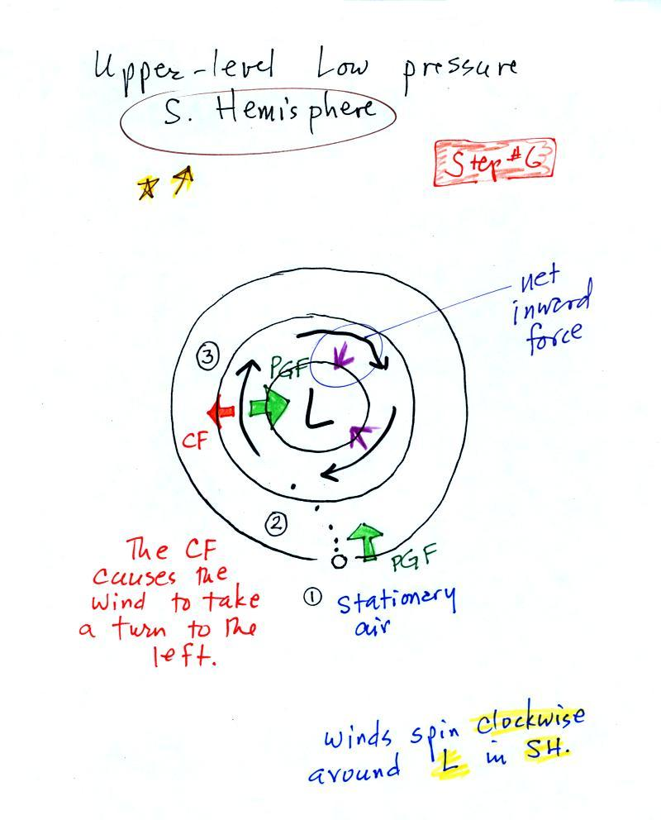

Here’s the other analysis you were supposed to do yourself.
