Upper Level Charts Pt. 3 – Effects on Surface Features

Now we are ready to look at some of the interactions between features on surface and upper level charts.

On the surface map above you see centers of HIGH and LOW pressure. The surface low pressure center, together with the cold and warm fronts, is a middle latitude storm.
Note how the counterclockwise winds spinning around the LOW move warm air northward (behind the warm front on the eastern side of the LOW) and cold air southward (behind the cold front on the western side of the LOW). Clockwise winds spinning around the HIGH also move warm and cold air. The surface winds are shown with thin brown arrows on the surface map.
Note the ridge and trough features on the upper level chart. We learned that warm air is found below an upper level ridge. Now you can begin to see where this warm air comes from. Warm air is found west of the HIGH and to the east of the LOW. This is where the two ridges on the upper level chart are also found. You expect to find cold air below an upper level trough. This cold air is being moved into the middle of the US by the northerly winds that are found between the HIGH and the LOW.
Note the yellow X marked on the upper level chart directly above the surface LOW. This is a good location for a surface LOW to form, develop, and strengthen (strengthening means the pressure in the surface low will get even lower than it is now. This is also called "deepening"). The reason for this is that the yellow X is a location where there is often upper level divergence. Similary the pink X is where you often find upper level convergence. This could cause the pressure in the center of the surface high pressure to get even higher.

This section examines in more detail how upper level winds can affect the development or intensification of a surface storm.

This figure (see p. 42 in the photocopied Classnotes) shows a cylinder of air positioned above a surface low pressure center. The pressure at the bottom of the cylinder is determined by the weight of the air overhead. The surface winds are spinning counterclockwise and spiraling in toward the center of the surface low. These converging surface winds add air to the cylinder. Adding air to the cylinder means the cylinder will weigh more and you would expect the surface pressure at the bottom of the cylinder to increase.
We'll just make up some numbers, this might make things clearer.

You'll find this figure on p. 42a in the Class Notes. We will assume the surface low has 960 mb pressure. Imagine that each of the surface wind arrows brings in enough air to increase the pressure at the center of the LOW by 10 mb. You would expect the pressure at the center of the LOW to increase from 960 mb to 1000 mb.
This is just like a bank account. You have $960 in the bank and you make four $10 dollar deposits. You would expect your bank account balance to increase from $960 to $1000.
But what if the surface pressure decreased from 960 mb to 950 mb as shown in the following figure? Or in terms of the bank account, wouldn't you be surprised if, after making four $10 dollar deposits, the balance went from $960 to $950.

The next figure shows us what could be happening (back to p. 42 in the Class Notes).

There may be some upper level divergence (more arrows leaving the cylinder at some point above the ground than going in). Upper level divergence removes air from the cylinder and would decrease the weight of the cylinder (and that would lower the surface pressure)
We need to determine which of the two (converging winds at the surface or divergence at upper levels) is dominant. That will determine what happens to the surface pressure.
Again some actual numbers might help (see p. 42b in the Class Notes)

The 40 millibars worth of surface convergence is shown at Point 1. Up at Point 2 there are 50 mb of air entering the cylinder but 100 mb leaving. That is a net loss of 50 mb. At Point 3 we see the overall result, a net loss of 10 mb. The surface pressure should decrease from 960 mb to 950 mb. That change is reflected in the next picture (found at the bottom of p. 42b in the Class Notes).

The surface pressure is 950 mb. This means there is more of a pressure difference between the low pressure in the center of the storm and the pressure surrounding the storm. The surface storm has intensified and the surface winds will blow faster and carry more air into the cylinder (the surface wind arrows each now carry 12.5 mb of air instead of 10 mb). The converging surface winds add 50 mb of air to the cylinder (Point 1), the upper level divergence removes 50 mb of air from the cylinder (Point 2). Convergence and divergence are in balance (Point 3). The storm won't intensify any further.

Now that you have some idea of what upper level divergence looks like (more air leaving than is going in) you are in a position to understand another one of the relationships between the surface and upper level winds.
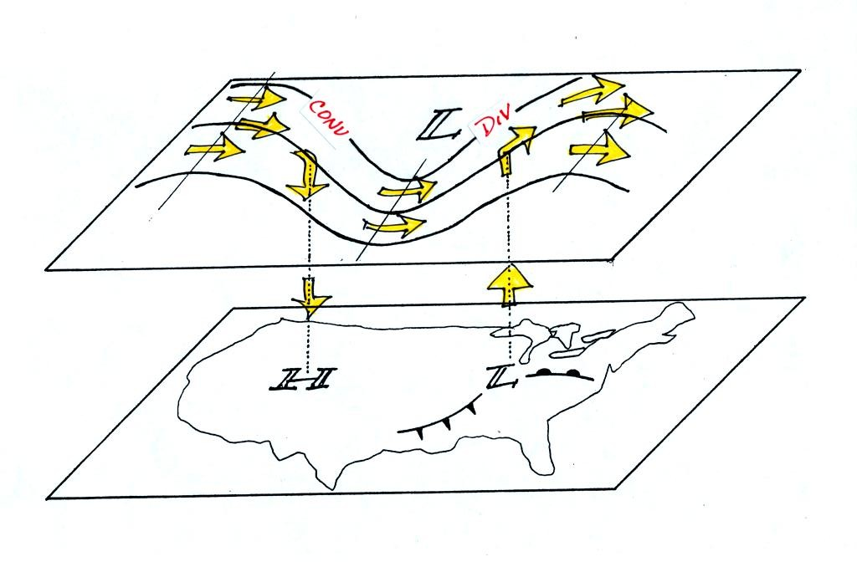

One of the things we have learned about surface LOW pressure is that the converging surface winds create rising air motions. The figure above gives you an idea of what can happen to this rising air (it has to go somewhere). Note the upper level divergence in the figure: two arrows of air coming into the point "DIV" and three arrows of air leaving (more air going out than coming in is what makes this divergence). The rising air can, in effect, supply the extra arrow's worth of air.
Three arrows of air come into the point marked "CONV" on the upper level chart and two leave (more air coming in than going out). What happens to the extra arrow? It sinks, it is the source of the sinking air found above surface high pressure.

