NATS 101 Name_________________________
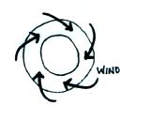
Optional Assignment

1. Does the figure show SURFACE or UPPER-LEVEL
winds? Are they blowing around a center of HIGH
or LOW pressure? Are these SOUTHERN or
NORTHERN hemisphere winds?

Surface winds always blow across the contours (upper level winds blow parallel to the contours) toward low pressure. Winds spin in a clockwise direction around low pressure in the southern hemisphere.

2. You observe a large storm system on a satellite photograph that is moving from east to west and spinning in a clockwise direction. This would most likely be a (circle 3 choices below, one from each column)
Northern hemisphere middle latitude anticyclone
Southern hemisphere tropical cyclone

A storm system means low pressure (rising air and clouds) so this could either be a middle latitude storm or a hurricane. Cyclone means winds spinning around low pressure. The fact that it is moving from East to West means tropical cyclone. And the winds are spinning clockwise, so low pressure in the southern hemisphere.
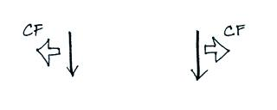
3. Which figure shows winds blowing in the southern
hemisphere? (CF shows the direction of the Coriolis force)

The figure on the right is the correct answer. You need to turn the page upside down so that you are looking in the direction the wind is blowing. The CF should be perpendicular and to the left of the wind in the southern hemisphere.

4. What characteristic do the “doldrums” and the “horse latitudes” have in common?
a. high pressure b. fast winds c. clear skies
d. low pressure e. calm winds f. cloudy skies

The doldrums are located at the equator and coincide with a belt of low pressure. You would expect to find rising air and clouds associated with them. The horse latitudes are found at 30 latitude where there is sinking air (clear skies) and a belt of high pressure

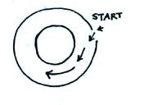
5. The direction of the initial motion in the figure at right
means this is a center of HIGH LOW pressure. Rather
than going straight toward the center of the picture the
wind turns to the left. The direction of this bending
means that this is a NORTHERN SOUTHERN
hemisphere chart.

The pressure gradient force can start stationary air moving. The PGF always points toward low pressure. Since the air starts moving inward in this case, this must be a center of low pressure. Once the air starts moving, it takes a turn to the left. The Coriolis force is what causes that to happen, so this must be a southern hemisphere map where the CF acts to the left of the wind.

6. The direction of the __a___ force changes when you move from the northern to the southern hemisphere.
a. Coriolis b. frictional c. gravitational d. pressure gradient

The Coriolis forces is what causes the direction of spinning winds to change when you move from the northern to the southern hemisphere. The Coriolis force is zero at the Equator where it is changing direction.

7. Would you find wind PATTERN A or wind PATTERN B at the intertropical convergence zone?
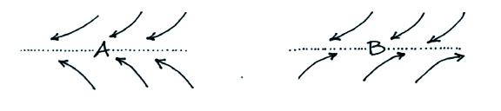

The northeasterly and southeasterly trade winds converge at the ITCZ (located at the equator). Pattern B is found at the polar front (60º N latitude)

8. The term _________monsoon______________ refers to a seasonal change in the direction of the prevailing winds.

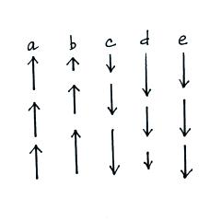
9. The speeds of 5 upward or downward moving
objects are shown at right. From careful study
of the object’s motions and making use of
Newton’s 1st law of motion, you could conclude
that there is no net force acting on the objects in
___a__ and ___e____. An upward force is
being exerted on the object in ___d___. A
downward force is acting on the object in
___b___ and ___c___.

In (a) and (e) the object is moving in a straight line at constant speed. Both conditions need to be true for there to be no net force.

Think about what would happen if you threw something up into the air. It would start upward but then gravity would then slow down and eventually cause it to stop. Then it would start to fall back toward the ground picking up speed as it fell. This is exactly what is illustrated in (b) and (c). So a downward force is present in (b) and (c)

That leaves (d) as an example of an upward directed force. The upward force is opposite the object’s motion and is causing it to slow down as it falls.

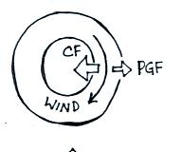
10. The direction of the PGF in the figure at right
tells you that this is a center of HIGH LOW
pressure. The direction of the CF is to the
RIGHT LEFT of the wind which indicates
this is a SOUTHERN NORTHERN hemisphere
chart.

11. In a thermal circulation the pressure gradient force is much STRONGER WEAKER than the Coriolis force.

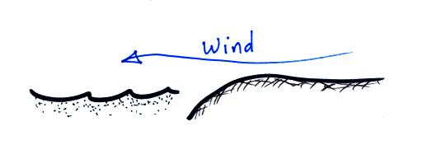
We generally ignore the Coriolis force in thermal circulations.

12. The surface wind in the picture at right is blowing offshore.
Would this be called a SEA or LAND breeze? Would the
land be WARMER or COLDER than the ocean? Would
the surface winds blow like this during the DAY or at NIGHT?
Would you expect to see clouds over the LAND or the SEA?

13. At 32º N. latitude, Tucson is closest to which of the following 3-cell model features?
a. doldrums (0º) b. ITCZ (0º) c. polar front (60º) d. horse latitudes (30º)

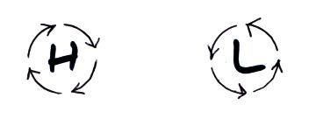
14. The wind is blowing in a circular path at constant
speed in the two figures at right. The direction
of the net force is
a. inward around L, outward around H
b. inward in both figures
c. in the direction of motion in both figures
d. zero in both figures

15. The strength of the ___a___ force and the ___b____force depend on wind speed.
a. Coriolis b. frictional c. gravitational d. pressure gradient force

