Name_______________________________

Surface Weather Map Worksheet

The surface weather map that you will be analyzing is drawn on the next page. Temperature, dew point, cloud cover, wind direction and speed, pressure, and pressure tendency data are all shown.

1. Perform an isobaric analysis by drawing in isobars to reveal the pressure pattern. Isobars are drawn at 4 mb intervals beginning with a base value of 1000 mb. Allowed values for isobars include: . . . 988, 992, 996, 1000, 1004, 1008, 1012, 1016, . . . Depending on the actual pressure values plotted on your map, you may use only some of these values or you may need to use values that are larger or smaller than the values shown on the list.

What is the largest and the smallest pressure value on your map? Which of the allowed isobar values in the list above fall between the largest and smallest pressure values on the map?

These are the isobars that you should sketch in on the map.

2. Locate the cold front on the map. One end of the cold front should originate in the center of low pressure. Cold fronts are found at the leading edge of a cold (and often dry) air mass that is moving into a region with warmer (often moister) air. Try to identify large air masses on the map with clear temperature and moisture (dew point) differences. The boundary between these air masses is a good place to start trying to locate a front. From the reading in the text you know also that winds will often blow from different directions on the two sides of a front. Clouds, rain or snow showers, and thunderstorms are often found near a cold front. The pressure tendency can also be very useful when trying to locate a front.

Once you have located the cold front indicate whether the pressure is rising or falling ahead and behind the front. Indicate the directions of the prevailing winds ahead and behind the front. Where is the warmest and the moistest air, ahead or behind the front?

3. Locate the warm front on the map. One end of the warm front should originate in the center of low pressure. Warm fronts are found where warm air is meeting the trailing edge of a retreating mass of colder air. Again you should try to identify large air masses with distinct differences in temperature and moisture content. The boundary between these air masses is a good place to tentatively locate the warm front. You should then use the wind direction, pressure tendency, cloud, and precipitation data to confirm or to adjust the location of the front.

Once you have located the warm front indicate whether the pressure is rising or falling ahead and behind the front. Indicate the directions of the prevailing winds ahead and behind the front. Where is the warmest and the moistest air, ahead or behind the front?

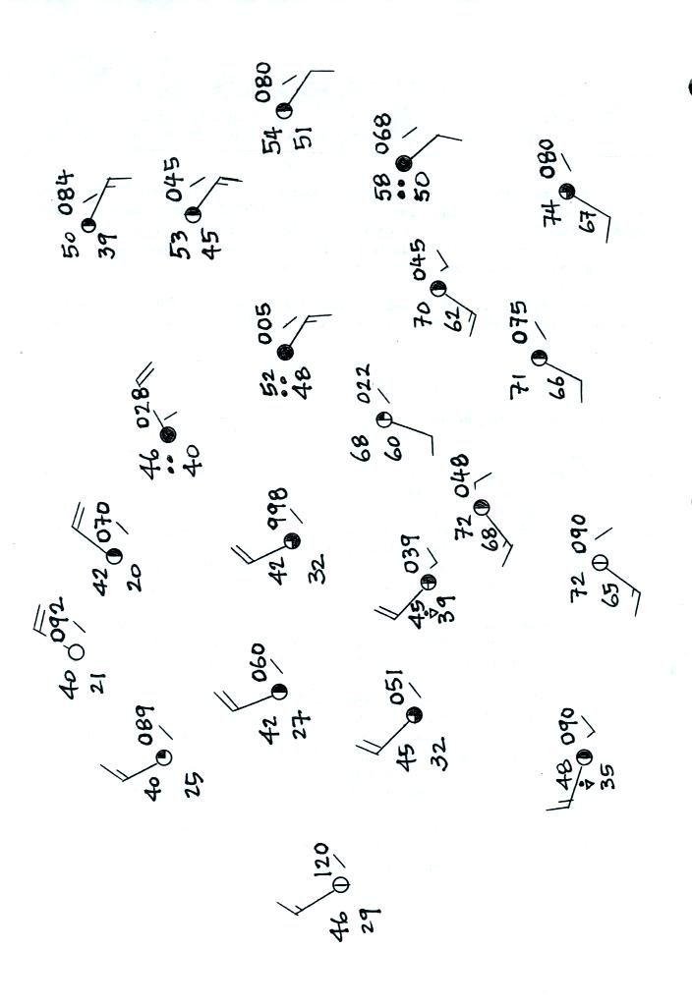
Name_______________________________

