Week #2 Assignment

1. The weight of an object depends on the object's _______ and _______.
a. mass b. atmospheric pressure c. volume d. gravity e. density
2. Based on the pressure values shown in the figure below, 30% of the weight of the
atmosphere lies
a. above C b. between B and C c. between A and C d. between A and B

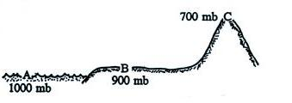
3. There is less and less air left overhead as you move upward in the atmosphere. This
explains why _______ and _______ both decrease with increasing altitude.
a. gravity b. air pressure c. air density d. air temperature

4. Pressure at the ground is HIGHER LOWER than at some altitude above the ground.
This change in pressure produces a force that points UPWARD DOWNWARD.

6. The two volumes of air in the figure br;pe have equal volumes but different densities. Parcel B weighs MORE than, LESS than, the SAME as the air in Parcel A. The
upward force on Parcel B from the pressure of the surrounding air is GREATER than, LESS than, EQUAL to force on Parcel A.

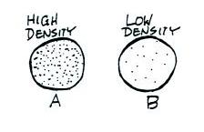
11. If you measured the air pressure and the air temperature, you could use the idea gas law to calculate the
a. dew point b. air density c. air composition d. altitude

12. Outside an airplane at 30,000 feet altitude, the air temperature would be ____________, the air pressure would be ____________, and the air density would be ____________ than(as) at sea level. (fill in each blank with HIGHER, LOWER, or the SAME)

13. The earth’s atmosphere is divided into layers based on the vertical profile of
a. air pressure b. air temperature c. air density d. wind direction

14. Indicate whether the following would be found in the BOTTOM, MIDDLE, or TOP layer in the figure below.
a. coldest air temperatures ____________ b. highest air density ____________
c. troposphere ____________ d. lowest air pressure __________
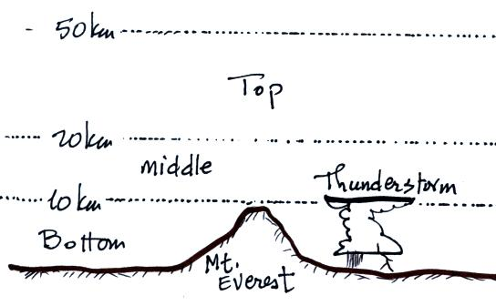

15. To determine whether an object will float or sink when thrown into water you need to know how the object’s ____________________ compares to that of water.

