Week #2 Assignment

1. The weight of an object depends on the object's _______ and _______.
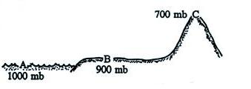
a. mass b. atmospheric pressure c. volume d. gravity e. density
2. Based on the pressure values shown in the figure
at right, 30% of the weight of the atmosphere lies
a. above C b. between B and C
c. between A and C d. between A and B
3. There is less and less air left overhead as you move upward in the atmosphere. This
explains why _______ and _______ both decrease with increasing altitude.
a. gravity b. air pressure c. air density d. air temperature
4. Pressure at the ground is HIGHER LOWER than at some altitude above the ground. This change in pressure produces a force that points UPWARD DOWNWARD.

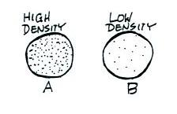
5. If the earth's gravity were to increase, but the mass of the atmosphere remained constant, the surface pressure would INCREASE, DECREASE, remain the SAME. Surface air density would INCREASE, DECREASE, remain the SAME.
6. The two volumes of air in the figure at right have equal volumes
but different densities. Parcel B weighs MORE than, LESS than,
the SAME as the air in Parcel A. The upward force on Parcel B
from the pressure of the surrounding air is GREATER than,
LESS than, EQUAL to force on Parcel A.

7. Sea level atmospheric pressure is determined by
a. the composition of the atmosphere b. the weight of the atmosphere
c. the thickness of the atmosphere d. the distance between the earth and the sun
8. Fill in any two of the following blanks with approximate values of average atmospheric pressure at sea level.
_________ millibars _________inches of mercury ________ pounds per square inch
9. The pressure of the gas in a parcel does not depend on the
a. parcel volume b. gas temperature c. gas density d. gas temperature
10. In the atmosphere if you heat or cool a small volume of air the DENSITY PRESSURE of the air inside the parcel will change in order to keep the DENSITY PRESSURE constant.
11. If you measured the air pressure and the air temperature, you could use the idea gas law to calculate the
a. dew point b. air density c. air composition d. altitude
12. Outside an airplane at 30,000 feet altitude, the air temperature would be ____________, the air pressure would be ____________, and the air density would be ____________ than(as) at sea level. (fill in each blank with HIGHER, LOWER, or the SAME)

13. The earth’s atmosphere is divided into layers based on the vertical profile of
a. air pressure b. air temperature c. air density d. wind direction
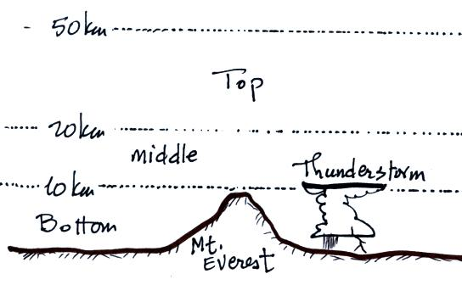
14. Indicate whether the following would be found
in the BOTTOM, MIDDLE, or TOP layer in the
figure at right.
a. coldest air temperatures ____________
b. highest air density ____________
c. troposphere ____________
d. lowest air pressure __________

15. To determine whether an object will float or sink when thrown into water you need to know how the object’s ____________________ compares to that of water.

