Week #3 Assignment

1. Which of the following is not plotted below?
a. pressure b. dew point temperature c. temperature d. relative humidity

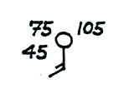

2. Which one of the following does not belong in the same group as the other three?
a. clockwise spinning winds b. converging surface winds c. sinking air d. clear skies

3. The L in the figure stands for low PRESSURE TEMPERATURE. A is a COLD WARM front.
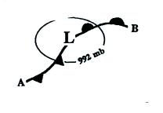

4. A(n) _______ correction is made before pressure measurements are plotted on a surface weather map.
a. temperature b. latitude c. wind speed d. altitude

5. Clouds can form above surface centers of HIGH LOW pressure when air RISES SINKS and COOLS WARMS.

6. Diverging wind motions are shown at the TOP BOTTOM of the figure below. If the divergence is stronger than the convergence, the surface pressure in the center of the picture will INCREASE DECREASE remain the SAME.
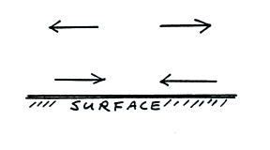

7. The winds in the figure below are blowing from the SW NW SE NE
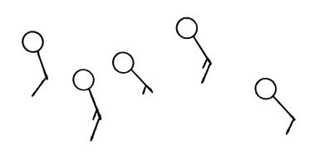

8. A strong pressure gradient would most likely produce
a. rainy weather b. cold weather c. strong winds d. warm weather

9. Generally speaking you will find PRESSURE HEIGHT contours on a surface weather map and PRESSURE HEIGHT contours on an upper level chart.

10. Points A and B in the figure below are at the same altitude. The 850 mb pressure level is indicated. Point A lies below an upper level RIDGE TROUGH. The air at Point A is WARMER COLDER than at B. The pressure at Point A is HIGHER LOWER than at B.
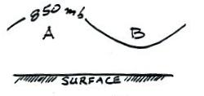

11. The surface pressure data in the figure below would indicate EQUAL DIFFERENT amounts of air on each side of the picture. The temperatures of the air in the left and right sides of the figure are EQUAL DIFFERENT. You would expect to find an upper level ridge on the RIGHT LEFT side of the figure.
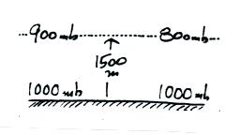

12. If you travel from Point A to Point B on the upper level chart below, the air temperature will ____________, the altitude will ____________, and the pressure will ____________. (fill in each blank with DECRease, remain the SAME, or INCRease)
