Week #6 Assignment

1. The sun will pass directly overhead at noon at the Equator _______.
a. always b. on March 21 c. on June 21 d. never

2. There are more than 12 hours of daylight in Tucson
a. between the summer and winter solstices
b. between the vernal (spring) and autumnal (fall) equinoxes
c. between the summer solstice and the autumnal equinox
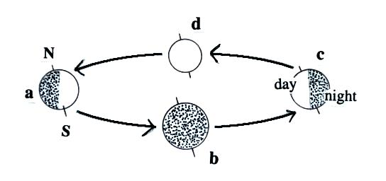
d. between the vernal equinox and the winter solstice

3. The summer solstice is at Point _______ in this figure
of the earth orbiting the sun (the sun is in the middle of
the figure). The vernal equinox is at Point _______.

4. The moon completes an orbit around the earth about once every _______.
a. day b. week c. month d. year

5. The earth is a little closer to the sun in January (during summer in the S. Hemisphere) than in July (summer in the N. Hemisphere). Summers in the S. Hemisphere are nonetheless cooler than in the N. Hemisphere. Which of the controls of temperature would best explain this?

6. Increasing which two of the following would increase the amount of sunlight energy arriving at the ground during the day.
a. length of the path sunlight travels through the atmosphere
b. distance between the earth and the sun
c. elevation angle of the sun in the sky
d. length of the day (number of daylight hours)

7. The greatest seasonal variability occurs at _______. At _______ the days are 12 hours long every day of the year. The sun will be overhead at noon one day each year at _______. The amount of sunlight energy reaching the ground during a day is a maximum at _______ during the summer. (each answer below should be used once)
a. 0º latitude b. 23.5º latitude c. 30º latitude d. 45º latitude

8. If the earth were tilted 30º (instead of the current 23.5º) would the Tropic of Cancer be found at HIGHER LOWER or the SAME latitude than(as) is currently the case? Would the Arctic Circle be found at HIGHER LOWER or the SAME latitude than(as) is currently the case?

9. You would expect a region where the sun is passing overhead (or nearly overhead) at noon to be in the middle of a DRY WET season.

10. Measurements of the relative amounts of the O¹⁶ and O¹⁸ isotopes in polar ice cores and ocean sediments have been used to determine _________________________.

11. Which of the following removes CO₂ from the atmosphere?
a. combustion b. respiration c. photosynthesis d. deforestation

12. Pick one entry from each of the three
columns at right to indicate where you latitude surrounded by altitude
would expect to find 0º
the coldest 30º OCEAN HIGH
region on earth _______ & _______ & _______ 60º LAND LOW
the hottest 90º
region on earth _______ & _______ & _______

13. Which of the following is not a reason why summertime temperatures at a location next to or surrounded by a large body of water will be lower than at a location surrounded by land.
a. incoming sunlight energy is used to heat a large mass of water than land
b. some of the incoming sunlight is used to evaporate not warm the water
c. water has a higher specific heat than land
d. water covers a larger fraction of the earth’s surface than land

14. Winter temperatures at the S. Pole are colder than winter temperatures at the N. Pole. Why is this true?

15. Estimate the annual mean temperature and the annual range of temperature for a location where the warmest and coldest average monthly temperatures are 85º F and 45º F, respectively.

16. Is it DECREASING or INCREASING atmospheric concentrations of CARBON DIOXIDE or OZONE that are thought to be responsible for global warming and climate change?

17. During the past 250 years or so atmospheric carbon dioxide concentrations have
a. remained about constant b. have been increasing
c. have decreased to near zero d. increased or decreased depending on location

18. Define or explain the term carbon sequestration.

19. Atmospheric carbon dioxide concentrations are highest during the WINTER SUMMER.

20. Anthropogenic CO₂ emissions into the atmosphere are GREATER about the SAME LESS than(as) natural emissions.

21. A high H₂O¹⁶ to H₂O¹⁸ ratio in a polar ice sample would indicate a relatively COLD WARM period in the earth’s climate.

