Tuesday Oct. 9, 2012
I had planned on playing two songs before class, "Hold On" and "Baka" from a group named Outback. In the end we only had time for the first one.
The Upper Level Charts Assignment has been graded. If you lost 3 pts or less on the assignment you earned a Green Card. Everyone that turned in an assigment earned 0.5 pts of extra credit.
I didn't mention it but most of the last of the 1S1P Assignment #1 reports (the radon topic) has been graded and was returned in class. My TA brought by the remaining pile of papers after class so I'll have everything with me in class on Friday.
The final version of the Quiz #2 Study Guide is now online.

This is really just a partial list of some of the different types of EM radiation. In the top list, shortwave length and high energy forms of EM radiation are on the left (gamma rays and X-rays for example). Microwaves and radiowaves are longer wavelength, lower energy forms of EM radiation.
We will mostly be concerned with just ultraviolet light (UV), visible light (VIS), and infrared light (IR). Note the micrometer (millionths of a meter) units used for wavelength for these kinds of light. The visible portion of the spectrum falls between 0.4 and 0.7 micrometers. UV and IR light are both invisible. All of the vivid colors shown above are just EM radiation with slightly different wavelengths. When you see all of these colors mixed together, you see white light.

The world would not look the same if we were able to see IR light instead of visible light
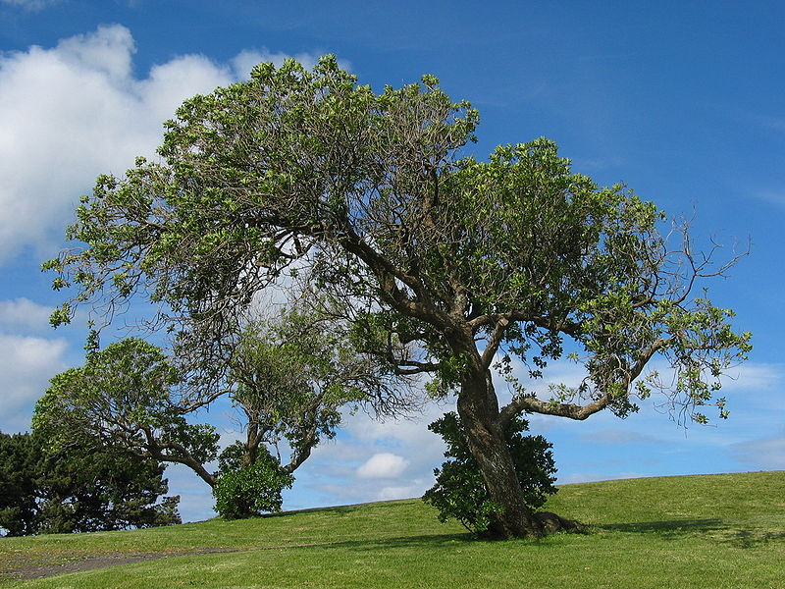 | 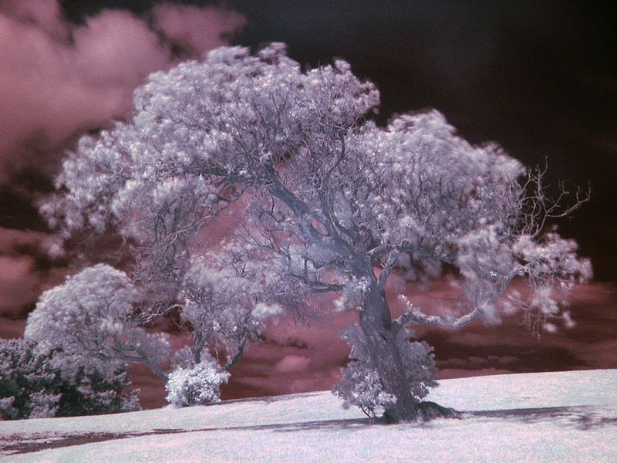
The picture at left was taken using normal film, film that is sensitive to visible light. The picture at right used infrared film. In both pictures we are looking at sunlight that strikes the tree or the ground and is reflected toward the camera where it can be photographed (i.e. these aren't photographs of light emitted by the tree or the ground). The tree at left is green and relatively dark (it reflects green light but absorbs the other colors of visible light). The tree at right and the ground are white, almost like they were covered with snow. The tree and grass on the ground are reflecting infrared light. Here are many more images taken with infrared film.
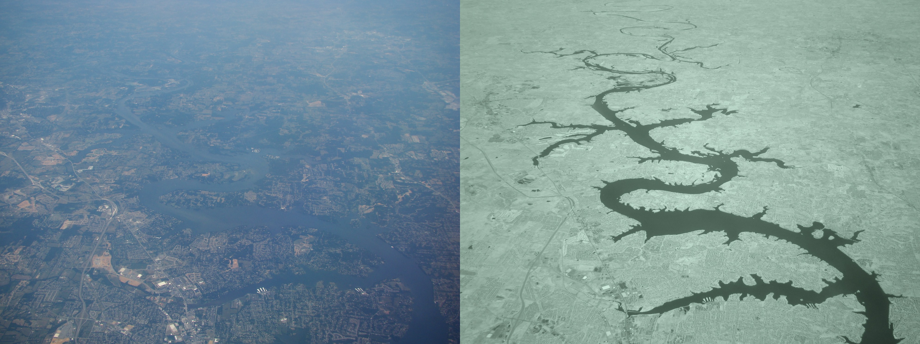
Here's another example, photographs of the ground taken from an air plane using ordinary film at left (responds to visible light) and infrared film at right. Notice how the IR photograph is able to "see through" the haze. The haze at left is scattered light. IR light is not scattered as readily as visible light.

Here are some rules governing the emission of electromagnetic radiation:

1.
Unless an object is very cold (0 K) it will emit EM radiation. Everything in the classroom: the people, the furniture, the walls and the floor, even the air, are emitting EM radiation. Often this radiation will be invisible so that we can't see it and weak enough that we can't feel it (or perhaps because it is always there we've grown accustomed to it and ignore it). Both the amount and kind (wavelength) of the emitted radiation depend on the object's temperature.
2.
The second rule allows you to determine the amount of EM radiation (radiant energy) an object will emit. Don't worry about the units, you can think of this as amount, or rate, or intensity. Don't worry about σ (the Greek character rho) either, it is just a constant. The amount depends on temperature to the fourth power. If the temperature of an object doubles the amount of energy emitted will increase by a factor of 2 to the 4th power (that's 2 x 2 x 2 x 2 = 16). A hot object just doesn't emit a little more energy than a cold object it emits a lot more energy than a cold object. This is illustrated in the following figure:

The cool object is emitting 2 arrows worth of energy. The warmer object is 2 times warmer and is emitting 32 arrows (16 times more energy).
3.
The third rule tells you something about the kind of radiation emitted by an object. We will see that objects usually emit radiation at many different wavelengths but not in equal amounts. But, objects emit more of one particular wavelength than any of the others. This is called λ_{max} ("lambda max", lambda is the greek character used to represent wavelength) and is the wavelength of maximum emission. The third rule allows you to calculate λ_{max}. The tendency for warm objects to emit radiation at shorter wavelengths is shown below.

The cool object is probably emitting infrared light so the 2 arrows of energy are colored red. The warmer object will also emit IR light but also shorter wavelengths such as yellow, green, blue, and violet (maybe even some UV if it's warm enough).
If the cool object were warm enough to be emitting a little visible light it would probably appear red or orange. In that case the warmer object would emit some of the shorter wavelengths of visible light and would probably appear white.
The graphs at the bottom of p. 65 in the photocopied ClassNotes also help to illustrate the Stefan-Boltzmann law and Wien's laws. We're really beating this topic to death.

1.
Notice first that both and warm and the cold objects emit radiation over a range of wavelengths (the curves above are like quiz scores, not everyone gets the same score, there is a distribution of grades). The warm object emits all the wavelengths the cooler object does plus lots of additional shorter wavelengths.
2.
The peak of each curve is λ_{max.} Note that λ_{max} has shifted toward shorter wavelengths for the warmer object. This is Wien's law in action. The warmer object is emitting lots of types of short wavelength radiation that the colder object doesn't emit.
3.
The area under the warm object curve is much bigger than the area under the cold object curve. The area under the curve is a measure of the total radiant energy emitted by the object. This illustrates the fact that the warmer object emits a lot more radiant energy than the colder object.

And for even more reinforcement, a demonstration. It consisted of an ordinary 200 W tungsten bulb is connected to a dimmer switch (see p. 66 in the photocopied ClassNotes). We'll be looking at the EM radiation emitted by the bulb filament.

The graph at the bottom of p. 66 has been split up into 3 parts and redrawn for improved clarity.

We start with the bulb turned off (Setting 0). The filament will be at room temperature which we will assume is around 300 K (remember that is a reasonable and easy to remember value for the average temperature of the earth's surface). The bulb will be emitting radiation, it's shown on the top graph above. The radiation is very weak so we can't feel it. The wavelength of peak emission is 10 micrometers which is long wavelength, far IR radiation so we can't see it.
Next we use the dimmer switch to just barely turn the bulb on (the temperature of the filament is now about 900 K). The bulb wasn't very bright at all and had an orange color. This is curve 1, the middle figure. Note the far left end of the emission curve has moved left of the 0.7 micrometer mark - into the visible portion of the spectrum. That is what you were able to see, just the small fraction of the radiation emitted by the bulb that is visible light (but just long wavelength red and orange light). Most of the radiation emitted by the bulb is to the right of the 0.7 micrometer mark and is invisible IR radiation (it is strong enough now that you could feel it if you put your hand next to the bulb).
Finally we turn on the bulb completely (it was a 200 Watt bulb so it got pretty bright). The filament temperature is now about 3000K. The bulb is emitting a lot more visible light, all the colors, though not all in equal amounts. The mixture of the colors produces a "warm white" light. It is warm because it is a mixture that contains a lot more red, orange, and yellow than blue, green, and violet light. It is interesting that most of the radiation emitted by the bulb is still in the IR portion of the spectrum (lambda max is 1 micrometer). This is invisible light. A tungsten bulb like this is not especially efficient, at least not as a source of visible light.
You were able to use one of the diffraction gratings handed out in class to separate the white light produced by the bulb into its separate colors.
When you looked at the bright white bulb filament through one of the diffraction gratings the colors were smeared out to the right and left as shown below.

Some of the gratings handed out in class behaved a little differently and spread out the colors horizontally, vertically, and diagonally.

Here's another infrared photograph that I didn't discuss in class - a thermal image of a house. These are photograps of infrared light that is being emitted (not reflected light) by a house. Remember that the amount of energy emitted by an object depends strongly on temperature (temperature to the 4th power in the Stefan-Boltzmann law). Thus it is possible to see hot spots that emit a lot of energy and appear "bright" and colds spots. Photographs like these are often used to perform an "energy audit" on a home, i.e. to find spots where energy is being lost. Once you locate one of these hot spots you can add insulation and reduce the energy loss.

Here are the rules for the amount and kind (wavelength of peak emission) of radiation emitted by an object.

Let's look at the light emitted by the sun and the earth.

The curve on the left is for the sun. We have used Wien's law and a temperature of 6000 K to calculate λ_{max} and got 0.5 micrometers. This is green light; the sun emits more green light than any other kind of light. The sun doesn't appear green because it is also emitting lesser amounts of violet, blue, yellow, orange, and red - together this mix of colors appears white. 44% of the radiation emitted by the sun is visible light, Very nearly half of sunlight (49%) is IR light (37% near IR + 12% far IR). 7% of sunlight is ultraviolet light. More than half of the light emitted by the sun (the IR and UV light) is invisible.
100% of the light emitted by the earth (temperature = 300 K) is invisible IR light. The wavelength of peak emission for the earth is 10 micrometers.
Because the sun (surface of the sun) is 20 times hotter than the earth the sun's surface emits energy at a much higher rate than the earth. Note the vertical scale on the earth curve is different than on the sun graph. If both the earth and sun were plotted with the same vertical scale, the earth curve would be too small to be seen.

In the earlier demonstration we learned that ordinary tungsten bulbs (incandescent bulbs) produce a lot of wasted energy. This is because they emit a lot of invisible infrared light that doesn't light up a room (it will warm up a room but there are better ways of doing that). The light that they do produce is a warm white color (tungsten bulbs emit lots of orange, red, and yellow light and not much blue, green or violet).
Energy efficient compact fluorescent lamps (CFLs) are being touted as an ecological alternative to tungsten bulbs because they use substantially less electricity, don't emit a lot of wasted infrared light, and also last longer. CFLs come with different color temperature ratings.

The bulb with the hottest temperature rating (5500 K ) in the figure above is meant to mimic or simulate sunlight (daylight). The temperature of the sun is 6000 K and lambda max is 0.5 micrometers. The spectrum of the 5500 K bulb is similar.
The tungsten bulb (3000 K) and the CFLs with temperature ratings of 3500 K and 2700 K produce a warmer white.
Three CFLs with the temperature ratings above were set up in class so that you could see the difference between warm and cool white light. Personally I find the 2700 K bulb "too warm," it makes a room seem gloomy and depressing (a student in class once said the light resembles Tucson at night). The 5500 K bulb is "too cool" and creates a stark sterile atmosphere like you might see in a hospital corridor. I prefer the 3500 K bulb in the middle.
The figure below is from an article on compact fluorescent lamps in Wikipedia for those of you that weren't in class and didn't see the bulb display. You can see a clear difference between the cool white bulb on the left in the figure below and the warm white light produced by a tungsten bulb (2nd from the left) and 2 CFCs with low temperature ratings (the 2 bulbs at right).

There is one downside to these energy efficient CFLs. The bulbs shouldn't just be discarded in your ordinary household trash because they contain mercury. They should be disposed of properly (at a hazardous materials collection site or perhaps at the store where they were purchased).
It probably won't be long before LED bulbs begin to replace tungsten and CFL bulbs. At the present time the LED bulbs are pretty expensive.

We now have most of the tools we will need to begin to study energy balance on the earth. It will be a balance between incoming sunlight energy and outgoing energy emitted by the earth. This will ultimately lead us to an explanation of the atmospheric greenhouse effect.
We will first look at the simplest kind of situation, the earth without an atmosphere (or at least an atmosphere without greenhouse gases). The next figure is on p. 68 in the photocopied Classnotes. Radiative equilibrium is really just balance between incoming and outgoing radiant energy. Pages 68 and 69 were somehow left out of the photocopied ClassNotes. Copies of these two pages were handed out in class.

You might first wonder how it is possible for the earth (with a temperature of around 300 K) to be in energy balance with the sun (6000 K). At the top right of the figure you can see that because the earth is located about 90 million miles from the sun and it only absorbs a very small fraction of the total energy emitted by the sun.
To understand how energy balance occurs we start, in Step #1, by imagining that the earth starts out very cold (0 K) and is not emitting any EM radiation at all. It is absorbing sunlight however (4 of the 5 arrows of incoming sunlight in the first picture are absorbed, 1 of the arrows is being reflected) so it will begin to warm This is like opening a bank account, the balance will be zero at first. But then you start making deposits and the balance starts to grow.
Once the earth starts to warm it will also begin to emit EM radiation, though not as much as it is getting from the sun (the slightly warmer earth in the middle picture is now colored blue). Only the four arrows of incoming sunlight that are absorbed are shown in the middle figure. The two arrows of reflected sunlight have been left off because they don't really play a role in energy balance (reflected sunlight is like a check that bounces - it really doesn't affect your bank account balance). The earth is emitting 3 arrows of IR light (in red). Because the earth is still gaining more energy than it is losing the earth will warm some more. Once you find money in your bank account you start to spend it. But as long as deposits are greater than the withdrawals the balance will grow.
Eventually it will warm enough that the earth (now shaded brown & blue) will emit the same amount of energy as it absorbs from the sun. This is radiative equilibrium, energy balance (4 arrows of absorbed energy are balanced by 4 arrows of emitted energy). The temperature at which this occurs is about 0 F. That is called the temperature of radiative equilibrium (it's about 0 F for the earth).
Note that it is the amounts of energy not the kinds of energy that are important. Emitted radiation may have a different wavelength than the absorbed energy. That doesn't matter. As long as the amounts are energy the earth will be in energy balance.

Before we start to look at radiant energy balance on the earth with an atmosphere we need to learn about filters. The atmosphere will filter sunlight as it passes through the atmosphere toward the ground. The atmosphere will also filter IR radiation emitted by the earth as it trys to travel into space.
We will first look at the effects simple blue, green, and red glass filters have on visible light. This is just to be able to interpret a filter absorption curve or graph.

If you try to shine white light (a mixture of all the colors) through a blue filter, only the blue light passes through. The filter absorption curve shows 100% absorption at all but a narrow range of wavelengths that correspond to blue light. The location of the slot or gap in the absorption curve shifts a little bit with the green and red filters.

The following figure is a simplified, easier to remember, representation of the filtering effect of the atmosphere on UV, VIS, and IR light (found on p. 69 in the photocopied notes). The figure was redrawn after class.

You can use your own eyes to tell you what effect the atmosphere has on visible light. Air is clear, it is transparent. The atmosphere transmits visible light.
In our simplified representation oxygen and ozone make the atmosphere pretty nearly completely opaque to UV light (opaque is the opposite of transparent and means that light is blocked or absorbed; light can't pass through an opaque material). We assume that the atmosphere absorbs all incoming UV light, none of it makes it to the ground. This is of course not entirely realistic.
Greenhouse gases make the atmosphere a selective absorber of IR light - the air absorbs certain IR wavelengths and transmits others. It is the atmosphere's ability to absorb jcertain wavelengths of infrared light that produces the greenhouse effect and warms the surface of the earth. Greenhouse gases also emit IR light. This is an important part of the greenhouse effect, something we'll return to after the quiz.
Note "The atmospheric window" centered at 10 micrometers. Light emitted by the earth at this wavelength (and remember 10 um is the wavelength of peak emission for the earth) will pass through the atmosphere. Another transparent region, another window, is found in the visible part of the spectrum.

