ATMO170A1 Name_________Answers_____________
In-class Optional Assignment

1. A mixing ratio of 6 g/kg means there are 6 grams of ______water vapor____________
mixed in with 1 kilogram of _________dry air_________________.

2. If you know the air's temperature you can look up the value of the ___b___ in a table.
a. mixing ratio b. saturation mixing ratio c. relative humidity d. dew point

3. Adding water vapor to the air will not increase the ___b___.
a. mixing ratio b. saturation mixing ratio c. relative humidity d. dew point

The saturation mixing ratio is a property of the air and depends only on the air’s temperature. The mixing ratio, relative humidity, and dew point temperature all depend on how much water vapor is in the air.

4. 90º F air can potentially hold ___c___ times as much water vapor as 45º F air (consult the table on p. 86 in the photocopied ClassNotes)
a. 2 b. 4 c. 5 d. 10
90º F air has a saturation mixing ratio value of 30 g/kg. That is 5 times larger than the saturation mixing ratio value for 45º F air, 6 g/kg.

5. To calculate the relative humidity you need to know the _______ and the _______.
a. mixing ratio b. saturation mixing ratio c. air temperature d. dew point

6. The value of the ___c___ will tell you whether moist air is saturated or not.
a. mixing ratio b. saturation mixing ratio c. relative humidity d. dew point
The value of the relative humidity tells you how close (percentage) air is to being filled to capacity (saturated) with water vapor.

7. Based on the data in the figure below, does the parcel of 70º F air have MORE LESS or the SAME amount of water vapor than(as) the 85º F air?
Both parcels have the same mixing ratio. The value of the mixing ratio tells you how much water vapor is actually in the air.
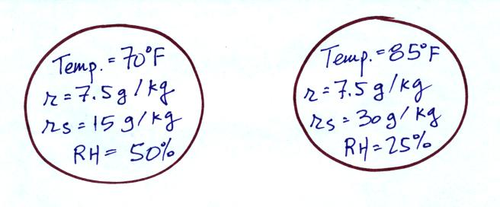

8. Which two of the following have the same job, telling you how much water vapor is actually in the air?
a. mixing ratio b. saturation mixing ratio c. relative humidity d. dew point

